Migrant Forum in Asia
Submission to the UN Special Rapporteur on the Human Rights of Migrants
Report on How to Expand and Diversify Regularization Mechanisms and Programs to Enhance the Protection of the Human Rights of Undocumented Migrants

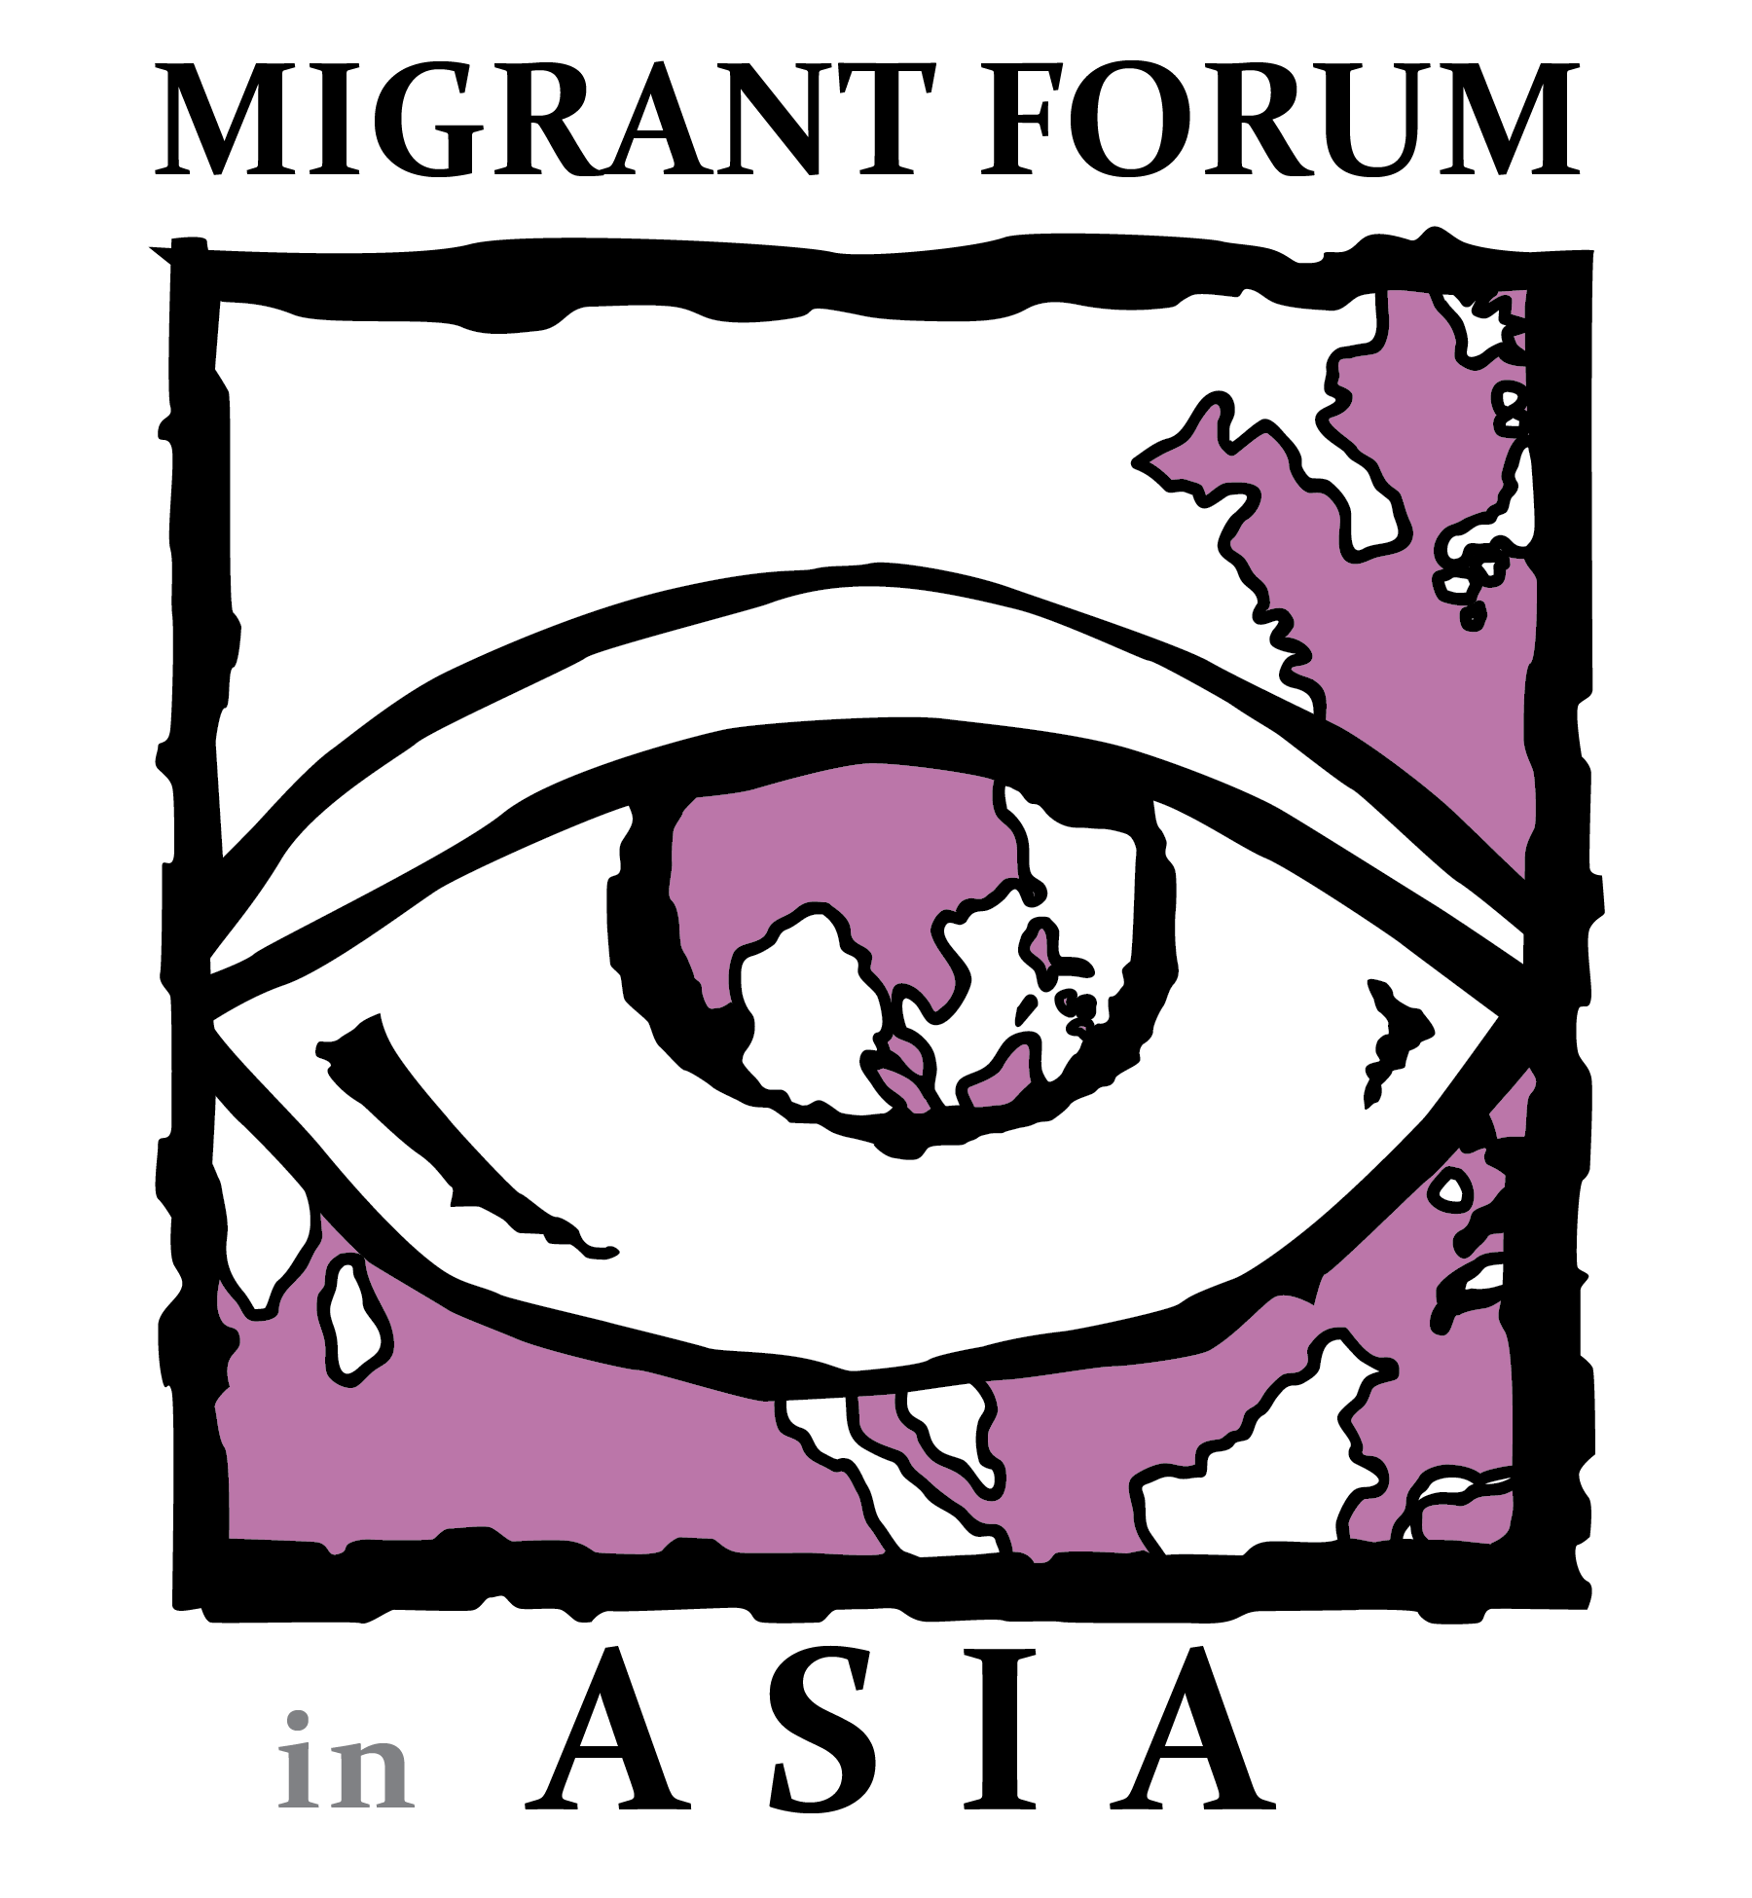

Migrant Forum in Asia Secretariat
25 Matiyaga St., Central District, Diliman, Quezon City, Philippines 1100
+63 (02) 8277 9484 | +63 921 540 5063
www.mfasia.org
Migrant Forum in Asia (MFA) welcomes the decision of the UN Special Rapporteur to dedicate the report to the 53rd session of the Human Rights Council to discuss how to expand and diversify regularization mechanisms and programs to enhance the protection of the human rights of migrants in irregular situations.

MFA is a regional membership organization of migrant organizations, grassroots organizations, faith-based organizations, and individuals committed to protect and promote the rights of migrant workers. Since the organization’s inception, MFA has campaigned for the global ratification and implementation of the UN 1990 Convention on the Protection of the Rights of Migrant Workers and Members of their Families. The MFA is also a member of the Global Steering Committee for the Campaign for the Migrants Rights Convention.

The MFA submission to the UN Special Rapporteur on the Human Rights of Migrants for the report on how to expand and diversify regularization mechanisms and programs to enhance the protection of the human rights of undocumented migrants is a compilation of inputs from MFA members working on the rights of migrant workers. The following members are the contributors to this submission:

Center for Migrant Advocacy (CMA), Philippines
Serikat Buruh Migran Indonesia (SBMI), Indonesia
Tamilnadu National Domestic Workers Welfare Trust, India
WARBE Development Foundation, Bangladesh
- Introduction

Detention, deportation, social exclusion, and the denial of their access to their rights in the country of destination are among the reasons why migrants in irregular situations live in fear for their lives. Undocumented migrants are detained due to various reasons. Refugees, asylum seekers, and vulnerable migrants fleeing violence and war often do not have the proper documentation. Because of this, many are questioned and detained for not having any valid forms of identifications despite having pending asylum claims.

Poverty has always been one of the reasons why people migrate. Impoverished migrants prefer irregular channels for migration which exacerbates their vulnerability and creates room for exploitation. The absence of regularization processes that ensure that their rights are protected creates a matrix of intersecting problems that exacerbate the inhumane conditions that these migrants are facing. Additionally, there are currently a number of additional new factors that are influencing migration, such as the worsening effects of climate change and environmental degradation, conflict and violence, and persecution in countries of origin (COOs).

The concept of “irregular migration” cannot be easily defined as there is no international consensus on its definition. What constitutes “irregular migration” varies and the definitions are based on the perspectives of individual states and governments to control mobility, restrict rights, and criminalize “irregular” migrants and those supporting them. This places the national interests of states at the core of migration policies, rather than the human rights of migrants.

There is an intersection between migration and other forms of discrimination on the basis of gender, class, race, ethnicity, religion, sexual orientation, and other forms of social stratification that can increase the vulnerability of “irregular” migrants. The exacerbated forms of discrimination and oppression resulting from the complex marginalization these migrants face result in the systemic violation of their human rights.

Through regularization processes, migrants are successfully integrated into the host communities, which allows them to access the same benefits enjoyed by citizens such as social protection, access to education, right to work, health care which includes sex and reproductive health care services and maternity services - without the fear of arbitrary arrest or detention and reduce their vulnerability to exploitation. With the continuous development of migration governance, it is imperative to adapt to the needs and realities of migrants with respect to their fundamental human rights and dignity.

A two-fold framework for migrant workers' cultural, social, and economic integration into host communities should be established. A combined governmental and non-governmental strategy will aid in the acquisition of technical knowledge for their jobs, as well as language training and other related skills. Furthermore, international organizations should promote processes creating socially inclusive settings in host nations. Therefore, a two-fold mechanism will support and reinforce the migrant workers' regularization process, thereby defending their human rights.

- National and regional solutions

Amnesty programs in the countries of destination are one of the most popular methods of “legalizing irregular migrants.” As an illustration, the Philippine government helps "irregular" migrants by providing them with valid passports, negotiating with the governments of their countries of destination to settle immigration fines, and repatriating those who have urgent needs, such as those who are ill or who may even have died. The Philippines' Aid to Nationals (ATN) program coordinates consular efforts in responding to urgent requests for assistance made by Filipino individuals or groups, primarily involving police, immigration, and judicial agencies. Additionally, the Philippines and Bahrain have entered into a cooperation agreement to issue flexi visas to allow them to sponsor themselves and work for multiple employers, including migrant domestic workers who were initially excluded in the target sectors of the flexi visa. The flexi visa programme has been reviewed and a new process has been established.

In Bangladesh, the government launched the Migration Compact Taskforce to ensure safe, orderly, and regular migration. However, Bangladesh has not ratified ILO conventions on migrants rights such as the Domestic Workers Convention (ILO C189). Furthermore, it is difficult for any country to lobby for legal reforms on its own. Therefore, regional and international processes like the Colombo Process, Abu Dhabi Dialogue, GFMD, etc. are vital to the involvement of different stakeholders in the discussion to protect migrants’ rights and reforms in the labor system.

MFA members in Bangladesh, India, Malaysia, and the Philippines all highlighted the importance of increasing awareness of regular migration pathways to minimize risks for undocumented or “irregular” migration. In the case of Bangladesh, a government-to-government (G2G) program was adopted with Malaysia in 2013 and 2021 to send migrants through legal pathways. Additionally, Bangladesh signed a Memorandum of Understanding (MOU) with South Korea which set the guidelines for sending manpower from Bangladesh to Korea.

- Contribution of Migrant Workers

Migrant workers have positive impacts to the economies of the countries of origin and destination and it serves as an opportunity for growth for migrant workers and they provide essential labor to key industries. Furthermore, they generate revenues for their countries of origin and are proven to be extremely beneficial. In India, migrant workers remitted between $90 to $100 billion just in 2022. In the Philippines, remittances from migrant workers increased by 3.6% to its all-time high of $36.14 billion.

From a cultural perspective, the presence of migrant communities in countries of destination also help in bridging cultural gaps by promoting diversity and introducing new cultures and perspectives through various activities such as sports, community outreach, and observance of holidays. The cultural diversity that results from migration allows for the sharing of new perspectives and life experiences through cross-cultural interactions, the emergence of innovative and hybrid cultural practices, and a general societal openness to difference and change.

- Role of Civil Society Organizations (CSOs) and Other Stakeholders

Civil society organizations (CSOs) have played an important role in advocating for migrants' rights and increasing awareness about their plight, as well as conducting pre-departure trainings with prospective migrant workers and promoting and lobbying initiatives for safe migration pathways and other related concerns. In present times, the government of Bangladesh has been open to working with CSOs on the human rights issues of migrant workers. Since the establishment of the Bangladesh National Human Rights Commission in 2008, the government of Bangladesh has worked with CSOs in addressing the issues of wage theft, social vulnerabilities, lack of access to the rights of migrant workers, etc. and has been working collaboratively in the gathering of information and implementation of policies. At the international level, the Bangladesh Parliamentarians Caucus on Migration and Development attended intergovernmental negotiations on the GCM and the GFMD.

In Indonesia, SBMI has found that the government lags in protecting migrant workers in countries of destination, especially during the COVID-19 pandemic. In their study “Human Rights Violations in Southeast Asia: The Allowance of Modern Slavery” in 2022, they found that there was a neglect in handling and solving cases which was a direct result of the absence of law and weak law enforcement. Moreover, they sued the president of Indonesia for violation of the law of not ratifying government regulations to protect migrant workers in the fisheries sector, which they were successful at because the government of Indonesia gave in and ratified government regulations protecting migrant workers.
- Recommendations
The following recommendations should be considered:
- Governments must monitor multilateral, regional, and bilateral agreements to make sure that these do not infringe on the human rights of migrants;
- Governments must ratify the UN Convention for the Protection of Migrant Workers and Members of Their Families, iLO Convention 143, and other core instruments and conventions relevant to the protection of migrants’ rights;
- Governments must conduct repatriation with due process, rather than mass deportation measures;
- Governments must examine existing policies and practices to identify inconsistencies;
- Governments must create and enforce mechanisms that recognize, protect, and assist all migrants, including asylum seekers, refugees, trafficked persons, and those in “irregular” situations;
- Create more regular pathways through capacitating states, embassies, and other relevant organizations and assessing the needs of migrants at every stage of their journey;
- Temporary or emergency policies must be integrated into long-term mechanisms;
- Adopting rights-based and inclusive migration policies to ensure that migrants are empowered and their rights are upheld, regardless of their status.
- Conclusion
Globally, the COVID-19 pandemic has devastated millions of people and reduced human mobility. It threatened the survival of all life on Earth, upended the world economy, and revealed persistent social problems. During the lockdown, many migrant workers lost their employment, were forced to reduce their spending, and were forced to take out loans to cover their basic requirements. Stimulus packages and low interest rates, if not zero interest loan rates, were implemented to ease the burden on migrant workers, particularly those at risk of losing their jobs or who have already lost their positions. For instance, to provide efficient and secure online services for the registration of new migrants and their families, the Indian government has created the Emigration Management System (EMS). The system also contains an online tool for evaluating the risk of migrating to any country, which also offers instructions on the required paperwork and other needs.
In general, migration strengthens the economy of any country. In order to strengthen their relationships with the countries of destination, countries of origin should expand their diplomatic networks, particularly through economic diplomacy. Governments in both the origin and destination countries should ratify the ILO Domestic Workers Convention No. 189 and its accompanying Recommendation No. 201 in order to protect the rights of domestic workers. Bilateral and multilateral agreements with the destination countries where the majority of women migrate should include provisions to accommodate female migrant workers.
With the evolving nature of migration governance, it is essential to adapt to the needs and realities of migrants with respect to their fundamental human rights and dignity. Mobility restrictions and other factors have increased and exacerbated the situations that force migrants into "irregular" status and make them more vulnerable. As laws and circumstances change, migrants' status may also change. Hence, regardless of their status, it is crucial that migrants are empowered and that their rights are protected at all phases of their journey.

