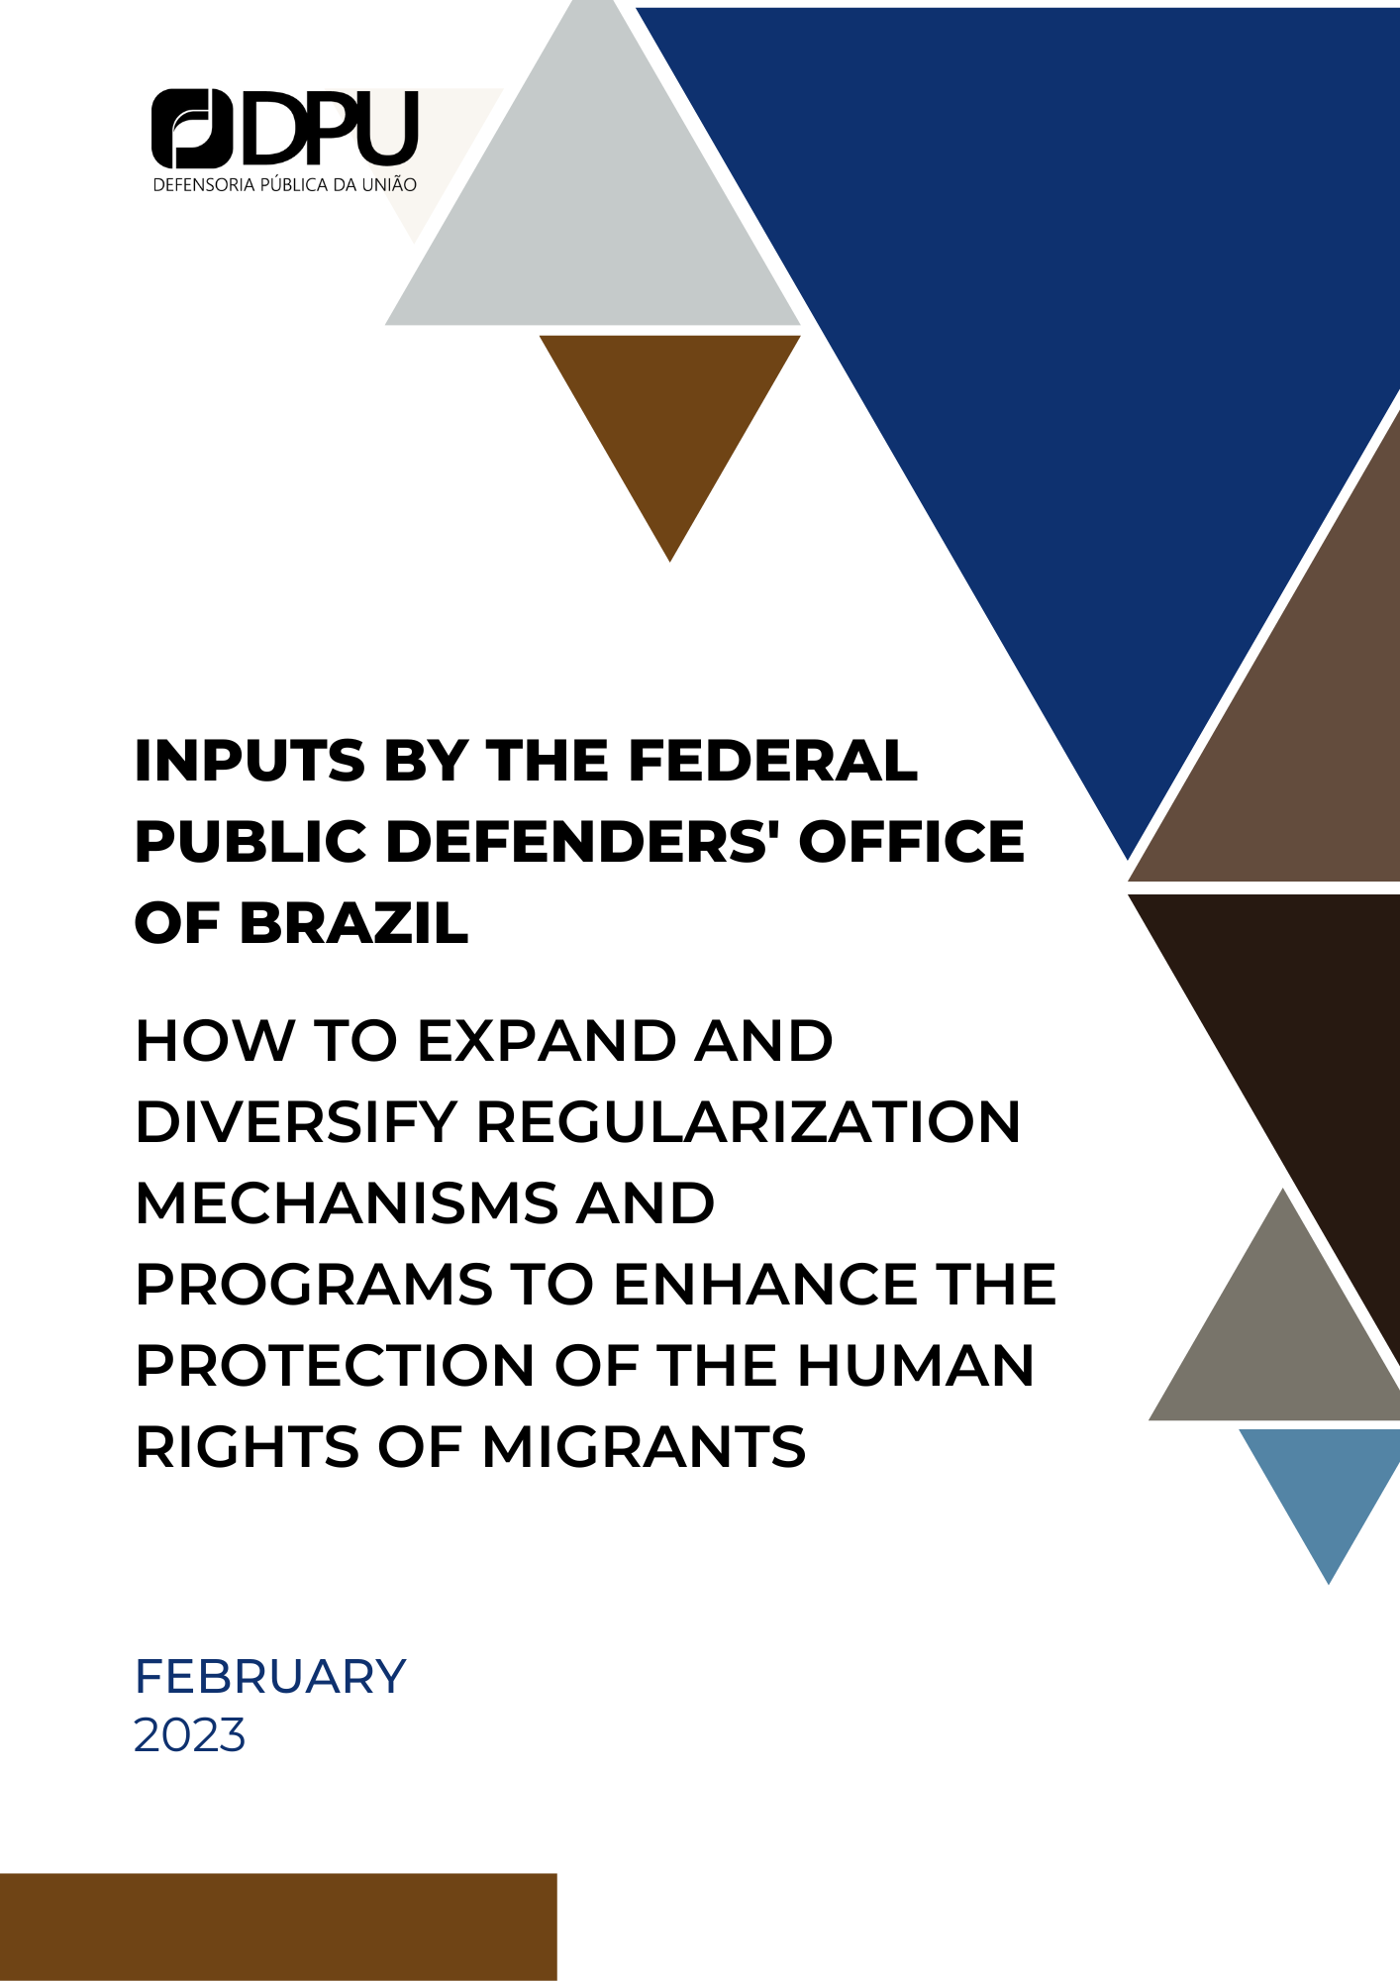
Brasília, Federative Republic of Brazil, February 14, 2023.

To the Mr. Felipe González Morales, Special Rapporteur on the Human Rights of Migrants

Subject: Input on how to expand and diversify regularization mechanisms and programs to enhance the protection of the human rights of migrants

The Federal Public Defender's Office of the Federative Republic of Brazil, through its Working Group on Migrations, Statelessness, and Refuge, in response to your call for input on how to expand and diversify regularization mechanisms and programs to enhance the protection of the human rights of migrants offers this contribution.

Introduction: role of the Federal Public Defender´s Office in the Brazilian migratory context

The Federal Public Defender's Office (DPU) is an autonomous, permanent institution. According to article 134 of the Brazilian Constitution, its function, as an expression and instrument of the democratic regime, is of legal guidance, promotion of human rights and defense, at all levels, judicial and extrajudicial, of individual and collective rights, integrally and free of charge, to those in a vulnerable situation.
Complementary Law nº 80/1994 regulates the Public Defender’s Office in Brazil and establishes several functions of this institution. We highlight those of “representing the international systems of protection of human rights, pleading before their organs”, and “exercise the defense of individual and collective interests [...] [of] vulnerable social groups that deserve special protection from the State” (article 4, VI ​​and XI, of Complementary Law nº 80/1994).
Law nº 13.445/2017, known as the Brazilian Migration Law, established a new regulation of the rights and duties of migrants in/from Brazil. It highlights the Public Defender's Office's role in the full and free-of-charge legal assistance (art. 4, IX) to migrants in need in administrative and judicial proceedings (such as deportation, expulsion, and extradition).[1]
Considering the distribution of competencies in the Brazilian State, the DPU acts primarily before federal administrative and judicial bodies and considering that, for the most part, public policy for migrants is conducted by federal bodies, DPU instituted the Working Group on Migrations, Statelessness, and Refuge (GTMAR) to support DPU career and senior management members in articulating the defense of the interests of migrants.
Ordinance GABDPF DPGU No. 200/2018 establishes in its art. 3, VIII, the competencies of GTMAR, among which are “promoting the defense of migrants in vulnerable situations, stateless persons and refugees” and “monitoring sensitive cases related to the theme of migrations, statelessness, and refuge.”

1. Regularization processes and the enjoyment of human rights by migrants

The Brazilian migration law Brazil (nº 13.445, of May 24, 2017) is grounded on principles of promotion of human rights, expressly establishing as guidelines the repudiation and prevention of xenophobia, racism, and discrimination based on the criteria or procedures by which the person was admitted to national territory and the non-criminalization of migration. In addition, it has as a principle and guideline the promotion of regular entry and document regularization, with ways to provide social, labor, and productive inclusion of migrant people through public policies, equal and free access to services, programs, and social benefits, public goods, education, legal assistance, work, housing, banking, and social security, for example.
However, in disharmony with the migration law, institutional negligence and lack of knowledge (of migrants and Brazilian society), represent obstacles to the realization of the rights of migrants in an irregular or undocumented situation. It is frequently seen, for example, cases of migrants seeking legal advice from the Federal Public Defender's Office or civil society organizations in the face of refusal to provide public and even private services, such as banking, to migrants because they do not have Brazilian identification documents. Human rights education is essential in this regard and has been promoted by DPU.
In addition, the insecurity experienced by migrants in these conditions causes fear of presenting themselves to the Federal Police to seek migratory regularization at the risk of suffering sanctions such as a pecuniary fine, detention or determination of compulsory departure from Brazil. Therefore, the tendency is that irregular or undocumented migrants are subject to precarious and informal work s in which the fulfillment of labor rights is not observed, do not seek public health, education, and social assistance services, do not enjoy the rights to which they would be entitled.

2. Examples of national and regional solutions to legalize the stay for migrants in irregular situations: Brazilian frameworks

Brazilian Constitution states that Brazil should seek the economic, political, social, and cultural integration of Latin America's peoples, aiming at forming a Latin American community of nations.
Considering the migratory dynamics between countries, in 2002, the Mercosur Residence Agreement was enacted. It guarantees the right to residence, work, and social security, in a reciprocal manner, to nationals of member countries of the Mercosur. It later included other South American countries associated with the bloc. The consolidation of the agreement, combined with other measures that favor the reduction of bureaucracy in the transit of people, meant that nationals of eight South American countries were given greater security for tourism, business, work or residence in Brazil. More recently, a similar condition granted to nationals of bordering countries that are not part of the list of countries that make up Mercosur and associates, embracing Suriname, Venezuela, and Guyana.

3. Examples of promising practices Brazil has adopted to promote a human rights-based approach to migration. Challenges Brazil has faced

3.1 Pacaraima Mission.

In 2018, with the intensification of the Venezuelan migratory flow due to the humanitarian crisis, and in support of the federal response of emergency assistance to Venezuelan migrants in vulnerable situations, called “Operação Acolhida” (Reception Operation), the DPU established the Pacaraima Mission, based on the city of Pacaraima, in the northern part of Brazilian State of Roraima, in the Amazon Region, which is in the with Venezuela and has been receiving thousands of Venezuelan migrants.
The Pacaraima Mission has the objective of, in addition to monitoring and promoting human rights in this border region with Venezuela, to promote the care of children and adolescents in particular migratory difficulties.
The Federal Public Defenders assist children and adolescents with special migratory difficulties, provide legal guidance to immigrants, promote periodic visits to monitor the sensitive installations and emergency shelter of the Acolhida Operation, as well as act to prevent situations of human trafficking, seeking to guarantee the safe, regular and orderly entry of people into Brazilian territory.
Since the beginning of the Pacaraima Mission, in 2018, there have been approximately more than 13,000 legal assistance services for children and adolescents, indigenous and non-indigenous, at this border point. Every six months, the DPU publishes a Defensorial Newsletter on the steps taken, and assistance provided.
One of the most challenging situations is the migratory regularization of undocumented children. In order to ensure protection to children while making possible their migratory regularization, the Joint Resolution CONANDA/CONARE/CNIg/DPU 1 of 2017 was enacted, which foresees a careful interview and a form of analysis and protection, which might corroborate the regularization of undocumented children, or, in case of risks direct them to protection measures. CONANDA Resolution Nº 232, of 28 December of 2022 recently substituted Joint Resolution 1 and foresaw similar measures.

3.2 CONARE´s recognition of serious and generalized violation of human rights in Venezuela
The National Committee for Refugees – CONARE recognized the existence of a situation of severe and generalized violation of human rights in Venezuela through Technical Note No. 3/2019 CONARE/DEMIG/SENAJUS/MJ, which means that there is a simplified analysis process for asylum applications for Venezuelans, with an enormous quantitative impact.

4. Specific or additional legislative and policy measures as well as challenges in the context of the COVID-19 pandemic in the implementation of regularization programs;
Recognizing the COVID-19 pandemic in January 2020 by the World Health Organization (WHO), the Brazilian National Congress enacted Law 13.979, of February 6, 2020, to provide measures to address the pandemic in Brazil. Article 3, VI, “a”, provides for exceptional and temporary restrictions on entering and leaving the country via highways, ports, or airports, based on a technical recommendation by the National Health Surveillance Agency (Anvisa) (art. 3, paragraph 6- B, I). After that, the Federal Government issued various ordinances. The Law 13.979/2020 does not foresee sanctions for irregular entry into Brazil. Nonetheless, most of the Ordinances state that those who infringed the entry prohibitions were subjected to the sanctions of (i) civil, criminal, and administrative liability, (ii) immediate repatriation or deportation; and (iii) bar to request refugee status. Those ordinances violated the human rights of vulnerable migrants and refugees, as provided in international human rights treaties and case-law, Brazilian’s Constitution, and Laws on Migration and Refuge. As a result of those ordinances, borders remained mostly closed only to land or waterway flow of people. They discriminated against those arriving by land and sea, and breached international obligations of non-refoulement and bar to collective compulsory withdrawal. They created, thus, illegal discrimination against the most vulnerable people - like the Latin American groups that enter the country by land. Those who were admitted by plane were subject to the usual visa requirements and submission to COVID-19 tests. The ordinances violated the principle of non-criminalization of migration since they criminalized cross-border movements and did not assure due process before measures of compulsory withdrawal. This principle is stated in article 3, III, of Brazilian Migration Law. It is also rooted in the Inter-American Court of Human Rights case “Vélez Loor versus Panama”, in its Advisory Opinions 18/2003 and 21/2014, and in the Inter-American Commission of Human Rights “Report on immigration in the United States: Detention and due process.”
The restrictions imposed on the entry of non-nationals from other countries into Brazilian territory led to a sudden reduction in the official number of migrants entering the country. Based on data from the National Migration Registration System - SISMIGRA, in 2020 there was a 71.32% reduction in new records in the Federal Police system compared to the previous year.
However, concerning the specific situation of forced migration, it is essential to mention that due to its nature, motivated by the search for one's own survival or subsistence due to issues related to the country of origin, which makes migration an imperative need, there was not, even with restrictive measures on the entry of non-nationals into Brazilian territory during the COVID-19 pandemic, an interruption in migratory flows, especially by land or waterway. Migration routes became even more difficult and risky for migrants because they had to enter the country through border points without migration control. In summary, the denial of migrants' rights increased with the sanitary justification and migration restrictions led to a rise in the number of undocumented and irregular migrants. During the COVID-19 pandemic, many migrants, especially forced migrants had to enter Brazil through unofficial borders to escape a bar to entry. In the context of the recovery from the pandemic, it is very relevant to make the regularization of migratory status possible.
DPU acted in many individual cases in this regard and promoted joint efforts for migratory regularization. In the State of Minas Gerais, DPU, in a joint effort with ACNUR, Caritas international, and the Townhall of Belo Horizonte, The Federal University of Minas Gerais Pontificia Catholic University of Minas Gerais trained volunteers. After the training, the joint effort assisted many Venezuelan indigenous migrants from the Warao ethnicity to regularize their migratory status and get documents. Documentation in the host State is often a milestone in the exercise of economic, social, and cultural rights, such as education, health, and work.
DPU and partner entities also make an effort to disseminate which are migrants' valid identification documents so that public and private entities become knowledgeable about them.

Final Considerations

DPU has developed an essential role and acted throughout Brazil to promote and protect migrants' human rights and is deeply compromised to promote the regularization of migrants.

Lutiana Valadares Fernandes Barbosa
Federal Public Defender
Member of DPU’s Working Group on Migration, Statelessness, and Refuge

Matheus Alves do Nascimento
Federal Public Defender
Member and current Coordinator of DPU’s Working Group on Migration, Statelessness, and Refuge

[1] Law 13445/2017 establishes in its art. 3rd the principles that govern the Brazilian migration policy, among them, several are directly or indirectly related to economic, social and cultural rights. Here, we emphasize the following principles:
I - universality, indivisibility and interdependence of human rights;

