Joint Response to the Call for Input
by the UN Special Rapporteur on the Human Rights of Migrants on Regularisation Process

Submitted by
BEBESEA
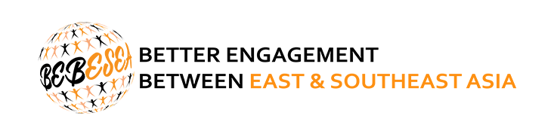
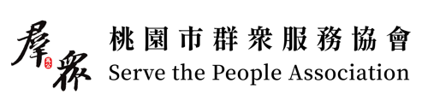
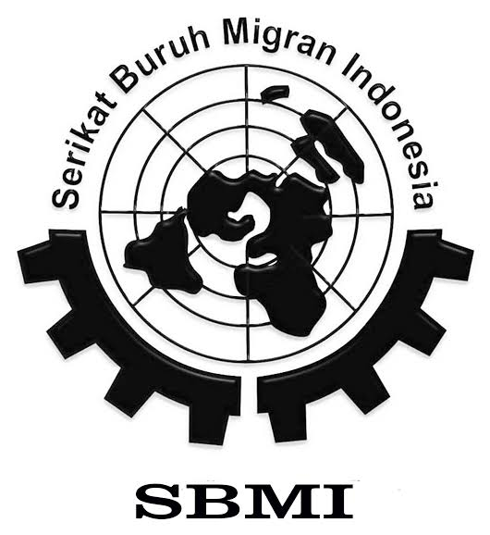
with contributions from

Endorsed by
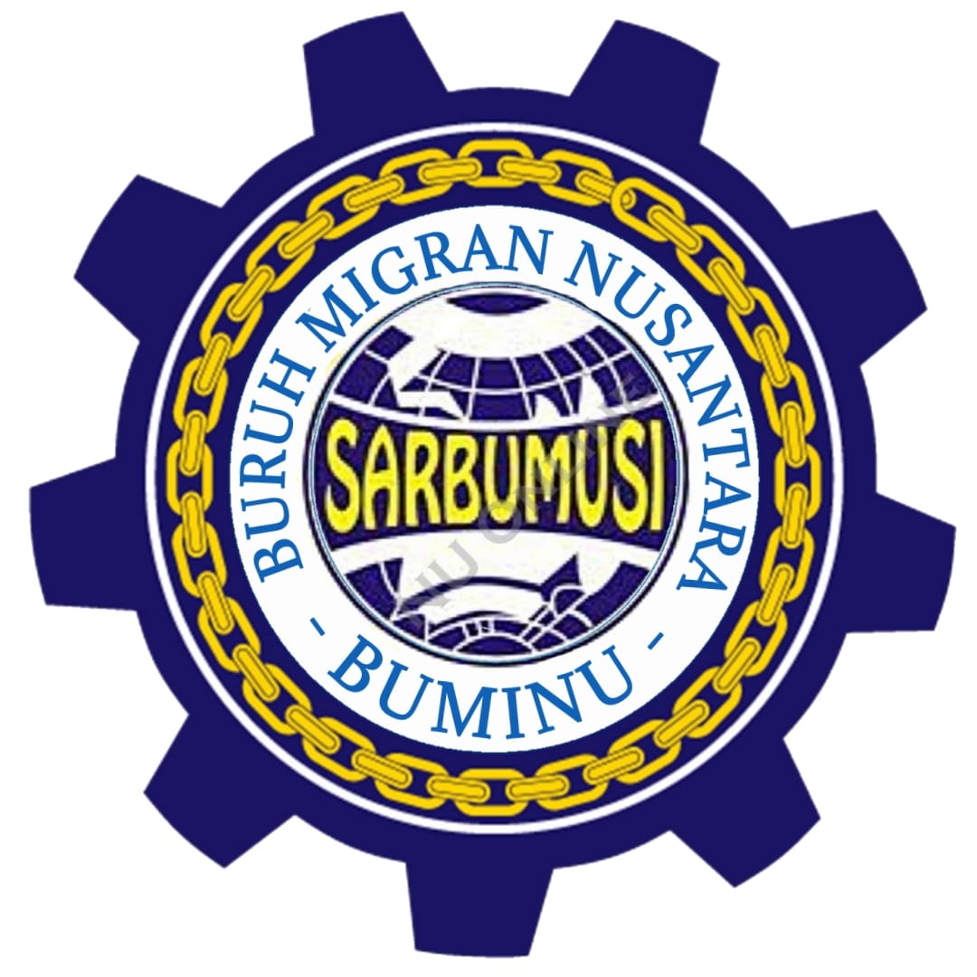
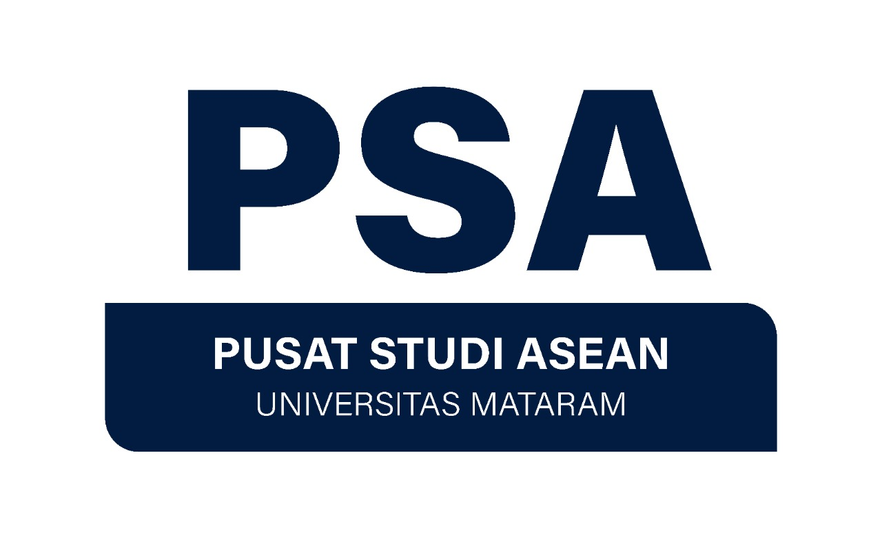

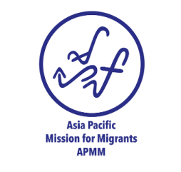
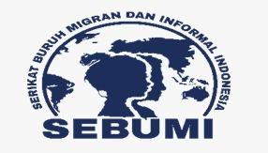
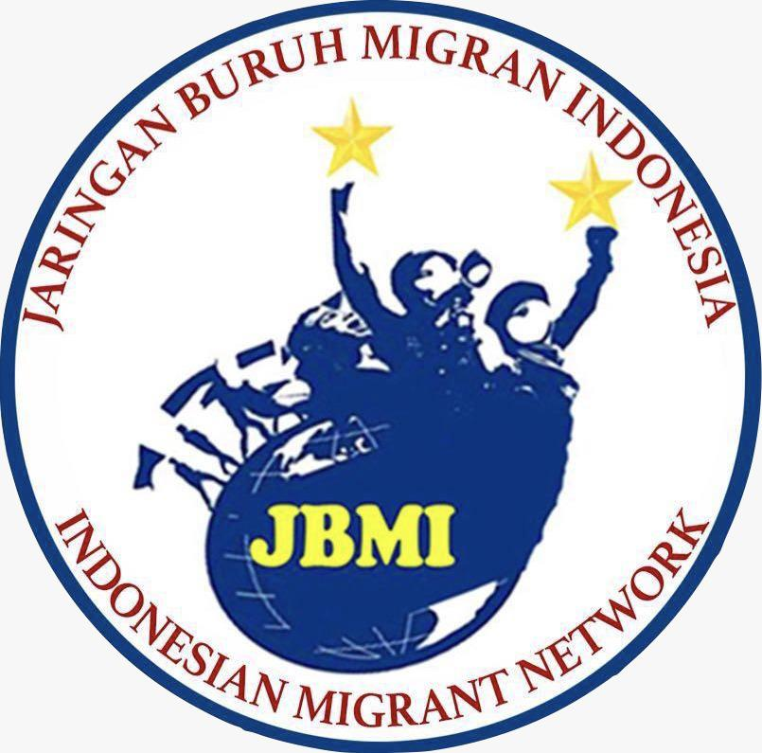
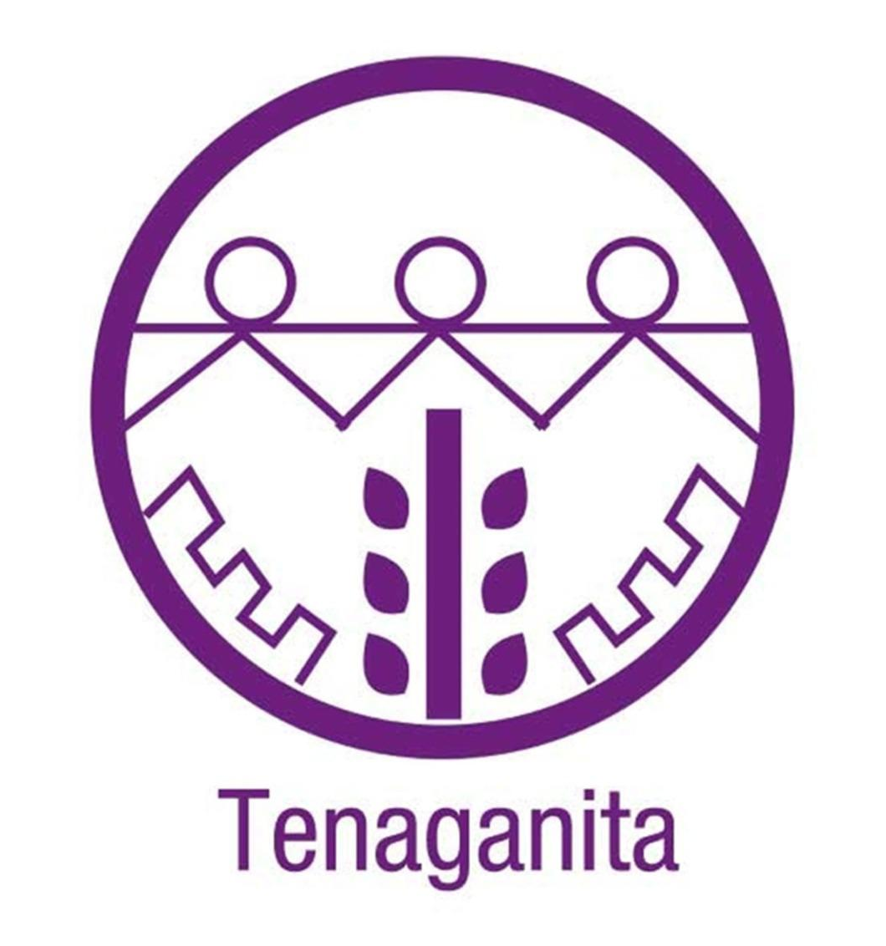

15 February 2023

Joint Response to the Call for Input
by the UN Special Rapporteur on the Human Rights of Migrants on Regularisation Process

This response draws on research conducted by Better Engagement Between East and Southeast Asia (BEBESEA) and Indonesia’s NGO Coalition for International Human Rights Advocacy (HRWG) during the first year of COVID-19 pandemic in seven major destinations of migrant workers in East and Southeast Asia, namely Hong Kong, Japan, Malaysia, Taiwan, Thailand, Singapore and South Korea as well as additional inputs from BEBESEA’s partners and network members in early 2023. This response is initiated by BEBESEA with contributions from HRWG, Serve the People Association (SPA), SBMI Malang and Trend Asia.

- How can regularisation processes facilitate the enjoyment of human rights by migrants?

Regularisation process can facilitate the enjoyment of human rights by migrants holistically - civil political rights as well as economic, social and cultural rights - by allowing them improved access to social protection, including healthcare, decent work, education, adequate living conditions as well as family reunification. Regularisation process will allow more undocumented migrants to live less precarious and more certain and dignified lives, leading to improvement of their socio-economic situations and hence improving physical and mental wellbeing. Regularisation process can also empower migrants to be able to take actions proactively to assert their rights without fear of immigration controls and their consequences.

Like many others, BEBESEA’s research found that vulnerabilities of undocumented migrants were exacerbated during the COVID-19 pandemic due to their limited or no access to healthcare, daily necessities, information and resources to protect their health as well as social welfare or social security. Some COVID-19 response measures taken in the migrant workers’ destinations have violated human rights of undocumented migrants and those who are seeking asylum in the name of disease control. For example, in Malaysia and Hong Kong there were increased or large-scale crackdowns of undocumented migrants and asylum seekers, who are stigmatised as virus carriers and/or taking jobs from the locals, as well as arbitrary detentions in harmful conditions. These phenomena made undocumented migrants increasingly go “hiding” leading to more isolation and vulnerabilities to rights abuses.

Undocumented migrants suffer abuses, exploitation and rights violations at work and often are not able to take action against them, including unionising or joining unions, due to fear of immigration control measures and criminalisation. The findings in Japan showed that some cases of mental health deterioration in undocumented migrants’ or precarious asylum seekers’ communities sadly led to domestic violences and even murders. Improved access to decent work, social security, mental and physical healthcare as well as more certainty in lives will facilitate the enjoyment of human rights by all migrants.

- What examples of national and regional solutions to legalise the stay for migrants in irregular situations does your country have?

Since the 1990s, the Thai government, by way of a series of Cabinet Resolutions, has permitted undocumented migrants to semi-regularise their status during periodic migrant worker registration windows. These large-scale exercises, which were held every couple of years, granted undocumented migrants permission to live and work in Thailand for one or two years without having to return to their country of origin. In response to the COVID-19 pandemic, the Thai government allowed undocumented migrant workers from Cambodia, Laos and Myanmar to work in the country legally for about two years, through a registration process opened between January and February 2021, with an estimate that between 60,000 and 80,000 migrants would benefit from the process. The Thai government has recently opened another similar registration process for migrant workers, whose employers still want them to work in the country, to be able to work in the country until Feb 13, 2024, or the same date in 2025. The migrant workers have to pay the fees for this registration, and any penalties for visa overstay will be waived while the workers will have access to social security programmes.

These examples from Thailand show some degree of positive responses from the government to legalise the stay of migrants. However, we observe that any temporary status that does not lead to the rights to settlement in the destination country or legal status that is tied to particular employers or type of work, including income requirements, do not facilitate full enjoyment of human rights by migrants. Temporary registration leaves them no closer to finding a long-term solution to regularise their stay and are often systemic causes of human rights violations. Any regularisation process should ensure that the legal status given to migrants can in the future lead to their rights to longer-term residency or citizenship to fulfil their rights to full social security as well as political participation.

Any regularisation process should also be implemented equally to all migrants, and not to be used discriminately for those who are considered “more deserving” such as those who are classified as “skilled workers.” They should be implemented with a human-rights based approach, instead of an economic-driven policies.

- Do you have examples of promising practices that your country or region has adopted to promote a human rights-based approach to migration?

ASEAN has made regional efforts to promote a human-rights based approach to migrants through development of regional norms standards, such as ASEAN Consensus on Protection and Promotion of the Rights of Migrant Workers (2017), ASEAN Declaration on Portability of Social Security Benefits for Migrant Workers (2022). Those documents mandated each ASEAN Member State to commit to develop policies that promote and protect the rights of migrants, especially in relation to access to social protection. However, the seven occupations (accountancy, architecture, dentistry, engineering, medicine, nursing, and tourism) represented in Mutual Recognition Arrangements, which aim to facilitate mobility of professionals/ skilled labour in ASEAN, clearly show that this market-driven regionalism gives only “skilled-workers” more recognition and rights. It is a discriminatory policy based on skills and ability. Moreover, the consensus-based approach and non-interference policy of ASEAN brings challenges with implementation of policies in each member state and often leave the most marginalised groups of people, including those who are stateless, behind.

- What specific challenges has your country encountered in regularisation processes and how have these challenges affected migrant workers, women and girls, and children?

In East and Southeast Asian countries, due to lack of legal framework and/or implementation to protect refugees, many people who are seeking asylum are often considered as undocumented or are given very precarious temporary status that does not give them adequate rights protection. For example, Indonesia has not ratified the 1951 Refugees Convention and people who are seeking asylum in Indonesia or temporarily or indefinitely staying in Indonesia hoping to continue their journey to another country where they wish to claim asylum rely on assistance and protection by international organisations such as UNHCR. Although the government of Indonesia has made efforts to handle cases of refugees and asylum seekers in Indonesia through presidential decrees, the impact on the enjoyment of human rights by these groups are limited due to lack of capacities and coordination of the governments and international organisations. Research conducted by HRWG on statelessness in 2022 showed that the lack of protection of refugees and people seeking asylum increases their risks of statelessness. Children born to these groups or people and other undocumented migrants often lack documentation and are at risk of statelessness and little or no access to education, healthcare and other social protection.

Workers in some sectors, such as domestic work, fisheries, agriculture or sex work, are not covered by national labour laws in many countries and hence given no or very limited status. Workers in these sectors are often victims of trafficking in person and often at high risk of experiencing occupational safety issues. However, due to lack of legal protections, they face challenges in seeking help and remedy including regularisation of their status.

Countries such as Taiwan and Japan have another layer of issues with legal status or people; aside from immigration status or nationality, these governments implement a system of “family registration” or “domicile registration”, without which brings barriers in accessing various state services and social protection including education and national health insurance. Even if regularisation of immigration status is achieved, people can be left in the situation of semi-undocumented without these administrative registrations.

The economic-driven immigration policies fail governments to fulfil their responsibilities to protect and promote human rights. For example, Indonesia’s Job Creation Law (Perpu 2/2022) prioritises the state’s economic developmental interests and it allows migrant workers in Indonesia to be managed within the closed investment schemes. This arrangement places migrant workers in precarious situations and makes it difficult for the government and other institutions in Indonesia to monitor and intervene in the rights violation of the workers including those who are in need of regularisation. The failure of rights protection due to over emphasis of economic benefits is often seen in the violation of maternity and reproductive health rights of women migrant workers. Women migrant workers often face unfair treatment when they are pregnant or are banned from becoming pregnant by employers, or by the government in case of migrant domestic workers in Singapore. Due to a lack of a gender-based approach to protect and promote human rights of migrants, gender-based violence and sexual harassment at workplace against women and marginalised-gender migrant workers are rampant.

Lastly, Taiwan's government faces unique challenges due to their status as a non-member state of the United Nations, which excludes the government from being part of most of the international frameworks except World Trade Organization. Although Taiwan has adopted its own mechanism to localise international conventions and adopt them into local laws, it can not fully maximise the international frameworks to promote and protect human rights of vulnerable groups including migrant workers, women and girls and children.

- What contribution do migrants make to the economy and society of the host communities?

Migrants make significant economic and social contributions to the host communities through their labour in sectors that directly relate to livelihood such as food, clothing, housing and health. Care work is one of the sectors host communities heavily rely on migrant labour. In Taiwan, daily personal care of patients admitted to hospitals is the responsibility of their family members. Due to the urgency and demand for flexible care, it is often the case that undocumented migrant caretakers are employed for these roles. Sectors such as fishery and agriculture in host communities also heavily rely on migrant labour, particularly those who are of irregular status.

- What specific challenges arose in this area in the context of the COVID-19 pandemic?

Undocumented migrants have been excluded from almost all counter COVID-19 assistance, and become most vulnerable to labour rights abuses and unemployment during the economic downturn relating to the global pandemic. They are also exempt from subsidised medical care, meaning that they avoid accessing any healthcare due to fear of high charges even though they are unwell.

Due to lack of sustainable and consistent measures to protect legal status of migrants with temporary status whose visa expired while they were not able to return home during the pandemic, many people have lost their legal status and hence became undocumented.

Rights to health, social security and decent work and job security of migrants were hugely impacted during the pandemic. Jobs which undocumented and irregular migrants often do are disproportionately affected by the COVID-19 pandemic – domestic work, constructions, catering, waste handling and recycling, care work and sex work. BEBESEA’s research also found that unfair dismissal, withheld wages, longer working hours without pay were rampant. Destitution, homelessness, lack of food and other daily necessities, poor physical and mental health have deteriorated. Since undocumented migrants did not enjoy access to healthcare even before the pandemic, they were unaware of their underlying health conditions, which led to severe cases of COVID-19 infections including deaths. Undocumented migrant workers were often forced to take unpaid days off or leave work when they were infected with COVID-19 or had to self-isolate for quarantine.

- Any other relevant information relating to the regularisation of migrants in an irregular situation.

East and Southeast Asia have a large ocean space, which is home and workplace to many. However, there is a lack of attention to these people by governments and international organisations when it comes to promotion and protection of human rights. As mentioned above, migrant workers in sea-based sectors are often of irregular status. There are also a number of ethnic groups who live as sea-nomad and cross sea borders without documentations and nationalities. We recommend the UN Special Reporter on human rights of migrants to take a closer look at the situations of people who live and/or work in the sea in his report on the regularisation process of migrants.

<END>

About BEBESEA
BEBESEA stands for Better Engagement Between East and Southeast Asia. It is a network of civil society organisations and individuals advocating for rights of migrants in and from East and Southeast Asia as well as cross-cutting/intersectional human rights issues in the regions. The development of this network started in 2018 and the first co-creating workshop was held in 2019 in Bangkok, where civil society actors fromEast and Southeast Asia gathered to share knowledge and experience and brainstormed the ideas for cross-regional advocacy work. BEBESEA works on research and knowledge building, content production for awareness raising, capacity building for regional advocacy and campaigns, and continues to expand the network of solidarity among multi-stakeholders across the regions.
Email: info@bebesea.org Website: https://bebesea.org
Facebook/Instagram/Twitter: @bebeseaorg

Repression and Resilience: COVID-19 Response Measures and Migrant Workers’ Rights in Major East and Southeast Asian Destinations (2020) by Human Rights Working Group Indonesia (HRWG); https://bebesea.org/2021/02/repression-and-resilience-covid-19-response-measures-and-migrant-workers-rights-in-major-east-and-southeast-destinations-2020-by-human-rights-working-group-indonesia-hrwg/
For a historic overview see generally AMC & MMN, “Migration Needs, Issues and Responses in the Greater Mekong Subregion: A Resource Book”, 2002.
Reuters, 2020, Thailand offers work permits to undocumented migrants to curb COVID-19 https://www.reuters.com/article/us-thailand-workers-migrants-idUSKBN293193
Bangkok Post, 9 Feb 2023, “Migrant permit renewals can be extended: cabinet”.https://www.bangkokpost.com/thailand/general/2502374/migrant-permit-renewals-can-be-extended-cabinet.
HRWG, 2023, Penelitian Dasar: Pemetaan Situasi Orang dengan Risiko Tanpa Kewarganegaraan di Indonesia; https://www.hrwg.or.id/2023/02/09/penelitian-dasar-pemetaan-situasi-orang-dengan-risiko-tanpa-kewarganegaraan-di-indonesia/

