OHCHR expert meeting on enhancing capacity-building for local governments to incorporate human rights into all their work

28 August 2023 | 10am – 12pm & 3pm – 5pm (CET)

Guidance note to register for the list of speakers and for sending video statements

This guidance note is for States, local and regional governments, specialized agencies, intergovernmental organizations, national human rights institutions and civil society organizations intending to register for the list of speakers.
Please note that:
- Participants who wish to take the floor in Sessions 1 and/or 2, please register to the list of speakers via Indico by Sunday 27 August 23:59 CET. Speaking time for participants wishing to take the floor will be two minutes. Speakers are highly encouraged to send a copy of their statement by 27 August at the latest to facilitate simultaneous interpretation.
- Participants who registered via Indico by 27 August will receive the Zoom link to join the event.
- Connect to Zoom and clearly identify yourself with the name of the country or organization you represent, then your name and last name. We will have to remove any participant without a proper identification. Do not hesitate to contact the Secretariat if you need help during the process.
- Participants are encouraged to be as concise and succinct as possible. We encourage questions that promote an interactive discussion or brief statement relevant to the meeting. All participants should ensure a sense of respect and tolerance throughout the discussion.
- Interventions can be made in any of the six UN languages (Arabic, Chinese, English, French, Russian, Spanish) as well as International Sign.
- The moderators together with the Secretariat will draw up the list of speakers ensuring a balanced participation of all stakeholders.
- Depending on time availability and technical capabilities, participants who are not registered on the list of speakers may be able to request the floor (by using the hand raising functionality on the online Zoom platform or by using the printed list in the back of the room), once all registered speakers have taken the floor.

Sessions 1 and 2 will include time for an interactive debate, with interventions from participants. Oral interventions can be made either by:
- making a live statement in-person or through Zoom during the event; or,
- sending a pre-recorded video message (refer to Annex I below on submitting the video); or,
- requesting the floor during the meeting, if time permits for additional speakers who did not register for the list of speakers prior to the start of the meeting.
Additional guidance for all of the above options is provided below.

Making a live statement via the online platform Zoom during the event
For participants or stakeholders registering to make a statement during the event, via the online platform, please:
- Register for the list of speakers (as indicated above)
- We encourage questions and concise reactions to the panels. However, if you will read a statement, please send a copy to manny.zhang@un.org by 27 August.
Note that the statement should not exceed two minutes. The moderator may have to interrupt you to allow other speakers to participate.

Sending a pre-recorded video message
For participants or stakeholders sending a pre-recorded video message, please:
- Register for the list of speakers (as indicated above)
- Carefully read the guidance for submitting your video file to the Secretariat via WeTransfer in Annex I below.
- Consider including captioning for the video statement in order to enhance participation of persons with disabilities. Guidance on creating captions using YouTube is available in Annex II below.
- Be mindful of the audio and video quality.
- Send your video message, together with a transcript of your message in Microsoft Word or accessible PDF format to manny.zhang@un.org by 25 August at the latest, via WeTransfer (see Annex I below for further guidance). Should the Secretariat not receive your video message and transcript by this time, your message may be excluded from the list of speakers.
Note that the video file should not exceed two minutes, otherwise in the interest of time the video may be cut off after the first two minutes.

Requesting the floor during the event
Depending on time availability and technical capabilities, participants who did not register on the list of speakers prior to the event will be able to request the floor once all participants who are on the list of speakers have taken the floor.
To request the floor during the event, participants may use the ‘raise hand’ function on the online platform or by registering to the printed list in the back of the room.

ANNEX I

GUIDELINES ON SENDING VIDEO MESSAGES VIA WETRANSFER
- Open a browser on the computer where the files you want to send are located. Go to https://wetransfer.com/.

- Click on “Add your files” and select the following files:
  - Your video message (see below for specifications);
  - A transcript of your statement in Word or accessible PDF formats.

- On the “Email to” field, add: manny.zhang@un.org

- On the “Your email” field, add your own email.

- On the “Message field”, include:
  - The stakeholder/organization on behalf of which you will be speaking;
  - The panel for which you are sending the video message.

- Click on “Transfer”. You will be prompted to enter a verification code, which will be sent to your email a few moments later (remember to check the spam folder). Copy the verification code, paste it in the transfer windows and hit verify.

- Once the verification code has been entered, your files will be uploaded. This might take a few minutes. After that, your files will be sent to us automatically. You will receive an email confirming that your files were sent successfully. You will also receive a confirmation email once we have downloaded your files.

Please note that all video statements should be sent by 25 August. If the sound / image quality is considered poor, it may not be played.

ANNEX II

GUIDELINES ON CREATING VIDEO CAPTIONS USING YOUTUBE (FOR PRE-RECORDED VIDEO MESSAGES)
The purpose of these guidelines is to explain how to use YouTube to caption video messages. We recommend its use as an example of a quick, simple and free solution to increase the accessibility of events, but stakeholders are encouraged to use any means of their choosing to add subtitles to video messages.
These guidelines only address how to create subtitles when a transcript of the video is available. YouTube also generates automatic captions, but this falls beyond the scope of these guidelines.
- Go to www.youtube.com and log in or sign up using a Google account.
- In the upper-right corner, click on the camera icon and select “Upload video”.
- Select the video file.
- The following screen appears. As the video will not be made public on YouTube, most details are not relevant. The only required fields are the title and the indication that the video is not meant for children. Complete them and click “Next”.
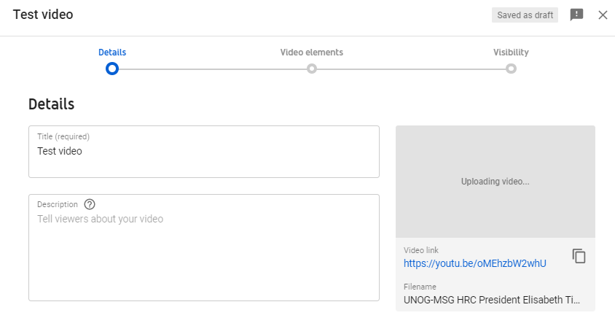
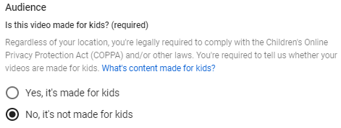
- Click “Next” on the “Video elements” tab. On the “Visibility” tab, select “Private” and click on “Save”.
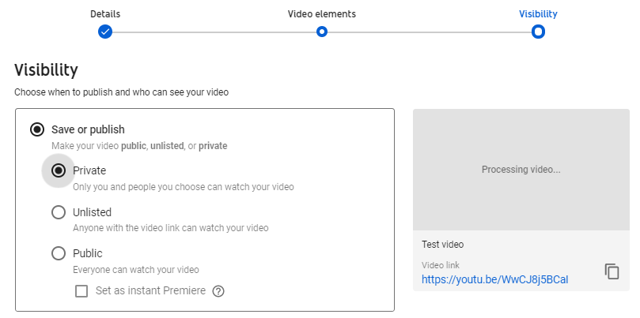
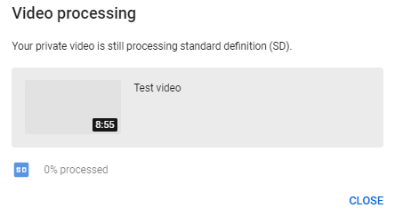
- After the video has finished uploading, it might be necessary to wait some minutes while it is being processed (capture below). Processing time depends on several factors, such as the format and size of the original file, as well as YouTube’s own upload traffic. As a rule of thumb, it can take around one minute of processing for each minute of video – and more than that for higher-resolution video. The progress bar is usually not linear: 0% takes a long time, and from there it jumps to almost completion. A few minutes at 0% does not mean that the processing is frozen.
- Go back to the dashboard by clicking on the icon on the upper-left side. On the left-hand column, select . Click on “Details” next to the video to caption. After that, select “Subtitles”.
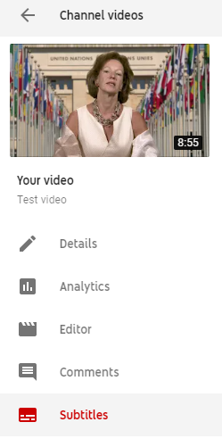

- Select “add” and then “Upload a file”. On the next screen, select “Transcript” as the file type. There might be a warning mentioning that “Uploading a file will overwrite this version of English”. This means that YouTube has already generated automatic captions for this video, which will now be overwritten.
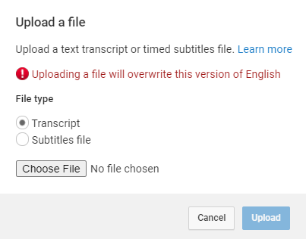
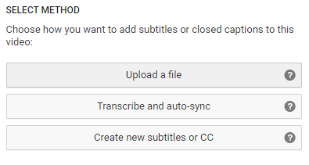

- Upload the transcript as a plain text (.txt) file. Using a Word document will not work properly. Before uploading it, edit the file so as to include only what is actually said in the video, without bullet points, headers or footnotes.
- The transcript will appear in the following box. Click on “Set timings”.
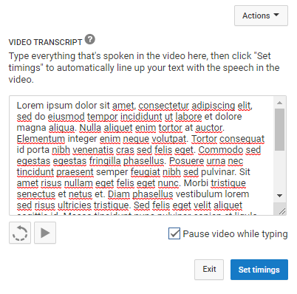
- YouTube will now transform the transcript in timestamped subtitles. For a 7-minute video, this takes 2 to 3 minutes on average. YouTube does not refresh the page automatically when this process has finished; so refresh the page after a few minutes to check whether it is finished (refreshing the page before it is complete does not reset the progress). When it is done, click on the draft.

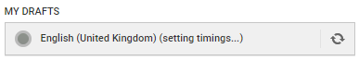
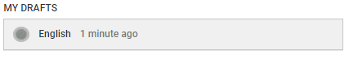
- It is possible to check and edit the subtitles at this stage, changing the wording or timing if needed. After this, click on “Save changes”.

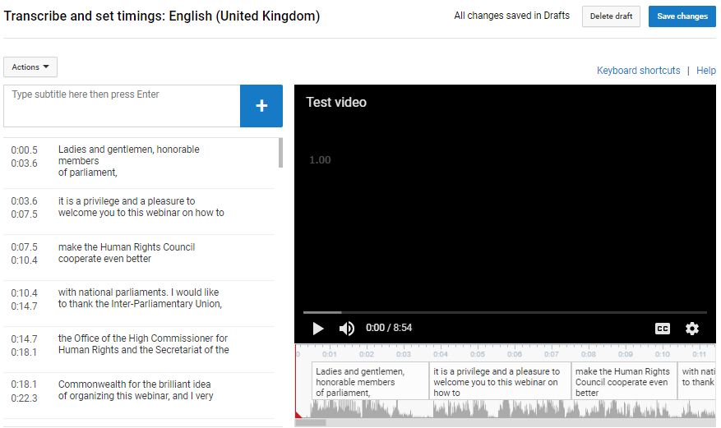

- Select again the edited subtitles. Click on “Actions” and download the captions as a .srt file. Save it with the same file name as the video, as shown in the capture below.

- To test it, open the video file using a player that supports subtitles, such as VLC Media Player. Provided that both files have the exact same name and are saved on the same folder, captions should be displayed automatically.
- Kindly upload the .srt subtitle file when uploading the video and related files on WeTransfer

