Submission by Quantic Association and The Common Front for Housing Rights,   
Bucharest, Romania

**ANSWER TO QUESTION NO. 5:**

In 36 urban administrative units in Romania, access to various social assistance benefits and services, including social housing, is restricted or hindered for extremely vulnerable individuals and families, due to a condition requiring them to pay off or not have any debts to the local budget. This means that if they are found with fines at the local tax departments, they will be unable to get essential help, such as *food allowances, emergency aids for medical problems, clothes or diapers for newborn babies, aids for rent payments, benefits to prevent marginalization or school dropout, social housing[1]*.

These fines often result from petty offenses or conduct that is necessary to survive, such as riding public transport without a ticket, informal street vending, washing car windshields in exchange for money, working in parking lots, begging, performing personal hygiene activities in public places etc. Some vulnerable individuals we worked with have fines even amounting up to 20.000 RON (approx. 4037 EUR), impossible to pay, while others have been fined since they were 14 years old. In other situations, children cannot benefit from certain social aids because their parents are found with fines.

There are several laws that regulate various types of social benefits, but only the Social Assistance Law no. 292/2011 through art. 9 (9) provides that social benefits “*shall be granted on condition that the beneficiary pays their debt to the local budget*”, with the fines mentioned above qualifying as debt to the local budget.

Some local authorities choose to impose this condition, using art. 9(9) of the Social Assistance Law as a legal basis, while other local authorities choose not to impose this condition and grant social benefits under other special laws. Therefore, eligibility for such social benefits depends on the interpretation and goodwill of the local authority, due to the lack of legislative coherence.

The legislation regulating social services (including social housing) does not include restrictions related to debt. There are, however, legislative loopholes used by local authorities to include additional restrictive criteria regarding debt to local budgets.

There is no national approach to address the very possibility of local authorities to impose additional restrictions for access to services/benefits, meanwhile legal intervention in dozens of cities across the country is beyond the capacity of any non-governmental organization. In this context, it seems that authorities persist in establishing discriminatory regulations.

## The following information is from the ***Report on the conditionality of social assistance benefits and services granted from local budgets*** - published in March 2022, Quantic Association and The Common Front for Housing Rights, Bucharest, Romania

**OVERVIEW AT NATIONAL LEVEL**

To understand how far reached the situation is at national level, between December 2021 and March 2022, Quantic Association carried out a nationwide study requesting public information from Social Assistance Directorates of all 319 cities and municipalities in Romania and to the administrations of the 6 districts of Bucharest[2].256 urban administrative units answered our request for information (meaning a 78% response rate[3]), of which 36 reported that access to social benefits/services/housing was conditional on the absence or payment of debts to the local budget (which includes fines), i.e. 14%.

7 out of 13 cities with more than 150.000 inhabitants reported some form of conditionality: Bucharest, Cluj, Constanța, Craiova, Brașov, Galați, Brăila. The other 6 large municipalities, Timișoara, Iași, Oradea, Arad, Ploiești and Pitești responded that they do not impose such a condition.

30 urban administrative units impose this condition for accessing certain social benefits granted from the local budget, such as: emergency aids, social vouchers, home heating aids, incentives for newborn babies.

8 urban administrative units establish the absence of debts as a criterion for applying for social housing or renewal of the social housing contract[4]: Ploiești, Bacău, Focșani, Zalău, Mangalia, Reghin, Cernavodă, Rovinari.

Among the public or social services restricted by the lack of debt to the local budget were elderly nursing homes (Constanța, Mangalia) and creches under the administration of the social assistance directorates (Brașov, Voluntari, Cugir, Sector 1 Bucharest)[5].

The conditionality of public/social services is of two types: (1) On admission: e.g. the elderly nursing home in Constanța[6] or the creche in Cugir[7] (2) For providing subsidies from the local budget for food or care services: the elderly nursing home in Mangalia[8], creche benefits in Bucharest Sector 1, Brașov[9].

**LEGAL FRAMEWORK**

**Social benefits**

The legal provision invoked by local authorities imposing the debt-free condition is **Article 9 Paragraph 9** of the **Social Assistance Law** **292/2011**:

”*Social assistance benefits financed from the state budget and, where applicable, from the local budgets shall be granted on condition that the beneficiary pays their debt to the local budget*.”

Other special laws that grant various types of aid to support vulnerable individuals/families **do not provide for such a condition**, e.g., Law 416/2001 on Minimum Guaranteed Income[10] or Law 272/2004 on the Protection of Children's Rights. For example, emergency aids may also be granted under Law 416/2001 on Minimum Guaranteed Income, art. 28 (1), which does not impose the debt condition[11]. In fact, several municipalities grant emergency aid under this law, i.e. **without making it conditional on the existence of debts**, such as Timișoara, Pitești, Oradea, Iași. However, other local authorities have included the debt condition for emergency aids, by using the Social Assistance Law as a reference. Therefore, due to a lack of legislative coherence, local authorities can choose how restrictive the access to these aids can be.

We have also identified situations where Law 416/2001 on Minimum Guaranteed Income is used as a legal basis for granting emergency aid, while still maintaining the condition of having no debts to the local budget, in spite of the fact that Law 416/2001 does not impose such a condition (as in the case of Brăila, through the Local Council Decision no. 375/2017).

To the extent that Law 416/2001 can be and is used as a legal basis for granting various types of aid from the local budget (to prevent and combat social exclusion), according to the legal principle of *specialia generalibus derogant*, Law 416/2001 being a special law is derogatory from the rule established by the general Social Assistance Law 292/2011.

**Social services**

There is no legal provision that makes social services conditional on the absence or payment of debt to the local budget. However, some local authorities deny or restrict social services based on this condition. In their argumentation, they assimilate social services to social benefits, considering them in terms of costs per beneficiary for the local budget.

One example is Brașov, where financial aid for educational services in public crèches (referring to the cost of maintenance for children) is denied, based on the debt condition. A similar situation is found in Sector 1 of Bucharest, where the costs of enrolment and food at creches are considered *exceptional financial benefits* provided for by Article 130 of Law 272/2004 on the Protection of Children's Rights, despite Article 70 paragraph 2 of Government Decision 1252/2012 on the Methodology for the Organization and Operation of Crèches, which states the following:

"*Parents/legal representatives, who care for children at risk of family separation and have approved service plans, shall be exempt from paying the contribution, the burden being borne by the local budget*."

The same assimilation with social benefits can be found in Mangalia regarding an elderly nursing home, where admission to the home is not conditional on the lack of debt to the local budget, but the provision of social services within the home is (food and personal hygiene), in contradiction with article 97 paragraph 2 of the Social Assistance Law:

"*Local public administration authorities have the obligation to ensure personal care services at home or in residential centers for dependent elderly people who are alone or whose family is unable to care for them*".

Local authorities also deny **access to social housing** or to **the renewal of a social housing contract,** if the applicant has not paid their debt to the local budget. This violates the Housing Law 114/1996, which provides a clear set of criteria for assessing the eligibility of applicants. The existence of debt to the local budget is not among them.

Moreover, arbitrary criteria in various municipalities have been the subject of several decisions of the National Council for Combating Discrimination, among which the Local Council of Focșani was fined for discrimination by imposing such absence of debts to the local budget as an eliminatory criterion for accessing social housing, remaining final by Decision no. 1529 of 11 March 2021 by the High Court of Cassation and Justice[12].

The legal argument invoked is the possibility for the local authority, by means of the *Norms for the application of the Housing Law (art.21*), to establish criteria additional to the restrictive and priority criteria laid down in the Housing Law 114/1996. As the reply received from Bacău shows, "to these criteria may be added other criteria, depending on specific local situations".

**DEBTS TO THE LOCAL BUDGET**

Where this condition is imposed, one of the documents requested to access social benefits is a **tax certificate** from the local tax department, which certifies that the applicant has no tax debt[13]. To our knowledge, no data is available on the structure of fiscal debt of individuals, i.e. how many people owe fines and in what amount, for what types of offenses the fines were given, how many people have arrears in paying taxes on the goods they currently own etc.

Partial information is occasionally available from official statements reported by the media, for example, in 2018 in the structure of debts to the state that amounted to 100 billion RON, about 3 billion were related to individuals, while the rest were related to companies[14]. Some more information is available on the fines imposed during the Covid-related state of emergency in 2020, both from public statements and from the explanatory memorandum of the draft law proposing the amnesty: more than 300 thousand fines amounting to more than 600 million RON[15].

From our field experience and that of other Romanian non-governmental organizations, vulnerable people with no income or extremely low incomes accumulate fines from informal work such as street vending, "parking" or appeals to public charity. Some of the people we worked with through the initiative Housing Union[16] have accumulated fines of up to 20.000 RON. This situation worsened during the Covid state of emergency, when people who relied on informal work to survive and support their families were fined thousands of RON for unjustified movement during lockdown or for incorrectly completing declarations required in that period.

The inability to pay the fines impedes the most vulnerable from access not only to local social benefits, but also to the formal labor market, as declaring income on the employment card would lead to a garnishment of wages, which at the minimum level is already insufficient for a decent living.

As far as we know, there have been no legal solutions for people in this situation. The Government Emergency Ordinance 6/2019 on the establishment of tax incentives (amnesty) only concerns legal entities and Law 151/2015 on the insolvency of individuals sets the minimum debt threshold for declaring personal bankruptcy at 15 minimum wages per economy, "to filter out insignificant claims"[17].

**IMPACT OF LOCALLY SET CONDITIONALITIES**

In most cases, the figures reported by authorities imposing the no-debt condition show a modest impact (see Annex 1), as the number of files rejected for this reason is relatively low compared to the number of benefits approved. Based on our experience on the ground[18], we believe that the relatively low percentage of rejected applications is due to the fact that applicants are informed from the onset on the existence of the no-debt conditionality.

One of the most prominent exceptions is the situation presented by the General Directorate of Social Assistance of the Municipality of Bucharest (DGASMB), in particular with regard to the incentives for adults and children with disabilities, which have been granted since 2017[19]. Analyzing the ratio of rejected applications, suspended applications and approved applications in the period 2017-2021, we see that even though a small percentage of applications were rejected (0.7% for the adult disability incentive and 0.4% for the for the child disability incentive), the percentage of those suspended due to the accumulation of debt after already being approved for the benefit is high (11% for the adult incentive and 33% for the child incentive).

This shows, in our interpretation, that the applicants inform themselves or are informed by the social assistance staff, when they intend to claim the incentive, that this condition exists, but after the benefit is established, they fail to comply. We believe this show that applicants are discouraged from the outset to apply for benefits, given the existence of this conditionality.

In most cities where this condition is imposed, the number of rejections is low compared to the number of approvals, with some social assistance directorates reporting 0 cases rejected. We forward the same explanation: applicants are informed about the debt condition from the onset and give up submitting the claim. Given the reported figures, it could be said that there is no other practical reason for setting the conditionalities other than discouraging vulnerable potential applicants from accessing these benefits. However, as the extent of this discouragement practice would only be quantifiable by a sociological survey, the only references available to us are testimonies of affected people who turn to non-governmental organizations for support:

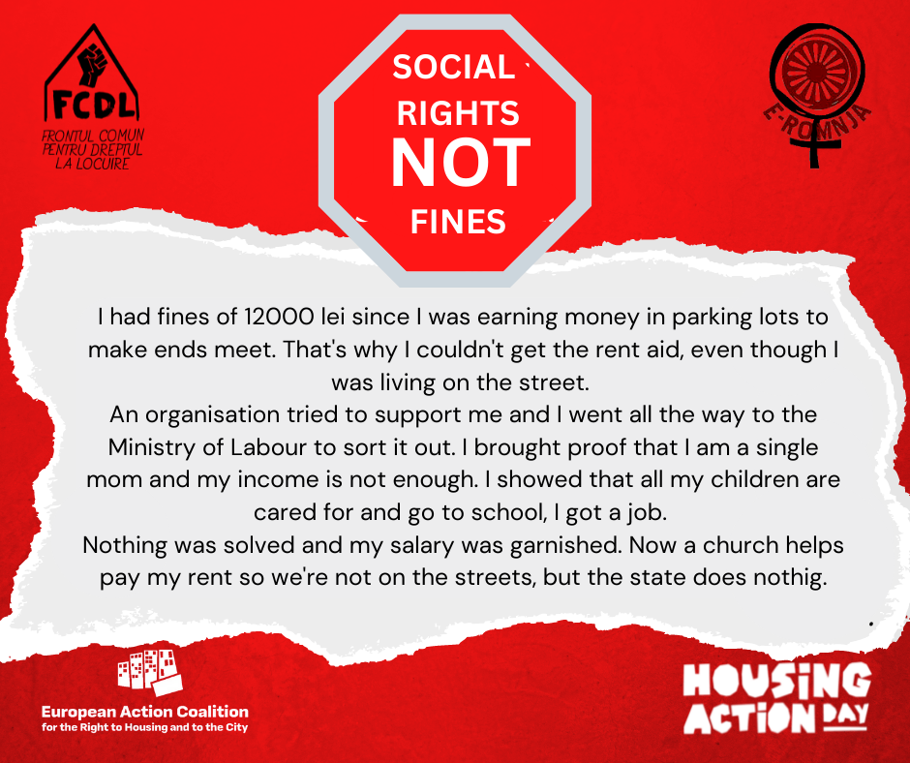

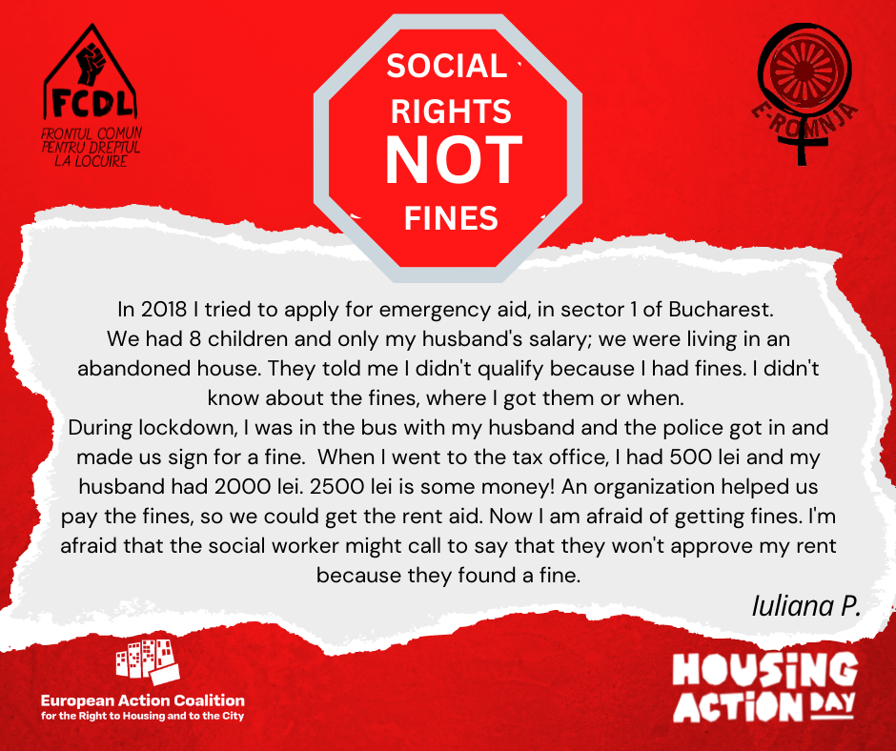

In support of our argument that this conditioning is imposed as a discouragement for claiming social benefits, we draw attention to the situation in Sector 3 Bucharest, where we can compare the number of approved before and after the municipality imposed the no-debt condition. Sector 3 municipality introduced restrictions for accessing community social aid, including the payment of debt to the local budget, in 2016 though the Local Council Decision 336/15.12.2016. The impact of this measure can be seen in the number of approved applications, taking as an example the community social aid for the purchase of food:

* 194 beneficiaries in 2015,
* 131 in 2016,
* 48 in 2017,
* 31 in 2018,
* 17 in 2019,
* 15 in 2020
* 6 in 2021

In the case of the aid for rent payment, the number of approved applications remains low over the years (even if here too we see a decrease), most likely due to the complicated procedure that applicants have to follow and the difficulty of finding a suitable rental accommodation under the required conditions:

* in 2015 - 22 beneficiaries
* in 2016 - 12
* in 2017 - 13 and one rejected application
* in 2018 - 15 beneficiaries
* in 2019 - 12
* in 2020 - 5
* in 2021 - 10 beneficiaries.

The purpose of limiting access to benefits is also confirmed in the *Strategy of the General Directorate of Social Assistance and Child Protection of Sector 3 for the period 2019-2024*, which reports a decrease in the number of community social benefits from 250 in 2015 to 45 in 2018[20].

**IMPACT OF CONDITIONALITIES SET AT NATIONAL LEVEL (2012-2015)**

In the period 2012-2015, the Minimum Guaranteed Income, Family Support Allowance and Child Raising Benefit were made conditional on the payment of due taxes for possessions such as real estate, land and cars/vehicles. The beneficiaries who had outstanding taxes had their social benefits suspended. This conditionality was established by the Government Emergency Ordinance 124/27.12.2011, justifying it as a form of modernization of the social assistance system and referring to the loan agreement with the International Bank for Reconstruction and Development. 27 local administrations provided us data on the termination or suspension of the Minimum Guaranteed Income, Family Support Allowance and Child Raising Benefit.

Even though the legislative amendment concerned taxes for possessions such as real estate, land and cars/vehicles**, the most affected individuals were those who had accumulated fines,** as one of the municipalities informed us in its reply[21]:

"*We would like to point out that the payment of local taxes and fees is done following the payment of fines, according to the law, therefore a large number of social benefits recipients, could not pay them due to the order of preference established by the Tax Code, even though they had a low amount of outstanding taxes*."

According to a press release from the Ministry of Labor in February 2012, "10.21% of all beneficiaries are in arrears" (11.65% of Family Support Allowance beneficiaries, 10.84% of Minimum Guaranteed Income beneficiaries and 6.71% of Child Raising Allowance beneficiaries have not paid their local taxes). "All those who have arrears in paying local taxes will be out of payment starting today, February 1".[22]

Although the Ministry of Labor has produced a statement of the number of beneficiaries suspended between 2012 and 2015[23], a statement of payment resumption is not available for those who have paid their outstanding debt within the prescribed 5-month period.

We believe that the measure imposed in 2012-2015 for the Minimum Guaranteed Income and Family Support Allowance, as in the case of the debt conditionality at the local level, was aimed at limiting access to these benefits and reducing social spending from the national budget, without concern for the social cost and poverty reduction.

Corroborating data from the National Institute of Statistics and Eurostat, as well as from other types of reports (Adăscăliței, Raț, Spătari, Friedrich Ebert Stiftung, 2020), the relative poverty rate has increased in Romania from 21.6% in 2010 to 23.8% in 2019[24], and although the risk of poverty or social exclusion has decreased by almost 10% between 2011 and 2019 (from 40.9 to 31.2%), it is still among the highest in the EU and well above the European average of 20.9[25].

At the same time, social protection expenditure as a percentage of GDP has steadily decreased from 17.3% in 2010 to 14.7% in 2018, with a slight increase to 15% in 2019, but well below the EU average of 26.9%[26]. Moreover, available data show that most of the social expenses are for financing old-age pensions (which operate on a contributory basis)[27], while redistributive benefits for the lowest income earners (Minimum Guaranteed Income and Family Support Allowance) account for only 6% of social expenditure[28]. The European Commission's 2020 Country Report on Romania also points out that social benefits and minimum income fail to reduce poverty, with one in three Romanians at risk of poverty or social exclusion[29].

**RECOMMENDATIONS**

**1. Tax amnesty based on income threshold for individuals**

Debts to local budgets due to fines deepen and perpetuate poverty and exclusion for vulnerable people. Being unable to ever pay them, they are excluded from the formal labor market because of the threat of wage garnishment. Moreover, in localities where social benefits are conditional on the absence of debts, these people and their families are excluded from the very inclusion measures that should be targeted at them. It is therefore necessary that a tax amnesty be introduced to help people with no or low income.

**2. Amendment of the Social Assistance Law to exclude Article 9 Paragraph 9**

30 of the 256 urban administrative units that responded to our request, i.e. almost 12%, reported imposing some form of conditionality for various social benefits granted from the local budget. Of course, not all benefits granted locally address the same level of urgency, with food aid, funeral aid or aid for rent payment responding to more immediate and pressing needs, compared to aid for the purchase of an alternative heating system (as in Galati and Deva). However, the fact that only 12% of municipalities and half of the municipalities with more than 150 000 inhabitants establish such a condition shows that there are cities that grant benefits from local budgets using another, less restrictive legal basis. For example, Timișoara, Pitești, Oradea and Iași grant emergency aid from the local budget on the basis of Law 416/2001 on Minimum Guaranteed Income.

In order not to leave the issue of access to social benefits to the goodwill of the local authority and to increase the degree of social inclusion, it is necessary to remove Article 9(9) of the Social Assistance Law, which stipulates that benefits shall be granted on condition that the beneficiary pays their debt to the local budget.. The effects of such a policy were also seen when benefits granted from the state budget had a similar condition imposed, with benefits for over 10% of recipients for Minimum Guaranteed Income, Family Support Allowance and Child Raising Benefits being suspended only in 2012. Given that reporting on the number of suspensions between 2012-2015 by the Ministry of Labour has recorded the amounts saved on such payments, we conclude that such a conditionality does not have as an objective a positive social impact and poverty reduction, but to limit social expenditure (which is still insignificant to the national budget).

**3. Amendment of the Housing Law to remove the possibility for local authorities to set additional criteria for access and priority and for the renewal of social housing contracts** Housing Law 114/1996 provides for a certain set of restrictive and priority criteria, in which social vulnerability takes precedence in accessing social housing, but the methodological norms also provide for the possibility that local authorities set additional criteria. This legal loophole has enabled discriminatory practices at local level to spread. Discriminatory criteria include not only lack of debts to the local budget, but also criteria related to level of education, type of employment contract and marital status. This has been shown by rulings of the National Council for Combating Discrimination (in the cases of Cluj, Focșani, Sector 2 Bucharest), but also by several studies on the subject[30]. To limit this practice and ensure non-discriminatory and inclusive access to social housing as a public service, it is necessary to amend the housing law in the sense mentioned above.

4. **Clarify and limit, in the specific legislation, the possibility for local authorities to restrict access to public and social services, by imposing a condition on paying debts to the local budget**

Imposing the absence of debts to the local budget as a condition for accessing care services offered as part of public services, such as elderly nursing homes or crèches, is contrary to the principles of public administration established by the Administrative Code, namely the principles of equality, proportionality and adaptability.

**About the organizations:**

**Quantic Association** was established in 2013 in Bucharest, by a group of sociologists, architects, planners and policy researchers. It functions as a platform for social and educational projects, groups and networks, with the goal of integrated and just social development.

**The Common Front for Housing Rights** is a grassroots and advocacy network established in 2013, after a long history of mobilizations and solidarity building for the right to housing for all, dating back to the early 2000s in Bucharest. It focuses on preventing evictions and advocating for the development of social and public housing, supporting housing as a fundamental right. Since 2016, it has worked in close collaboration with Quantic Association. Since 2017, The Common Front is part of the Block for Housing national platform.

**Annex 1 and 2**

**Annex 1 - Local (urban) authorities limiting access to social and public benefits and/or services with the condition of paying debts to the local budget (of those who responded to our information request)**

|  |  |  |  |  |  |  |  |
| --- | --- | --- | --- | --- | --- | --- | --- |
| **No** | **City** | **Benefit** | **Local Council Decision[31]** | **Rejected** | **Service** | **Local Council Decision** | **Rejected** |
| 1 | Cluj | Social vouchers for food | HCL 515/2018 | 2018: 5449 claims, 147 rejected  2019: 5312 claims, 82 rejected  2020: 3513 claims, 48 rejected  2021: 4280 claims, 70 rejected |  |  |  |
| Aid for rent payment | HCL 413/2020 | 2020: 75 claims, 1 rejected  2021: 93 claims, 2 rejected |
| 2 | Constanța | Program Infant- financial support for in-vitro fertilisation | 59/2020 | - | Elderly nursing home Constața | ? | 1 claim rejected in 2021, according to the Admission Procedure from 18.02.2021 |
| Value vouchers – Program Respect | 24/2016 | 2016-2021: 16.753 claims rejected from a total of 208.116 submitted, of which 12.565 rejected due to debt at the local budget  6% rejected |
| 3 | Craiova | Social program Solidarity, support for individuals / families in situations of social risc – social vouchers of 30 de lei for food | 487/2017 ammended by 383/2019 Granted during 2018-2020 – suspended during lockdown due to lack of funds | 2018-2020:  Rejected: 84  Approved: 3099  2,7% rejected |  |  |  |
| 4 | Brașov | Social vouchers for elderly | 71/2019 | 0 rejected |  |  |  |
| Clothes for newborn babies | 664/2018 | 2019:  17 rejected,1725 approved  2020: 51 rejected, 1651 approved  2021: 33 rejected,1841 approved  2,1% rejected |
| Aid for paying preschool educational services | 274/2021 | 0 rejected, 121 approved |
| Aid for rent payment | 71/2021 | 0 rejected, 5 approved |
| 5 | Galați  (social assistance directorate founded in 2018) | Aid for buying a heating system altrenative to the centralized one | 328/2018 | 2018-2021: 5773 files approved |  |  |  |
| Incentive for newborn babies | 137/2021 | 2018-2021: 4 files rejected, 740 approved |
| 6 | Ploiești |  |  |  | Renewal of social housing contract | 40/2021 | 14 families |
| 7 | Brăila | Emergency aid | 375/2017, art. 4 alin.6 | 2017: 163 de claims, 117 approved, 14 rejected  2018: 134 claims, 121 approved, 5 rejected  2019: 113 claims, 97 approved, 4 rejected  2020: 90 de claims, 80 approved, no rejection  2021: 103 claims, 74 approved, 1 rejection  3,9% rejected | Redirected to the Public Utility Service for the administration of the housing fund |  |  |
| 8 | Bacău | Home heating aid from the local budget | OUG 70/2017 | 2019-2021: approved 893 of 3100 claims – the reason for rejections is not specified | Social housing (applicants for social housing who, at the time of the analysis of the claims, had debts to the local budget, were not included in the lists of applicants entitled to receive a social housing in the following year) | 302/6.09.2017  355/28.09.2018  238/28.06.2019  148/28.07.2020  24/28.01.2021 | 2017: 2 files  2018: 9 files  2019: 8 files  2020: 7 files  2021: 14 files |
| 9 | Focșani | Emergency aid | 95/ 30.04.2015  192/ 30.05.2017 | No rejected claims | Social housing | 277/27.07/2017 | 2017: 55 files  2018: 49 files  2019: 34 files |
| 10 | Alba Iulia | Emergency aid | ? | 2019: 49 approved, 1 rejected  2020: 14 approved, 3 rejected  2021: 15 approved, 2 rejected  7,6% rejected |  |  |  |
| 11 | Deva | Social vouchers for buying individual heating systems | HCL 242/2021  488/2021 | They did not communictae the situation of approvals/rejections |  |  |  |
| 12 | Zalău |  |  |  | Social housing | 120/ 20.05.2013 | 2016: 4  2017:1  2020:1 |
| 13 | Roman | Financial incentive for newborns | 234/ 28.10.2021 | 23 files approved, 0 rejected |  |  |  |
| 14 | Turda | Emergency aids – funeral, medical issues | 326/2018,  Annex 1 (I), death of pers. With no income or low income  (II) | 2018-2022:  30 granted, 7 rejected  23% rejected |  |  |  |
| Medical issues | 31 granted, 4 rejected  12,9% rejected |
| 15 | Voluntari |  |  | 1 file rejected in 2021 based on art.9 (9), it is not specified what tye of aid  There is no statistic regarding the reasons for rejection | Creche | 58/ 23.06.2021 | 1 file rejected |
| 16 | Mangalia | Monthly food package – program for supporting categories of people in difficult or vulnerable socio-economic situations | 126/2017 | There were no rejected or suspended files, it was allowed to pay the debts in installments | Renewal of the social housing contract | 144/ 22.10.2021 | 6 tenants |
| Social services granted by the elderly nursing home in Mangalia |  | They did not mention rejections |
| 17 | Râmnicu-Sărat | Emergency aid | ? | 2017-2021:  19 rejected  87 approved  21,8% rejected |  |  |  |
| 18 | Reghin |  |  |  | Social housing | 180/ 29.07.2021, anexa 1, art.9 pct.11 | 15 files |
| 19 | Săcele | Firewood/heating aid for 100 families in need | ? 2016 | 2016-2021:  65 claims rejected |  |  |  |
| 20 | Caracal | Food program for people in special socio-economic or medical situations | 18/2020, art. 5.1.7  Social vouchers are not granted to individuals or families with debts to the local budget, except for the elderly | No of rejections/approvals not sent |  |  |  |
| 21 | Roșiorii de Vede | Social vouchers for elderly people | HCL 2017, 2018, 2019, 2020, 2021 | Files rejected 2017-2019: 23  Suspended 2019: 3  Approved 2017-2021: 885  2,5% rejected |  |  |  |
| 22 | Cugir |  |  |  | Creche | 2020-2021 | No rejections |
| 23 | Târgu Neamț  (DAS inființată in 2015) | Emergency aid | 168/2015  273/2017  167/2020  66/2021 | 2016: rejected 9, approved 30  2017: rejected 6, approved 31  2018: rejected 3, approved 16  2019: rejected 2, approved 14  2021: rejected 2, approved 23  21% rejected |  |  |  |
| 24 | Cernavodă |  |  |  | Social housing allocation | 348/27.11.2017 | 64 people, of which 18 payed their debt and were allocated housing |
| 25 | Bragadiru | Emergency aid, exceptional financial benefits | 91/ 2012  107/2016  91/2021 | 2011-2015: rejected 0 files  2016-2021: rejected 43 files  2011-2021: granted 1633 beneficiaries  2,6% rejected |  |  |  |
| 26 | Luduș | Emergency Aid  Funeral Aid | ? 2018 | No file rejected  Approved: 2018: 1 emergency aid, 3 funeral aids  2019: 2 emergency aids, 4 funeral aids  2020: 2 emeregency aids  2021: 4 emergency aids 4 funeral aids | There is no social housing |  |  |
| 27 | Bolintin | Emergency aid | 25/ 29.03.2018 | 2018: 8 rejected, 8 granted  2019: 3 rejected, 12 granted  2020:14 rejected, 8 granted  2021: 5 rejected, 3 granted  2018-2021:  30 rejected  31 granted | No social services are granted |  |  |
| 28 | Vălenii de Munte | Financial support for pregnant women to cover medical services not covered by the health insurance | HCL 70/28.05.2021 | 6 files, all granted |  |  |  |
| 29 | Rovinari |  |  |  | Social housing | ? | 5 files deemed uneligible |
| 30 | Hârlău | Social vouchers | 28/ 22.04.2021 | No response to our request for clarifications |  |  |  |
| 31 | Covasna | Newborn clothes | 31/2021 | 1 file rejected, 36 approved |  |  |  |
| 32 | Curtici | Emergency aid for death or calamities | 76/2021 | 0 rejected, 2 approved |  |  |  |
| 33 | Ungheni | Food aid | 19/2016  10/2019  13/2020 | 775 claims  493 claims  302 claims  0 rejected |  |  |  |
| 34 | S1 | Emergency aid to prevent social marginalization | 12/  28.01.2020  120/2004  65/2019  100/2014 | 2019: 114 rejected, 580 approved  2020: 51 rejected, 500 approved  2021: 44 rejected, 495 approved  13% rejected | Creche/ suportarea din bugetul local a costurilor de inscriere și hrană, ca prestație financiară excepțională pentru copiii aflați in pericol de separare | 12/ 28.01.2020 | 2019: 3  2020: 0  2021: 1 |
| Aid for rent payment | 2019-2021: 0 rejected  2019: 171 approved  2020: 158 approved  2021: 165 approved |
| Exceptional financial performance  -powdered milk  -diapers  -medication | 2019: 4 rejected, 77 approved  2020: 6 rejected, 91 approved  2021: 1 rejected, 44 approved  5,1% rejected |
| 35 | S3 | Community social aid  Food allowance | 80/2021 regarding ammendment 336/2016 | Rejected/Approved:  2015: 191 benef.  2016: 33/131  2017: 16/48  2018: 6/ 31  2019: 11/17  2020: 5/ 15  2021: 4/ 16  29% rejected |  |  |  |
| Rent payment | 2015: 22 benef.  2016: 12 benef.  2017: 13 benef./ 1 claim rejected  2018:15 benef.  2019: 12 benef.  2020: 5 benef.  2021: 10 benef/ 1 claim rejected |
| Arrears for housing utilities | 2015: 8 benef.  2020: 1 claim rejected |
| 36 | General Directorate of Social Assistance of Bucharest (DGASMB) | Incentive for adults with disabilities | HCGMB 330/2017 | 2017-2021: rejected: 1610 files  suspended: 25300  Approved: 227800  0,7% rejected  11% suspended |  |  |  |
| Incentive for children with disabilities | 292/2017 | 40 files rejected  2973 suspended  8941 approved  33% suspended  0,4% rejected |
| Incentive for newborn babies | 209/2017 | 172 rejected  80853 approved  0,2% rejected |
| Benefit for single-parent families | 492/2017 | 2 rejected  2 suspended  486 approved |
| Preventing school dropout | 482/2018 | 3 rejected  1583 approved |
| Voucher for pregnant women | 120/2018 | 22 rejected  52772 approved |

**Annex 2. Questions sent to local authorities from 319 cities and municipalities in Romania and the 6 sectors of the Municipality of Bucharest, based on Law 544/2001**

1. Are certain social benefits granted in your locality under the condition of absence or payment of debts to the local budget?

2. Which social benefits are conditioned in this way?

3. Please indicate and attach the local council decision(s) establishing this condition.

4. If in your locality certain social benefits are conditional on the absence/acceptance of debts to the local budget, please provide us with the following information:

- How many files were rejected because the applicant or a family member was in debt to the local budget from 2011 to 2021? Please provide us with data broken down by type of social benefit and by year.

- In how many files were social benefits stopped due to the accumulation of debts to the local budget after the claim was granted, from 2011 to 2021? Please provide data broken down by type of social benefit and by year.

- In the case of those social benefits conditional on the absence or payment of debts to the local budget, what is the number of approved files in the period 2011-2021? Please provide us with data broken down by type of social benefit and by year.

5. Are certain social services granted in your locality under the condition of no debt to the local budget?

6. Which social services are conditioned in this way?

7. Please specify whether this condition applies for accessing social housing.

8. Please indicate and attach the local council decision(s) establishing the condition of no debt to the local budget for access to those social services.

9. If in your locality certain social services are conditional on the absence/payment of debts to the local budget, please send us the following information:

- How many files were considered ineligible because the applicant or a family member was in debt to the local budget from 2011 to 2021? Please provide us with data broken down by type of social service and by year.

Sent by,

Internship expert

Vlad Andreea-Ioana

1. A full list of social benefits and services restricted by this condition can be found in Annex 1.
2. The 2nd Annex contains the questions sent to local authorities.
3. The total number of answers was 264, but we considered 8 of them invalid, not being clear whether they impose conditions or not; some of them only communicated that they did not reject files due to debts, others communicated information only related to social services, not benefits.
4. A study by the Center for Legal Resources in 2021 in Romania on the criteria for accessing social housing identified 21 municipalities and cities that impose no debt as a restrictive criterion and 4 others that impose it as a scoring criterion. Restrictive criterion: Aiud, Alba Iulia, Pitești, Bacău, Marghita, Reșița, Câmpia Turzii, Dej, Turda, Galați, Târgu Jiu, Deva, Slobozia, Baia Mare, Slatina, Zalău, Vatra Dornei, Focșani, Ghimbav Brașov county, Hârșova Constanța county, Pătârlagele Buzău county. Scoring criterion: Dorohoi, Constanța, Reghin, Abrud Alba county.
5. See table in the first Annex
6. From the answer of the Social Assistance Directorate of Constanța: "according to the Procedure regarding the admission of beneficiaries to the Elderly Nursing Home Constanța within the General Directorate of Social Assistance of Constanța, elderly people who have unpaid debts to the local budget cannot be admitted to the elderly nursing home"
7. According to the response received from the Public Social Assistance Service of Cugir: "For enrolment at the creche in the last 2 years there has been a requirement to submit a tax certificate from the Local Tax Department, valid on the date of submission, certifying that the family has no outstanding debts to the last payment term of the current year. This is requested because the parent pays a modest amount for each day of the child's presence at the creche (…) the difference being fully borne from the local budget."
8. According to the answer from the Directorate of Social Assistance of Mangalia, "the absence of debts to the local budget is not a criterion that leads to the exclusion of access to the Elderly Nursing Home in Mangalia", but "the social service is granted under the condition of the absence of debts to the local budget within the home (services for providing food and nutritional supplements, housekeeping help, support for achieving bodily hygiene and providing personal hygiene materials)."
9. See the discussion in the following section.
10. Law 416/2001 on Minimum Guaranteed Income will be replaced as of January by Law 196/2016 on Minimum Inclusion Income, which also does not provide for this condition.
11. *"Mayors may order the granting of emergency aids, in cash or in kind, to families or individuals in situations of need arising from natural disasters, fires, accidents, epidemics, epizootics, and other special situations that may lead to the emergence or increased risk of social exclusion, including in the event of death in the country or abroad, established by decision of the local council, which shall also include the procedure and/or conditions for granting"* article 28 (1) - According to Law 158/2021 of June 7, 2021 for the amendment and completion of Law 416/2001 on Minimum Guaranteed Income
12. See studies Policy monitoring report on housing and inclusion of Roma after employment, Resource Center for Roma Communities, 2020 <https://romacenter.ro/wp-content/uploads/2021/04/HEKS-raport-de-monitorizare-A4-RO.pdf> and Identifiying discriminatory criteria in granting social housing, Center for Legal Resources, 2021 [Copy of Final - Identificarea criteriilor discriminatorii în acordarea locuințelor sociale (crj.ro)](https://www.crj.ro/wp-content/uploads/2022/05/Final-Identificarea-criteriilor-discriminatorii-%C3%AEn-acordarea-locuin%C8%9Bel....pdf)
13. Tax certificates are requested not only to show whether the applicant has fiscal debt or not, but also whether they own any property
14. Statement of Finance Minister Eugen Teodorovici<https://adevarul.ro/economie/amnistia-fiscala-buna-sau-rea-cine-sunt-1878834.html>
15. Explanatory Memorandum, Draft law on some administrative and fiscal measures<http://www.cdep.ro/pls/proiecte/upl_pck2015.proiect?idp=18700>
16. Support initiative for housing justice, developed through the collaboration of Quantic Association with the Common Front for the Right to Housing, Bucharest
17. Annex to the draft law on insolvency for natural persons <http://www.cdep.ro/proiecte/2014/500/70/9/ax823.pdf>
18. We supported vulnerable individuals and families throughout the process of applying for social benefits, which includes accompanying them to the social assistance offices in Bucharest. We are also in contact with other nongovernmental organizations who report similar situations from the ground, one of which partnered with us for an online awareness campaign on this issue - E-Romnja Association (The Association of Promoting Roma Women’s Rights).
19. Children are denied the *incentive for disability* if their parents are found with debt
20. Strategy of the General Directorate of Social Assistance and Child Protection of Sector 3 for the period 2019-2024, Annex to the Local Council Decision Sector 3 500/2019 (HCLS3 nr. 500/2019), p. 71
21. According to the reply received from the city of Marasesti

    According to Article 165 paragraph 2 of the Tax Procedure Code, "fines shall be extinguished with priority individualized in enforceable titles, in order of date, even if the debtor indicates another type of fiscal obligation".
22. Press release ”The situation of beneficiaries of Minimum Guaranteed Income, Child Raising Benefit and Family Support Allowance, who have not paid their local taxes", February 2012

    <https://mmuncii.ro/j33/index.php/ro/comunicare/comunicate-de-presa/2278-ref-situatia-beneficiarilor-de-venitminim-garantat-indemnizatie-lunara-pentru-cresterea-copilului-si-alocatie-pentru-sustinerea-familiei-care-nu-si-auplatit-impozitele-locale>
23. The situation of beneficiaries suspended between 2012-2015, by year, type of benefit and county:

    <https://www.mmanpis.ro/wp-content/uploads/2016/09/Beneficiari-suspendati_neplata_taxe_2015.pdf>
24. National Institute of Statistics, Tendințe sociale 2021, p.133
25. People at risk of poverty or social exclusion, Eurostat

    <http://appsso.eurostat.ec.europa.eu/nui/submitViewTableAction.do>
26. Social protection benefits expenditure – in % of the GDP, Eurostat

    <https://appsso.eurostat.ec.europa.eu/nui/show.do?dataset=spr_exp_gdp&lang=en>

    <https://ec.europa.eu/eurostat/statistics-explained/index.php?title=Social_protection_statistics_-_social_benefits>
27. INS, Tendințe sociale 2021, p. 144 <https://insse.ro/cms/sites/default/files/field/publicatii/tendinte_sociale_2.pdf>
28. FES 2020, p.4-6 <http://library.fes.de/pdf-files/bueros/bukarest/16835.pdf>
29. European Commission, Country Report 2020 on Romania, p.7

    <https://ec.europa.eu/info/sites/default/files/2020-european_semester_country-report-romania_ro.pdf>
30. Policy monitoring report on housing and inclusion of Roma after employment, Resource Center for Roma Communities, 2020 <https://romacenter.ro/wp-content/uploads/2021/04/HEKS-raport-demonitorizare-A4-RO.pdf>

    Identifying discriminatory criteria in granting social housing, Center for Legal Resources, 2021

    <https://www.crj.ro/wp-content/uploads/2022/01/Studiu-Identificarea-criteriilor-discriminatorii-%C3%AEnacordarea-locuin%C8%9Belor-sociale_dec.pdf>
31. In Romanian Local Council Decision is abbreviated as HCL (Hotărâre Consiliu Local) and we use this abbreviation here, because the names usually appear with this abbreviation