Inputs to the joint report of the Special Rapporteur on the right to adequate housing and of the Special Rapporteur on extreme poverty and human rights on efforts made to decriminalize offenses frequently associated with homelessness and poverty

Reporting Organization

The Danish Refugee Council (DRC) is a leading, international humanitarian organization, working in 40 countries supporting refugees and internally displaced persons throughout the displacement cycle: in acute crises, in exile, when settling and integrating in a new place, or upon return. In the Americas, DRC works in the context of mixed migration flows and internal displacement dynamics providing protection services, including legal aid, to the millions of people who have been forced to seek protection outside their countries of origin due to persecution, generalized violence, massive violations of human rights, and non-international armed conflicts.
The DRC Latin America Protection programme submits this contribution as part of its advocacy efforts to strengthen the legal environment and the respect of the human rights of displaced and conflict-affected populations in the region.

Summary of key inputs

- Non-citizens, including migrants, refugees, and asylum seekers facing homelessness and poverty are disproportionately affected by strict local and national sanctions related to economic activities and the fulfillment of physiological needs in public spaces. Evidence shows sanctions throughout Latin America particularly in countries such as Argentina, Colombia, Ecuador, Mexico, Peru, and Brazil.
- A significant number of refugees and migrants in the region resort to street vending as a means of economic survival due to limited integration into formal economies and limited avenues to regularize their migratory status. This situation is well-documented in countries like Argentina, Peru, Ecuador, Colombia, Uruguay, and Mexico.
- Street vendors, especially non-citizens without a regular migratory status, are more exposed to mistreatment and exploitation. Legal initiatives that protect migrants and refugees from disproportionate sanctions for carrying out activities aimed at generating income to meet basic needs.
- In Colombia, non-citizens, particularly those without a regular migratory status, are disproportionately exposed to sanctions for working in public spaces. Migratory regularization initiatives have had limited effects in including people in formal labor markets. Most refugees and migrants continue to engage in informal economic activities; even when they work under contracts, these are often verbal and without full recognition of rights. Moreover, the ambiguity in some administrative sanctions can have a negative impact on the lives of migrants including deportation or ineligibility to migratory regularization.
- In Peru, migrants and refugees grapple with notable economic vulnerability, frequently resorting to precarious and unstable work. DRC has documented that 32.4% of migrants and refugees cite the lack of regular migratory status as the primary barrier to find employment. The majority earn incomes below the monthly minimum wage and are compelled to engage in informal economic activities including working in public spaces which leaves them at risk of administrative sanctions and potential expulsion.

Regional overview:

Increased vulnerability to poverty and homelessness has exposed non-citizens, including migrants, refugees, and asylum seekers to sanctions and restrictions from administrative authorities in countries such as Argentina, Ecuador, Mexico, Peru, and Brazil. Refugees and migrants in Latin America are particularly exposed to administrative sanctions for carrying out livelihood activities and performing personal hygiene activities in public spaces.

The combination of limited pathways for migratory regularization and access to international protection translates in precarious economic integration leaving refugees and migrants with meagre livelihood opportunities other than street vending to satisfy their basic needs. This reality is well-documented in countries like Argentina, Peru, Ecuador, Colombia, Uruguay, and Mexico. Refugees and migrants who rely on informal street vending are exposed to heightened risks of exploitation. In addition, street vendors, particularly those without a regular migratory status, frequently find themselves vulnerable to sanctions and potential abuses of authority. Thus, initiatives aimed at promoting economic inclusion and establishing legal pathways to formal employment are crucial steps in mitigating disproportionate sanctions for vulnerable migrants and refugees who are unable to meet their basic needs.

Countries such as Colombia and Peru maintain regulatory frameworks that sanction informal sales in public spaces, through administrative processes that even confiscate the goods people sell and that constitute their livelihood to meet basic needs. Although in both countries there are initiatives to mitigate the negative effects of these laws on people, progress has been partial and unstable. Other countries in Latin America share similar regulatory frameworks.

Colombia:

In Colombia, available information shows that non-citizens, including migrants, refugees, and asylum seekers — especially those without a regular migratory status or lacking documentation — are disproportionately exposed to sanctions for working in public spaces. DRC has been conducting Protection Monitoring since 2019 reaching over 50,000 vulnerable refugees and migrants through which it has gathered evidence that 52.2% of the respondents rely on street vending as their main source of income. This evidence also reflects the high exposure of migrants and refugees to informal work in the country, DRC Protection Monitoring shows that 96.9% of the respondents work in the informal sector.

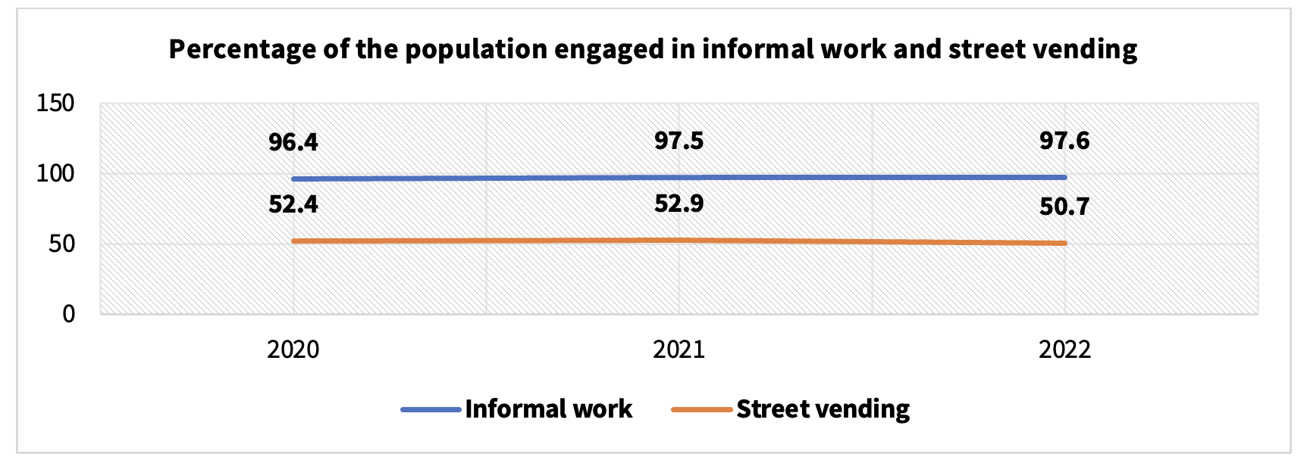
Figure 1. Informal work and street vending. Data from the DRC protection monitoring survey.
The available information shows that the share of migrants and refugees working in the informal sector and relying on street vending have been relatively stable since 2022, showing that economic inclusion policies continue to be insufficient to address formal employment and labor rights for the migrant and refugee population. Evidence does not show substantial differences between men and women in terms of street vending as their main economic activity.

Working in the public space

Working in the public space aggravates the vulnerability for migrants and refugees, as Colombian legislation contains restrictions on working in public spaces. In fact, the National Police Code (Law 1801 of 2016), establishes that occupying public space in violation of the established prohibitions and requirements constitutes a conduct contrary to the integrity of the public space and implies exposure to administrative sanctions. Migrants and refugees have greater exposure to this type of sanctions, as they have more difficulties in accessing the necessary permits to comply with current legislation. In particular, those who do not have a regular migratory status or lack migratory documentation are more exposed as they are completely excluded from the possibility of applying to a permit.

Protection gaps for migrants and refugees working in public spaces persist despite the progress that has been made in terms of protection thanks to judicial decisions from the Constitutional Court. In Judgment T-772/2003, the Constitutional Court stated that sanctions for selling in public spaces cannot be applied to people working in informal street vending, as it is directly related to their ability to survive and access essential goods. The special vulnerability of migrants was mentioned in this judgement. However, in Decision T-424/2017, the Constitutional Court included restrictions on the protection previously provided to street vendors, arguing that sanctions could be applied when people could not prove that they had acted in accordance with the principle of legitimate trust. This principle assumes that individuals act under the reasonable expectation of acting in accordance with the law and with a minimum level of diligence. This change in jurisprudence would imply a lower level of protection than what had been established.

Effects of not having access to public hygienic services

Refugees, migrants, and asylum seekers, especially those in transit without regular migratory status or without migratory documentation and without access to shelter and public bathrooms are subject to administrative sanctions. The National Police Code establishes a prohibition on defecating, urinating, or addressing any other excretory need in public spaces. In this regard, the Constitutional Court of Colombia issued a judgment with the purpose of providing special protection to homeless individuals. In said judgment, it stated that homeless individuals could not be sanctioned under this prohibition, due to their lack of access to appropriate infrastructure to meet these types of needs. This decision constitutes an important advancement and should be highlighted as an example in the region. However, the decision has limitations and gaps in the protection of migrants and refugees. Firstly, because it does not specifically cover people in transit since they are not necessarily homeless as they do not permanently reside on the streets, but during their journey they may face similar restrictions to those experienced by street dwellers. Additionally, the concept of a "street dweller" is often linked to ideas and prejudices based on appearances and behavior with few clarities regarding the legal determination of the status of a "street dweller". Consequently, some police authorities may be guided primarily by an aesthetic prejudice about the imagined appearance of a homeless person and target people in transit for not fitting this idea.

Potential effects on migratory status

Sanctions for street vending and for fulfilling physiological needs in public spaces expose individuals to deportation and may be grounds for denial of the opportunity to access the Temporary Protection Statute for Venezuelan Migrants (ETPV). These restrictions and sanctions further exacerbate the legal vulnerability of refugees and migrants, especially in Colombia, where migration policies are ambiguous.

For example, the Decree 1067 of 2015 states that one of the reasons a person can be expelled from the country is for jeopardizing social o and public health, both categories that can be broadly interpreted against individuals in situations similar to those highlighted in this document. In Colombia, having been fined twice for the same offense by the same entity is a ground for deportation, implying that migrants who are fined twice for the “misuse” of public spaces could be expelled. For example, a person who has been sanctioned on two or more occasions for street vending would then formally fall under this legal assumption and may be deported.

The Temporary Protection Statute for Venezuelan Migrants (ETPV) incorporated some exceptions of eligibility for individuals who had been administratively sanctioned under the prohibitions of the National Police Code. Article 12 of the ETPV Decree states that one of the requirements to receive the Temporary Protection Permit is "Not having criminal records, annotations, or ongoing administrative, punitive, or judicial processes in Colombia or abroad." This measure constitutes a significant restriction for individuals who have been sanctioned for activities such as street vending or performing physiological needs in public spaces. In response to Article 12, the Judgment T-100 of 2023 of the Constitutional Court, in which the Court states that the immigration authority cannot deny the Temporary Protection Permit to those who have been administratively sanctioned for irregular entry into the country, but it does not address those who have been sanctioned in other matters. This implies that sanctions related to street vending and using public spaces for physiological needs may have negative effects on the migrants’ access to migratory regularization.

Peru:

The Peruvian context presents situations similar to those observed in Colombia. Particularly in cities like Lima migrants and refugees who cannot access sufficient income and have to work in public spaces are at risk to face sanctions by administrative authorities. This is posited, for example, by some local regulations aimed at regulating the use of public spaces, which include sanctions that can entail the confiscation of people's belongings and thereby jeopardize their livelihoods.

Working in the public space

In recent years, there have been some legislative initiatives in Peru with the explicit goal of providing greater protection for people working in public spaces. The bills introduced in 2020 and 2022 shared the common objective of safeguarding against the confiscation of belongings, deeming this practice excessive, disproportionate, and a threat to livelihoods. However, these projects have not succeeded due to political challenges within the Congress and a lack of consensus surrounding this issue. Despite the public acknowledgement on the vulnerability that street vendors, as was evident during the COVID-19 pandemic, such consensus has not been achieved.

Migrants and refugees living in Peru face high considerable economic vulnerability, with a significant portion of them having to engage in informal and unstable economic activities. The DRC Protection Monitoring in Peru has gathered information covering 9093 individuals since October 2020 indicating that "occasional daily work" is the main source of employment for 34.2% of the surveyed migrants and refugees. While not exclusively limited to individuals who derive their income from work in public spaces, “occasional daily work” serves as an indicative indicator to gauge the socio-economic precarity of refugees and migrants.

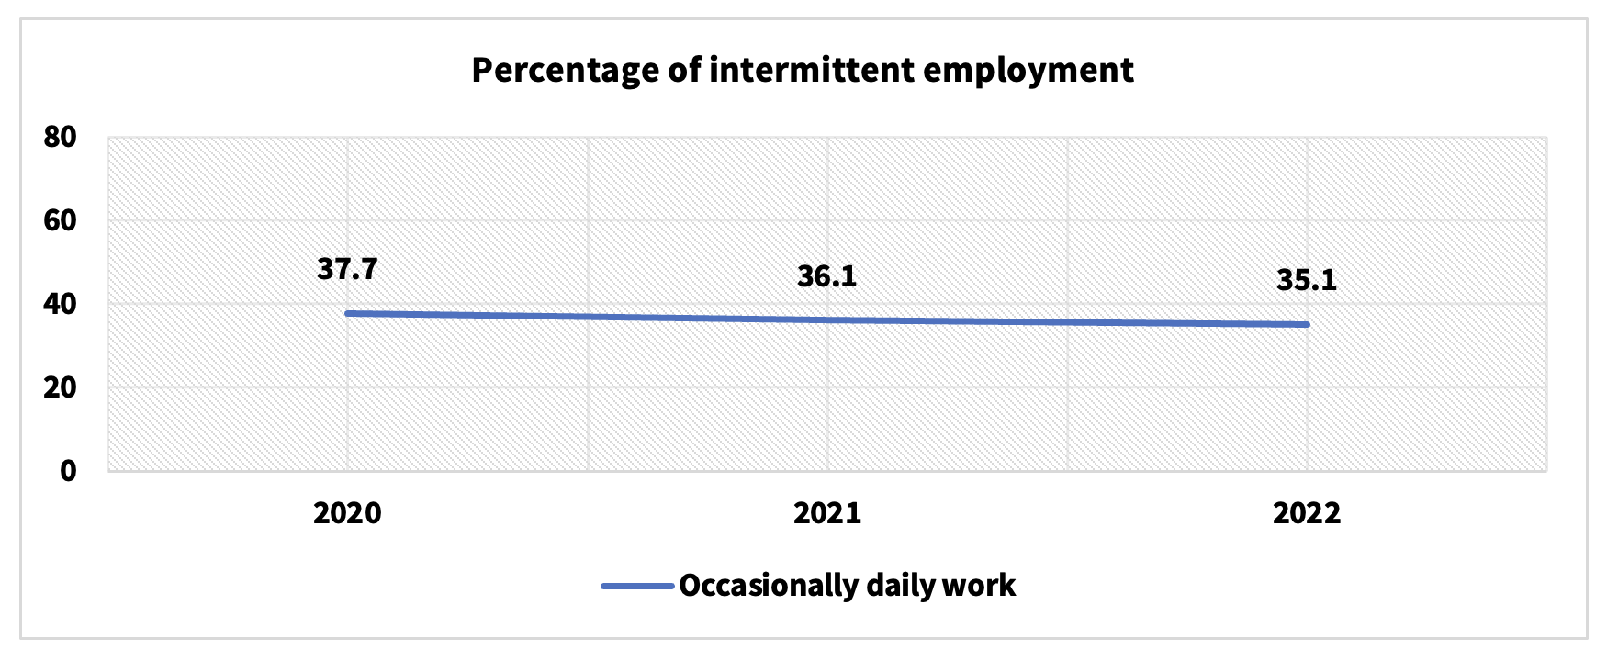
Figure 2. Intermittent employment
Additionally, the available information shows that the vast majority of refugees and migrants in Peru earn economic resources well below the monthly minimum wage. Over 70% of migrants and refugees earn less than the minimum wage ( approximately 1,025 soles or 277 USD) and 43.1% earn less than 600 soles (160 USD). Consequently, the vast majority of migrants and refugees have insufficient income to satisfy their basic needs. Some of the main reasons explaining this situation are the barriers associated with documentation. Indeed, 32.4% of those surveyed stated that the main reason for not being able to find formal work was the lack of documentation.

Potential effects on migratory status

Migrants facing homelessness and extreme poverty are at risk of encountering economic and administrative penalties that heighten their likelihood of deportation. Local regulations, such as Miraflores District's Ordinance 518/MM, establish duties that directly affect individuals in situations of profound vulnerability and poverty. For instance, the ordinance stipulates that physiological needs must be met in designated private or public facilities, expressly prohibiting their fulfillment in public spaces. Furthermore, migratory legislation identifies non-compliance with public health regulations as a justifiable cause for expulsion. Thus, Legislative Decree 1350 of 2018 states that it will be grounds for compelling someone to leave the country: "For failing to comply with or contravene imperative norms regarding public health”. Similarly, this same regulation, in its article 58, indicates that causes for expulsion from the country include "Engaging in activities that threaten public order, internal order, or national security". Both regulations employ broad language that could potentially be interpreted to expel individuals for reasons related to their use of public spaces.

Unfortunately, there have been documented instances where individuals categorized as “indigent” have faced expulsion from the country, exemplifying the grave consequences faced by those already grappling with extreme adversity. Overall, these legal provisions place migrants in precarious situations, amplifying their vulnerability and impeding their journey toward stability. The ambiguous language employed allows for subjective interpretation, raising questions about fairness and equity in enforcement.

Any questions regarding this contribution can be addressed to María Elena Hernández, DRC Regional Protection Coordinator for Latin America mariaelena.hernandez@drc.ngo

International Organization for Migration (2021), Argentina: DTM Argentina, monitoreo a Mendoza, Misiones y Jujuy; United Nations High Commissioner for Refugees,Comisión Argentina para Refugiados y Migrantes, United Nations High Commissioner for Refugees (2022). Argentina: Fronteras cerradas por pandemia. Familias en movimiento y sus tránsitos hacia Argentina 2020-2021.
R4V. (2021) Ecuador: ERI Ambato jul-ago 2021; R4V. (2021). Ecuador: Reporte operacional GTRM Tulcán - ABR-JUN 2021.
Danish Refugee Council (2022). México: Snapshot Monitoreo de Protección DRC, junio-julio, 2022.
International Rescue Committee (2022). Perú: Need Assessment Report Venezuelans in Peru, Oct-2021.
Mixed Migration Centre (2021) LAC_Quarterly Mixed Migration Update (QMMU)-Q3-2021.
Servicio Jesuita a Migrantes (2021). Argentina: Informe Situacional SJM Argentina -Otoño 2021.
United Nations High Commissioner for Refugees (2022). Perú: Impactos psicosociales en la población refugiada y migrante en el contexto de la COVID-19, jun 2022.
United Nations High Commissioner for Refugees (2022). Ecuador: ACNUR - PMT - Quito 2022; (United Nations High Commissioner for Refugees, Ecuador: Monitoreo de Protección - Informe Frontera Norte - Enero 2022.
Mixed Migration Centre (2022). Colombia: 4MI Informe Medellín, 2022.
International Organization for Migration (2021). Uruguay: DTM Impacto COVID Frontera Rivera y Rocha.
International Organization for Migration, ReliefWeb (2022). México y TN: Informe de monitoreo programas de retorno voluntario asistido octubre 2021, en México y países del norte de América Central No. 11.
Abiuso, L. y Kleidermacher, G. (2022). Sistematización de detenciones policiales a población senegalesa en la ciudad de Buenos Aires, desde una perspectiva espacial. URVIO. Revista Latinoamericana de Estudios de Seguridad, (33).
Protection monitoring is one of DRC's core activities and aims to identify protection gaps, protection incidents and human rights violations, as well as the capacities and coping strategies of the population of concern in order to reinforce the responsibility of the State and other actors to protect the affected population (advocacy) and inform the programming of DRC and other humanitarian response organizations.
ARTÍCULO 140. COMPORTAMIENTOS CONTRARIOS AL CUIDADO E INTEGRIDAD DEL ESPACIO PÚBLICO. <Artículo corregido por el artículo 11 del Decreto 555 de 2017. El nuevo texto es el siguiente:> Los siguientes comportamientos son contrarios al cuidado e integridad del espacio público y por lo tanto no deben efectuarse: 4. Ocupar el espacio público en violación de las normas vigentes. https://www.policia.gov.co/sites/default/files/ley-1801-codigo-nacional-policia-convivencia.pdf
“11. Realizar necesidades fisiológicas en el espacio público.”
Infobae. (2023). “Ambulantes vuelven a tomar Mesa Redonda: caos, disturbios y cobros de cupos en zona comercial del Centro de Lima”.
Proyecto de Ley 6194/2020 - CR
Proyecto de Ley No. 04502/2022-CR
Mendoza, J.; Viera, P. and Yaipén, R. (2022). Vendedores ambulantes vs. fiscalizadores: la realidad del comercio ambulatorio en las calles del Cercado de Lima durante la pandemia. Revista Ideele, (302).
Municipalidad de Miraflores. (2019). Ordenanza 518/MM.
Presidencia de la República de Perú. (2017). Decreto 1350.
Ibid.
Ibid.
Ibid.

