Check against delivery

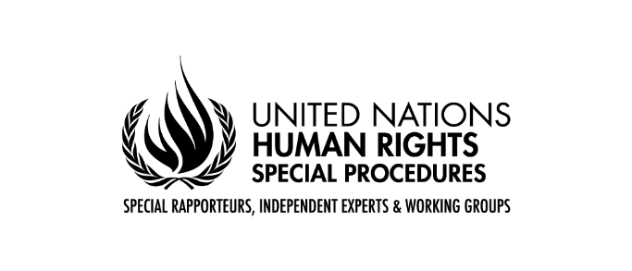

Statement of
Mr. José Francisco Calí Tzay
Special Rapporteur on the Rights of Indigenous Peoples

22nd Session of the United Nations Permanent Forum on Indigenous Issues

​

New York
18 April 2023

Chairperson of the Permanent Forum,
Chairperson of the Expert Mechanism
Distinguished Members of the Permanent Forum,
Assistant-Secretary-General for Human Rights,
Indigenous representatives, Excellencies, ladies and gentlemen,

It is an honour for me to address the Permanent Forum and all those attending the interactive discussion on the human rights situation of Indigenous Peoples today.
As the Special Rapporteur on the Rights of Indigenous Peoples, I constantly receive information on accounts of violations of Indigenous Peoples’ rights. As I am providing this update to you today, I, unfortunately, cannot conclude that threats to Indigenous Peoples’ rights have become less severe since I reported to the Forum last year. The main areas of concern of this mandate include violation of the right to self-determination and self-government through a State practice of not recognizing the existence of Indigenous Peoples; escalation of conflicts and continued militarisation of Indigenous Peoples’ ancestral lands; development of mega-projects in indigenous territories, including conservation projects and green-economy projects, without their consent, leading to displacement, dispossession and violence; and systematic discrimination against Indigenous Peoples.
Mr. Chairperson,
Before updating you any further on my activities, allow me briefly to say a few words about the theme of this year’s session.
In my last year’s thematic report to the Human Rights Council, I documented the importance of Indigenous women’s knowledge in managing the risks and impacts of climate change and I urged States to address the factors threatening the transmission and conservation of this knowledge. These factors include the loss of Indigenous territories, disappearance of indigenous languages, violence against indigenous women and girls, and lack of adequate legal protection of Indigenous knowledge.
Finally, I constantly receive information that Indigenous Peoples fear a new wave of green investments without recognition of their land tenure, management, and knowledge, increased restrictions on access to their lands, waters, and resources, and scaled-up ‘fortress conservation’, which has proved to generate forced evictions, violence, and killings. I called upon the States to embrace a genuine commitment to a human rights-based approach to conservation, including while implementing the post-2020 global biodiversity framework adopted at the fifteenth COP in December 2022.
Now, allow me to briefly provide an update on my work as Special Rapporteur since the last time I addressed the Permanent Forum.
I have been able to carry out various activities, including two official country visits to Denmark and Greenland in February 2023 and Canada in March 2023. I will continue to seek country visits to Asia and Africa and urge States in these regions to accept requests to visit officially. I also carried out six academic visits, and participated in several in-person and virtual meetings with Indigenous organizations and International and Governmental institutions.
I have collaborated with several UN specialized entities and other international organizations including, OHCHR, CEDAW, UN Forum on Business and Human Rights, IUCN.

I have also collaborated with regional human rights bodies. I presented three amicus curiae before the Inter-American system on Human Rights on the topics of land rights, FPIC and indigenous peoples in voluntary isolation and initial contact and I provided an expert brief to the European Parliament Human Rights Subcommittee.
Mr Chairperson,
Allow me to say a few words on the two topics that I have identified for my upcoming reports to the Human Rights Council and the General Assembly.
I will dedicate my annual report to the General Assembly on “Tourism and the Rights of Indigenous Peoples.” The report will review the ways in which tourism both negatively impacts and positively benefits Indigenous Peoples by examining the role of States, international organizations, and the private sector in developing tourism facilities, including resorts, amusement parks, sporting events, World Heritage Sites, game reserves, national parks and other protected areas. The report will highlight examples of Indigenous-led tourism ventures, as well as best practices undertaken by States and international organizations.
In seeking contributions for this thematic report, on May 25, 2023, I will hold an online consultation to collect inputs from Indigenous Peoples, indigenous organizations, and state representatives.
My annual report to the Human Rights Council will focus on “Green financing, a just transition to protect Indigenous Peoples’ rights”. The report will cover the role and potential impact on Indigenous Peoples’ rights of international climate finance mechanisms, the carbon credit markets, international conservation organizations and investors, international financial institutions, and UN agencies financing green energy, sustainable development projects, REDD+ programmes and biodiversity targets.
Mr. Chairperson,
I hope that we can use this session of the Permanent Forum to identify constructive ways forward to ensure Indigenous Peoples’ rights.
I look forward to hearing your reflections from the floor, as we discuss further.
I now wish to conclude my statement. I thank you all for your attention.

