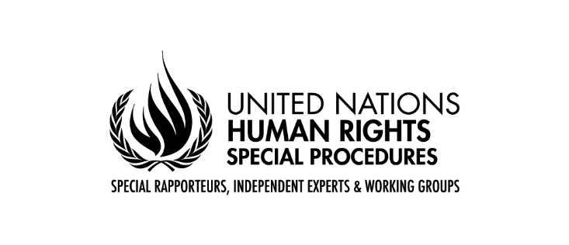

Statement of Mr. Francisco Calí Tzay
Special Rapporteur on the Rights of Indigenous Peoples
51st session of the Human Rights Council

The impact of social and economic recovery plans in the COVID-19 context on Indigenous Peoples, with special focus on food security.

Geneva

28 September 2022

Mr. President,
Distinguished delegates,
Indigenous peoples’ representatives,
Ladies and gentlemen,

It is a great pleasure to be part of this distinguished panel and to share views from the perspective of my mandate.

In my annual report presented last year to the HRC, I identified and assessed the impact of social and economic recovery plans of the COVID-19 pandemic on Indigenous Peoples, focusing, inter alia, on food security. I also shared the good practices, lessons learned, and current challenges for indigenous peoples in the development and implementation of COVID-19 recovery plans. Today there is further need to assess and promote Indigenous Peoples’ rights linked to the development and implementation of the social and economic recovery plans including as it relates to food security. In this regard I would like to highlight that the protection of Indigenous territories is central to the recovery from the health crisis as it promotes food security and sustainable livelihoods, increasing resilience in the face of future pandemics.

During and in the aftermath of the pandemic there has been a sharp rise in illegal deforestation, incursions, land grabbing and violence with little state oversight or redress. The lack of protection of indigenous lands leads to deforestation, violence, killings, resource extraction, food insecurity, pollution and forced evictions of Indigenous Peoples. Unfortunately, in many states we see that the enforcement of COVID-19 recovery plans is being used to strengthen authoritarian, militarized responses criminalizing the indigenous human rights defenders, restricting peaceful protests, while the expansion, construction and operation of commercial and extractive industries continues without a free, prior and informed consent of Indigenous Peoples and with the justification of promoting economic recovery.

This year is a critical year. Negotiations by world leaders in Montreal in December 2022 will determine the fate of the post-2020 Global Biodiversity Framework which will set the world’s environmental agenda for the next decade. This is indeed closely linked with the human rights of everyone, but especially the rights of Indigenous Peoples. Indigenous Peoples have been nurturing, protecting, preserving the biodiversity, nature and environment. Deforestation on indigenous lands is much lower than anywhere else. For indigenous peoples, land is everything. As an indigenous person myself, I want to reiterate a motto we guard dearly – ‘We belong to the land, land does not belong to us’. Land is the source of our scientific traditional knowledge. It nurtures us by providing food and medicine. Indigenous Peoples over generations, learned to live in a mutually respectful way with the land. Indigenous peoples are the protectors, restorers, and servers. However, unfortunately, they are the ones suffering most the consequences of the food insecurity and crises.

I would like to highlight the commitment made at the UN Climate Change Conference (COP26) in Glasgow last year by several countries and private donors. They pledged $1.7 billion to support indigenous peoples and local communities’ conservation and climate-advocacy efforts. Without securing land rights of indigenous peoples - relentless, violent displacement and forced eviction in the name of development and post pandemic economic and social recovery will continue. This impacts and negatively affects the food security of the indigenous peoples.

Findings from both thematic reports of my mandate this year and the inputs and information we received from all stakeholders indicate that indigenous initiatives to recover from COVID-19 pandemic need to get the support from the state. Indigenous Peoples seek to restore and increase the use of traditional seeds and crops in order to strengthen their food sovereignty and long-term health resilience. Indigenous women and their scientific and technical knowledge play a vital role and should be recognized and applauded.

I hope this panel discussion will reiterate the importance of the effective and meaningful participation of indigenous peoples and call upon states to adopt dedicated measures in this regard. The COVID-19 social and economic responses are indeed very important for all of us, but they need to be whole-of-government and whole-of-society responses, with the inclusion and participation of the groups and peoples, whose needs and rights have been neglected, and who suffer most the negative consequences of the pandemic, including the food insecurity. Information and reports my mandate received from around the world indicate that state social and economic pandemic recovery measures have so far prioritized and supported the expansion of business operations at the expense of Indigenous Peoples, their lands and the environment. While promoting the post pandemic recovery is indeed very important, it needs to be conducted in consultations with the Indigenous Peoples, by including them in the decision-making processes, and thus by leaving no one behind, as was reaffirmed by the states adopting the Sustainable Development Goals.

I thank you for your attention.

