EXPERT MECHANISM ON THE RIGHTS OF INDIGENOUS PEOPLES
Statement on expert seminar and inter-sessional meeting
UPEACE San Jose, Costa Rica, 6-10 November 2023
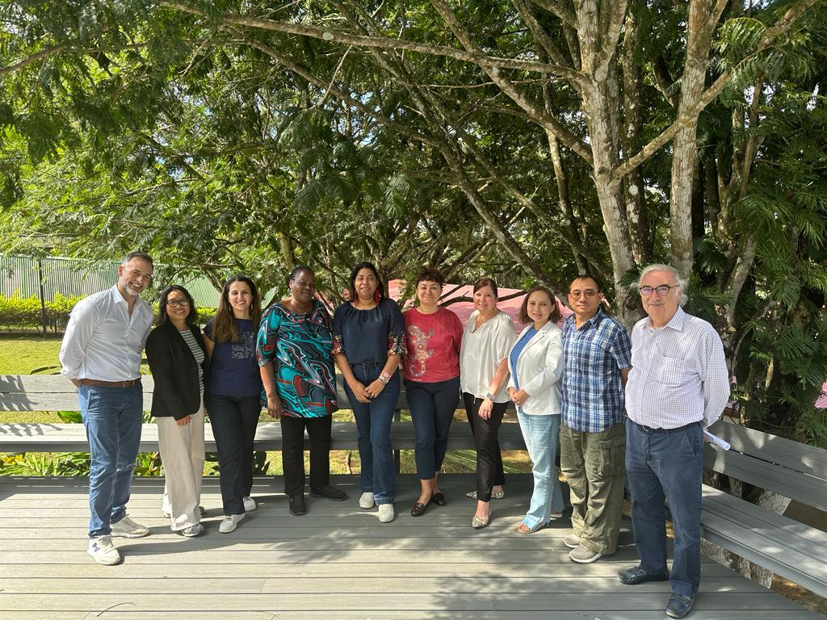

The United Nations Expert Mechanism on the Rights of Indigenous Peoples (EMRIP) held an expert-seminar hosted by the University for Peace-UPEACE in San José, Costa Rica from 6 to 8 November, and an inter-sessional meeting, from 9 to 10 November.

The purpose of the seminar was to gather information for the EMRIP’s study on “Analysis of laws, legislation, policies, constitutions, judicial decisions, and other outcomes concerning how States have taken measures to achieve the ends of the UN Declaration on the Rights of Indigenous Peoples consistent with Article 38.” (Resolution 33/25, para. 2a, of the Human Rights Council). The seminar provided an opportunity for exchange among academics, practitioners, and other experts on this issue.

A request for inputs to the above study has been announced on the EMRIP’s webpage. A draft of this study will be discussed and finalized by the EMRIP during its 17th session from 8 to 12 July 2024, before being presented to the Human Rights Council during its 57th session in September 2024.

The purpose of the inter-sessional meeting was to plan for the EMRIP’s forthcoming activities including new elements of the Human Rights Council resolution A/HRC/RES/54/18, requests received for country engagement under its 2016 amended mandate and related working methods and policies. Information on recent country engagement missions or missions to be undertaken will be provided on the EMRIP’s webpage and reported upon during the EMRIP session from 8 to 12 July 2024.

The EMRIP has also discussed its programme of work, including the agenda for its 17th annual session, the annual study for 2025 (resolution 33/25, para. 2a) and its report for 2025 (resolution 33/25, para. 2b). The Expert Mechanism will announce the themes of the study and the report during its annual session in July.

The EMRIP takes this opportunity to thank the University for Peace for its excellent collaboration in hosting the expert seminar at its premises in San Jose, Costa Rica.

***

The Expert Mechanism on the Rights of Indigenous Peoples (EMRIP) is a subsidiary body of the Human Rights Council mandated to provide the Council with expertise and advice on the rights of Indigenous Peoples as set out in the United Nations Declaration on the Rights of Indigenous Peoples, and assist Member States, upon request, in achieving the ends of the Declaration through the promotion, protection and fulfilment of the rights of Indigenous Peoples.

