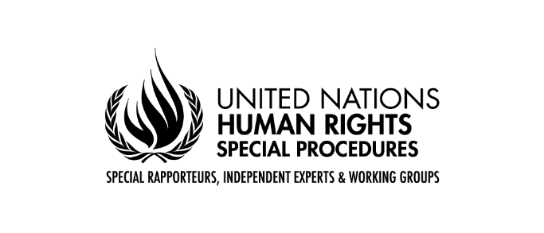

**Statement of**

**Mr. José Francisco Calí Tzay**

**Special Rapporteur on the Rights of Indigenous Peoples**

**Expert Mechanism on the Rights of Indigenous Peoples**

**Seventeenth session**

**​**

**Geneva**

**09 July 2024**

Chairperson of the Expert Mechanism

Chairperson of the Permanent Forum,

Chairperson of the UN Voluntary Fund for Indigenous Peoples,

Distinguished Members of the Expert Mechanism,

Representatives of Indigenous Peoples,

Excellencies, Ladies and Gentlemen,

It is an honour for me to address this session of the Expert Mechanism on the Rights of Indigenous Peoples and all those attending the interactive dialogue on the human rights situation of Indigenous Peoples today.  As the UN Special Rapporteur on the rights of Indigenous Peoples, I continually receive reports detailing serious human rights violations against Indigenous Peoples worldwide.

Racism and discrimination against Indigenous Peoples remains one of the most pressing human rights issues globally, that undermine the dignity, autonomy, and the rights of Indigenous Peoples. This discrimination manifests in various forms, from social and economic marginalization to violence and cultural erasure.

Indigenous Peoples continue to face displacement from their ancestral lands due to government policies, commercial interests, and illegal land grabbing. Mining and logging frequently occur on Indigenous lands without their free, prior and informed consent, or fair and adequate compensation for damages caused. Extractive activities often lead to pollution of water sources and land, affecting health of Indigenous Peoples, in many cases leading to lasting health issues and impairments, which in interaction with attitudinal and environmental barriers hinders the full and effective participation in society on an equal basis with others and results in disability.

There are disproportionately high rates of persons with disabilities among Indigenous Peoples. Indigenous persons with disabilities often experience multiple forms of individual and structural discrimination that creates barriers to the full enjoyment of their rights, based on their Indigenous identity and disability.[1] I identified this theme as a focus for my report after hearing directly from Indigenous persons with disabilities about the challenges they face in exercising their rights, and will be presenting it to the Human Rights Council in September this year.

I have dedicated my thematic report to the UN General Assembly to the rights of Mobile Indigenous Peoples. The lands and territories of Mobile Indigenous Peoples are often vulnerable to appropriation because they are used seasonally or periodically, while sometimes shared with others. Due to a prevailing tendency to recognize territorial claims based on permanent and settled land use, Mobile Indigenous Peoples face eviction, forced urbanization, and induced sedentarisation. This results in the loss of culture and livelihoods and the fragmentation of families, social relations, and governance.[2] Land insecurity remains at the heart of all inequalities for Mobile Indigenous Peoples, including lack of participation in decision-making processes.

Madam/Mr Chairperson,

Despite international instruments like the UN Declaration on the Rights of Indigenous Peoples (UNDRIP), many countries fail to recognize the existence of Indigenous Peoples and fail to implement and promote their rights effectively.

Indigenous Peoples’ rights to self-determination, cultural rights and land ownership should be recognized and protected. States should ensure that Indigenous Peoples have access to their ancestral lands and natural resources which are crucial for their cultural survival, economic development and identity. In addition, many Indigenous languages are endangered, and with them, traditional knowledge and cultural practices are also endangered. In this regard, I would like to recall the Global Action Plan of the International Decade of Indigenous languages, which provides a unique opportunity for multi-stakeholder collaboration and calls for a coherent and well-coordinated approach to maximize positive impact and social change.

When States fail to recognize the collective identity, territorial rights, and governance structures of Indigenous Peoples, their lands are vulnerable to expropriation and exploitation, violating the rights to self-determination, self-government, and autonomy, among others.

I regret to state that unfortunately Indigenous Peoples and individuals often face legal challenges and denial of access to justice when asserting their rights, including criminalization and harassment. Indigenous activists and leaders who stand up for their rights and protect their lands often face threats and violence. In many parts of the world, they are criminalized, persecuted, and even murdered for their activism.

As the High Commissioner stated yesterday at the opening session,’ the data compiled by his Office shows that at least 42 Indigenous human rights defenders were killed in 2023 in 11 countries, and this is certainly unreported’. The reprisals for engaging with the United Nations and its human rights mechanisms also persist. I call upon all states and other actors to refrain from any act of intimidation or reprisals against any Indigenous Peoples or individuals who engage with my mandate, or any other Indigenous or human rights mechanisms.

Together with the other Indigenous mechanisms we have continuously stated the need to address the problematic use of the term “local communities” in conjunction with Indigenous Peoples. With the aim of strengthen the implementation of the UN Declaration on the Rights of Indigenous Peoples and address. I once again call upon States, UN, its agencies, funds and programs, as well as all other relevant stakeholders, to refrain from such interchangeable use of Indigenous Peoples with local communities. States must fully implement international human rights standards, including the UNDRIP, and ensure that Indigenous Peoples have a genuine voice in decision-making processes that affect their lives. Legal systems should protect Indigenous rights robustly, and perpetrators of violence and discrimination must be held accountable.

Thank you for your attention, and I look forward to continued dialogue and cooperation.

1. UN DESA, “The United Nations and Indigenous Persons with Disabilities,” <https://www.un.org/development/desa/disabilities/issues/the-united-nations-and-indigenous-persons-with-disabilities.html>.
2. Expert Seminar Outcome Document; Sea Nomads Contact Group submission.