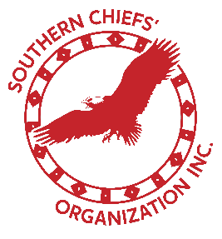

United Nations Expert Mechanism on the Rights of Indigenous Peoples

17th Session, Geneva, Switzerland

08 - 12 Jul 2024

_____________________________________________________________________

**Item 10**: *Future work of the Expert Mechanism, and follow up to thematic studies and advice*

INTERVENTION by the Southern Chiefs’ Organization, Grand Chief Jerry Daniels

_____________________________________________________________________________

Hello Chair, distinguished representatives, and Indigenous relatives.

My name is Jerry Daniels and I have the honour of being the Grand Chief for the Southern Chiefs’ Organization, representing 34 First Nations in southern Manitoba, Canada.

Our organization would like to recommend that the Expert Mechanism expand its 2016 study on the right to health by examining, in particular, the ways that Indigenous Peoples are working to improve outcomes through their own, self-determined health care systems and practices.

In southern Manitoba, Canada, we continue to witness our people dying sooner than our non-Indigenous counterparts. Our people face the harsh reality that they can expect to live 11 years shorter than all other Manitobans due to the significant barriers and unique challenges that our people face concerning health.

In 2019, the 34 Chiefs that comprise the Southern Chiefs’ Organization passed a resolution to support a community-driven process to transform the healthcare system in Manitoba by establishing a First Nations healthcare system. Importantly, this process includes an Elders and Knowledge Keepers Committee, a Gender-Based Violence Advisory Circle and a Health Transformation Advisory Circle to ensure that our community experts inform our self-determined path towards health for all.

Based on this direction, we have been working in collaboration with the federal and provincial governments to develop a First Nations-designed and led health system for our Nations. This system will bring together western medicine and the traditional practices of the southern Anishinaabe and Dakota First Nations to provide our people with a more comprehensive healthcare system that is accessible and culturally responsive, consistent with article 24 of the UN Declaration on the Rights of Indigenous Peoples.

Recognizing and affirming Indigenous peoples' right to control our health and to create and design our own healthcare systems is a critical step in achieving the goals of the Declaration.

We are interested to learn more about similar initiatives undertaken by Indigenous Peoples in other regions of the world, a dialogue we started at a Side Event held this past Monday. The Southern Chiefs Organization would also be honoured to work with the Expert Mechanism to explore the possibility of hosting an expert symposium on our territory.

Pedamaya and, thank you for the opportunity to speak.

Grand Chief Jerry Daniels, Southern Chiefs’ Organization