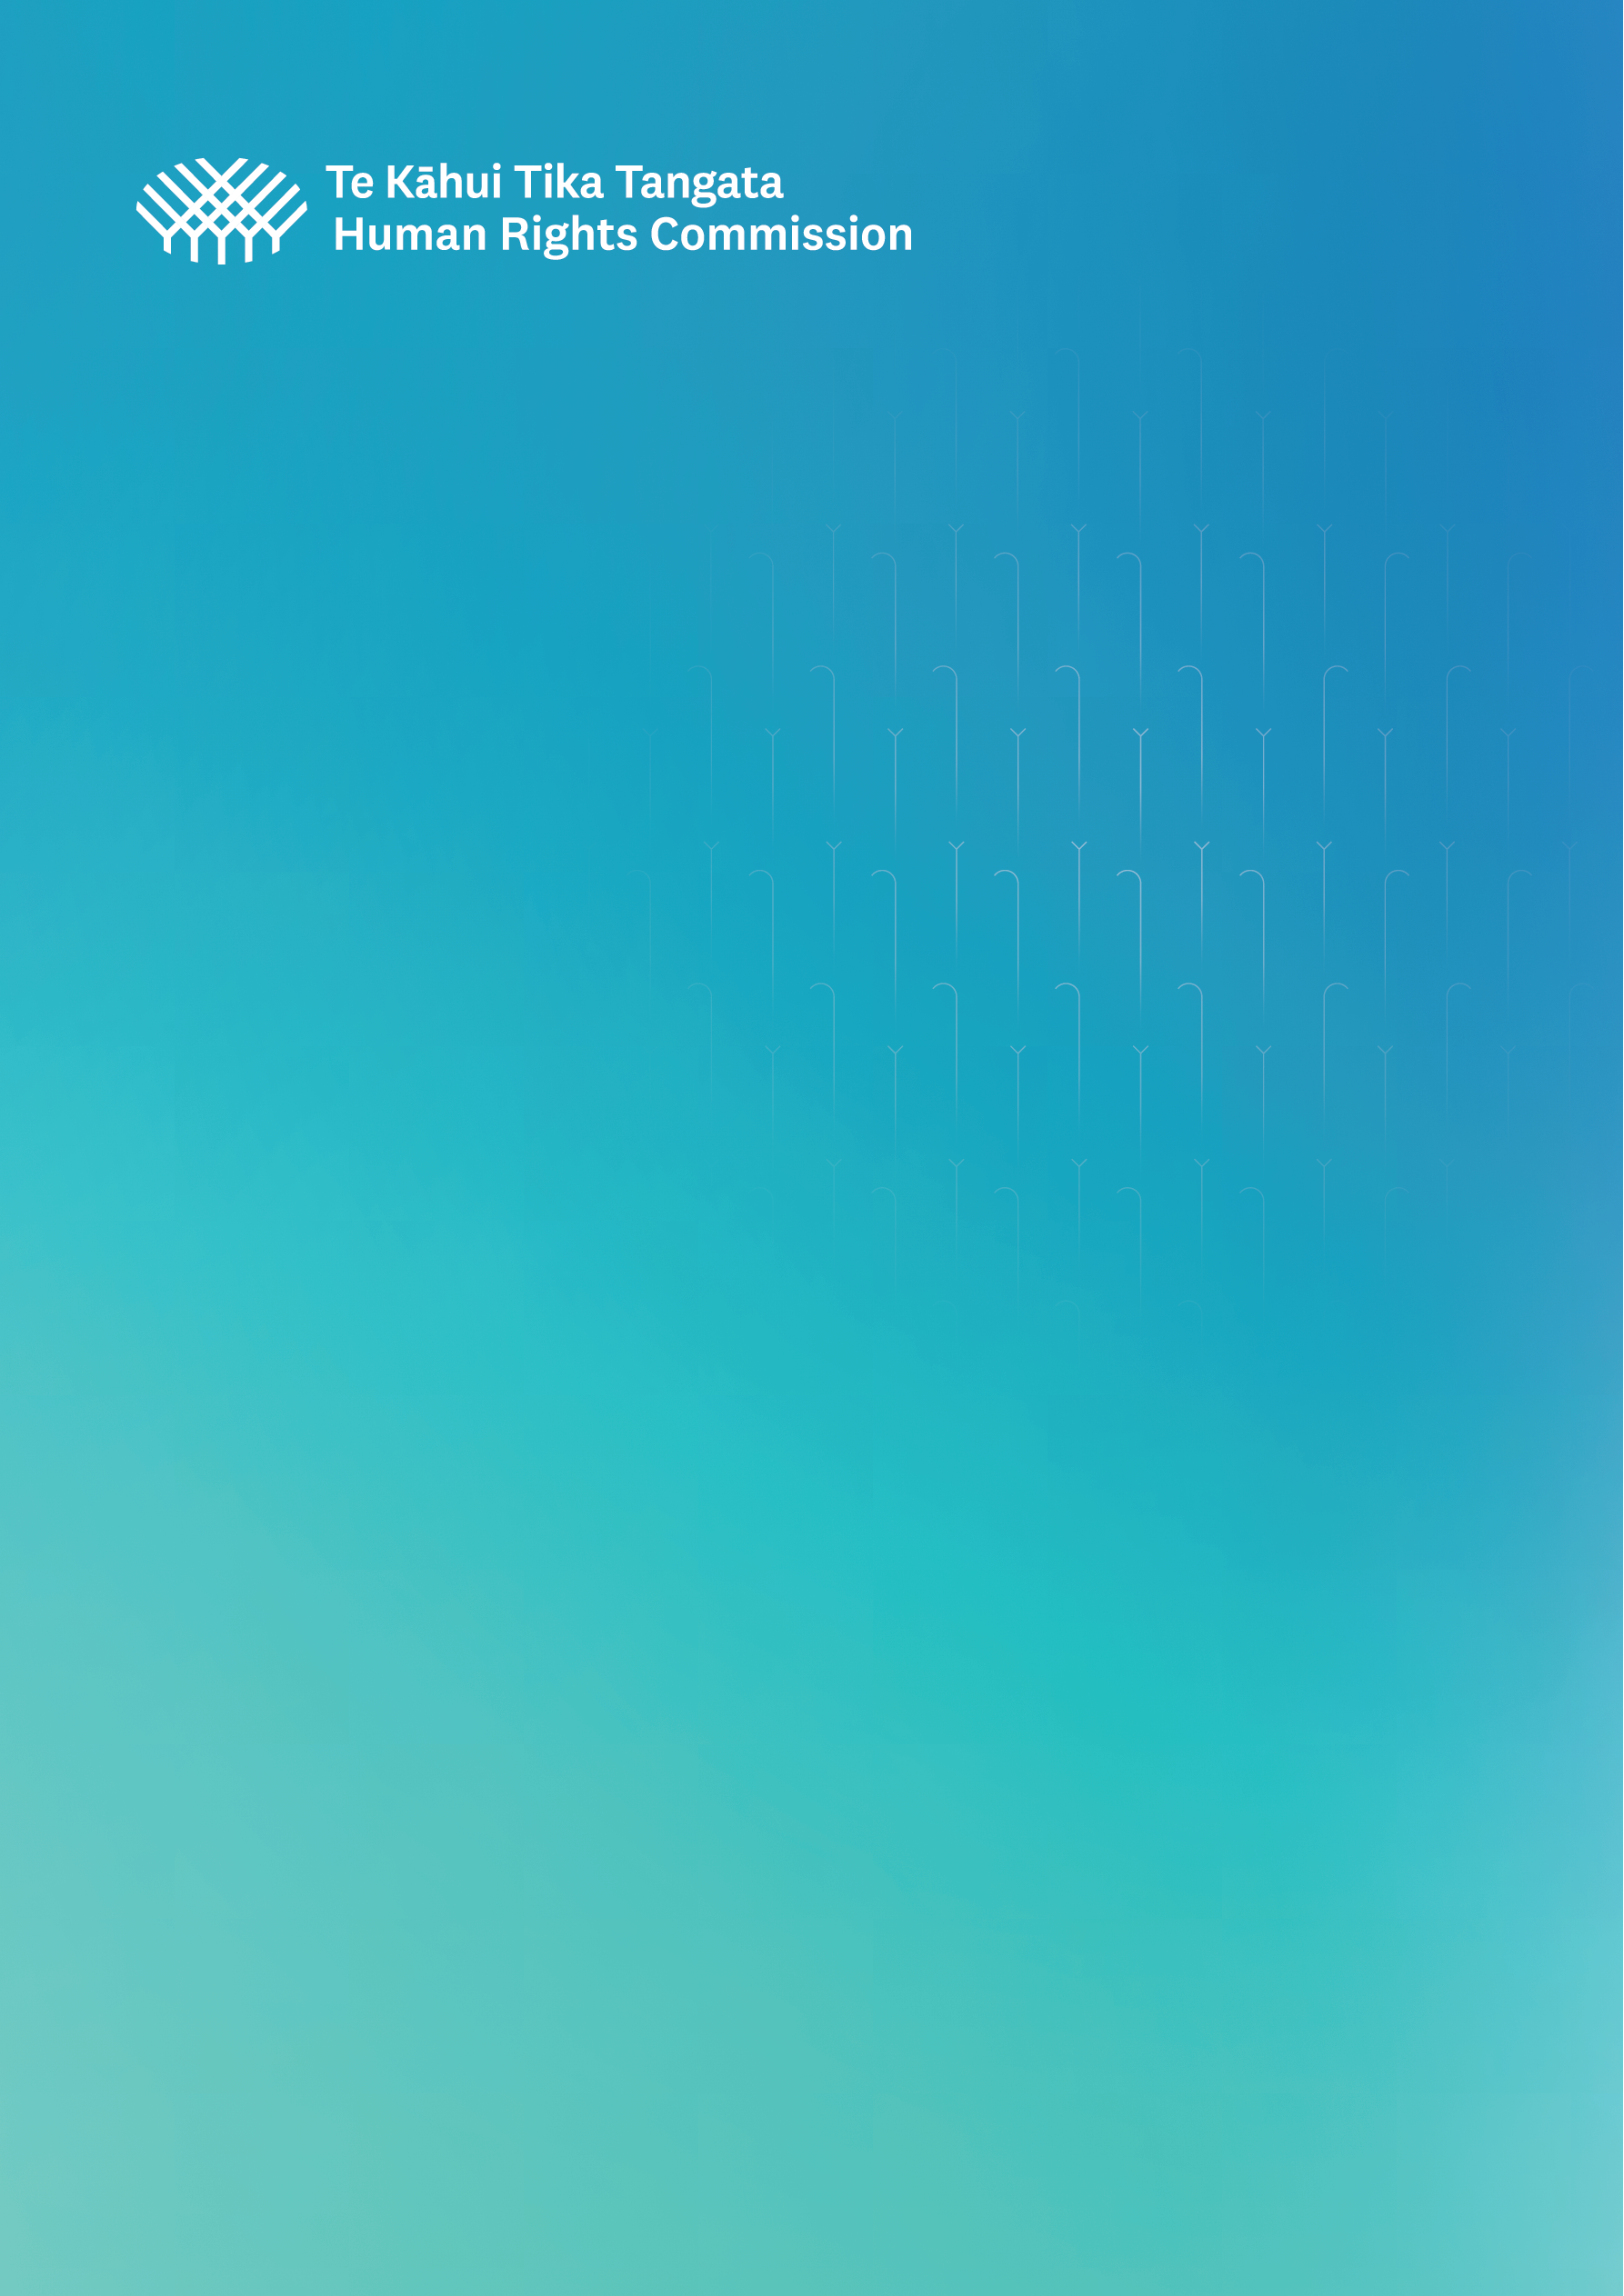

# **Supplementary Submission**

# **To the UN Expert Mechanism on the Rights of Indigenous Peoples (EMRIP)**

# **Study on “Laws, legislation, policies, constitutions, judicial decisions and other mechanisms in which States had taken measures to achieve the ends of the United Nations Declaration on the Rights of Indigenous Peoples, in accordance with article 38 of the Declaration”**

## **January 2024**

1. **Introduction**

In November 2023, Te Kāhui Tika Tangata o Aotearoa | New Zealand Human Rights Commission (the Commission) provided a submission to the EMRIP for its expert seminar, as a contribution to the development of its thematic study on:

Laws, legislation, policies, constitutions, judicial decisions and other mechanisms in which States had taken measures to achieve the ends of the United Nations Declaration on the Rights of Indigenous Peoples, in accordance with article 38 of the Declaration.

The November submission outlined the political, legal, and constitutional status of the Declaration in New Zealand. It noted:

* That there are considerable synergies between the Declaration and Te Tiriti o Waitangi (the treaty signed in 1840 between Māori and the Crown), and that the Declaration has been recognised by both the courts and Waitangi Tribunal;
* The stalled progress in developing a national action plan to implement the Declaration in New Zealand; and
* The lack of any explicit legal acknowledgement or protection for the Declaration, and indeed the very the limited and fragile protections for Te Tiriti.

In light of these fragile protections, the submission concluded by noting that measures to advance Māori rights under the Declaration and Te Tiriti are vulnerable to politicisation and regression.

1. **Updates**

The vulnerability of Indigenous peoples’ rights in New Zealand has been further highlighted in recent months, with the new Government committing to remove, review or repeal numerous laws and policies that impact upon Māori rights. These include:

* Stopping all work on the national action plan to implement the Declaration;
* Disestablishing the Māori Health Authority – the body tasked with advancing health equity for Māori, and whose creation was prompted by Waitangi Tribunal’s 2019 report on health services and outcomes;
* Renaming Government agencies so that their primary names are in English, rather than Māori
* Ending ‘race-based’ special measures, such as the Māori and Pacific Admission Scheme (MAPAS), which seeks to address the vast underrepresentation of Māori and Pacific Peoples amongst healthcare professionals;
* Amending legislation in a way that may make it more difficult for Māori to have their customary rights in New Zealand’s coastline recognised;
* Repealing recent resource management and water reforms, that introduced aspects of shared decision-making between Māori and the Crown;
* Repealing recent local government reforms that have enabled Māori wards to be introduced;
* Reviewing legislation that contains references to the Principles of the Treaty of Waitangi;
* Reviewing the role of the Waitangi Tribunal; and
* Introducing a Treaty Principles Bill, that would rewrite and reinterpret treaty principles to omit reference to Māori rights to self-determination and recognition of Māori as Indigenous peoples.

Many of these actions were announced as part of the Government’s plan for its first 100 days.[1]

The announcements have prompted a number of urgent claims to be filed in the Waitangi Tribunal, and legal action to be filed in the High Court. The announcements have also prompted widespread demonstrations by Māori communities, and the calling of a national hui by the Māori King, attended by over 10,000 people.

While the response from Māori to date has been to assert their rights and affirm the central importance of Te Tiriti, these developments highlight the ease and swiftness with which measures to uphold the rights of Indigenous peoples can be reversed.

In light of the fragile legal and constitutional protections of human rights and Te Tiriti, the Commission continues to call on Government to: [2]

* **Progress discussions and action, in partnership with Māori, to determine and implement the appropriate constitutional processes and institutions to recognise, respect, and give effect to the Treaty.**
* **Intensify efforts to implement the Declaration on the Rights of Indigenous Peoples, grounded in the Treaty of Waitangi, including through a National Plan of Action.**
* **Consider re-introducing policies and laws that provide for Māori self-determination and address systemic inequities for Māori.**

To support ongoing constitutional conversations, the Commission is partnering with the National Iwi Chairs Forum and the University of Auckland to hold a Constitutional Convention in memory of the late Dr Moana Jackson, lead author of the 2016 Matike Mai report on constitutional transformation. The conference will be held 2-4 April 2024 in Auckland.

1. Many of these initiatives were announced as part of the Government’s plan for its [first 100 days](https://www.beehive.govt.nz/sites/default/files/2023-12/100%20Day%20Plan%20%281%29.pdf) in Government. Others are found in the coalition agreements between the [National and Act](https://assets.nationbuilder.com/nationalparty/pages/18466/attachments/original/1700778592/National_ACT_Agreement.pdf?1700778592) parties, and [National and NZ First](https://assets.nationbuilder.com/nationalparty/pages/18466/attachments/original/1700778597/NZFirst_Agreement_2.pdf?1700778597). The latter includes the commitment to: “Confirm that the Coalition Government does not recognise the United Nations Declaration on the Rights of Indigenous Peoples (UNDRIP) as having any binding legal effect on New Zealand”.
2. For example, as recommended in the Commission’s recent submission to the Universal Periodic Review of New Zealand.