THE PORGERA MINE IMPACT ON IPILI WOMEN & YOUNG GIRLS
Porgera Red Wara (River) Women’s Association advocating for the rights of Porgera indigenous women/girls. Girls.
9/1/2017
By Cressida Kuala
Secretary, porgera red wara WOMEN’S association inc.

- OVERVIEW
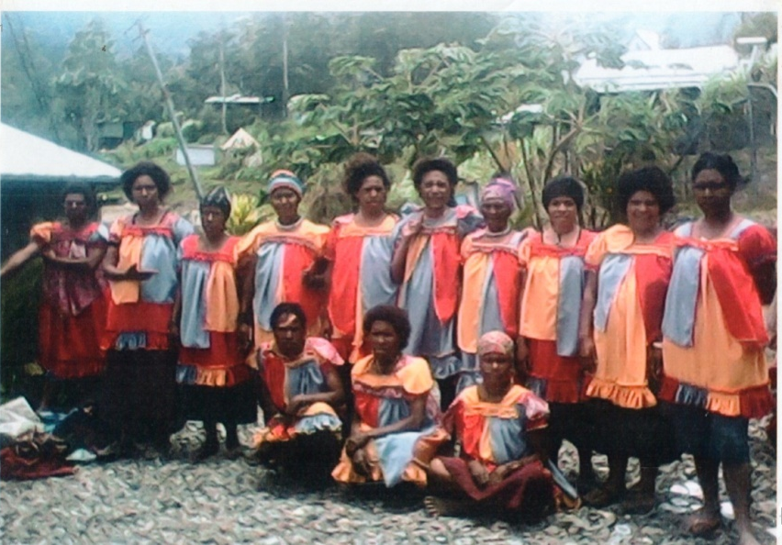
Porgera Red Wara (River) Women’s Taken on the 30th September 2017
Voice of Indigenous Ipili (Porgera) Women & Girls
The Voice of Indigenous Ipili (Porgera) Women is not an incorporated entity but it is just a group named to represent the female population of Porgera District in Enga Province, Papua New Guinea. It has been written as a mission statement compiled and titled as “The Voice of Porgera Women in Mining Today”, based up on a research done on the August-September 2015 by Porgera Red Wara (River) Women’s Association Secretary and Director, who is also the Human Rights Of Women’s Right Activist, Ms Cressida Kuala. This compiled mission statement had attracted the attention of the former US President, Mr Barack Obama, who sent the US Ambassador to PNG, Vanuatu and Solomon Islands, Mr Walter North, in response to the article and visited Porgera on the 30th October 2015.
The primary concern of the group is to advocate for equal participation in Social, economic and political affairs of district packets; including those affected by the impact of the operations of Porgera Gold Mine. Main Goal is to work through “Creating Justice and to Promote Good Governance System “in Porgera, Enga and in Papua New Guinea. The rapid changes from a traditional subsistence farmers, hunters and gatherers to a cash economy over a short span of time have left many confused and unable to keep up with the changes. This problem has been compounded by low level of literacy, especially amongst the Indigenous Ipili women and young girl population.
The influx of people into Porgera during and after the start of the Porgera Gold Mine in 1989 has displaced and marginalized the indigenous women and girls. As of today many young women and men are scared to travel out to Porgera Station, Paiam Town or even outside of Porgera District access basic government services such as education, health, law and justice. As we reached the 28th year of mining operations, a lot of cases of abuse of rights of the indigenous landowners have been recorded ranging from human rights abuses, sexual Harassment/pack rapes, environmental damages and unwarranted brutal killings by security forces guarding the mine site, mine site security guards and company employees.
Apart from Porgera Red Wara (River) Women’s Association (PRWWA) that advocates Human Rights of Women’s Right, there are other local community based organizations in Porgera that have been established to advocate for and address various issues. However, the fundamental missing link is cooperation and harmonious working relationships amongst the different groups; they operate in isolation and compete for recognition by Barrick Niugini Limited (BNL), the operator and manager of Porgera Gold Mine under Porgera Joint Venture (PJV). Hence, the PRWWA INC had tried to focus on the issues affecting the Indigenous women and young girls on how they can be empowered to gradually embrace modern changes whilst still maintaining their traditions and cultures.
The purpose of this compiled mission statement is to highlight and advocate on the current and legacy issues that is affecting the indigenous women and girls of Porgera. The facts and allegations presented in this paper is to provide information, generate discussions and compel BNL to observe and abide by the regulations of national and international human rights and environmental laws. It covers the following key areas:
- Sexual Harassment/Violence & Rape;
- Physical assault and brutal deaths;
- Chemical Discharged into the river & polluted gas released to the Air ;
- Land and Environment issues; and
- Social Dislocation/ Disorder.

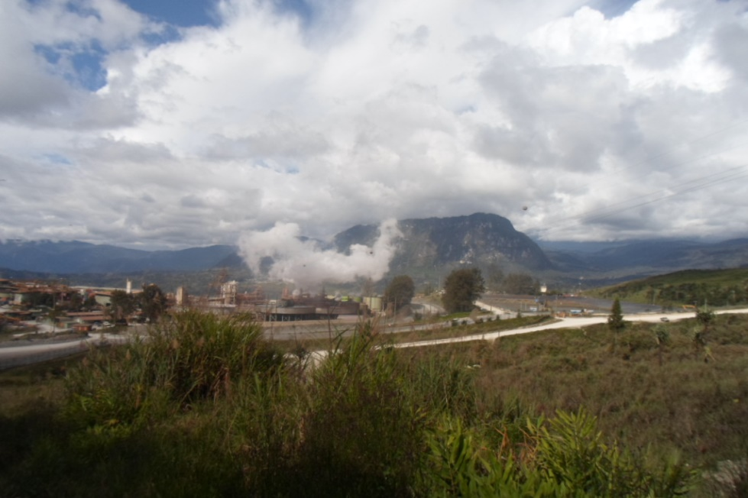

There are other issues such as environmental damages, unwarranted killings and resettlement of the indigenous people living within the special mining lease (SML) and lease for mining purposes (LMP) areas but these issues have been taken up by other local NGOs.
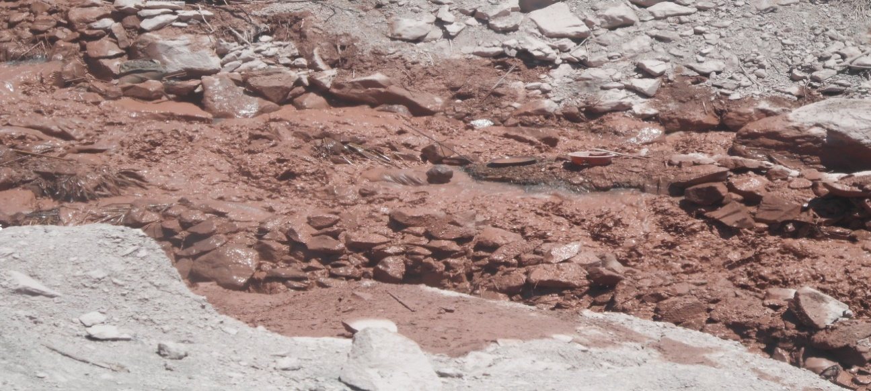
We concentrate on the negative impact of discharges of bi-chemical products or concentrate from the mill by PJV into the dumps which eventually feed into the Porgera River and the Mine Impact on the land, Environment and on Indigenous Women& girls live.
A local women diving in the cyanide & lime concentrate for alluvial gold

The Outlets at Anawe Dump
- PORGERA MINE AND ITS IMPACT ON THE LIVES OF WOMEN
Before Porgera mine’s construction, there were small scale mining at Alipis and alluvial gold mining along Porgera River from Mt Warowari to Kaiya/ Pongema rivers junction. Mining operations that took up little subsistence life supporting land. The male population of Porgera went to work at this small scale mines or pan for gold along the river banks while women were family gardeners that produced food for the family members and livestock.
The mothers and girls woke up early to cook breakfast, feed children, released the pigs into their forage waste lands and went to the garden to work the family land, Later in the afternoons, women and girls came home with food from their gardens to feed the male members, the children and their livestock. These activities were routine tasks that occupied the lives of Porgera women from as early as 10 to old ages of 70 years. The women of Porgera had inseparable relationship with the land and environment, particularly land for gardening, bush for hunting, trees for firewood and fresh bush/ underground water for drinking before Porgera mine was constructed in 1988.
The explosive changes that occurred to lives of women during and after mine construction shuttered an ancient bondage between the Porgera women and her land and environment. The indigenous women saw huge trucks and earth moving cut down mountains and pushed millions of tons of surface over burdens down Porgera Rivers. Millions of tons of waste buried gardens, housing sites, livestock foraging sites, forest product sources, economic trees, sacred sites, cemeteries, and forced the clan members, particularly women to drift around Porgera, land poor. The women helplessly lived through that era of their gardens along the plains or benches along the river ways being submerged under sediments build-ups. The man was too quick to claim compensation from Porgera mine and when paid, they went out to spend them all on beer, women and gambling.
After the natural clan boundaries had been buried in the sediments layers at the special mining lease (SML) areas, the Porgera Gold Mine expanded outwards into non SML areas. That came to be known as land leased for mining purposes (LMP) that displaced a large population of clans’ women and girls who had been land poor for decades, foraging for gold or waste from the mine that could be sold to local scrap metal dealers.
Competitive interests to claim more money each year motivated men and boys to dispute boundaries, i.e., the strong encroached well into the weak territories and the weak went complaining to police that charged and still continue to charge service fees for all complaints brought before its general duties counters.
The women of Porgera virtually were deprived of their rights to maintain subsistence livelihoods and pressed into a life of feeling inadequate and valueless, Being forcefully rendered idle in their former subsistence life, the Porgera women and girls now are finding occupation niches as foraging the stock pile dump sites for rocks containing precious mineral gold, sitting for hours in the local markets selling food, remain at home to raise livestock, or venture into various business operations.
After almost 28 years of gold mining operations, the general atmosphere in terms of cash flow had been extremely discouraging for the Porgera women. The mine operators fly in/ fly out arrangements of mine employees does not help much in variations to the cash flow situations of Porgera. That truth therefore, is Barrick who operates Porgera Gold Mine is robbing the Porgera women their opportunities to participate in spin-off businesses. That leads us to commonly asked questions as the following:
- Is sacrificing gardening land and houses for just a few years meal a fair compensation Barrick paid to Porgera women?
- Where do we get water and firewood for household use?
- Will we ever go back to subsistence life again after Porgera Mine?
- If we do return to subsistence life, how will our children who do not have hands on training now fare?
- Why doesn’t Barrick consider buying land outside for Porgera women and girls to engage in livestock husbandry and market crops growing?
- Does anyone in Porgera, PNG or expatriates realize that Barrick’s presence dwarfs the presence of state authority in Porgera?
- How could we create a female population friendly Porgera public attitude?
- Why the subsistence livelihood must deprived Porgera women and girls become street vendor all their life?

- CHEMICAL EFFECT ON PORGERA WOMEN AND YOUNG GIRLS
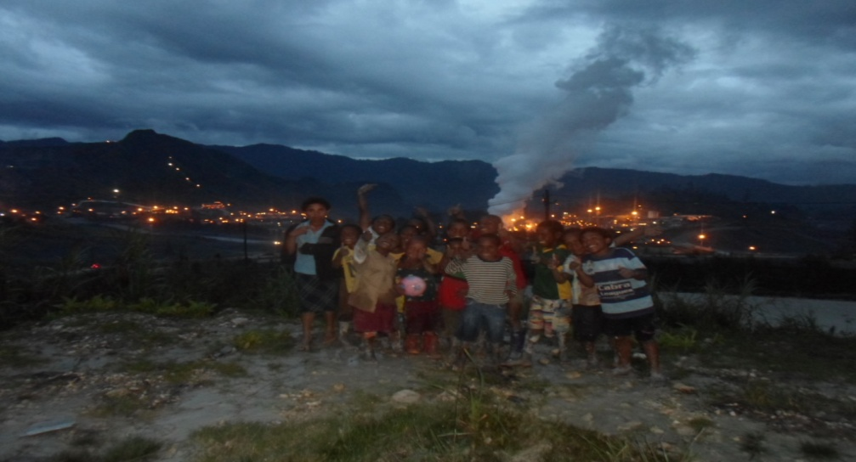
Children @ Anawe Village on the August 21st 2017,
In the past 20 years women and young mothers have been giving birth to deformed babies and have not known what the causes were, it was generally believed to be a curse from their long lost ancestors, until both local and international human rights advocators pointed out that chemical waste discharged from the mine through the Porgera Riverine system and chemical contained gases let out through the autoclaves are likely to cause women to produce deformed babies and the polluted air could possibly cause acidic rain in the near future.
- A young woman, who is married to a young man from Panadaka Village in Porgera, had given birth to a double headed baby boy in 2016; that almost costed her life but instead the baby passed away and the mother was saved.

- Early this year (2017), a mother of 3 children gave birth to a baby girl with her mouth split apart and her gums were stucked creating a small passage way for her to breathe and feed on milk and liquid only. She had 6 toes on her right leg and the infant’s belly button was open with the intestine spilled out. The baby died within 30 minutes after given birth.

- There were 16 women, 15 man and 11 children, totalled of 41 altogether were burnt by lime contained in waste rocks dumped at the Panadaka Dump by mine contractors’ truck in early July, 2017. This caused a few severe burns on 6 women and 3 men who were full time treated by Barrick medical staff. The rest were minor burns treated by Barricks’ medical staffs as reported by the Barrick Mine Executive General Manager, Mr Richmond Fenn.

Few young adults have gone crippled at an early age and exist as burden or liability to their poor parents lives. The chemically polluted waste discharged from the Anawe plant through the air and water exposed closer to villages near the mine may have driven physiological terrors into the local land population, the ever consuming need for food on the table each evening is an indispensable fear.
There had been many complains of chemical poisoning at Anawe waste dumps and along the length of the Porgera riverine system, These complaints came in the form of reports and records of treatment and aid posts in remote Fly/ Strickland river plains. However, there had been little medically examined and proven cases of chemical poisoning. Many of such complaints from women living at the edge or within
The SML and LMP areas have visited doctors at various hospitals in Enga and Western Highlands Provinces of PNG. The human rights and women’s right advocates possess no concrete evidence of incidence of chemical poisoning and we hope to research further before commenting.

- ILLEGAL MINING AND PORGERA WOMEN
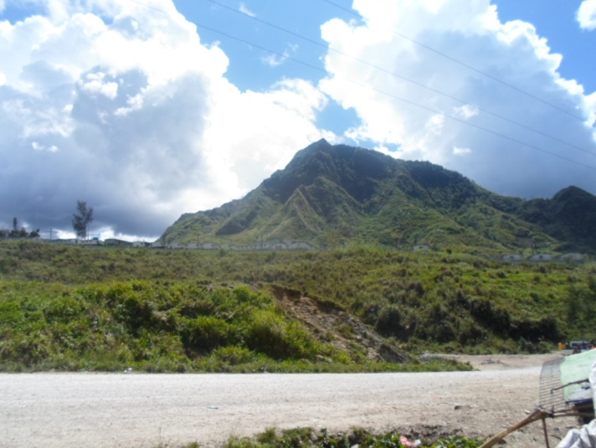
The Burned Wingima Village at Alpis Porgera, Picture taken on the 14th August 2017
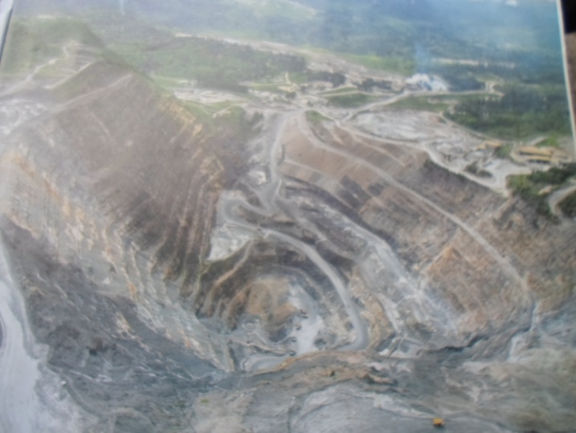
Porgera Open – Pit Mining
The rape, gang rape, physical abuse, torture cases and killings by PJV Barrick employees of indigenous men, women and young women from the most affected areas of the Porgera Gold Mine, who are registered with four (4) human rights NGO advocates in Porgera so far are mostly synonymous with the word “illegal miners”. The mine security guards, mine hired police, the mobile squad police also known as call out operational units and few other mine department employees of the period between 1998 and 2016 had felt insulated by company policy and the high security fences surrounding the mine camp sites to break laws within special mining lease (SML) areas and leased for mining purpose (LMP) areas, and were not tried or jailed as do the ordinary people of clans and communities.
Although a few expatriates had been caught raping local women and sexually abusing some, national hired/ hire employees of the mine had developed both sexual and physical abuse of indigenous Porgera women and young girls as their special occupation on site.
On the other hand, the male illegal miners caught searching for gold within the SML and LMP dump sites had been shot dead until investigations into some killings in 2006 had caught the attention of the international NGOs such as Canada Mining Watch, the Human Rights Institute of Columbia University Law School and the Human Rights Law Clinic of New York University. This had raised the alarm at the international level. The female illegal miners were raped, pack raped and physically assaulted and released or taken to the local jail when they refused to have sex with them. Once taken to the local cell they are either further sexually abused there or refused them bail, no court appearance and send them direct to serve 7 months with hard labour at established prisons. Sometimes the women and young girls were chased into the murky polluted tailings discharge outflow for drowning.
The Canada Mining Watch team, the Columbia University Human Rights Law Clinic and New York University Human Rights Law professors and students discovered in 2007 that the indigenous women and young women of Porgera were silent victims of sexual and physical abuse by mine employees. These women had kept quiet for a long time because the customary law of Porgera stops females from discussing sexual issues including rape cases publicly, almost all institutions were male dominated; and communication was very complicated with indigenous women and young girls with limited understanding until Barrick Niugini Limited (BNL) created the Porgera Remedial Frame Work Assessment Program (PRFA).
The PRFA was referred to as “Brain Child”. A remediation program set out to collect complaints and grievances for women and young girls who were sexually and physically assaulted by PJV Barrick employees for compensation payments in 2012. The synonymous catch phrase to rape, pack rape, physical abuse, torture and killing by mine national hired policeman, stock pile security guards and mine hired operation mobile squads is “illegal mining”.
Other deaths are being caused by drowning in dirty tailings flow had been viewed locally as chemical poisoning. There are some women and young women that had been repeatedly raped, pack raped and physically abused that told different stories. They had become constant contacts for these mine site hired police and security guards to gain access to the mine site for scavenge for gold. They sell sex to gain access to the stock pile area and dumps.
There are other women who have fallen pregnant after such encounters with the mine site hired police and security guards and have named their child after the perpetrators. However, many innocent women are now infected with the deadly virus, HIV/AIDS. Also the perpetrators and their wives. We are now seeing many father and motherless children, their parents passed away due to HIV and AIDS. The fatherless children are now becoming the community’s liabilities.
The incidences of prostitution compounded with escalating lawlessness, corruption in high offices, drug and alcohol abuse, property theft and trespassing properties with deliberate gaols of financial advancement are some symptoms of Barrick Corporate negligence and respect for rule of law.
Apart from complaints of rape, gang rape, physical abuse, torture, killings, the awe inspiring realities that confronts women and young women of Porgera is loss of subsistence survival rights, That awe inspiring reality of subsistence survival alternative search by Porgera women and young women drives them to disregard the looming dangers of being caught and raped, pack raped and or physically assaulted when they participate in searching for gold at the low grade stock pile and the tailings outlets.

- BNL PORGERA REMEDIAL FRAME-WORK ASSESSMENT PROGRAM (PRFA)
Almost 28 years of gold mining operations in Porgera has caused extensive damage to the land, environment and the lives of indigenous women and girls that led to a lack of human rights of women’s rights in the form of gender inequality, environment degradation, social discord, population growth, poverty and corrupt government system undermines development efforts in Porgera immediate affected communities.
fresh water and The land, once used for gardening and provides nourishment for families, the environment once provided firewood for household use, old burial grounds and sacred places are now covered deep with tons of waste rocks, containing precious mineral gold dumped by the mine operation, and Porgera river system is contaminated with by-products of chemical waste dumped through discharged tailings by the mine mill operations.
These dumps of the Porgera mine had damaged the lives of women and young women who live within the vicinity of the mine and the Porgera river system. These women and young women’s garden lands or subsistence farming lands have been lost due to direct dumping while others have lost their land to erosion of the dumped materials and weight of the dump had also caused landslides in some areas. These farming lost lands have been their life support or source of food since time of our ancestors.
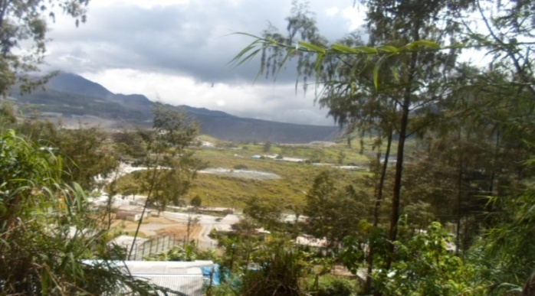
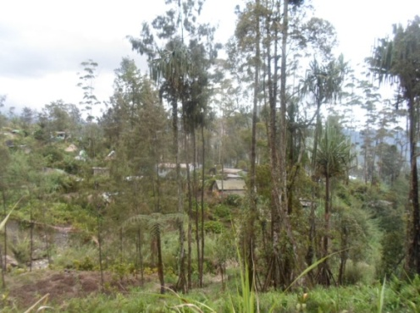
However, from the modern perspective the mining companies may have viewed relocation house worth K100, 000.00 were sufficient substitutes for land loss compensation but failed miserably over the years; many relocation houses owners do not possess or maintain them now or continue to benefit from it. Due to such culturally miss communicated futures imposed on the simple women were forced to find their own means to struggle for survival. Most women and young girls in Porgera for over the past 20 years have been rotating small daily floats of K150.00 - K200 to purchase immediately consumables from Porgera Station retail stores and resells them on road side markets and other community gathering areas just to earn enough for their families daily meals and to make ends meet. They don’t make enough to meet other everyday basic needs such as clothing, school fees, and medical bills, build decent houses, beddings, cooking utensils and other efficiencies. The general living standard has been very poor ever since.
Panadaka relocation House Roofs near Porgera Gold Mine September 12 2017.
Kulapi Village relocation houses near Porgera Gold Mine September 12 2017.

Some of these women’s children eligible for education have missed out because of shortage of school fees. Many have also lost their children and family members to illness caused due to health and hygiene problems since they cannot afford to take care of their family’s health and hygiene problems or either meet medical fees charged at Paiam Hospital in Porgera were too much for the small people who don’t earn regular income.
Some of these women and their children ended up roaming in the stock pile dump areas in the hope of picking up gold containing stones and risked their lives to do so just to provide food in the house daily.
Almost all women are uneducated and illiterate. Therefore, they did not know how to seek aid with their problem they have been living with all these years. Until confrontations amongst one of the associations, the Porgera Landowners Association PLOA working in collaboration with Akali Taeng Association (ATA) and BNL on global frontiers over humanitarian issues of Porgera Mine operations in 2006 resulted in the current initiatives of Barrick responsibilities towards Porgera SML and LMP land loss victims.
That led to the commencement of a revitalization and rehabilitation program known as Porgera Remedial Framework Assessment (PRFA) which Barrick funded and charged Cardno Marketing Ltd run at Porgera Station and got 119 women and young women victims interviewed. Cardno engaged reputable Social Welfare Officers, independent legal advisors (ILA) and sociologists in2012 to collect information on complaints and grievances of women and young girls who were sexually and physically abused by PJV employees, especially mine site policemen and security personnel.
The PRFA was contracted to operate for 3 years which should have been completed in 2015 but somehow it ended in April 2014 after Barrick bridged a legal waiver signed by the 119 female victims who took part in the remedy program. A compensation of K20, 000.00 was paid to the victims in 2013 as out of court settlement saying it was the final payment. Also Barrick paid the 14 victims K200, 000.00 each who were with ATA and registered their case with Earth Rights International, which was more than 4 times the amount paid to 119 of the victims who opted to receive settlement out of the court process. When the 119 victims complaint, PRFA paid them another K30, 000.00 each on top of the K20, 000.00 they received earlier and told them to seek legal advice if they desire. These 119 victims received K50, 000, 00 each. This group of women have raised the issue of unfair payment with PJV Grievances Office but no responses have been received to date until end of last year (2018), the 119 received a grievance number as BNLs’ response to their first letter in 2015.
The 119 victims were not advised properly the consequences of signing the legal waiver by the independent legal advisors (ILAs’) who discouraged them by saying “small people like them with not enough money cannot fight a big giant like Barrick, who is more powerful and has the money and resources. If small people like them (119 victims) take the company to court, it will take a long time and will cost them dearly. These independent legal advisors were and acted like Barrick agents who instil fear into the minds of the victims and entice them to sign the legal waiver saying they will not sue Barrick in the future. However, the 119 women realized that the legal waiver was not effective and demanded Barrick to pay them the same amount of K200, 000.00 as the 14 victims who went through and suffered the same consequence but were paid higher. The 119 women have been raising this matter with PJV Grievance Office but no response have been received to date.
This situation changed when International Human Rights advocates from Columbia University Law School came to Porgera and conducted a 2 weeks human rights workshop in January 2016. These 119 women attended this workshop and made the following four recommendations:
- Barrick must pay them the balance of K150,000.00 each so that they are on par with the 14 victims that were paid K200,000.00 each;
- School fee subsidies for the victims and their children must be continued by Barrick to the PRFA;
- Medical fees for the victims and their children must be continued as planned and promised by Barrick through the PRFA; and
- Provide business start-up grants for the 119 women to venture into income generating activities to sustain themselves economically.

These 119 women who have come out for the first time in public to raise their grievances have broken the strong cultural barrier dominated by the male folks. These issues have been haunting and traumatizing their inner thoughts and minds and have not been exposed for so long. They have resolved that if Barrick is unable to address their demands they would seek legal advice both locally and internationally. Hence, they sent one of their representatives, Ms Evelyn Gaupe and Jocelyn Mandi to the last Barrick AGM in Toronto, Canada on 26th April 2017.
Despite their presentation at the AGM Barrick as yet to formally respond to their petition to date.

- DESIRED ACTIONS TOWARDS REDRESSING THESE CRITICAL HUMAN RIGHTS VIOLATIONS

US Ambassador to PNG, Vanuatu and Solomon Island, (Mr. Walter Norths’ Right and Cressida Kuala Left and His Protocol Officer Mr Bradley Colley at the Back), Visit to Porgera, Enga Province, PNG on the call of Voice of Porgera Women In Mining today by the Porgera Red Wara (River) Women’s Association In-cooperated on the 30th October 2015.
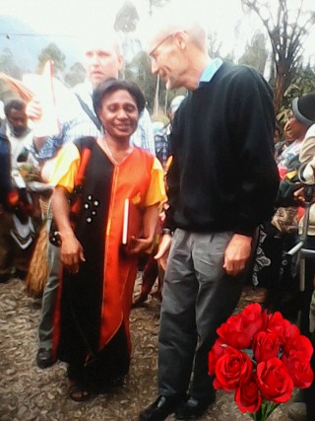

The catch phrase that Coins Voice of these indigenous ipili Porgera women raped and physically assaulted victims principal goal is “create alternative niches for rural Porgera women population flushed out from their ancient survival niches” by the operation of Porgera Gold Mine.

  - We desire a centralized establishment comprised of national and international NGO organization personnel that must possess extreme traits of steady commitment, dependable and trust which are godly qualities. We hope to form a team that must instil and set dynamism with the “spirit of maximizing outputs with less inputs”. Production culture that can be likened to local Porgeran home brew addicts popular chant, “liklikmoni, bikpela spak” (little money, getting dead drunk). This development strategy encouraged is merely creating a dual survival means for Porgeran women so that they have 50% of their time engaged in economic activities while the other half remain with their ancient subsistence livelihoods.

  - The Porgera Gold Mine management may agree that corporate plans exist for relocation of affected landowners and they had been relocating the Tuanda, Waiwa, Tieni and Pulumaini clans to Apalaka, Kulapi, Mungalep and Yarik relocation villages. However, these relocation within the SML and LMP boundaries, the ethnic Ipili Porgera people perceive this move as “sitting on one’s own excreta”. These relocation villages should be relocated well away out of the mining corridor and the affected indigenous women deserving corporate attention.

  - We would need an establishment of international human rights of women’s rightsombudsman commission watching over international enterprise must comply with the international laws to promote and protect women’s rights.

  - We need to be more advance and empowered through being educated so that we can mentor other Ipili Porgera women to raise their silent voice that kept them isolated in fear of dishonouring their male relatives which had made them feel embarrassed and ashamed to tell in small communities which all institutions are male dominated.

  - Free education and free health services must be provided for these poor women who were physically and sexually abused.

  - Seed money or business start-up grants worth K600, 000.00 must be given to these sexually and physically abused women victims as a way to say sorry for the damages done to their lives. These seed money has to be paid into their individual bank accounts and not paid into any NGO organizations’ bank accounts.

  - The sexually abused victims must become stakeholders to the company as long as they are alive and their children after them.

  - Sexual and physical abused victims must invest with other foreign companies with assistance from the company that violet these women’s rights according to how the victims want their money to be invested. All these women victims’ children and spouses must have shares to their investments.

  - The company responsible for violation of human rights of women’s rights must seek international funding agencies to fund or donate aids to women and young women who were raped, pack raped, sexually and physically abused. Appropriate small project and business management trainings must be provided to these women to empower them to establish and manage their investments and business activities.

  - These Ipili Porgera women and young girls must gain dignity and hope in their lives to sustain development in their respective communities if BNL can say sorry to these simple indigenous women who have unintentionally involved in being affected severely by its employees’ inhuman actions that put Barrick in the global spot light; accusing him of violation of human rights of women’s rights. In the following recommendations above Barrick will surely put an end to any future accusations of violating human rights of women’s rights in Porgera because everyone will feel responsible in protecting the gold mine operations as their own. Thereby, the current Porgera women population wonder about feeling hopeless, inadequate and valueless would face their future with confidence and a sense of purpose in life.

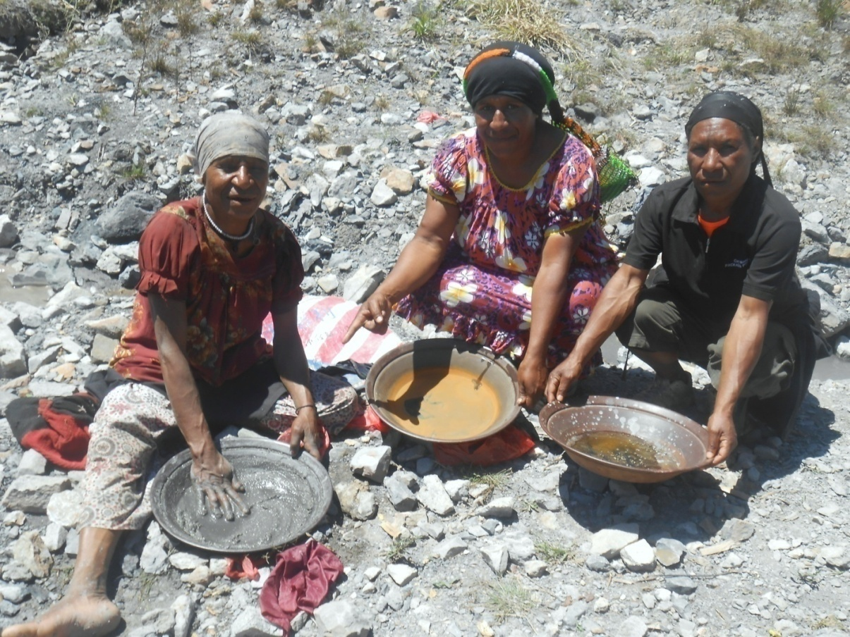
Picture taken on 25th September 2015: Women near Anawe Outlet Tailings.

Compiled by Cressida Kuala Based on the
Research done on August - September 2017

___________________________

DIRECTOR - PRWWA INCOPORATED
& CHIEF SECRETARY

