Enhancing the Participation of Indigenous Peoples*
Based on A Traditional & Ethical Modality Used by the Peoples Themselves,
Written contribution by Uncle Ken Kampe
Background Standard UN and government venues, organization and practices for IP participation are alien, restrictive and [often] demeaning, forcing indigenous people to act in an imposed bureaucratic manner which severely limits their input and acceptance of issues and decisions.
What’s missing? Equality/equity, mutual respect, familiar environment, support, fun, and sincerity – all highly appreciated by IPs [persons without power]. The practice of such new ideas may lead to initial dismay, suspicion, and wariness. Give it time, mutual trust takes time. This is often the case when with and without power try to work together, e.g. UN and IPs.
What to do/or not? Do not lead the discussion, present a proposal, pass out documents, etc. Do begin with a fun ice breaker by the IPs, listen to their issues without a quick response, let the IPs ask the questions, support them, drop the bureaucracy i.e. respect them. Then admit your own limitations – institutional, x0010_ rules, budget, timing, and note what might be negotiated.
What else? It may be difficult to change venues, but formal methods can be changed – this is often critical. Throw out the “bureaucracy of participation”, the formal rules. Sit in a circle, on the floor if possible (the ultimate equalizer - just like home). Perhaps an indigenous person conducts a brief ceremony … and so on.
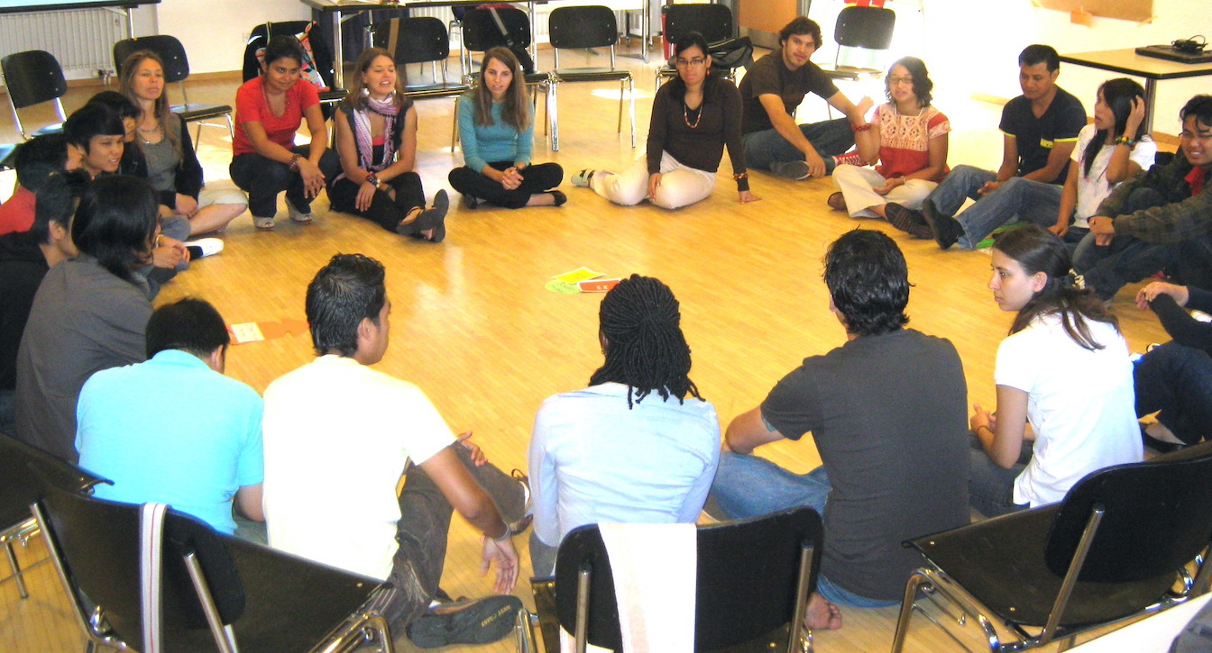
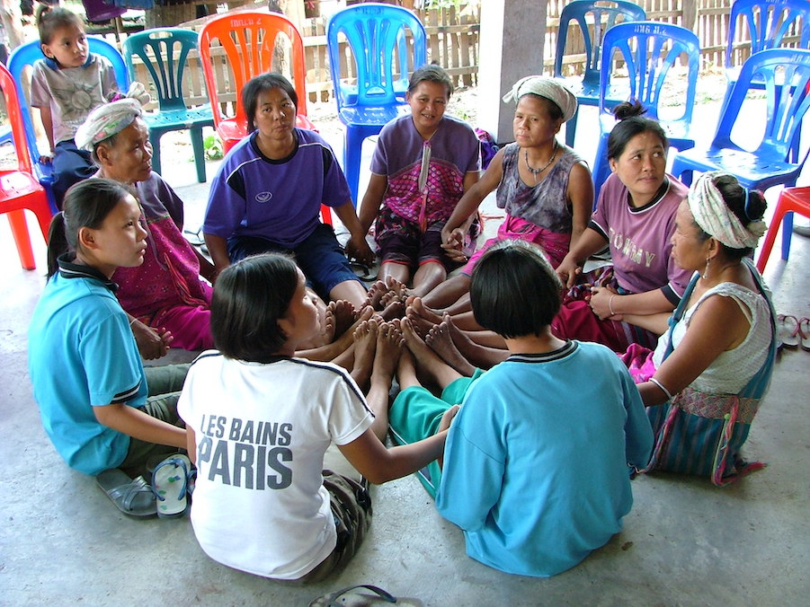
Switzerland
Thailand

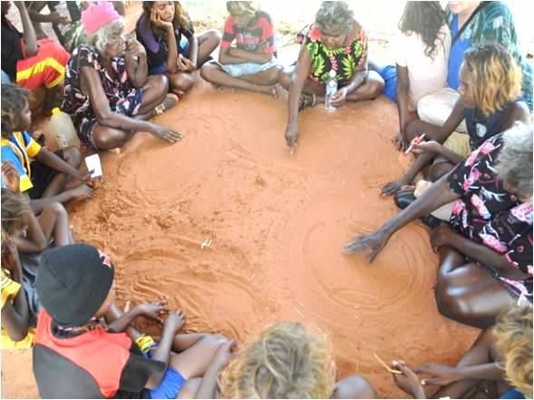
Not sure

*Following the practices of indigenous peoples and the unwritten philosophy of Participatory Learning & Action (Robert Chambers) and successfully used in many countries in Southeast Asia in recently sharing, deciding and implementing ideas for over 20 years.

