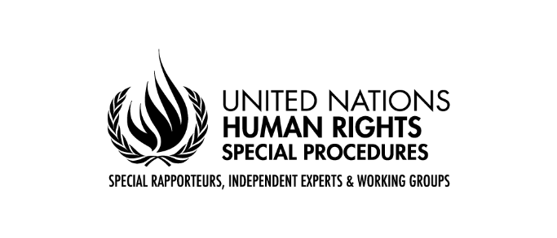
Mandate of the Special Rapporteur on the independence of judges and lawyers
Call for inputs
Safeguarding the independence of judicial systems in the face of
contemporary challenges to democracy
The United Nations Special Rapporteur on the independence of judges and lawyers, Margaret Satterthwaite, invites Member States, national human rights institutions, and other relevant State institutions, international and regional organizations, civil society, scholars, activists, and other interested individuals and organizations to provide written inputs for her next thematic report on safeguarding the independence of judicial systems in the face of contemporary challenges to democracy. The report will be presented at the 56° session of the Human Rights Council in June 2024.
The report will examine the role of judges, prosecutors, lawyers, including community justice workers, in safeguarding democracy. A special focus will be placed on the ways independent judicial systems provide institutional checks and balances and oversight of the actions of the executive and legislative branches of government.
Submissions will help inform her views and understanding of the issues. The report will include relevant and achievable recommendations for Member States and other stakeholders and be made available on her website and other channels.

Key questions
All submissions are welcome and the topics below are not exhaustive. However, the Special Rapporteur would be grateful for comments that address one or more of the following topics. She is particularly eager to receive submissions that take an intersectional, gender-sensitive, and decolonial approach.
JUDGES
- Have judges played an active role in safeguarding democracy and upholding fundamental democratic rights in your country?
- Are judges facing any obstacles, risks, or challenges in your country when fulfilling this role? If so, provide examples, and highlight if judges face particular obstacles, risks, or challenges based on their gender, racial identity, or other characteristics protected by human rights law.
- Is there a specific role played by the judiciary in democratic elections?
- Are there any policies or institutional arrangements in place to limit the role of judges in safeguarding democracy?
- Are there any additional issues you wish to raise with the Special Rapporteur in this context?
- What are the approaches taken to protect judges in this role?
- Are there any additional issues you wish to raise with the Special Rapporteur in this context?
PROSECUTORS
- Have prosecutors played an active role in safeguarding democracy and upholding fundamental democratic rights in your country?
- Are prosecutors facing any risks, obstacles, or challenges in your country when fulfilling this role? If so, provide examples, and highlight if prosecutors face particular obstacles, risks, or challenges based on their gender, racial identity, or other characteristics protected by human rights law.
- Is there a specific role played by the prosecutor’s office in democratic elections?
- Are there any policies or institutional arrangements in place to limit the role of prosecutors in safeguarding democracy?
- Are there any additional issues you wish to raise with the Special Rapporteur in this context?
- What are the approaches taken to protect prosecutors in this role?
- Are there any additional issues you wish to raise with the Special Rapporteur in this context?
LAWYERS
- Have lawyers played an active role in safeguarding democracy and upholding fundamental democratic rights in your country?
- Are lawyers facing any risks, obstacles, or challenges in your country when fulfilling this role? If so, provide examples, and highlight if lawyers face particular obstacles, risks, or challenges based on their gender, racial identity, or other characteristics protected by human rights law.
- Is there a specific role played by the Bar association in democratic elections?
- Are there any policies or institutional arrangements in place to limit the role of lawyers or the bar association in safeguarding democracy?
- Are there any additional issues you wish to raise with the Special Rapporteur in this context?
- What are the approaches taken to protect lawyers in this role?
- Are there any additional issues you wish to raise with the Special Rapporteur in this context?
COMMUNITY JUSTICE WORKERS
- Have community justice workers played an active role in safeguarding democracy and upholding fundamental democratic rights in your country?
- Are community justice workers facing any obstacles, risks, or challenges in your country? If so, provide examples, and highlight if community justice workers face particular obstacles, risks, or challenges based on their gender, racial identity, or other characteristics protected by human rights law.
- Are there any policies or institutional arrangements in place to limit the role of community justice workers in safeguarding democracy?
- What are the approaches taken to protect community justice workers in this role?
- Are there any additional issues you wish to raise with the Special Rapporteur in this context?

Please send your submission via email to hrc-sr-independencejl@un.org by 31 January 2024 at the latest, with the subject: Submission to report for HRC 56.

Respondents are requested to limit their contributions, in English, French, or Spanish, to a maximum of 2,500 words. Additional supporting materials, such as reports, academic studies, and other background materials may be linked in the body of the submission or annexed to the submission.
Unless otherwise specified by those making a submission, submissions will be made public on the Special Rapporteur’s website at the time that the report is published.
The Special Rapporteur greatly appreciates the effort that goes into making such contributions and looks forward to reading all submissions.
Please feel free to circulate this call for inputs widely in your networks.
__________

See her previous report A/78/171.

