**Report of the UN Special Rapporteur on the right to adequate housing to the   
52nd session of the Human Rights Council**

**The right to adequate housing and climate change**

**Questionnaire**

***Impact of climate change on the right to adequate housing***

*In real life*

1. In your country, what have been the main effects of the climate crisis, on the enjoyment of the right to adequate housing? Please specify whether there have been any climate-induced impacts on the security of tenure, availability, affordability, accessibility, habitability, location and cultural adequacy of housing, including climate crisis related displacement.[1]

In the Slovak Republic as a Central European country, climate crisis impacts on enjoyment of the right to adequate housing are not so direct and visible yet. However, it is possible to identify **impacts on habitability and affordability of housing.** Climate change affects the weather stability and changes in climate characteristics. Phenomena which might be ascribed to climate change and have impact on housing are longer periods of meteorological and hydrological droughts (which ultimately result in lowering water supplies), more frequent occurrence of storm rainfalls which result in flood events and more frequent heat waves with higher number of tropical days.

Today the average temperature in Slovakia is 2 °C higher in comparison with 1950 - 1960, during summer months (June - August) it is even more than 3 °C. Higher temperature in combination with meteorological droughts result in lower water supplies even in public water pipelines. For example, in July 2022 in the region of Banská Bystrica with a population of 647 874 inhabitants, the limited supplies of drinkable water in public water pipelines affected households with more than 240 000 inhabitants[2].These households have to limit the use of water for direct consumption and hygienic purposes only. Households that are not connected to public water pipelines (10 %) and have either their own well or use municipal water filling stations are much more vulnerable in these extreme situations.

Damages on buildings and land of households caused by flood events in the period of 2016 to June 2019 are of value about 618 000 EUR. Distribution of the flood events and its impact on the households is not regular. Floods had the worst impact (based on the reported amounts which might be lower than real damages) in the second half year of 2016 and second half year of 2018. None of these damages was remunerated by any public authority. Most of the damages, though, are on infrastructure and might have secondary impact on transport accessibility to villages or towns that have only one access road.

**Periodical evaluation of damages caused by flood events**[3]

|  |  |  |  |  |  |  |  |  |
| --- | --- | --- | --- | --- | --- | --- | --- | --- |
|  | 2019/1 | 2018/2 | 2018/1 | 2017/2 | 2017/1 | 2016/1 | 2016/2 | Total 2016 - 2019/1 |
| Households | 73 454,- € | 163 070,- € | 31 883,- € | 36 080,- € | 28 601,- € | 1 970,- € | 283 859,- € | 618 917,- € |
| Businesses | 87 104,- € | 1 043 506,- € | 3 500,- € | 142 915,- € | 196 913,- € | 16 000,- € | 22 330,- € | 512 268,- € |
| Municipalities | - | 458 423,- € | - | - | 240 986,- € | 32 340,- € | 467272,- € | 199 021,- € |
| Regions | 20 2175,- € | 412 902,- € | - | - | 443 300,- € | - | 300 000,- € | 1 358 377,- € |
| State | 20 2175,- € | 382 3291,- € | 304 159,- € | 548 519,- € | 5 738 637,- € | 97 6621,- € | 960 3194 ,- € | 21 196 596,- € |

Worsened conditions of habitability in buildings which are not adapted to higher temperatures are related to the higher frequency and longer periods of tropical days during summer periods. Members of households, which do not have enough financial resources to be invested into reconstruction (e.g. isolation, aircondition) might have health issues related to overheating. There are no available data that would allow us to evaluate how many people suffered by overheating in their homes.

1. Are there differences how the climate crisis affects the right to adequate housing in urban and rural areas? If yes, is there an interrelationship between the two?

SNCHR is not aware of any differences between urban and rural areas apart from the access to

drinking water (elaborated below).

1. Are there groups distinctly affected in the enjoyment of their right to adequate housing as a result of the climate crisis? Please describe in what way.

SNCHR would like to draw attention to three main conditions, which create vulnerable situations in relation to the impact of the climate crisis on enjoyment of the right to adequate housing: access to public water pipelines, legal status of a dwelling and form of tenure, and energy poverty (or housing costs and energy poverty).

Although almost 90 % of total population live in households with access to public water pipelines, distribution is not steady between the regions[4]. The most relevant factors are limited natural resources of passive water supplies in south and southeast regions. During long periods of draught (2022, 2021, 2020) approximately 400[5] of villages are at risk of being without water supplies.

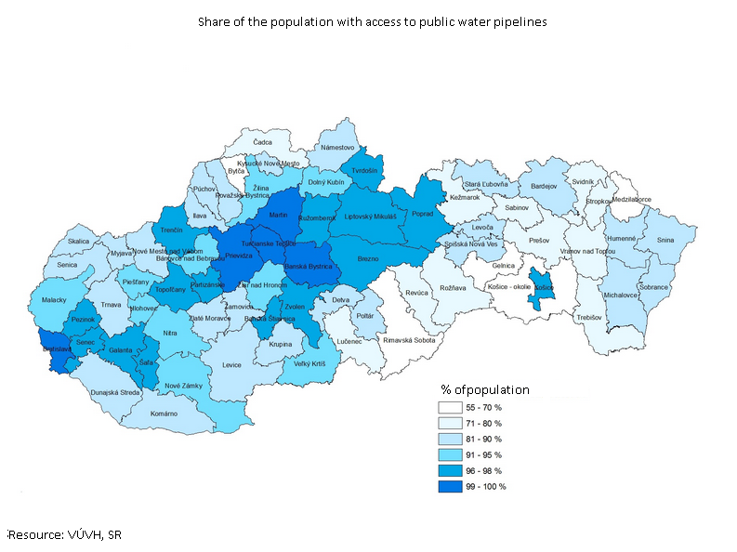

**Figure 1: Share of the population with access to public water pipelines**

Other relevant factors are social status, social segregation (especially of Roma minority – either outside of towns or to the peripheries) and legal status of a dwelling. As a result, only 68 % (2019) of the Roma population living in 804 villages or communities have access to public water pipelines. Alternative resources of water such as own well (16 %) or public water filling station (10 %) are used by 26 % of Roma population and 6 % doesn´t have any access to standard drinking water. Limited access to drinking water is a human rights issue itself, climate crisis is worsening the situation even more during periods of long drought and high temperatures.

In marginalized Roma communities there is also a relatively high proportion (35 %) of households living in dwellings without legalized status/statutory approval. These families live in tenure instability and risk of homelessness in general, in relation to climate crisis they are neither able to adapt their households to climate change nor to protect their home against natural disasters through commercial insurance and are left in legal and administrative limbo.

One of the challenges posed by climate change are high temperatures during summer time. With an increasing number of days with temperatures above 30°C there is also an increase in perceived discomfort and health risks related to overheating. As hot summers were not so typical in the past, most of the buildings are not adapted to it. More than 22.8 %[6] households in the first income quintile in Slovakia cannot comfortably cool their homes during summer time.

1. How is the right to adequate housing ensured for persons that have been internally or internationally displaced by the climate crisis? How and under what conditions is their right to voluntarily return ensured?

N/A

1. When housing has been damaged or lost due to climate-induced events, what has been the related impact on the lives, health and livelihoods of the affected populations?

In case of damaged houses, households are provided with temporary accommodation (free or with reduced price) but there is no financial contribution from any public authority. Therefore, the most important factor is a financial stability or social networks of affected families. In case of older persons or socially disadvantaged households, they are in high risk of homelessness.

1. How have people been able to access redress and compensation for damages to or loss of their housing as a result of the climate crisis and extreme weather events? What are the main obstacles to accessing timely redress and compensation, and what could be effective solutions?

There is no specific legislation on remuneration in case of damages caused by climate-induced events. If there is no direct causality between human agency and a damage (e.g. malpractice in management of water dams or other water course management), a damage is considered to be caused by natural events outside of human accountability. Owner of the estate property can protect the house and/or land only through commercial insurance products. Act No. 7/2010 Coll. Legal act about protection against floods defines in § 44 (3, 5, 6) conditions under which households living in damaged estates might demand a state contribution to compensate (proportion of) damages caused during floods: “entitlement to financial compensation for constrainment of ownership rights, disposal rights, fulfilment of personal participation at operations, damages on their estate…incurred if and only if these were in direct relation to anti-flood protection operations or flood rescue operations. Request of financial compensation … has to be submitted in the course of 5 days after a 2nd degree of flood risk situation is recalled.”

Based on the above, SNCHR concludes that there is no effective legal instrument which would define the circumstances under which it would be possible to claim that any damages were caused by climate change and which would further define other conditions of entitlement to financial compensation.

The use of existing commercial insurance products is limited by financial availability and by legal relationships to a dwelling (owners or long-term tenure with permanent residence). Also, commercial insurance products are not being approved in case of a high risk of floods (based on the flood maps).

1. Please indicate any key rulings of national courts and tribunals protecting tenants and homeowners from the impact of the climate crisis or on their right to adequate housing or related to climate induced displacement? Please also describe their outcome and impact?

N/A

*In measures*

1. Please explain how energy efficiency, green urban planning, climate mitigation and adaptation policies and programmes take into account the right to adequate housing. What measures have been taken to ensure that they do not have any (unintended) discriminatory impact on particular population groups?

Relevant strategic documents of the Slovak Republic do not explicitly refer to the right to adequate housing. The Action Plan for Implementation of the Climate Adaptation Strategy of the SR[7] (2021) was developed in a participatory process governed by the Ministry of Environment of the SR, the participatory process was open for civic society (NGOs active in the area of climate change) and representatives of some vulnerable groups[8]. Specific measure 7.5 of the Action plan “Improvement of the support of socially vulnerable people and people in poverty” formulates the need to address economic impacts of climate change[9]. However, the individual tasks are so far very general and focus on preparatory steps such as collection of data, calculations and estimations of financial impacts, etc. The actual positive impact of the Action Plan will depend on further implementation.

Another relevant strategic document is “Framework for the protection of customers at risk of energy poverty”[10] (further on as “Framework”) which should inform about current situations, challenges and propose a general strategy and viable measures with an analysis of impact. Currently proposed Framework (entered the legislation process in 2019) underlines the importance of increasing employability and “activation” of people rather than the role of regulation. Nevertheless, it proposes a series of measures, such as: financial subsidies to renew the buildings and improve energy efficiency but also financial benefits to cover energy costs. Based on the current practice, SNCHR is concerned whether these measures will be directed to the most vulnerable, as they often require certain financial contribution or financial stability. Also, SNCHR would like to point out that measures are focused on heating and cooking (gas consumption) rather than on isolation and cooling systems and therefore does not reflect future needs of the households in energy poverty.

National Recovery and Resilience Plan (chapter Green Economy)[11] also recognizes lower access of households at risk of poverty to existing financial subsidies and schemes and underlines the importance to develop separate tool of financial assistance to this target group.

1. Please explain how natural disaster preparedness, response and recovery/reconstruction strategies and plans ensure non-discrimination?

SNCHR doesn´t have knowledge about specific prevention measures, which should ensure non-discrimination in the above-mentioned policies.

Act. No. 365/2004 Coll. about equal treatment in selected areas and protection against discrimination and on change and complements of some legal acts provides general legal grounds for protection against various forms of discrimination, including indirect discrimination in the following areas: social welfare, health care, labour-law relations/employment and provision of goods and services.

1. What are the main barriers to addressing and mitigating the adverse impacts of climate change on the realisation of the right to adequate housing?

First of all, the definition of “adequate housing” in the national legislation is very narrow, therefore allows provision of social housing (e.g. in cases of loss and damage) which does not meet criteria of the human rights understanding of adequate housing.

Secondly, without proper definition of climate change impact or damages together with accountability and liability in legal terms, households are left to commercial insurance products and the social welfare system. However, if assistance in relation to climate change will be built on currently applied criteria in the social welfare system, the most vulnerable won't reach it.

The most vulnerable to the climate change impact on the realisation of the right to adequate housing are the groups who are already at risk of homelessness and their access to available schemes and measures is limited (e.g. because of their tenure status to the dwelling, financial situation or segregation).

***Impact of housing on climate change***

1. How does the housing sector in rural and urban areas contribute to climate change? It may be helpful to think in terms of:

* energy consumption for heating, cooling, cooking, lighting of housing;
* urban sprawl and related climate impacts (soil sealing, commuter traffic etc.);
* increase of average per capita living space;
* water use;
* emission of pollutants;
* climate impact of construction and used construction materials;
* deforestation, desertification and loss of biodiversity caused by housing development projects.

Building industry as such has had a stable proportion on energy consumption in the last five years - below 2% if evaluated by the share on the taxes from energy consumption. Households share on the energy consumption is significantly the most dominant, above 35 %.

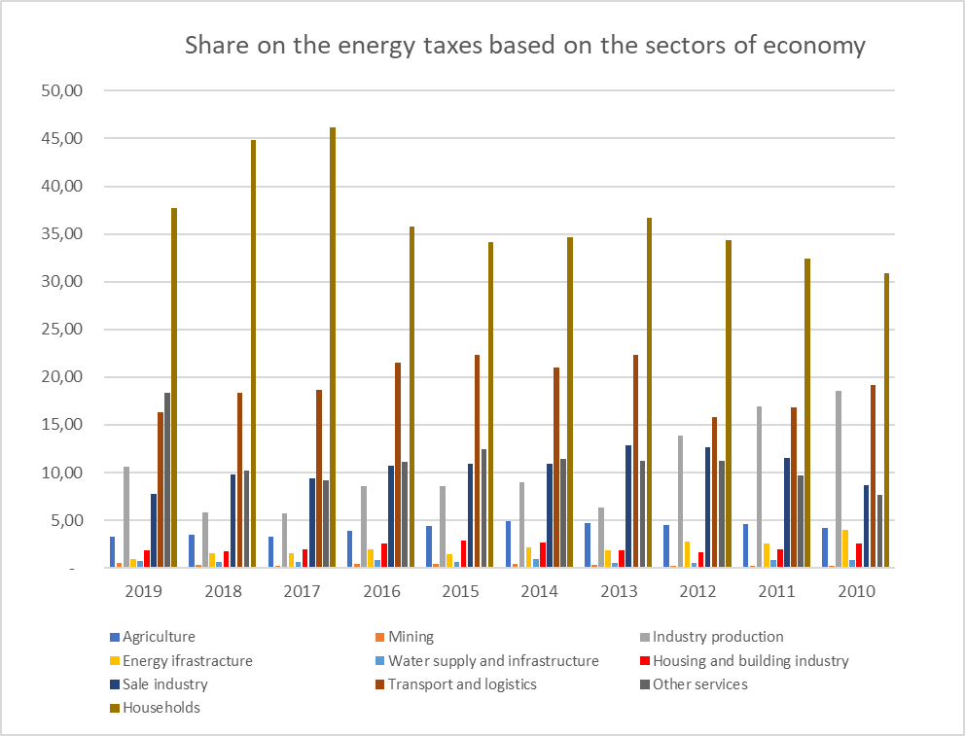

**Figure 2: Share of the economic sectors and households on the energy taxes.**

**Resource:** Statistical Office. Data Cube: [Podiel odvetví hospodárstva a domácností na daniach z energie [zp1009rs] - DATAcube. (statistics.sk)](http://datacube.statistics.sk/#!/view/sk/VBD_SK_WIN/zp1009rs/v_zp1009rs_00_00_00_sk)

Energy consumption had a decreasing trend in the sectors of agriculture, industry and traffic. However it has risen in the sector of households (Figure 2, Figure 3).

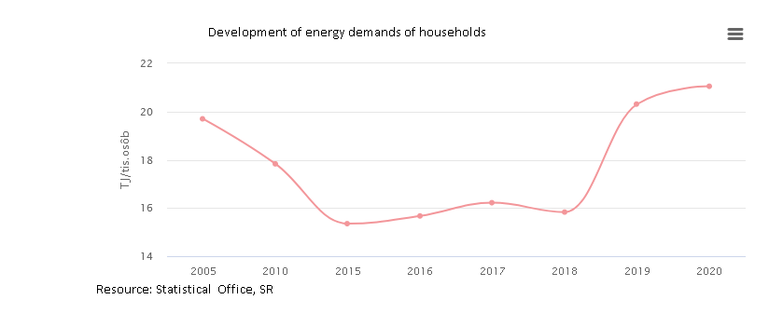

**Figure 3: Development of energy consumption by households**

Resource: <https://www.enviroportal.sk/indicator/detail?id=902>

Emissions of CO2 (without emissions from biomass) decreased, emissions by the building industry are stable in the long term with a slight increase from 2015. In the case of households, emissions increased in 2016 and from 2016 to 2019 are rather stable. (Figure 4).

SNCHR would like to mention also an ongoing practice of producing heat by burning not only wood but also other waste materials, especially in rural areas with higher proportion of low-income households. Prices of other fuels (wood, gas, electricity) are very high and some villages are not connected to gas distribution infrastructure.

In the period of 2005 – 2020, there was a decrease of agricultural land (2,4 %, -57 954 ha). Increase was identified for water areas (2 %, +1 869 ha) and forest land (1,3 %, +22 618 ha). The most significant increase in comparison with 2005 was identified for developed urban areas (5,8 %, +13 190 ha) (Figure 5) . From the environmental point of view is the increase of developed areas at the expense of productive agricultural lands evaluated as negative trend.[12]



**Figure 4: Emissions of CO2 without emissions from biomasss**

Resource: Statistical Office, SR

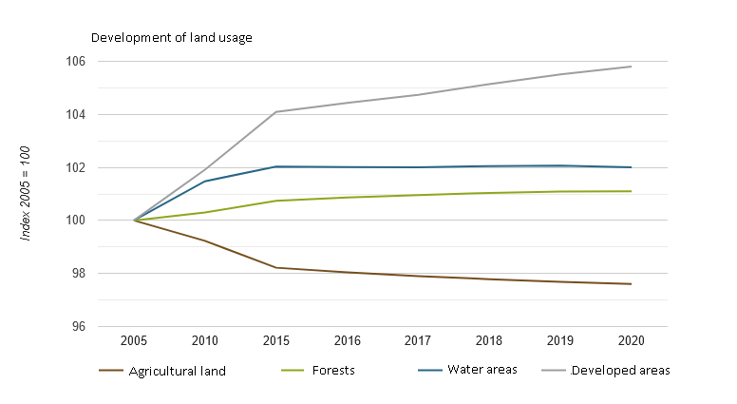

**Figure 5: Development of land use**

Resource: Slovak Environmental Agency

1. What measures are being implemented in rural and urban areas to reduce and eliminate the adverse impacts of the housing sector on the climate? How successful have been these programmes?

Environmental fund – the key source of financial schemes to increase energy efficiency of buildings, lessen emissions of CO2 of heating systems, etc. Eligible beneficiaries are mostly municipalities but also individual house owners.

Legislation – over the last two years there was a new legislation[13] on building development discussed adopted. Prior to the adoption, there was an intensive criticism by environmental activists and legal experts who underlined, that: a) the new legislation is unbalanced with greater power to be guaranteed to developers than to municipalities and civic society, b) it is in breach of several articles of Aarhus Agreement regarding meaningful and timely participation of civic society and c) it doesn´t reflect the adaptation and mitigation of climate change (and doesn´t include the effect on climate as one of criteria for development projects). Although some of the proposed changes by civic society and legal experts were incorporated, the new legislation is still considered as unbalanced[14].

1. What are the main barriers to reducing and eliminating the adverse impacts of the housing sector on the climate?

One of the barriers are the criteria of eligible beneficiaries of environmental fund schemes which usually requires co-financing of the project. This criteria excludes the low-income households, smaller villages etc.

***Towards a just transition to a rights-compliant, climate-resilient and carbon-neutral housing***

1. What specific legislation, policies, or programmes have been adopted to put in place and finance a just transition to a rights-compliant, climate-resilient and carbon-neutral housing for all, without discrimination?

SNCHR is not aware of such legislation.

1. What measures have been taken to ensure that the costs of green transition in the housing sector are fairly shared between public authorities, taxpayers, homeowners, and tenants/renters or other affected interest groups, and to ensure the continued affordability of housing?

SNCHR is not aware of such measures.

1. What adaptation strategies are needed to ensure the continued habitability of housing in the face of the climate crisis? (protection from e.g. heat, flooding, extreme weather, etc.)

* Access to public water pipelines and protection of water resources
* Adaptation to increased summer temperatures
* Prevention of flood events by ecological forest management and water management

1. How are different interest groups, including marginalized communities, homeowners and tenants, being consulted, and able to participate in the design, implementation, monitoring and evaluation of:

* legislation, policies, or programmes been adopted that provide for specific measures to ensure the realization of the right to adequate housing in the face of the climate crisis;

Standard participatory processes – NGOs and experts are being invited to share proposals and expert opinions, which might or might not be accepted[15].

* natural disaster preparedness, response and reconstruction, as well as in mitigation and adaptation efforts;

No participatory processes.

* measures to reduce and eliminate the adverse impacts of the housing sector on climate.

No participatory processes.

1. What is the role of international cooperation, technology transfer and development assistance of States and multilateral agencies to ensure a just transition?

N/A

1. What are the main barriers to achieving such a just transition?

SNCHR doesn´t have enough data and expertise to provide overall analysis. NGOs active in the field of climate adaptation and mitigation identified as the main barriers[16]:

* Lack of crossectoral cooperation (e.g. environment, building development, social welfare, finances) which result in contradicting policies on national but also international level;
* Low initiative to fulfil national goals (e.g. Fit for 55) and implement necessary measures,
* Low initiative to use available resources from EU.

There are high expectations from the new Climate Act being currently in preparations including participation of NGOs and experts. However, it is not clear so far, to what extent the Climate Act will cover various aspects of climate justice and responsibility and liability of public actors.

***Other issues***

1. Please use this space to indicate any issue that should be considered for this report.

**Submission instructions**

**Deadline:** **8 July 2022**

**Email:** Please return this questionnaire to: [ohchr-srhousing@un.org](mailto:ohchr-srhousing@un.org); [ohchr-registry@un.org](mailto:ohchr-registry@un.org)

**Email subject line:** Input for SR housing - report on climate change

**Accepted File formats:** Word only (supporting documents may as well be submitted in PDF)

**Accepted languages:** English, French and Spanish

Please include references to reports, academic articles, policy documents, text of legislation and, judgements, statistical information with hyperlinks to their full text or source or attach them to your submission (please respect total file size limit of 20 MB to ensure that it can be received)

**Potential confidentiality:** Please indicate on top of this questionnaire and in your e-mail if you want to have this submission or any particular attachment not to be published on the website of the Special Rapporteur and treated as confidential.

**Expected presentation** of the report of the Special Rapporteur: February/March 2023

1. Under international law, the right to adequate housing is more than having four walls and a roof. It is essentially the right to live in a place in peace, security and dignity. Housing adequacy covers the following seven essential elements: legal security of tenure; availability of services, materials, facilities and infrastructure; affordability; habitability; accessibility; location; and cultural adequacy. For organizations and stakeholders that may not be as familiar with the right to adequate housing in international human rights law, please consult General Comment No. 4 of the UN Committee on Economic, Social and Cultural Rights, available [here](https://tbinternet.ohchr.org/_layouts/15/treatybodyexternal/Download.aspx?symbolno=INT%2fCESCR%2fGEC%2f4759&Lang=en).
2. List of municipalities with limited resources of drinkable water as of 4.8.2022: <https://www.stvps.sk/vyzva-obmedzenie-uzivania-vody/>
3. Periodical half-year reports are published at the website of the Ministry of environment of the Slovak Republic: <https://www.minzp.sk/voda/ochrana-pred-povodnami/informacie-priebehu-nasledkoch-povodni-uzemi-sr.html>

   Damages on buildings, estates or agricultural land was included.
4. <https://www.enviroportal.sk/indicator/detail?id=1277>
5. <https://www.vodaprevsetkych.sk/>
6. Eurostat - EU-SILC survey, ilc_hcmp03, 2018-02-15, <https://eepi.openexp.eu/eepi.html#data>
7. Action Plan for Implementation of Climate Adaptation Strategy of the SR. Adopted by the decision of the government of SR No. 476/2021 on 31. August 2021. [akcny-plan-implementaciu-nas.pdf (minzp.sk)](https://www.minzp.sk/files/odbor-politiky-zmeny-klimy/akcny-plan-implementaciu-nas.pdf)
8. Response of the Ministry of Environment of the Slovak Republic (6.12.2021) to the request of information by SNCHR from 21.11.2021.
9. Action Plan for Implementation of Climate Adaptation Strategy of the SR. p. 67-66
10. Gestor of the document is The Regulatory Office for Network Industries is a state authority which is independent from both state power and regulated entities.   
    Currently, the document is inbetween the legislative process, LP/2019/332 Koncepcia na ochranu odberateľov spĺňajúcich podmienky energetickej chudoby. <https://www.slov-lex.sk/legislativne-procesy/-/SK/dokumenty/LP-2019-332>
11. <https://www.planobnovy.sk/kompletny-plan-obnovy/zelena-ekonomika/>
12. Indicator: Development in land usage. Slovak Agency for Environment. <https://www.enviroportal.sk/indicator/detail?id=161>
13. Act No. 50/1976 Coll. about land development and building procedure; Act No. 201/2022 Coll. on housing construction.
14. SNCHR doesn´t specialize on legal framework for house development. Therefore, it is recommended to reach VIa Iuris, n. o. (the key actor of public and expert dialogue about the abovemention legislation) for further legal analyses: <https://viaiuris.sk/en/>
15. Consultations with representative of alliance of NGOs and experts in SR, Climate coalition, Dana Mareková (28.7.2022): <https://klimatickakoalicia.sk/>
16. Consultations with representative of alliance of NGOs and experts in SR Climate coalition, Dana Mareková (28.7.2022): <https://klimatickakoalicia.sk/>