**8**



Karachi Bachao Tehreek

Submission to the UN: Resettlement As a Human Rights Issue

# Executive Summary

This report has been compiled by Karachi Bachao Tehreek in response to the call by the United Nations Special Rapporteur for inputs on resettlement as a human rights issue intended to be submitted to the Human Rights Council and General Assembly in 2024.

The insights gathered in this report are a direct retelling of the experiences of residents affected by displacements and ‘anti-encroachment’ operations in urban Pakistan, and specifically in Karachi. Gathered through community engagement sessions and community-led surveys, these findings underscore the urgent need for a comprehensive **Rehabilitation and Resettlement Plan** that addresses issues related to forced evictions, demolitions and displacement; and provides fair compensation and support to those displaced by these processes.

Based on feedback from the sessions and survey responses, the following major themes have emerged. The first portion covers the events and experiences of the affectees and residents (used interchangeably):

1. Many affected residents expressed concerns about the **arbitrary nature of demolitions.**
2. Some residents emphasised the **intergenerational nature of their land claims,** with homes passed down through several generations, since before the creation of the country.
3. Several residents reported receiving **little or no notice before their homes were demolished resulting in a total loss of property,** including furniture, home appliances.
4. **Residents report facing police brutality**, when they try to resist forced evictions and businesses (home-based networks).
5. The sudden demolitions have resulted in severe **health-related consequences**.
6. The demolitions not only **displaced families but also** **fragmented communities**.
7. **The financial burden on affected families is substantial, especially due to the loss in business, rising inflation and no or delayed compensation after demolitions.**
8. **Children have stopped going to school as families can only afford two-time meal, education expenses, household expenses or hospital, and other necessities' expenses.**
9. **There has been a disproportionate impact on women and children.**
10. **State support has been missing throughout and what has been offered has been too little, too late.**

The following are the demands and suggestions made by the affectees and residents:

1. **Affectees must be active participants in the decision making process.**
2. **If affectees are to be relocated, the proposed relocation must be in a place of equal value and quality.** The community existence specially in case of minorities, Shia, Christian and Transgender ate special considerations.
3. **They demand damages for the impact on health, loss of property (such as furniture and household appliances), and the loss of business.**
4. **Demolition-affected residents demand to be covered by the policy and their entitlement to resettlement and rehabilitation to be recognized as legitimate.**
5. The government procedures remain unclear at large and so lack transparency, during the cheque disbursement, instances of officers asking for bribe are on record. Hence, affectees demand inclusion of legal title of the allocated land by the government.

## 

## 

## Introduction

Karachi Bachao Tehreek (KBT) is a people’s movement based in Karachi, Pakistan that fights for housing rights and resists unlawful and arbitrary urban displacement. In October 2023, we organised several public hearings with residents of informal settlements across Central and North Karachi who have been victims of urban displacement. The purpose of these hearings is to gather feedback on the drafted Rehabilitation and Resettlement (R&R) plan of the Sindh Government Policy 2022 by those who have had their homes demolished as the policy primarily concerns them. KBT organised these sessions as the Provincial government responsible for drafting the legislation approached NGOs, CSOs and other members of the elite civil society, but never approached those directly impacted by the demolitions (the affectees) for their input.

The following report is based on findings from the surveys, as well as the community engagement sessions with the aim to provide participatory, grounded and inclusive feedback on the Sindh Government’s R&R draft policy, the Supreme Court’s proceedings on Nullah (stormwater) demolitions, and an overall sense of what a road-map for development-induced displacement should look like for working-class residents in urban Pakistan.

## Methods

## Public Hearings and Sessions

KBT conducted five public hearings across neighbourhoods in Central and North Karachi in October 2023 which were attended by a total of approximately 650 residents that have faced displacement. These hearings were attended by men, women, and children of all ages, various religions and ethnicities ensuring cultural, religious, ethnic, national and cultural inclusivity.

The details of public hearings held are as follows:

1. Orangi Nullah on 1st October 2023
2. Gujjar Nullah on 4th October 2023
3. Mujahid Colony on 7th October 2023
4. Wahid Colony on 8th October 2023
5. Mujahid Colony (women only) on 15th October 2023

This report contains findings from all sessions except for the one conducted at Orangi Nullah.

2. Surveys

Over the years, the KBT team has also engaged in long-term research on the ground for various different purposes. From September 2023 to October 2023, surveys were carried out along different parts of Gujjar Nullah in order to gather opinions about the government’s proposed resettlement and rehabilitation plans. This research activity was a community-based effort demolition-affected residents who are members of KBT’s Mohalla (Neighbourhood) Committees. They carried out door-to-door surveys to ask respondents what their preferred mode of resettlement would be. In some areas, ‘survey camps’ were set up where affectees showed up to have their responses recorded themselves. The sample size for this survey was 732 respondents including both men and women.

## Findings

1. Survey Results

On August 17th 2023, the petition related to the Gujjar and Orangi Nullah demolitions was heard in the Supreme Court. In this hearing, the Sindh government was directed to expedite the disbursal of rental cheques which were promised to the affectees in lieu of compensation. These cheques were supposed to be distributed bi-annually (at the meagre rate of PKR 15,000 per month) and account for two years worth of rent from the time the affectees were first displaced.

However, the delay in their disbursal has been two years itself. Nonetheless, since the hearing, the Sindh government has been distributing the due cheques but the delay has had adverse psychological, social, and financial implications on residents. In addition to the checks issue, the Supreme Court also directed the provincial Sindh government to provide adequate resettlement to the affectees. In this regard, the following two proposals were presented by the Chief Minister of Sindh, the Mayor of Karachi, and other Senior Officials of the Government of Sindh:

1. *The government of Sindh will release the amount to each of the 6932 affectees for purchase of land and construction according to the market value of the piece of land from where the 6932 affectees were dispossessed. So far as the cost of construction is concerned, the standards laid down by the Pakistan Engineering Council for the construction of houses measuring 80 square yards will be followed.*
2. *In the alternative, the Government of Sindh shall allot a plot measuring 80 square yards to each of the 6932 affectees situated at Malir Development Authority and after handing over peaceful vacant possession of 80 square yards piece of land, with title and free from all encumbrances, the cost of construction will also be paid to each of the 6932 affectees in accordance with the standards set out by the pakistan Engineering Council for the construction of house measuring 80 square yards.*

To get a sense of which option out of the two is preferred by the affectees, KBT’s Neighborhood committee carried out a survey, with a simple questionnaire (See Appendix 1). The main question in the survey asked respondents which proposal they would choose. 92% chose option A, i.e **cash compensation based on market value of land and construction cost, taking in account of the means of income/business established on the property,** whereas 8% chose option B, i.e allocation of 80 sq. yards plots in Malir and construction cost. The results are depicted in Fig1. below:

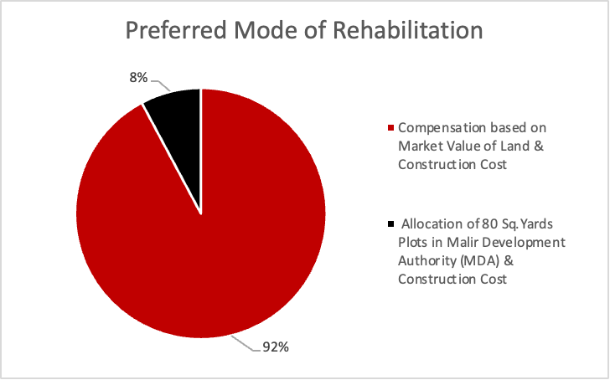 Figure 1. Survey results depicting resident’s preferred mode of rehabilitation

2. Public Hearing Themes

## Arbitrary Demolitions, Inter-Generational Claims To Land, And Participatory Policymaking

Many affected residents expressed concerns about the arbitrary nature of demolitions. They pointed out inconsistencies in government policy and service provision, illustrating that some areas received essential amenities like gas, electricity, and water lines, yet their homes were still demolished on the basis of not being recognized by the government.

Gulzada, a labourer in Mujahid Colony, also commented on how his house was built before the partition of India and Pakistan, highlighting how their claim to land transcends several generations. He further stated that even though their area was not scheduled for any development works, their home was still demolished. This points to an overreach of demolition activities to usurp land without adequate justification. Mohammad Jamil, a 55-year-old, also commented on how he had been living in his family home for generations.

Nazakat Ali Raj, a former UC Councilor & former District Chief from the Pakistan People’s Party (PPP), commented how 5 generations from his grandfather to his grandson all lived under the same roof for 73 years. He highlighted how 26 acres of formal, leased land was razed to the ground without adequate compensation. From KBT’s previous report (2021)[1] and other recent research on displacement in Karachi (KUL, 2021)[2], we know that many people who are displaced and dispossessed by ‘anti-encroachment’ operations have some kind of ownership documents with legal standing. Yet, these documents are either overlooked or overruled when ‘anti-encroachment’ operations are carried out.

​​In Wahid Colony, Tanvir Shah, a 55-year-old with 4 kids, was left homeless after his home was demolished despite having a formal stamp paper of home ownership. Syed Naveed, born in the neighborhood in 1970, has stamp papers proving home ownership as well. We find it crucial to highlight that at the beginning of the Gujjar and Orangi Nullah clearing operation in 2021, the Karachi Metropolitan Corporation issued an illegal and arbitrary notification that ‘cancelled’ the leases of residents living along the Nullahs (Fig.2).

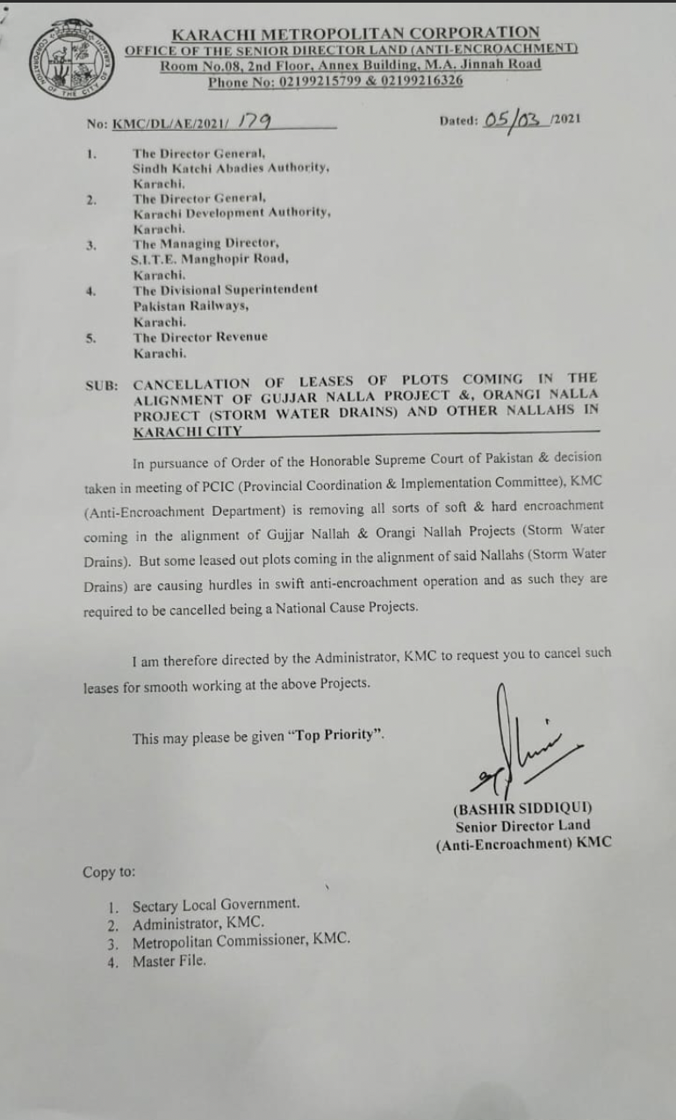

Fig. 2. KMC notice on the arbitrary cancellation of leases

Salim Shah, a 47-year-old from the same neighbourhood with 3 brothers, had gas, electricity, and water lines connected to his home before the demolition. He recounted how all of these amenities were cut off, then half of his home was demolished and now his family regularly experiences sewage water entering the remainder of his home. Emphasising the importance of having a place he can call home, he said that *“even living in the smaller, partially demolished space was a better option for him than sleeping in the open or affording the rent.”*

Abdul Rahim from Wahid Colony said he had been living in his home since the time of the Ayub Khan’s rule and has documents that prove home ownership. His home was demolished despite legal documents. Another resident, Amjad Ali, from Wahid Colony, demanded that he wanted to be rehabilitated in the same district (Central) or a place with utility connections. He commented, “*The government became quite active when it came to demolition, but has made no moves to rehabilitate the affectees.*” He demanded quick shelter for his family. Another participant, living in the area for 50-60 years, also raised the question, *“Why did the government want to build a service road when local residents never needed it, destroying all of these homes in the process?”* This comment speaks to lack of public participation during the planning application, and approval stage. Local residents are completely kept in the dark about plans for development works until they learn something through the media, or word of mouth. This causes immense confusion, stress and psychological hardship that often result in health related implications.

State support has been missing throughout and what has been offered has been too little, too late. Residents did not receive information regarding the horrors they faced or the compensations they were entitled to. Rental cheques were offered, but delayed and denied for over a year. The cheques were finally disbursed after an incredible struggle to sue the Chief Minister of the province for contempt, but the amount provided was not adjusted for inflation or increased to compensate for governmental negligence. The unannounced due diligence on part of affectees - required by the government officials, make the process of cheque disbursal even more strenuous, preventing affectees from acquiring their rightful cheques.

Affectees still have no confirmed notice regarding alternative housing and relocation, and the proposed policy by the government does not include any affectees impacted by demolitions before the passing of the bill into law or those who never acquired formal ownership paperwork.

## Lack of Notices and the Use of Police Brutality

Several residents reported receiving little or no notice before their homes were demolished. This lack of notification left them unprepared and with no time to make arrangements, resulting in a total loss of property for some and a sudden and devastating displacement for all. Residents in Mujahid and Wahid colony specifically have also since not received any further information regarding what to expect next or if they are entitled to any government protection or welfare.

For Hamza Jami, in Mujahid Colony, no notice was served before demolitions. Tanvir Shah, from Wahid Colony, commented how his family was only given a 3-day notice without any time to prepare to move out into a new home. Without warning, the government authorities threw them out of their house the day after serving them a notice and bulldozed their home.

Shah Hussain, 48 years old, has a 300-yard plot with a double-story, including a cement shop on the ground floor. His family consists of four brothers, all of whom lived in the same house. He was given a 2-3 day notice before demolitions were carried out and no heed was paid to their ‘please’. The excavator brought by government workers demolished more of the structure of their house than was initially marked. He further remarked how the road construction was not a necessity for local residents at all. When asked about rehabilitation, he commented that he prefers being given a plot and construction cost in lieu of compensation, but only if it is in a good area with steady & regular access to all utilities.

Azhar Shah from Wahid Colony, a 50-year-old, owned a 4-storey building of 12 rooms where his 4 brothers and their families lived. He was given no notice and it has been over a year since they are stuck in limbo.

**Police Brutality**

The government failed to inform residents about the plan for demolitions or even the dates, according to the women of Wahid and Mujahid Colony. They arrived without a notice while the residents weren’t home; all their furniture and belongings were under the rubble. They even asked the bulldozer operators to wait while they tried to salvage their possessions but the police prevented them from doing this as well. They were also thrown out by policemen and felt defenceless since no men from their families were present at the time due to work obligations. Residents also report facing police brutality, with the use of tear gas and shellings used at early hours of the morning to forcefully remove residents from their homes.

M. Nadeem from Mujahid Colony & Rehana Bibi from Hassan Colony Liaquatabad cite their sister in law, and new born nephew, and husband respectively, passed away when excavators hit their home walls and demolished the structure.

## Reduced Living Standards: Health-Related Implications, Loss of Education, and Gendered Implications

Residents have lost loved ones due to the circumstances surrounding demolitions. Further study is recommended to tally the number of heart attacks and stress related casualties resulting from these demolitions. Children and families live in dangerous conditions exposed to a crumbling environment, unable to move due to the high cost of rent. Thousands of children have also been pulled out of school as a consequence of displacement. Additionally, the lack of hygiene and protection in partially demolished homes has led to injuries, the rise in Hepatitis, and other chronic medical issues. There has been an increase in drug use, crime, and infrastructure deterioration in the impacted neighbourhoods.

**Health Related Implications**

For Hamza Jamil, in Mujahid Colony, due to the sudden demolition of the home, his parents both had a heart attack and lost their lives due to demolitions. He outlined the brutal treatment of government authorities who they shelled and injured women and children to drive them out of the homes for demolitions. Delays in implementation of Supreme Court decisions have also added more stress upon his shoulders when it comes to his family and home.

Fida Hussain s/o Muhammad Hussain, from Mujahid Colony, comments on how people were sleeping inside their homes when the shelling started at 7 AM. Her daughter-in-law and grandson passed away due to the manner in which the demolitions were carried out.

Nazakat Ali Raj, from Mujahid Colony, said he knew several people who died due to heart attacks from the stress of demolitions.

The demolitions are also haphazard, and people living in the area do not have any clarity if their home is next. M. Nadeem from Wahid Colony, commented how the people left in the neighbourhoods are suffering because they do not know when this will end.

Syed Naveed, living in Wahid Colony for 53 years, whose father is a cancer patient, said he was with his father at the hospital when the government came to demolish their house with no warning. He demanded answers about how a road could take precedence over the cost of multiple families losing their homes and sources of income.

Several women from Mujahid Colony remarked that they have seen an increase in medical issues in their families since the demolitions, such as bodily injuries and hepatitis. The lack of hygiene and protection while living in partially demolished homes is hard, especially since the government doesn’t allow families to repair their homes.

Many women are forced to live in open-air, partially demolished homes that expose them to insects, the severities of the weather, and a complete lack of safety from strangers outside. They rely on kindness from their community to stay safe, which they commented can run thin. After initial demolishing, these women had nowhere to go and slept on the rubble where they once had their homes. These are women used to purdah (veiling in public) and exposure like this is a gravely sensitive matter. They did not have access to bathrooms and relied on neighbours giving refuge to multiple women in one room.

Children are also in danger of getting injured due to their living conditions, and families cannot afford to move out due to the high cost of rent.

**Loss of Education**

Children have stopped going to school. There has been a worrying number of children, especially young girls, who have been removed from schools as families can no longer afford to pay for their education. For some this was also due to them relocating to rental homes further away from schools, making it more difficult and expensive to reach school on foot. For others, it was due to the loss of a multigenerational household that supported childcare, which mothers now rely on their older children for. Many have had to employ their children to help earn for the house, or at best, enrol them into free madrasahs instead. Uzma Bibi from Mujahid Colony had to remove all 6 of her children from school, and Safia Bibi chose to keep her son in school while ending her daughter’s education due to lack of finances.

**Gendered Implications**

There has been a disproportionate impact on women and children. Women have lost most semblances of privacy in their new homes which mostly consist of one bedroom. An average of 6 people and 2 families share this space. With the infiltration of drugs in the communities, women have had to become employed or work multiple jobs to make up for the addiction-incapacitated male family members and face sexual harassment due to increased distance commutes.

Many women of Mujahid Colony are single mothers or with husbands who have become addicts. They need schools and jobs nearby so their daughters can go to school. They don't even have motorcycles, so they can only walk; hence, it is crucial for women’s physical and financial mobility that schools and work be in close proximity.

A lot of affectees now have to live in 1-room homes with six others on average due to high costs of rent. A lot of women said that they have very little privacy from other men in their homes, such as fathers, brothers, etc. They are concerned for their daughters, too, who are living in such a condition.

## Social Impact: Community Fragmentation, Loss of Access, and Quality of Life

The demolitions not only displaced families but also fragmented communities. Homes were split, and extended families were forced to live separately. Single mothers and families living in cramped, single-room spaces face challenges related to privacy, security, and education.

Some residents emphasised the intergenerational nature of their land claims, with homes passed down through several generations. As Pakistan is a postcolonial state that received millions of migrants due to the Partition of India in 1947 before cities could accommodate them, and formal city planning to this day does not take place in Karachi, such settlements are inherent features of Karachi. Those that face demolitions and displacement, however, are always working class neighbourhoods. Even those with legal ownership documents found their rights overlooked or overruled during 'anti-encroachment' operations.

Haider Ali, 27, and his family bought their house in 1987. His home was marked for demolition by the NED Survey (See KBT report on Gujjar Nullah demolitions, 2021). Since the demolitions, he has been forced to move to a single-room space within the same area because he does not want to trail too far away from his community. For him, the best-case scenario would be to find another home in District Central. He would even consider moving into an apartment as it is the best solution for efficient land use, especially as his family is not allowed to rebuild the portion of their property that was not demolished. There have been reports of the police harassing residents who wanted to build walls to cover their partially demolished homes.

From Wahid Colony, Azhar Shah lived with his four brothers and their families in the same house. After the demolition, his extended family was forced to move into separate households causing a fragmentation of their family. Nazakat Ali Raj demands in-situ resettlements since his Rajput and Pashtun communities will be forced to scatter and move to a far-off land where education, businesses, and community will be gone. He commented, *“we need peace here.”*

Moving to Taiser Town would also be unsafe, according to the women of Wahid Colony. They do not want to live exposed to the highway where trucks go by all night and are unconnected to essentials like transport and water lines. Women also felt unsafe living in such an area. It is also necessary to highlight that Taisar Town was first established as a resettlement site for people who were displaced by the Lyari Expressway in the early 2000s. People who live there currently report unlivable conditions with criminally inadequate access to basic utilities such as water, sanitation, cooking gas and electricity. The nearest hospital is about an hour’s drive and the resettlement site is disconnected from even informal public transit routes. A lot of the residents in Taiser town report to have been pushed further into poverty after moving there due to the difficulty of accessing jobs, education, and healthcare (KUL, 2021)[3].

Women at the session in Mujahid Colony also highlighted the increase in drug-use since the colony is now flooded with them. They reported that syringes are littered everywhere. The demolitions have led to this since the community was much more active with representatives working on addressing drug abuse for decades. They also worked on ending electricity outages; but now, electricity outages have become more frequent and the colony’s infrastructure is deteriorating, while crime has increased in the area.

## Financial Strain

The financial burden on affected families is substantial, especially due to the loss in business. Many residents have to rent new accommodations at high costs. Families struggle to balance rent with the cost of education and food. Demolitions were conducted on residential, commercial, and mixed use buildings where the ground floor was a shop or store. The loss of businesses and the high cost of construction further exacerbated their financial difficulties in an unprecedented time of inflation.

Qari M. Tariq, in Wahid Colony, who has been living in the area for 45 years, bought a home with a shop below it as an added source of income for the household. Since the entire building was demolished a year ago, his family has been forced to rent out a 1-room apartment with a high rent of 18k a month. Mohammad Yamin Baba, in Mujahid Colony, highlighted how the family income is too low to bear the additional burden of rent after his home was demolished. Yamin Siddique, from the same area, highlights how difficult it has become for her family to pay rent now that they do not have their own home.

Asif s/o Mohammad Asad, in Mujahid Colony, is facing huge issues when it comes to rent since he has to shoulder the financial responsibility of a family of 12 people. Due to delays in his ability to pay rent, he now has to deal with landlords who want immediate payments. His concern is for the fear of crime increase in his neighbourhood due to the demolitions and increased financial burden on families.

Fida Hussain s/o Muhammad Hussain, commented on how a lot of affectees have had to shift to rental homes for housing. They are becoming increasingly strained since they have to make tough choices between paying rent and educating and feeding their children. Gulzada from Mujahid Colony also commented on how demolitions have created a huge economic burden on families, which is worsened by local inflation rates. They highlighted the high cost of construction on families, demanding that the government should compensate affectees for the cost of construction of new homes.

Mohammad Jamil so Saleem from the same neighbourhood also commented that even if the government gives them barren land, they have to account for the construction costs that will come for families. He demands that the government offer them completely constructed homes as compensation. Nazakat Ali Raj, from Mujahid Colony, shared how businesses have ended due to the demolitions. His friend, Khan bhai, from the neighbourhood lost all of his vans that he had to sell for housing after his home was demolished.

M. Waqeel, who lived in the same home in Wahid Colony since 1965, had his home completely demolished. Now, he is forced to pay 15K for rent so that he can have shelter. Abdul Rahim from Wahid Colony was forced to move out of his home and into a rental home. Due to inflation, his rent doubled and caused great financial strain on him. Tahir Shah, lived in a 3-floor house comprised of 4 families, but his entire property was demolished. No belongings survived and he lost his shelter and shop in one go.

Azhar Shah from Wahid Colony, a 50-year-old, owned a 4-storey building with shops and a home of 12 rooms where his 4 brothers and their families lived. Without a notice, both his home and his confectionary shop were demolished and now has to do odd-jobs related to confectionary sales to ensure that he can fulfil the educational expenses of his 5 children in the 1st, 3rd, and 6th grades at a private school in Nazimabad. Moreover, his family had to split and now he is the head of his nuclear family, forced to they pay Rs. 20-25K a month for a rented space.

The government proposed giving them land in Taiser Town. However, women of Mujahid and Wahid Colony remarked that they have visited the area and it is completely barren and far away from the center city. This can increase costs for them since they have to travel further for schools, work, and hospitals. It also doesn’t have utility connections that are needed for families to survive.

The biggest loss for families, according to women of Wahid and Mujahid Colony, is not just homes but the complete loss of income. Their families’ shops were demolished as well, which was their biggest source of income. It would bring in Rs. 20-30K a month and now they are forced to remove children from schools since they cannot afford education costs.

## Recommendation and Suggestions

1. **Affectees must be active participants in the decision making process.** Consultations and sessions must not exclude them and their representation must be true, not token.
2. **If they are to be relocated, the proposed relocation must be in a place of equal value and quality.** As the affectees and their ancestors built their neighbourhoods from scratch before much else existed in the area, they demand relocation only to the places where all of the amenities they have built and enjoyed in their current neighbourhood are available. They do not want to be moved to new proposed settlements beyond city limits that are isolated and without basic facilities. They want to be relocated within a neighbourhood with existing essential amenities and infrastructure such as water, gas, electricity and access to public transport. Women, the elderly, and children especially insist on these neighbourhoods having schools, hospitals, and commercial networks. If the government cannot guarantee this, they would rather receive cash value for their property and manage housing themselves.
3. **They demand damages for the impact on health, loss of property (such as furniture and household appliances), and the loss of business.** The affectees of demolitions and displacement seek justice for all that they have loss, material and intangible.

## Conclusion

In conclusion, there is substantial evidence for the violation of human rights inflicted upon working class communities in Karachi. In a city where 62% residents live in informal housing, ‘anti-encroachment’ operations are a major hurdle in the way of realising housing justice and equality. The criminalisation of working-class informality in urban Pakistan jeopardises any hope for a sustainable urban future in the country. Government authorities, law-makers and policy-makers must reckon with urban realities which are unique to Pakistan, and formulate structures that integrate and work with these processes - rather than seeking to erase, displace and shun working-class communities.

For now, due to the lack of genuine participatory planning, demolition-affected residents have not been approached for their input in the government policy that directly impacts them. The policy in question is therefore inadequate as it stands and does not address fundamental concerns held by the affectees. For the policy to be valid and effective, it requires this consultation and revision. The points detailed in this report are the direct suggestions of the affectees for the purposes of policy making concerning rehabilitation and to highlight a grave injustice that has been ongoing and sees no end.

## 

## Appendix 1

Rehabilitation & Resettlement Survey Form

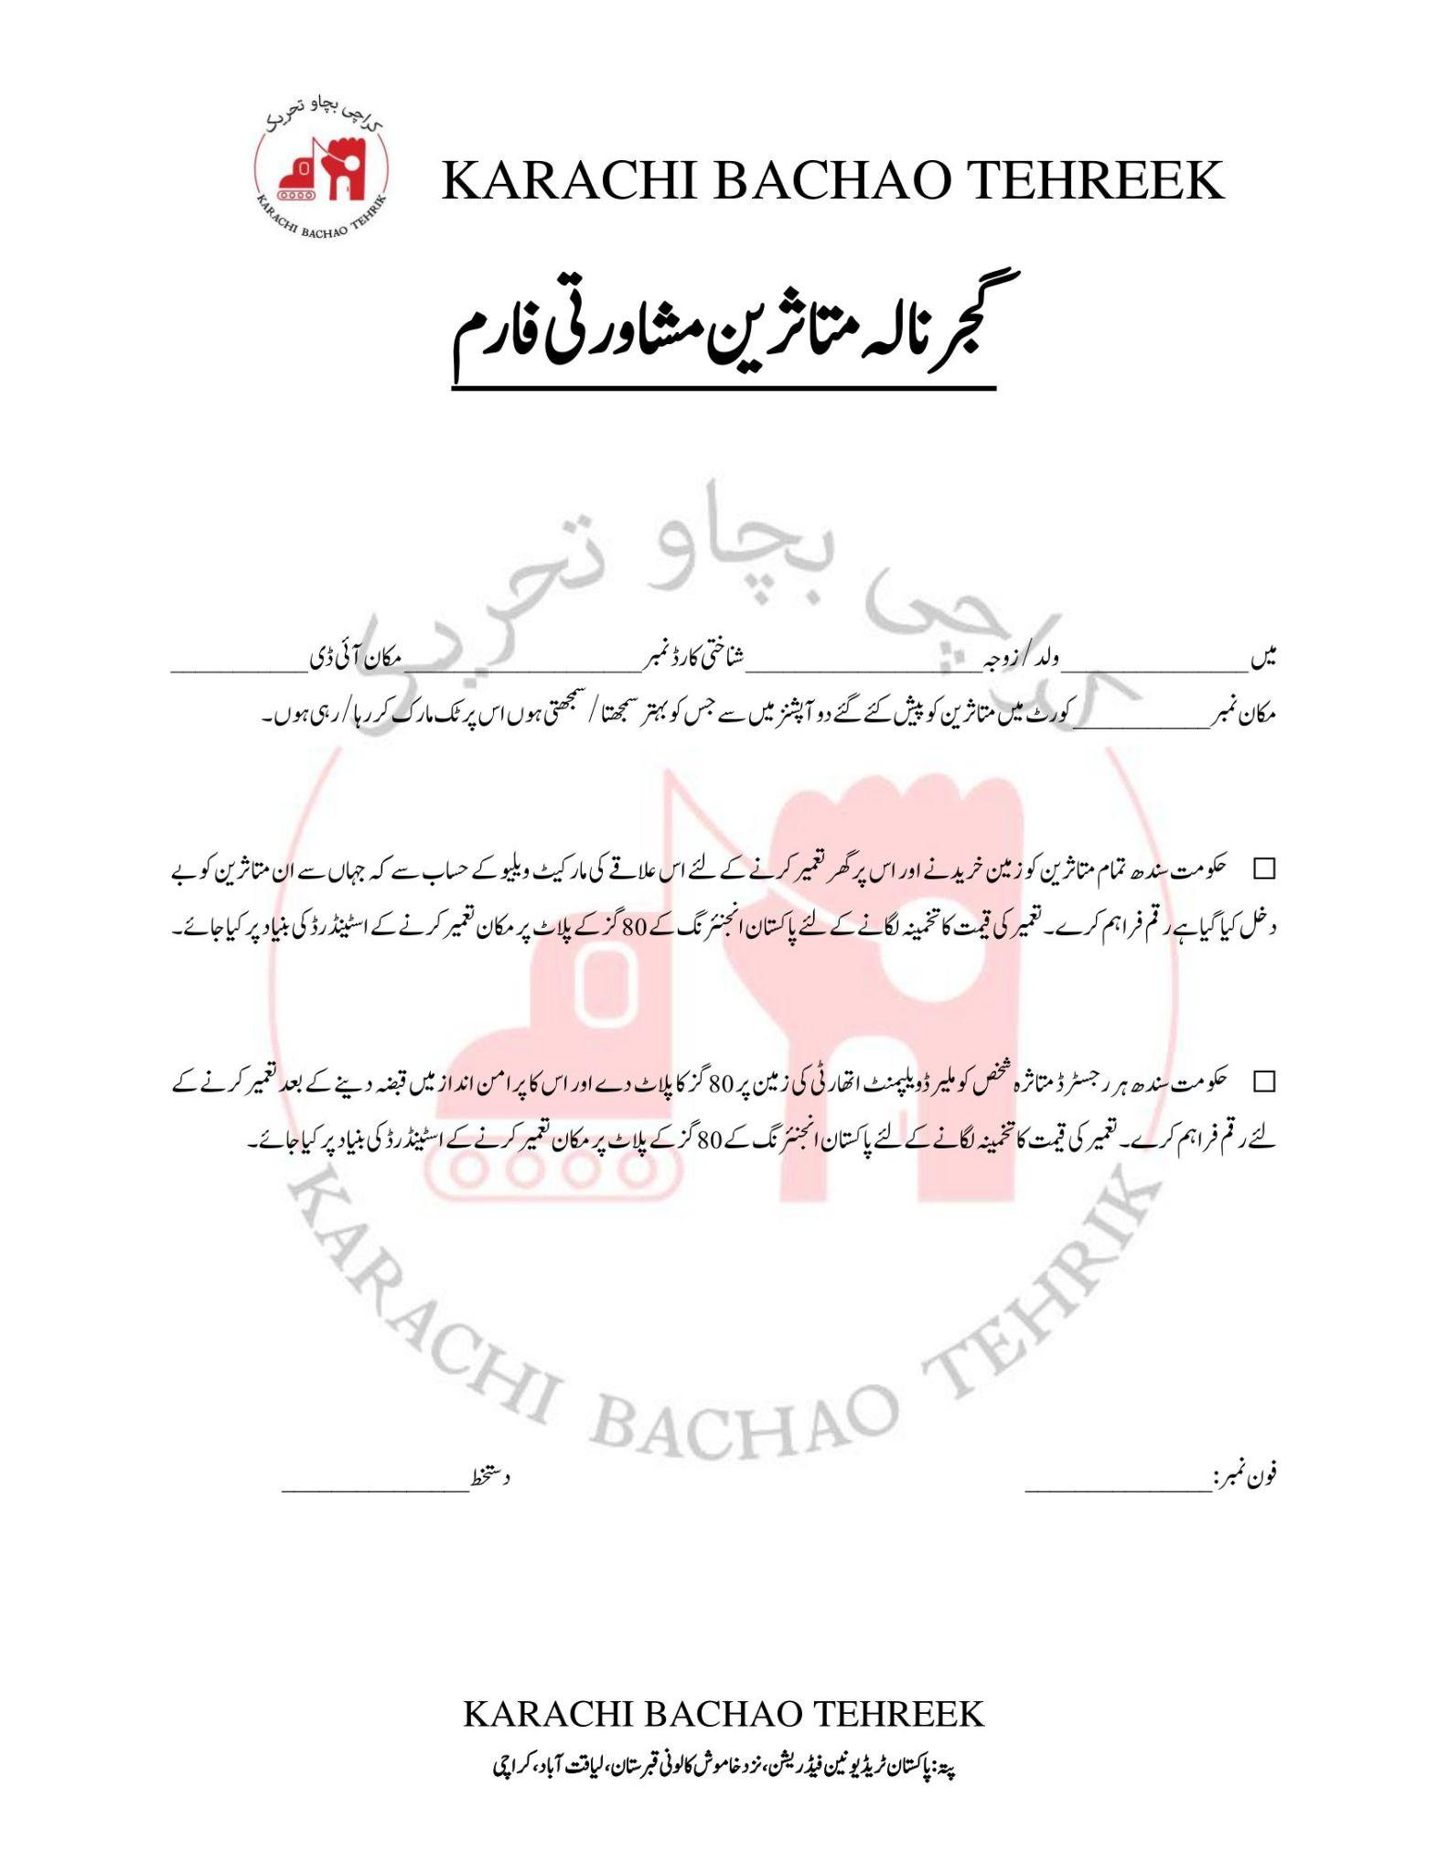

1. <https://karachibachaotehreek.org/docs/gujjar-nala-report.pdf>
2. <http://karachiurbanlab.com/projects/land-governance-gendered-politics-of-displacement.html>
3. <http://karachiurbanlab.com/projects/land-governance-gendered-politics-of-displacement.html>