A place to live in dignity for all: Making housing affordable
Report of the Special Rapporteur on the right to adequate housing to the
78th session of the UN General Assembly
Questionnaire

For States: please share this questionnaire as well with your National Statistical Office and relevant Ministries to assist completing statistical sections relating to housing affordability.
Name of submitting entity, organization or individual: Strategy & Institutional Directorate, Ministry of Housing & Urban Planning (MOHUP).
National law, policies and jurisprudence relating to affordable housing
- Does your country’s national law, including constitutional, housing or social protection law, refer to affordability of housing or provide any other guarantees to ensure a minimum standard of living? Or in its absence, are there national policies that refer to affordable housing or minimum standard of living? Please provide references and links to the respective key laws or constitutional provisions as well as policies.

Since the 1960s, Bahrain’s leadership and government started a long, but steady journey of initiatives and efforts to provide adequate and affordable social housing to facilitate a better life for middle/limited and low-income Bahraini families. This journey started with the issuance of Decree No. (2) Finance of 1962 regarding the Establishment of the Housing and Ownership Project and its operational components, Housing Department, its competent committees, executive regulations, and its explanatory note. In that same year, the Housing and Ownership Committee was established, drafting the first legislation with policies related to offering housing services to citizens and 1963 witnessed the laying of the Foundation Stone of the first new town in Bahrain, i.e. Isa Town.
Bahrain’s Constitution was promulgated in 1973 and amended in 2022, with emphasis on the different components of civil rights, with explicit mention of the citizens’ rights to housing as stipulated within Article 9, Paragraph “F” which declares: “The State shall endeavour to provide housing for citizens with limited income”.
Therefore, there was a need for an official entity to assume the role of providing housing services to citizens, hence the Ministry of Housing was established in 1975, and this historical and important step was followed by a series of Decrees, laws, and ministerial orders to enhance the process and to find the best policies and venues to deliver affordable housing solutions in several affordable forms, beginning with building subsidised dwellings and providing different types of loans to assist eligible Bahraini families to purchase or build their homes on lands they owned or receive a gifted plot from the government represented by the Ministry of Housing to build on, which prompted an approach of a logical sequence in the process of developing and delivering housing services, and it was equally important to develop a housing strategy, controls, and provisions to govern and ensure the delivery process of adequate and affordable housing services to the eligible categories of the community in all its aspects, hence Decree-law No. (10) of 1976 with respect to Housing, with all its regulatory articles, was developed and promulgated to serve that purpose, followed by the promulgation of Ministerial Resolution No. (3) of 1976 with respect to Housing, and Resolution No. (8) of 1976 with respect to Housing Plots Regulations.
Bahrain, as a state and nation, was growing rapidly, and the demand for housing was increasing, and there was a need for a bigger budget to shoulder the growing number of eligible applications and rising costs and development of other government entities to support the housing process. This paved the way for the introduction and establishment of a strategic partner and an executive arm to assist in matters of financial control, disbursement of housing loans, other administrative and financial transactions related to the collection of the reduced installments, and other banking operations to support the process. Therefore, a Housing Bank, i.e Eskan Bank was established to carry on such responsibilities and focus on providing real-estate financing for citizens with low and middle income, which became apparent and was realised through the promulgation of Decree-Law No. 4 of 1979 with respect to establishing the Housing Bank, i.e Eskan Bank. Over the years, Eskan Bank thrived to achieve growth and development, and became a strong strategic partner to the Ministry of Housing and its projects and operations, in regards to providing comprehensive and sustainable housing solutions. Subsequently, many Ministerial orders were issued with respect to the distribution of housing loans to consecutive batches of citizens pertaining to the different categories that were being treated equally as per the terms and conditions with no discrimination whatsoever. Ministerial Order No. (8) of 1976 with respect to Housing Plots Regulations and respective amendments regulated the distribution of gifted housing land plots that were initially government-owned lands designated as residential areas and given to citizens to build on.
The Ministry of Housing continued managing the housing file with all the different developments and challenges, which included economic and political fluctuations in the Gulf and the Middle East region, global economic recessions, and recently the Covid-19 Pandemic with its negative impacts on health and the economy for about two years, and the increase in the public debt, which the government managed successfully through its fiscal balance programme; all collectively have impacted the speed and progress in the construction of housing projects and the sustainable development process. Furthermore, Bahrain signed a number of International agreements and treaties, including Human Rights treaties, and have worked closely with the UN through its different related organisations, i.e UNDP, UN-Habitat, UN-Human Rights, which recognised the rights of different new segments to adequate housing in the Bahraini community, such as divorced and widowed women with minors, was realised with the promulgation of “Ministerial Order No. (83) of 2006 amending some provisions of Resolution No. 3 of 1976 with respect to Amending certain provisions of Ministerial Order No. (3) of 1976 with respect to housing regulations. and finally, the promulgation of the Ministerial Resolution No. (909) for the year 2015 with respect to housing and all its amendments that followed, adding more segments of eligible citizens, including women under the 5th category (Divorced women and widows with no children, and single orphaned from both parents. There was also an emphasis on special cases and citizens with special needs, etc., which helped to increase the number of applicants eligible for housing services, which became evident in the ever-growing housing waiting list.
In addition, the joint efforts of the Ministry of Housing and the different United Nations organisations and programmes, namely the UNDP and UN-HABITAT, in 2019 resulted in updating the National Housing Policy, identifying key challenges, and developing recommendations and solutions towards launching a new national strategy with a new National Housing Policy that aims at making social housing services more sustainable and will ensure more efforts and innovative solutions that involve the private sector’s partnership on a larger scale with the aim to provide sustainable and affordable housing solutions to the Bahraini citizens and work on zeroing the long housing waiting lists.

All regulatory decisions that were issued over the past 6 decades, worked successively to sustain the provision of different subsidised housing services for low and limited-income Bahrainis and through reduced monthly installments (that do not exceed 25% of the beneficiary’s income) paid by the citizen.

- Please explain if there is any official definition or criteria to assess whether a household faces housing costs above the level of affordability in your country.

MOHUP has always strived to provide solutions within its resolutions, policies, and procedures to make housing affordable and sustainable for the Bahraini families. One of the most important criteria in providing housing services is the criterion with respect to the quarter (25%) of the salary, adopted and exercised to ensure the affordability of all housing services for the eligible Bahraini head of the household, and to avoid the housing service beneficiaries incurring installments that are beyond their financial capabilities. As part of the sustainability process, the value of the beneficiary’s salary is updated every two years, and accordingly the installment is adjusted in proportion to the quarter (25%) of the income.
This practice comes in accordance with Article 76 from the Ministerial Order No. (909) of 2015, which states: “The amount of the housing service monthly installment is calculated in proportion to the payment period, provided that the monthly installment does not exceed 25% of the head of the family/household’s monthly income.

The Kingdom of Bahrain as is the case with any other developing sovereign State faces housing unaffordability. Applying the following criteria are employed at MOHUP to assess housing affordability as part of the development of the Housing Policy are as follows:
- Median Multiple is a concept devised by ‘Demographia International’ & calculates a ratio of median house prices with that of median household income.
Source of Information:
Chrome-extension://efaidnbmnnnibpcajpcglclefindmkaj/http://www.demographia.com/dhi.pdf
- Housing Affordability Index is defined the ratio of actual payable income & the required payable income towards house installment. This methodology is widely used by ‘National Association of Realtors, United States of America.
Source of Information:
https://www.nar.realtor/research-and-statistics/housing-statistics/housing-affordability-index

- Please share any important court decisions in your country that relate to the issue of affordable housing or enjoyment of a minimum standard of living, including important judgements on State policies or measures aimed at ensuring housing affordability. Please provide if possible a short summary of the decision and a link to its text.
(e.g. judgements by international, constitutional, supreme or high courts, to rent control measures or rent freezes, to access to housing subsidies, public or social housing, non-discrimination and equal access to affordable housing etc.)
The MOHUP has never filed lawsuits for evictions against the beneficiaries of housing services, whether they are beneficiaries of housing units or ownership apartments, especially that the ministry is aware of the insolvency of the beneficiaries and their inability to pay the monthly installments for their use of the housing service. In this case, the ministry offers support with solutions to assist the beneficiary to pay his dues.

Data and trends on housing affordability
- Is housing affordability regularly measured in your country, region or city, by the national statistical office or other entities? Please explain how housing affordability is measured and tracked. Where is the data published?

Housing affordability is measured & notified with respect to formulation of housing policies. The methodologies are mentioned above for your reference. Further, housing spending (rents and maintenance) is monitored through the Household Income and Expenditure Survey, the results of which are published in the Bahrain Open Data Platform Bahrain Open Data Portal, Home Page.
Moreover, Data related to property valuation are regularly updated on the National Real Estate Data Bank.

- Has housing affordability increased or decreased in your country over the past 10 years? In which regions or cities has housing affordability changed and for whom?

The answer to this question is divided into two parts, A & B:
Part A: Affordability for houses in the Kingdom of Bahrain has declined over a period of ten years with an average median multiple (10.39) above the level 3.0 that denotes affordability. The reason that can be attributed to the reduction in affordability is the rise in the cost of housing units & household income not being able to match the elevated costs. Please, refer to Table No. (1), No. 2 & Diagram No. (2).
Considering the government subsidy, the median multiple would be 3.43 for houses, this increases affordability for citizens to own a suitable house.
As per Demographia International, the following table No. (1) shows housing affordability standard rating:

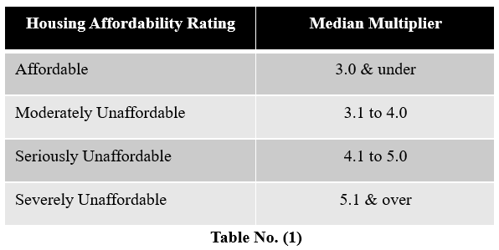

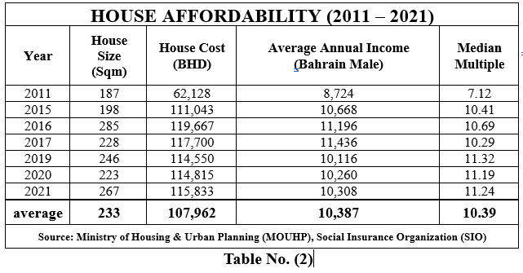
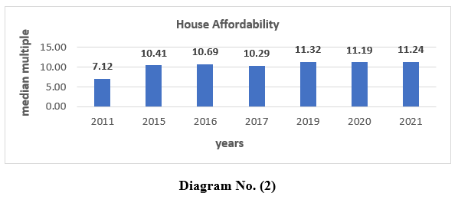

Part B: Apartment affordability is experiencing a southward movement from 6.49 to 8.73 during the period 2016 – 2021. The average median multiple stands at 7.68 against the standard of 3.0. Please, refer to Table No. (3) & Diagram No. (3). Considering the government subsidy, the median multiple would be 3.36 for apartments, this increases affordability for citizens to own a suitable apartment.

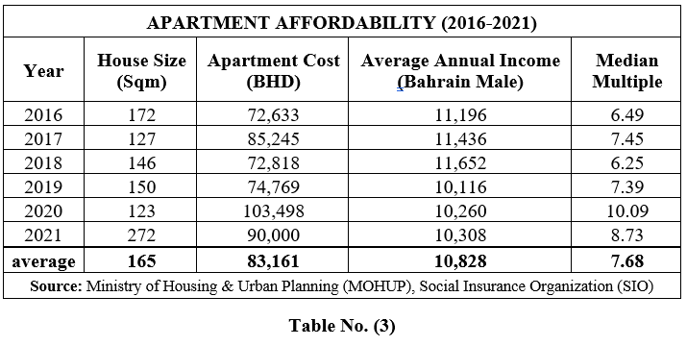
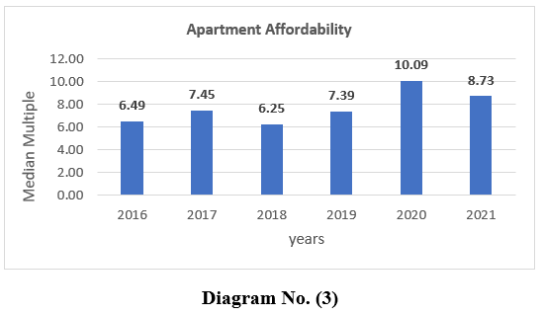

- Please describe which households, persons or groups are at particular risk of being exposed to housing affordability in your country, region or city.
(Please provide data on housing affordability disaggregated on the basis of household size, form of tenure (living in self-owned housing, rental, other), type and quality of housing (e.g. living in formal or informal housing); location (region, urban, rural), type of household (with or without children, single parent households), income, employment status, gender, disability, age, nationality, ethnicity, religious affiliation or immigration status.)

All eligible Bahrainis have the right to Housing as per the government’s social obligation. Therefore, an increase or decrease in housing costs has an impact on the Government and not on Bahrainis eligibility for the housing service.

- May certain specific groups or persons, such as persons experiencing homelessness, living in informal settlements, students, asylum seekers or refugees, potentially be left out in data collection in relation to housing affordability?

Official homelessness is not a reality in the Kingdom of Bahrain. Nevertheless, Bahrain has a state-of-the-art Central Population Registry (CPR) at IGA, which keeps track of all population and living conditions.

Causes and Consequences of housing unaffordability.
- What are main reasons why housing is unaffordable to certain persons or groups in your country? Please provide if possible as well links to (scientific) studies that have analysed such reasons.

The main reasons that can be attributed to unaffordable housing are the high cost of housing units (see Diagram 4) & a certain population living in relative poverty.

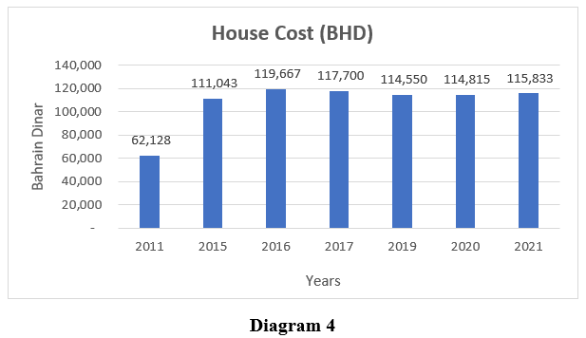
The cost of a housing unit in Bahrain has increased by around 86% during the period between 2021 & 2011. The second reason is the extent of relative poverty. Relative poverty is defined as ‘relative deprivation’ of a certain standard of living by households although the basic requirements towards existence are met. In terms of quantification, a set of the population that is not able to earn an income that is at least 50% of the average household income is called upon as relatively poor. Although, absolute poverty is technically non-existent in the Kingdom of Bahrain as the minimum daily income per household (Bahrain citizens) is 23.71 USD, i.e., 4.00 USD per Bahrain national, however around 9% of the total Bahraini households (143,391), i.e., 13,185 households are categorized as relatively poor.

- What percentage of land is owned or otherwise controlled by the State or other public entities, as contrasted with private entities (both for profit and not for profit)? Please explain if there are any policies or laws which seeks to control the price of land, prevent land speculation including its supply and finance?

In 2019, the Ministry of Housing and Urban Planning (MOHUP) launched the Government Land Development Program (GLDP). This initiative aims to increase the number of affordable housing units available to eligible beneficiaries by creating a strategic partnership with the private sector through a competitive bidding process.
Under the GLDP, real estate developers can bid on government lands to develop sustainable social housing projects. The MOHUP auctions the rights to develop and sell housing units on its lands with capped sales prices in line with social housing financing solutions. Developers bid for the lands based on criteria set by the MOHUP, and the developer with the highest land value wins the rights to develop and sell the units.

After the developers develop the land, they sell the units to MOHUP beneficiaries, and the MOHUP receives the land value agreed upon. If sales do not take place, the MOHUP has a buyback arrangement for the developers. This program eases the burden on developers by not charging them the land value at the onset and ensures a supply of affordable housing units in the market.
Additionally, the GLDP provides a win-win situation for both the government and developers. The government gets to benefit from the sale of the developed lands and generate revenue, while the developers get to access affordable land and creative financing solutions provided by the MOHUP. This approach encourages the private sector to play an active role in providing affordable housing solutions while easing the burden on the government.
The GLDP controls overall land and unit prices, creates a market correction, and prevents a spike in land prices. Moreover, as the units will only be sold to social housing beneficiaries, it controls speculative sales to some degree and pushes the market towards serving the real demand for affordable housing.

- How many households have, during the last ten years been evicted because of their non-payment of housing costs? Please provide, if possible, more information on the socio-economic profile of the concerned households.

As far as MOHUP is concerned, no citizens have been evicted from their housing units/homes due to non-payment of installments, but rather certain facilitations are provided to those citizens defaulting on the payment of their installments, who are unable to pay or settle their debts. The ministry usually facilitates by reducing their monthly installments, knowing that the ownership of the property is conditional to the payment of the complete installments due to the ministry before that can be possible.

- How many individuals, households or groups have, during the last ten years, been rendered homeless because of inability to afford housing? Please provide a breakdown of the socio-economic characteristics of such individuals.

Homelessness or Slum formation in Bahrain is absent. The mandate of MOHUP is to facilitate housing solutions for citizens with low or limited income and cannot afford a house.

- Please describe how housing unaffordability impacts the capacity of individuals and families to enjoy their other human rights including rights to work, health, education, and access to personal security in all its dimensions.

Bahrain’s Constitution explicitly mentions the citizens’ rights to housing as stipulated within Article 9, Paragraph “F” which declares: “The State shall endeavour to provide housing for citizens with limited income”. Moreover, all human rights in the Kingdom of Bahrain is granted regardless of affordability.
- Please share an overview of the laws, policies, programmes and practices adopted in your country/region/city to ensure that housing is affordable for all without any discrimination, Please, provide links to relevant official texts.
(e.g. affordable housing, social and energy cost subsidies, preferential mortgage, building support schemes, provision of social and public housing, of serviced land for self-construction, rent containment and rent control measures, taxation, measures to reduce housing vacancy, multi-stakeholder initiatives by State, local Governments, construction industry, housing providers, tenant unions etc).
Please find the answer below.
- Please share an assessment of the success, limitations or potential failures of the above mentioned laws and policies in your country/region/city, including any studies or independent evaluation reports related to them. Who has benefited from them, who has not? What has worked well, what - less? What lessons can be learned? What could potentially be replicable in other countries/regions/cities?

Answer is for both questions (13 & 14):

As per the updated National Housing Policy in 2019, the Ministry of Housing and Urban Planning (MOHUP) has provided around 130,000 housing services since its inception.
Ministry of Housing and Urban planning in the kingdom of Bahrain always seeks to offer affordable housing solutions to achieve the aspirations of citizens, by offering flexible financing solutions and options as shown below:
Tas’heel Aqari Programme options: Financing for the purchase of a land plot and construction on it, purchasing a building and adding to it, purchase of a ready-built home, financing for the construction of a residential land plot owned by the applicant and purchase of residential land plot for a maximum finance amount of BD70,000/- and minimum of BD40,000/- where the repayment term is up to 30 years.
Tas’heel Albait Aloud: Financing to provide a housing unit within a family property. Where the beneficiary can purchase or build a housing unit in the form of an apartment or an attached independent annex to the family house, buy or build on a real estate owned by up to the fourth-degree relative of the husband and wife. Ownership of the home can be transferred to the applicant as shares on a pro-rata basis or by the issuance of an individual separate title deed.
Tas’heel Ta’awon: Financing jointly purchase or construct a property with other friends or family members. Buying or constructing a property in the form of an apartment building, apartment complex, or attached dwellings or compound. Ownership of the property to be transferred in case.
Mazaya Program: Financing from a Partner bank where monthly installments are subsidized by the government.
Housing Plot service: This service grants citizens a free land plot to build a housing unit from their own savings or financing.
Unit Ownership Service: This service allows citizens to apply for a housing unit or an apartment in one of the residential buildings or housing projects of MOHUP.

Furthermore, the Government Land Development Programme (GLDP) is a new and promising initiative launched by the MOHUP in 2019. The pilot project at Al Lawzi, consisting of 132 units, is expected to be completed by the end of April 2023. Currently, three new projects are in the auctioning stage launched in December 2022.
To ensure the success of the program, MOHUP has taken a proactive approach and sought feedback from developers and unsuccessful bidders of the pilot project to refine and enhance the new projects' requirements. The main challenge is ensuring that developers have the appropriate resources and support to raise the required funding for development in challenging market conditions with rising interest rates.
To address this challenge, the MOHUP has provided a buy-back guarantee that would be assigned to the financing bank of the developer. The MOHUP has also calculated the most appropriate sales cap price of the unit to ensure that the units are attractive to social housing beneficiaries.
Another challenge faced by the program is coordination with all the required authorities to ensure that all the necessary permits are available to the developer to facilitate the construction of the units and obtain the required title deeds to smoothen the sales process.
The MOHUP recognises the importance of feedback from developers and continues to take their concerns into consideration. The GLDP program allows the private sector to provide the required units for social housing beneficiaries and create movement in the market. In conclusion, the GLDP is a promising initiative that has the potential to significantly impact the affordable housing crisis and contribute to the sustainable development of the housing sector.

Submission instructions
Deadline: 20 April 2023
Email: Please return this questionnaire to: Human Rights Affairs Sector - Ministry of Foreign Affairs
Email subject line: Input for SR housing - report on housing affordability
Accepted File formats: Word (supporting documents may be submitted in PDF)
Accepted languages: English, French and Spanish
Please include references to reports, academic articles, policy documents, text of legislation and judgments, statistical information with hyperlinks or attach them to your submission (please respect total file size limit of 20 MB per email to ensure that it can be received)
Publication: Submissions of States and public authorities will be published. For other stakeholders, submissions will be published, except confidentiality is explicitly requested.
Expected presentation of the report of the Special Rapporteur to the General Assembly: October 2023.

