Human rights data on affordable housing
The Human Rights Measurement Initiative (HRMI) produces data tools that track how effectively a country is using its resources to protect human rights. Our data on the right to affordable housing include 36 European countries, and could assist in the preparation for the upcoming report on the right to adequate housing for the 78th session of the UN General Assembly.
HRMI calculates its scores by looking at what a country could be achieving at its level of income (100%) and then producing a score to show what the country is actually achieving. This means that every country should be able to achieve 100% if it used its resources effectively to meet its human rights obligations. All of our data are freely available on the Rights Tracker.

Right to housing
HRMI tracks the right to housing for 193 countries and territories. The SERF methodology we use to produce country scores selects a small number of ‘bellwether’ indicators to give an overview of people’s experiences in each country. The indicators we use to produce country scores include housing affordability and safely managed sanitation (for high income countries), and access to water on the premises and basic sanitation (for low and middle income countries). These indicators are sourced from databases such as the World Health Organisation, the UNICEF Joint Monitoring Project, and EuroStats.

Stats
Our methodology on economic and social rights scores each country on their fulfillment of the right to housing within the limits of their income. Income-adjusted scores allow us to compare different countries’ performances.
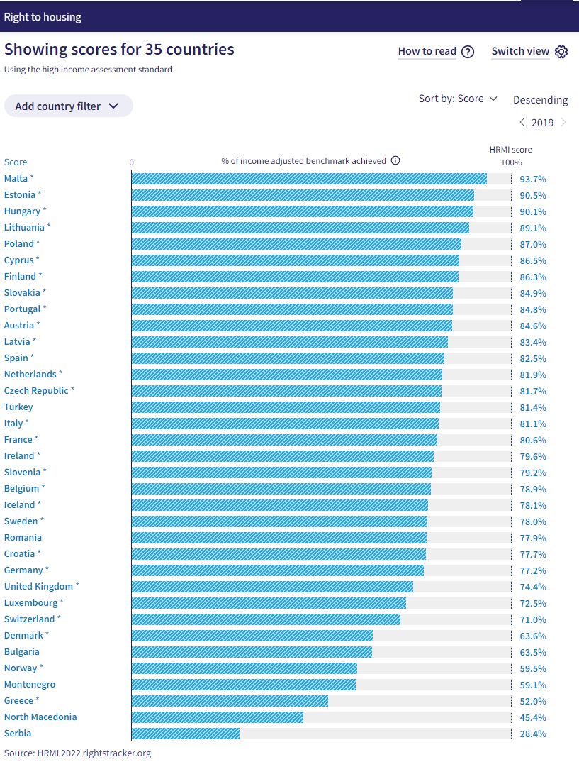
HRMI right to housing scores using the high-income assessment standard (Income-Adjusted)
Our latest dataset measures the right to housing in 2019 (the most recent indicators available). The 10 top scoring countries for the right to housing, taking income into account, are:
Low and middle income countries  - Singapore  - San Marino  - Puerto Rico  - New Zealand  - Macao  - Kuwait  - Burundi  - Austria  - Malta  - Israel | High income countries  - Malta  - Estonia  - Hungary  - Lithuania  - Poland  - Cyprus  - Finland  - Slovakia  - Portugal  - Austria
The top 8 of the low and middle income countries are scoring 100%.
A 100% score means a country is using its resources as effectively as possible to guarantee and protect the right to housing. In order to improve housing rights for its people, it needs more financial resources.

Right to affordable housing
We measure the right to affordable housing in our high income assessment standard, but we produce scores for all countries where the underlying indicator data are available. On the following page you may find our most recent income-adjusted data from 2019 regarding the right to affordable housing. The table includes 36 European countries and ranks each from highest to lowest scores.
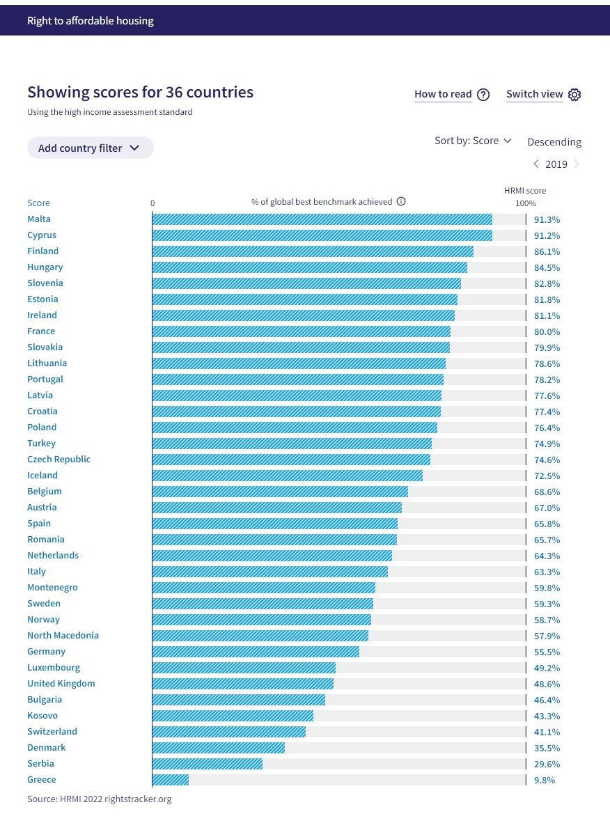
HRMI right to affordable housing scores (Income-Adjusted)

Changes over time
The Rights Tracker also shows how scores change over time. Looking at Greece, the right to affordable housing scores dropped significantly after 2010.
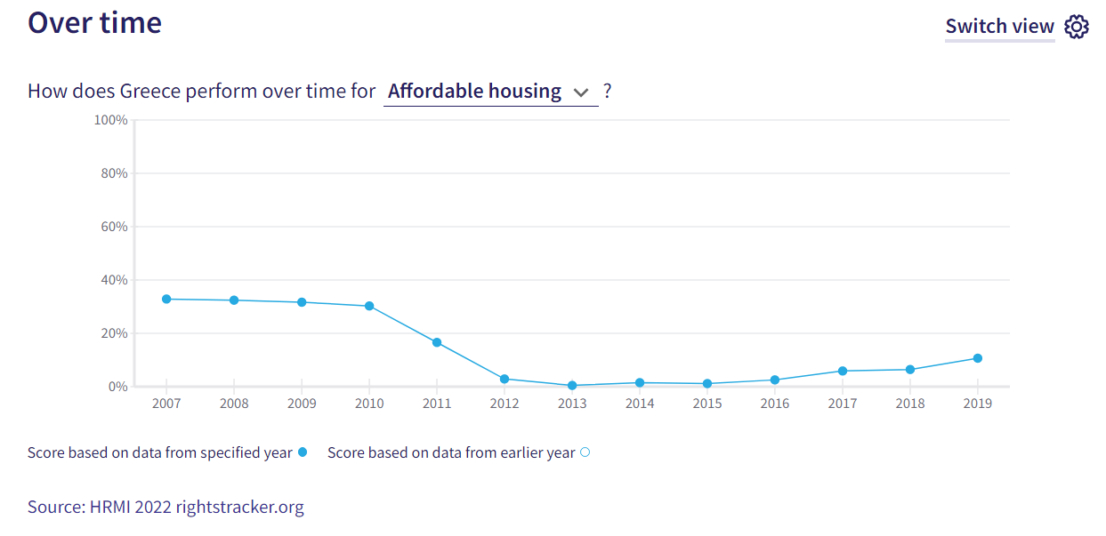
Right to affordable housing performance over time in Greece, HRMI scores

If we take a look now at Croatia, we can see steady improvement from 2015, when it comes to ensuring access to affordable housing.
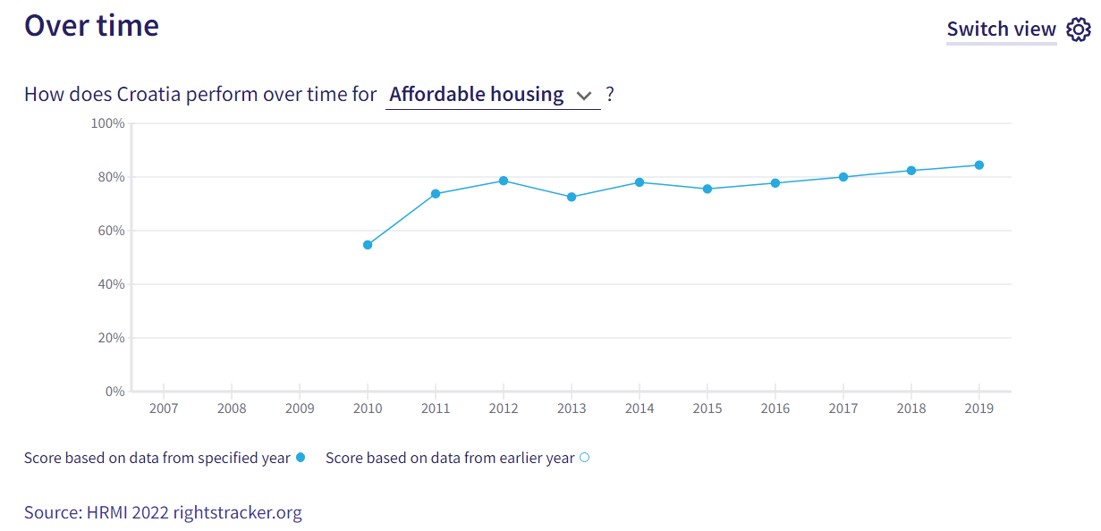
Right to affordable housing performance over time in Croatia, HRMI scores
For additional information on how countries have scored on the right to affordable housing over time, please visit the country page on the Rights Tracker, click the Quality of Life tab, scroll down to the Over Time graph, and select the Affordable Housing option in the dropdown menu.
HRMI also categorizes each score as good, fair, bad, and very bad to help interpret how a country is performing. To view this information for a specific country, please refer to the At a Glance tab on the country’s page.

Groups at risk
HRMI uses a different methodology for measuring civil and political rights by surveying human rights experts about rights violations in their country, and asking them which groups of people are especially vulnerable to violations.
We ask expert respondents specifically about which groups of people are at risk of violations of their right to housing. Experts also provide additional context about violations of this right in their country.
For example, in 2022, the vulnerable groups in Australia most frequently identified as being at risk of having the right to housing violated were (image below):
- Indigenous people
- People with low social or economic status
- People who are homeless
- Street children or homeless youth
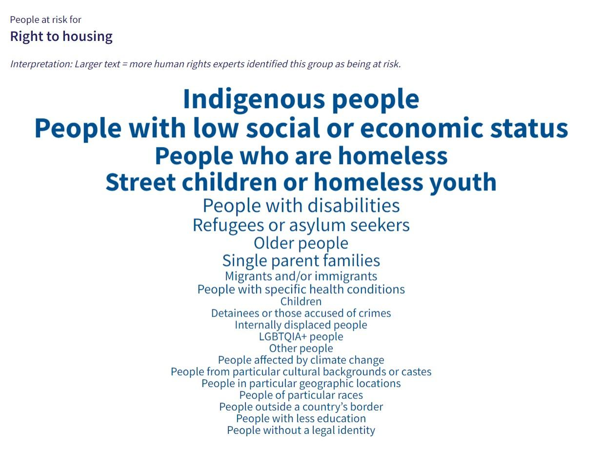
People at risk groups for right to housing in Australia

When asked for further details about people at risk of housing rights violations in Australia, human rights experts said:
- Older people and people with disabilities, as there has been no increase in access to affordable housing or social and public housing
- All people, particularly people who are homeless, due to an expensive rental market and the lack of policies to solve housing problems
- Young people, people with disabilities, and older people, especially Aboriginal people and Torres Strait Islanders, due to the low quantity of public housing available and high prices in the private market
- Indigenous people, particularly those who live in state-owned houses, which are not fully adequate for habitation

Similarly, South Korea and Saudi Arabia also indicate that groups especially at risk of having their right to housing violated include young people and people with low social or economic status. Both countries attribute these risks in part to rising housing costs and lack of affordable housing and public/social housing.
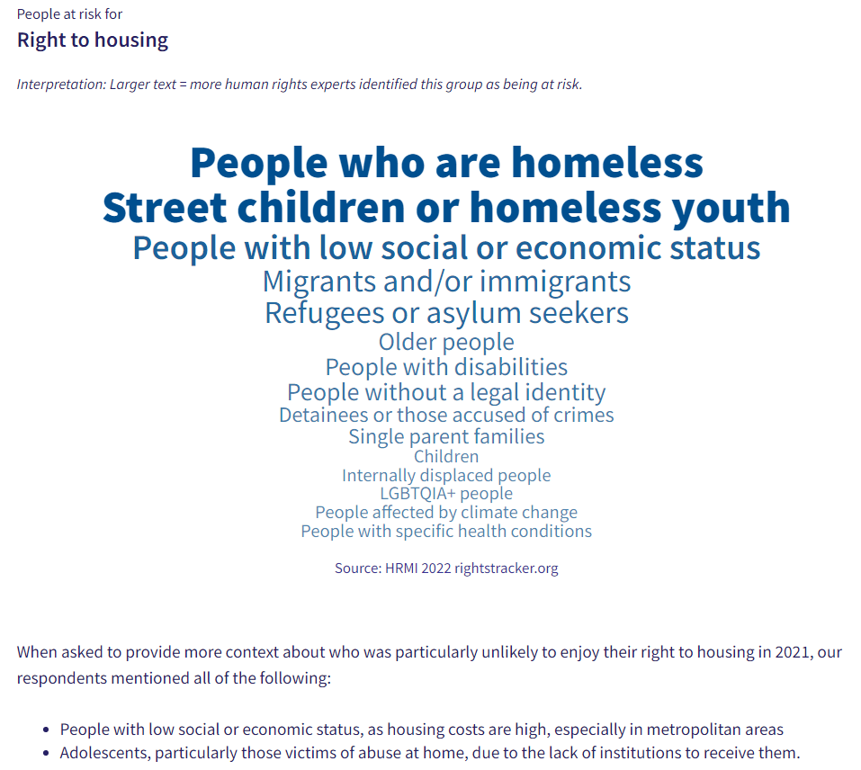
People at risk groups for right to housing in South Korea
For additional information on the groups that are at risk of having the right to housing violated, you can find these data on a country’s page by clicking the People at Risk tab and scrolling down to the Right to Housing section. Select ‘show more information from survey respondents’ for the additional context.

Please don’t hesitate to contact us at HRMI if you have clarifications or inquiries. We are always happy to help you incorporate Rights Tracker data in your work.
Contact information: Thalia.KehoeRowden@hrmi.ngo and Yoyo.Pasieka@hrmi.ngo
Prepared by Nazia Kazi from the Human Rights Measurement Initiative, for the United Nations Special Rapporteur on the Right To Adequate Housing: Balakrishnan Rajagopal, April 2023.

