A place to live in dignity for all: Making housing affordable
Report of the Special Rapporteur on the right to adequate housing to the
78th session of the UN General Assembly
Questionnaire
For States: please share this questionnaire as well with your National Statistical Office and relevant Ministries to assist completing statistical sections relating to housing affordability.
Name of submitting entity, organization or individual:
Centre for Affordable Housing Finance in Africa (CAHF), based in Johannesburg, SOUTH AFRICA

29 April 202

National law, policies and jurisprudence relating to affordable housing
- Does your country’s national law, including constitutional, housing or social protection law, refer to affordability of housing or provide any other guarantees to ensure a minimum standard of living? Or in its absence, are there national policies that refer to affordable housing or minimum standard of living? Please provide references and links to the respective key laws or constitutional provisions as well as policies.

This is not our organisation’s area of expertise.

- Please explain if there is any official definition or criteria to assess whether a household faces housing costs above the level of affordability in your country.

This is not our organisation’s area of expertise.

- Please share any important court decisions in your country that relate to the issue of affordable housing or enjoyment of a minimum standard of living, including important judgements on State policies or measures aimed at ensuring housing affordability. Please provide if possible a short summary of the decision and a link to its text. (e.g. judgements by international, constitutional, supreme or high courts, to rent control measures or rent freezes, to access to housing subsidies, public or social housing, non-discrimination and equal access to affordable housing etc.)

This is not our organisation’s area of expertise.

Data and trends on housing affordability
- Is housing affordability regularly measured in your country, region or city, by the national statistical office or other entities? Please explain how housing affordability is measured and tracked. Where is the data published?
Housing affordability is tracked as part of CPI. StatsSA publishes CPI Housing and Utilities data every month, with 2008=100. In the last year, CPI Housing and Utilities has risen from 100.4 in April 2022 to 104.5 in March 2023.

The National Department of Human Settlements defines the affordable housing market to be the approximate cost of bonded entry level housing in South Africa, capable of being mortgaged, adjusted annually by the midpoint of the average Consumer Price Index (CPI) and the average Building Cost Index (BCI). This is in accordance with Financial Sector Code Affordable Housing Standards.

- Has housing affordability increased or decreased in your country over the past 10 years? In which regions or cities has housing affordability changed and for whom?

The number of high end properties has been growing over the last two years, while the number of properties under R600 000 (32 698 USD) is dropping. From 2020 to 2021, the number of properties over R3m (163 488 USD) increased by 13%, while the number of entry level properties below R300 000 (16 349 USD) fell by 28%. This was a continuation of the same trend from 2020, when the number of luxury properties increased by nearly 10%, while the stock of low value properties declined.

This is likely due to appreciation of low-end properties—these figures are in nominal terms and do not account for inflation. As noted above, the total value of the residential property market increased by 6.23% in 2020 and then by 4.86% in 2021. With this nominal increase in value, properties will shift into higher value bands.

- Please describe which households, persons or groups are at particular risk of being exposed to housing affordability in your country, region or city.

(Please provide data on housing affordability disaggregated on the basis of household size, form of tenure (living in self-owned housing, rental, other), type and quality of housing (e.g. living in formal or informal housing); location (region, urban, rural), type of household (with or without children, single parent households), income, employment status, gender, disability, age, nationality, ethnicity, religious affiliation or immigration status.)

Housing affordability is a pervasive issue in South Africa. The persons or groups who are most affected are: residents of informal settlements, households living in overcrowded dwellings or in backyard rental units which are not safe and properly serviced, the homeless population in the inner city of major urban areas. With an extraordinarily high unemployment rate of 32.7%, millions of households do not have an income earner in formal employment and thus are unable to access a mortgage. South Africa’s government housing programme has delivered over 4 million housing opportunities since 1994, but there is still a large portion of the population who are living in informal dwellings. Many poor households have been on the ‘waiting list’ for fully subsidised housing (available for eligible residents with an income of R3500/month of less (191 USD)) for a number of years, up to 20.

- May certain specific groups or persons, such as persons experiencing homelessness, living in informal settlements, students, asylum seekers or refugees, potentially be left out in data collection in relation to housing affordability?

In the most recent national Census 2021, South Africa increased efforts to reach the population living in informal settlements, student housing, and the homeless population or those living in abandoned buildings in the inner city. However there is still concern the these groups are not well-represented and reflected in survey data. One particular population which is not well-understood is households living in backyard rental—informal shacks, small buildings or rooms, in the backyard of formal dwellings, that are rented out formally or informally, or provide accommodation for extended family members. The government’s Free Basic Services programme, implemented through the municipalities, provides an allotted amount of electricity and water to low income households at no cost, but when there are a number of backyard dwellers, the single FBS connection for the formal house doesn’t reach the backyard tenants, who are accessing utilities through the main house.

The research and analysis that CAHF undertakes on South African cities utilises deeds registry data as of 31 December 2021 which was obtained from Lightstone Pty Ltd. in June 2022. Because of this, the analysis only covers properties which appear on the deeds registry (the formal market) – it does not include backyard units and informal settlement dwellings. According to the 2021 General Household Survey, there are 17.9 million households living in South Africa, of which 11.7%, or approximately 2 million, live in informal dwellings.

Deeds data analysis also does not do a good job of tracking the rental market. Given that more than one family might live in a rental property with a single title deed—for example, a high-rise building—the data used in our CAHF analysis also does not provide a clear picture of the 18.7% of households who stay in rented dwellings (approximately 3.6 million households).

Causes and Consequences of housing unaffordability
- What are main reasons why housing is unaffordable to certain persons or groups in your country? Please provide if possible as well links to (scientific) studies that have analysed such reasons.

Housing affordability is effectively a function of three factors:
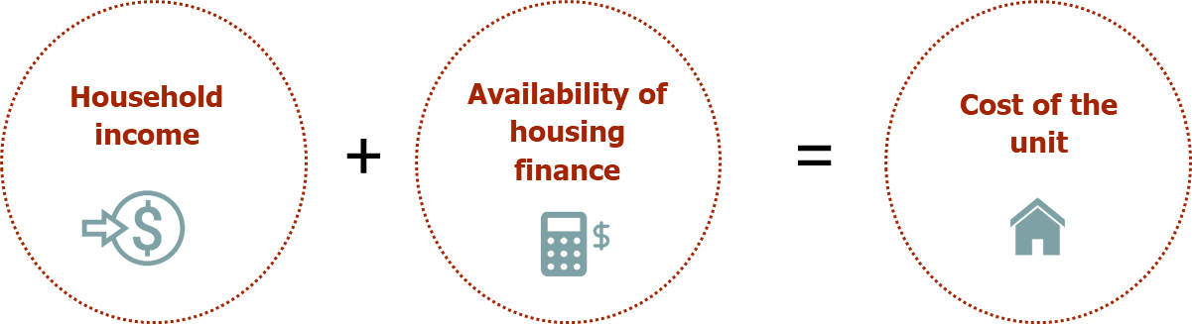
Availability and terms set by the lender within the framework of the National Credit Act, and Basel III, and monetary policy (especially the Repo Rate)
Disposable income, after payment of monthly expenses, including existing credit obligations.
Also impacted by spatial segregation, which increases cost of travel from work to home.
Newly-built unit: a function of land, infrastructure, construction costs; professional fees; taxes, levies, and time – the time it takes to make certain approvals has a significant impact on the price.
Resale unit: a function of the local property market dynamics, including the interplay of demand and supply, and transaction costs.

Household income

For low income households, monthly disposable income is often undermined by existing debt obligations, which lead to home loan applications being declined. In South Africa, the main reasons for loan application rejections are affordability, over-exposure to credit, and poor credit scores.

Spatial segregation also has a direct financial impact on household income. A unit outside the city centre may be less expensive to purchase or rent. But the savings from purchasing a lower-price unit 50 kms outside the city centre may be negated by the additional travel costs of commuting daily into the city centre for work. In the absence of an affordable, safe, wide network of public transport, travel costs are a major factor in undermining household disposable income, and thus impact on housing affordability.

Cost of the unit

After household income, the second element of understanding housing affordability is the cost of the unit. The cost of newly-built housing unit is a function of land, infrastructure, construction costs, professional fees, taxes, levies and time, while the cost of a resale unit is a function of the local property market dynamics, including the interplay of demand and supply, and transaction costs.

Relevant research: Calculating the cost of an affordable house in different African countries

CAHF has done extensive work to develop a standardized methodology to calculate the cost of a benchmarked (standard design and specification) ‘CAHF house’ in thirty cities in fifteen countries across Africa. The 2019 report provides a detailed cost breakdown comprising up to 300 discrete cost elements that meets construction conventions across the continent. This costing framework was completed by professional Quantity Surveyors in each selected country and consolidated into a centralized database for comparison—an online dashboard allows exploration of the data.

The study shows wide variation in the total costs of the standard ‘CAHF house’ in the thirty cities and fifteen countries, with significant variation in the composition of costs between the main cost elements. This analysis thus illustrates the difficulty of comparing affordable housing costs across cities, countries and continents without greater methodological rigour regarding how housing is defined and how costs are compiled.

The results of this study have implications for how affordable housing is defined and analysed, and for better understanding the cost drivers of affordable housing in different geographies. Analyzing housing costs beyond general figures such as cost per square metre provides a better platform for applied analysis that can ascertain where and how to tackle factors that drive up affordable housing costs in specific countries and cities.

The full report is available here: https://housingfinanceafrica.org/documents/using-cahfs-housing-cost-benchmarking-methodology-to-analyse-housing-costs-in-fifteen-african-countries/

Are there low-priced units available in the South African market? As at end of 2021, there were approximately 6.74 million residential properties on the deeds registry in South Africa, of which 31% were delivered through national housing subsidy programmes (2.13 million properties). The contribution of government housing programmes at the lower end of the market is significant: approximately 69% of residential properties in the bottom market segment under R300 000 are government-subsidised. Therefore, largely as a result of government housing programmes, the majority of the residential property market is actually valued below R600 000 (32 698 USD)—at the end of 2021, 52% of residential properties (3.46 million) fell in the affordable category below R600 000, as shown in the figure below.

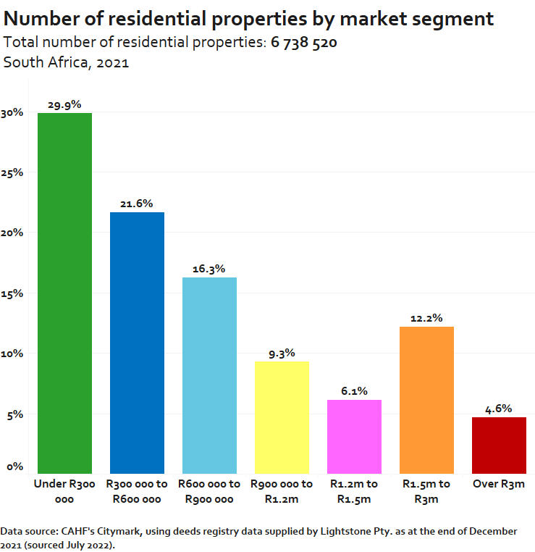

However the stock of houses in the lower market segments has been declining, while the stock at the high end is rising, as shown in the figure below.

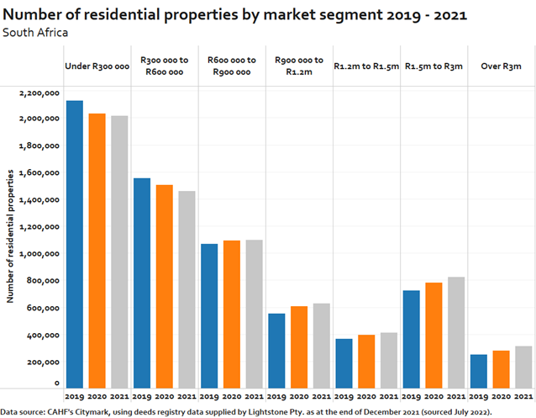

Government housing programmes are responsible for a significant share of the new build market: 32% of new residential transactions in 2021 (approximately 20 000 transactions) were government-subsidised houses. Indeed, new housing stock at the lower end of the market is almost entirely the result of government intervention: in 2021 86% of new residential transactions in the under R300 000 market segment were built by government.

If a low income household is unable to obtain a government-subsidised house, then the only other option for obtaining a new unit is to purchase one from a private developer or to self-build. However, in recent years, we are seeing few private developers building new units in the lowest market segment. It is rare to find private developers building houses priced below R750 000 (40 872 USD), as most developers feel the project costing is not viable. Research from CAHF reports that the cheapest newly-built house being produced and sold in South Africa in urban areas in 2022 was R679 000, (37 000 USD) but supply is limited—as noted in the figures above.

On the whole, private developers are not building new units in the low market segments below R600 000 (32 698 USD) or even R900 000 (49 046 USD). Overall, the number of properties in the lower market segment valued below R600 000 has been falling in the last 5 years due to reduced delivery and some of the properties filtering into higher market segments. This poses a serious challenge to many South African households whose incomes only allow them to purchase entry level properties valued R600 000 or less.

Availability of housing finance

Housing finance serves as the third critical element in housing affordability, by bridging the gap between household income and the cost of the unit. With a mortgage at current interest rates (11.25%), a monthly income of at least R21 300 (1 161 USD) is needed in order to purchase the cheapest newly-built house (R679 000; 37 000 USD) with a bond. (This is assuming that a poor credit score or other demands on disposable income do not lead to the mortgage application being declined.)

However, there has been little growth in the mortgage market in recent years. Mortgage lending in South Africa has largely recovered after the 2008 global financial crisis, but only in the middle and high end markets. In 2007, approximately 14.5% of households in South Africa had a mortgage. By 2021, this had declined to 9.3% of households. In 2020 the South African Reserve Bank reduced interest rates substantially, dropping them to record lows in order to respond to the economic impact of COVID. In 2021, we then saw a spike in residential transactions and bonded sales, as the residential property market rebounded from COVID (see figure below). However market activity has since dropped again in 2022, and is closer to 2018-2019 levels.

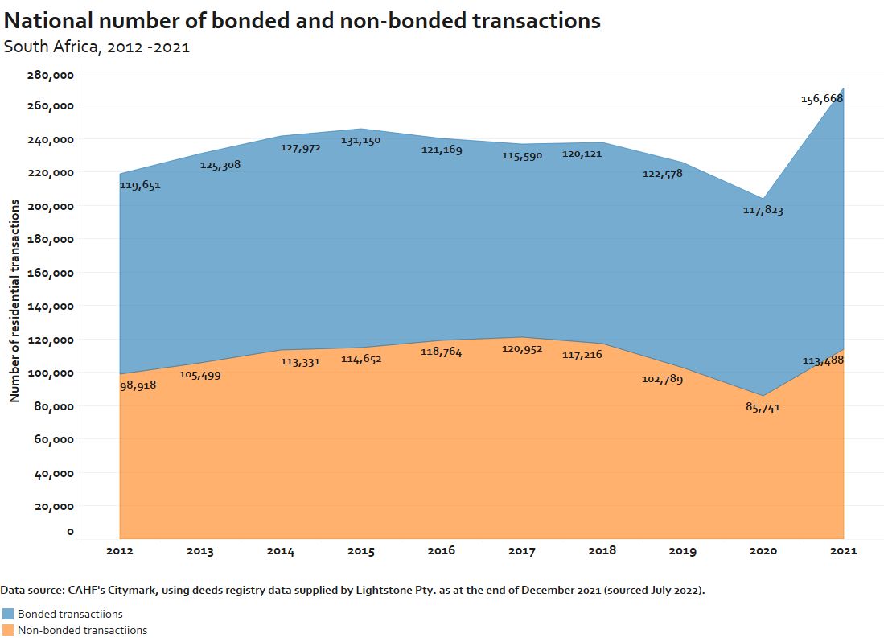

For low-income households especially, access to housing finance is limited, and declining, for both new and resale transactions. Increasingly, mortgages are approved for the purchase of higher priced homes, not for affordable houses at the lower end of the property ladder—see figure below. In Q4 of 2022, 68% of mortgages were granted in favour of larger sized credit agreements over R700 000 (38 147 USD). A further 22% of mortgages were granted for agreements were between R351 000 (19 128 USD) and R700 000 (38 147 USD), leaving only 10% of mortgage agreements for less than R350 000 (19 074 USD). Of all the bonded transactions in 2021, only 10% were in the two lowest market segments and less than 1% were for properties valued under R300 000 (16 349 USD).

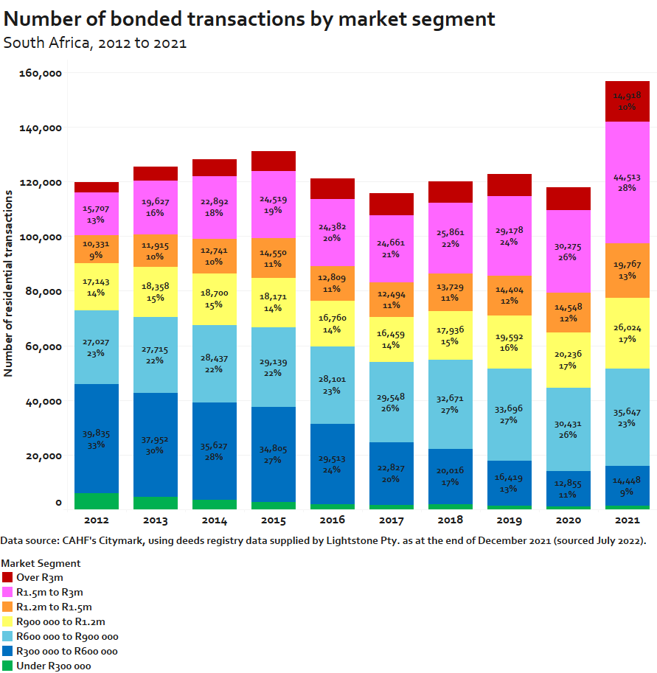
The data also shows that far more mortgage agreements are made with higher income individuals. In 2022, 98.3% of mortgage agreements granted were for individual with gross monthly income of over R15 000/month (817 USD).

In an effort to address these issues, housing affordability in South Africa is aided by specific housing subsidy programmes targeted at the ‘gap’ market—households that earn too much to qualify for fully subsidised housing, and too little to purchase a house with a mortgage without state assistance.

The FLISP programme, recently re-branded as First Home Finance, is a government subsidy programme in South Africa intended to provide funds to first-time homeowners with an approved mortgage from a bank—the funds are intended to be used either for the downpayment or to reduce the monthly repayments. However over the last few years, delivery on the programme has been incredibly slow, partly due to low awareness of the programme and low take-up, and partly due to burdensome and slow approval and payment procedures. However, with the rebranding of the programme to First Home Finance, government has also made two important policy changes aimed at expanding the reach of the programme. First, the subsidy was extended to non-mortgage credit such as pension-backed loans and housing micro finance, although the regulations and procedures for how to disburse these subsidies has not yet been sorted out. Second, the subsidy amount was increased. Administered on a sliding scale, households with total gross income of R3 501 qualify for a maximum subsidy of R130 505, while those with a total gross income of R22 000 (1 199 USD) only qualify for R30 000 (1 635 USD).

With a mortgage and a FLISP, the cheapest newly built house by a private developer (R679 000; 37 000 USD) might be affordable to a household earning R20 400 (1 112 USD) per month, assuming that a poor credit score or other demands on disposable income do not lead to the mortgage application being declined. However, R22 000/month (1 199 USD) is the maximum monthly income allowable to be eligible for FLISP. And since the focus of the FLISP has mainly been on new build, most of the delivery on the FLISP programme has been at the very high end of the target market. Furthermore, partly as a result of the high level of indebtedness of many low-income households in South Africa, the rejection rate for mortgage applications stood at 69% at the end of 2022.

The housing sector is trying to tackle these affordability issues in a number of ways: reducing the cost of the construction of the house through alternative building methods, working with banks to support and encourage down-market lending, improving service delivery and urban management to increase property values in neighbourhoods, and addressing the challenges in the FLISP subsidy programme. However the particular issue of non-creditworthiness of households requires interventions to roll out financial literacy and debt rehabilitation programmes. Another important innovation in South Africa is rent-to-own schemes that see households pay rent and contribute to savings for a few years before acquiring a bond to purchase the unit. These programmes possess great potential in South Africa, as they enable households to recover and build up their credit record and prepare financial for home ownership, before approaching the bank for a bond. Combined with the FLISP programme, rent-to-buy can be a structured, facilitative pathway to ownership.

- What percentage of land is owned or otherwise controlled by the State or other public entities, as contrasted with private entities (both for profit and not for profit)? Please explain if there are any policies or laws which seeks to control the price of land, prevent land speculation including its supply and finance?

This is not our organisation’s area of expertise.

- How many households have, during the last ten years been evicted because of their non-payment of housing costs? Please provide, if possible, more information on the socio-economic profile of the concerned households.

This is not our organisation’s area of expertise.

- How many individuals, households or groups have, during the last ten years, been rendered homeless because of inability to afford housing? Please provide a breakdown of the socio-economic characteristics of such individuals.

This is not our organisation’s area of expertise.

- Please describe how housing unaffordability impacts the capacity of individuals and families to enjoy their other human rights including rights to work, health, education, and access to personal security in all its dimensions.

This is not our organisation’s area of expertise.

Laws, policies, programmes and practices aiming to ensure that housing is affordable to all without discrimination
- Please share an overview of the laws, policies, programmes and practices adopted in your country/region/city to ensure that housing is affordable for all without any discrimination, Please, provide links to relevant official texts (e.g. affordable housing, social and energy cost subsidies, preferential mortgage, building support schemes, provision of social and public housing, of serviced land for self-construction, rent containment and rent control measures, taxation, measures to reduce housing vacancy, multi-stakeholder initiatives by State, local Governments, construction industry, housing providers, tenant unions etc).

This is not our organisation’s area of expertise.

- Please share an assessment of the success, limitations or potential failures of the above mentioned laws and policies in your country/region/city, including any studies or independent evaluation reports related to them. Who has benefited from them, who has not? What has worked well, what - less? What lessons can be learned? What could potentially be replicable in other countries/regions/cities?

Delivery of government housing programmes since 1994 has profoundly altered the shape of South Africa’s property market such that more than half of residential properties are in the affordable housing segment (valued less than R600 000). The national government housing programme has played a massive role in shaping the supply and segmentation of the market. The availability of stock in the entry market is predominantly attributable to public investment: 69% of units valued under R300 000 were GSP. In the affordable market (R300 000 – R600 000) (16 349 USD – 32 698 USD), 39% of the properties were government-subsidised.

However shrinking household size, urbanisation and poverty levels have meant that 48% of South African households (6.959 million households) still stay in inadequate housing. The fully-subsidised provision of housing to low income households by government will not be able to address this gap. It is not sustainable—environmentally, financially—for government to continue a policy of providing fully-subsidised housing to the current eligible population. Instead the state must shift its primary role towards ensuring the effective functioning of the residential property market at the lower end. Toward this end, the policy conversation has recently shifted towards the delivery of serviced sites, expansion of rental programmes, and subsidies to the ‘gap’ market (the FLISP programme, as discussed above).

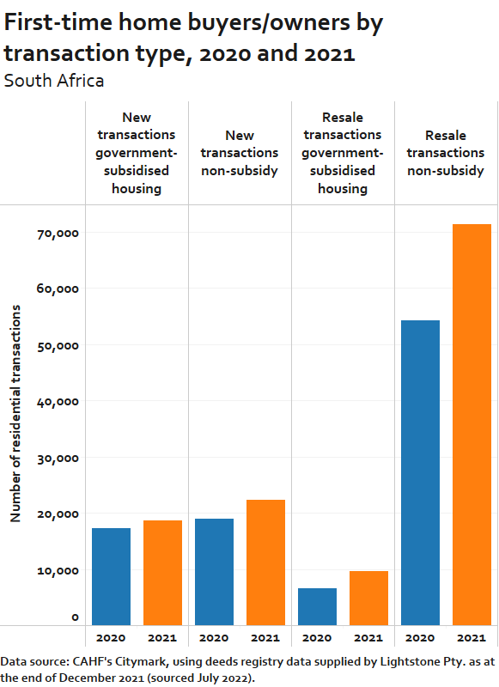
However even with access to FLISP, a household with a monthly income of R22 000 (1 199 USD) (highest allowable income to be eligible for the programme) would likely struggle to find a newly built unit at the R700 000 (38 147 USD) price they could afford. In short, the new build market is too expensive to serve as a first step onto the property ladder. Low income households who are not selected as beneficiaries of fully-subsidised houses must enter the resale market in order to become first-time homeowners. This is reflected in the data: of the approximately 122 000 households became homeowners for the first time in 2021, of which only 15% received a new house via a government programme, and just 18% were able to buy a newly built property from a private developer. The remaining 66% bought houses on the resale market. Overall, the main avenue through which most first-time homebuyers/owners step on to the property ladder is the resale market.
The data therefore suggests that the resale market offers great potential as a means for low income households to access affordable housing. Substantial lending opportunities therefore exist at the low end of the resale market (if issues with accessing FLIP are addressed) and some lenders are explicitly targeting low income households, despite the fact that first-time homebuyers in this income bracket are likely entering the market with no equity and thus these mortgages would require high loan-to-value ratios.

Unlocking the resale market would help to enable access to housing for low-income households. However the resale market is not functioning effectively at the lower end of the market, which means that households are unable to leverage equity to move up the property ladder. For a number of reasons, the number of informal transactions exceeds formal sales for low-value properties. This occurs mainly because formal sales can be unduly complex, costly and slow. Problems with regularising title deeds, slow response times from regulatory bodies (including the municipality, province and deeds office), limited trust in formal processes (such as the role of conveyancers) and limited awareness of the protection afforded (to both buyer and seller) by these formal processes, leads to households reverting to cash sales. Estate agents may also promote cash sales because they believe the banks are unlikely to approve bonds for this market, given particular restrictions by some lenders on what constitutes a ‘mortgageable product’.

The net result is that, relative to the value of the property, the transaction costs (in time and money) for a formal sale are too expensive and households rely upon informal sales, which provide very limited consumer protection and expose them to high risk. Apart from the legal risks around tenure security, informal sales also carry a financial cost for the seller. The average value of transaction with a mortgage is considerably higher than transaction without a mortgage. This means that the buyer has less equity to use towards their next house purchase and move up the property ladder.

Leveraging the potential of the resale market to improve access to affordable housing depends on resolving the title deeds backlog and addressing the incidence of informal transactions, both of which undermine healthy market functioning and constrain transaction values. Intentional and targeted transaction support and title deed restoration efforts are needed. This would also increase municipal revenue.

Submission instructions
Deadline: 30 April 2023
Email: Please return this questionnaire to: hrc-sr-housing@un.org; ohchr-registry@un.org
Email subject line: Input for SR housing - report on housing affordability
Accepted File formats: Word (supporting documents may be submitted in PDF)
Accepted languages: English, French and Spanish
Please include references to reports, academic articles, policy documents, text of legislation and judgements, statistical information with hyperlinks or attach them to your submission (please respect total file size limit of 20 MB per email to ensure that it can be received)
Publication: Submissions of States and public authorities will be published. For other stakeholders, submissions will be published, except confidentiality is explicitly requested.
Expected presentation of the report of the Special Rapporteur to the General Assembly: October 2023.

Conversions are done with the exchange rate 29 April 2023: 18.35 ZAR = 1 USD.
Countries included in the study are Cameroon, DRC, Ghana, Kenya, Liberia, Malawi, Morocco, Mozambique, Nigeria, Rwanda, Senegal, South Africa, Tanzania, Uganda and Zambia.
Residential property market data used in this document is title deeds data as of the end of 2021, purchased from a private company, Lightstone Pty Ltd., CAHF. See https://housingfinanceafrica.org/documents/south-africa-housing-market-report-2021/
In South Africa government-subsidised houses are not explicitly recognised or marked on the title deed. Therefore CAHF uses a proxy to identify government-subsidised properties on the deeds registry. The proxy is based on common programme characteristics of houses delivered through national government programmes, including the year, first registration price and buyer type, maximum prices, and proximity to other similar housing types. Furthermore, it’s important to note that, since this data is drawn from the deeds registry, by definition, it does not include delivery of government-subsidised houses where the beneficiary has not yet received the title deed.
CAHF. 2022 Housing Finance in Africa Yearbook. Available at: https://housingfinanceafrica.org/resources/yearbook/
This assumes: no government housing subsidy, a 30% premium to income ratio, 20 year loan tenor, 10% deposit, and that the mortgage interest rate is the prime lending rate (11.25%).
(2018). Bringing life to mortgage markets in South Africa. Published by CAHF. Available at: https://housingfinanceafrica.org/app/uploads/Bringing-life-to-mortgage-markets_Final60818.pdf
National Credit Regulator (December 2022). National Consumer Credit Market Report – Fourth Quarter December 2022. Available at: https://ncr.org.za/documents/CCMR/CCMR%202022Q4.pdf
National Credit Regulator (December 2022). National Consumer Credit Market Report – Fourth Quarter December 2022. Available at: https://ncr.org.za/documents/CCMR/CCMR%202022Q4.pdf
Census 2011 – ‘Inadequate housing’ includes informal dwelling/shack not in backyard, informal dwelling/shack in backyard, traditional dwelling, formal dwelling with no flush toilet, and overcrowded formal dwelling. As quoted in presentation by 71point4 ,“Affordable Housing in South Africa” June 2018. Accessed at: https://www.71point4.com/Projects/affordable-housing-in-south-africa/

