A Submission to
the Report of the Special Rapporteur on the right to adequate housing to the
78th session of the UN General Assembly: A place to live in dignity for all: Making housing affordable
Name of submitting organization: the Archive City Cultural and Social Research Association
30 April 2023
This submission is made by the Archive City Cultural and Social Research Association in Türkiye as a response to the call of the Special Rapporteur on the right to adequate housing.
National law, policies and jurisprudence relating to affordable housing.
- Does your country’s national law, including constitutional, housing or social protection law, refer to affordability of housing or provide any other guarantees to ensure a minimum standard of living? Or in its absence, are there national policies that refer to affordable housing or minimum standard of living? Please provide references and links to the respective key laws or constitutional provisions as well as policies.
At the level of legislation and regulations concerning the right to housing in Türkiye, the issue is not taken up holistically and systematically. Solutions to the problem were sought by adopting different proposals in different periods. The right to housing was introduced to the Constitution of Türkiye in 1961. The third section of the 1961 Constitution on Social and Economic Rights and Duties describes the right to housing as a part of the right to health. Under the heading of right to health, it is stated: “The State has the duty of ensuring that everyone lives in good bodily and spiritual health and can receive medical care. The State takes necessary measures to meet the needs of poor and low-income families for housing that is suitable to their health conditions” (Constitution of 1961, art. 49). It is worth noting that rather than treating housing as a right, the state assumes the role of a social state and takes up a duty regarding the shelter problems of the poor. The right to housing was finally listed under its own heading in the 1982 Constitution. Article 56 under the section of the 1982 Constitution on Social and Economic Rights and Duties states “Everyone has the right to live in a healthy and balanced environment. Improving the environment, maintaining environmental health, and preventing environmental pollution are duties of the State and citizens.” Article 57, titled the Right to Housing, states “The State takes measures to meet the need for housing in the framework of planning that will account for the characteristics of cities and environmental conditions and also supports mass housing initiatives (Constitution of the Republic of Türkiye, 1982). The state thus points out two basic responsibilities. The first is that while stating that the right to affordable housing, though not overtly, it declares that the state will take measures to meet the need for housing. Secondly, it states that in practice this will be in the form of mass housing. In this sense, the text of the Constitution of Türkiye guarantees the right to housing, although its approach has its limitations. There are many pieces of legislation and regulation that may be indirectly connected with the right to housing in addition to the constitution. These include the Law 5393 on Municipalities, Law 5216 on Metropolitan Municipalities, Law 5302 on Province Special Administrations, Law 2985 on Mass Housing, Law 6306 on the Transformation of Areas at Risk of Natural Disaster, Law 5366 on the Restoration, Protection, Maintenance and Use of Damaged Immovable Cultural and Historical Assets, Law 3194 on Zoning, Law 4708 on the Audit of Buildings, Law 2872 on the Environment, Law 2828 on Social Services, Law 3294 on Promoting Social Aid and Solidarity, Law 5434 on the Pensioner’s Retirement Fund (Emekli Sandığı), and the Law 5510 on Social Security and General Health Insurance. These laws do not directly regulate the right to affordable housing. Therefore, it may be said that there is no structural and holistic legislation on affordable housing in Türkiye.
- Please explain if there is any official definition or criteria to assess whether a household faces housing costs above the level of affordability in your country.
At present, there are no legislative criteria for affordable housing in Türkiye. For example, housing data in the income and living conditions study published by the Turkish Statistical Institute (TÜİK) are based on subjective evaluations. The lack of established indicators in this field makes monitoring studies considerably more difficult. Just as governments have failed in their responsibilities in this matter, the policies they produced following every crisis have fallen far short of a rights-based approach and have placed capital and the free market at their core. With the housing crisis rendered a means for capital accumulation, the solutions produced by public policies further increase inequalities and add every day to the number of people being displaced and dispossessed.
Data and trends on housing affordability
- Please share any important court decisions in your country that relate to the issue of affordable housing or enjoyment of a minimum standard of living, including important judgements on State policies or measures aimed at ensuring housing affordability. Please provide if possible a short summary of the decision and a link to its text. (e.g. judgements by international, constitutional, supreme or high courts, to rent control measures or rent freezes, to access to housing subsidies, public or social housing, non-discrimination and equal access to affordable housing etc.)
- Is housing affordability regularly measured in your country, region or city, by the national statistical office or other entities? Please explain how housing affordability is measured and tracked. Where is the data published?
The state statistical agency TÜİK (Turkish Statistical Institute) periodically publishes data on construction and housing. The published data cover a very narrow range of information pertaining to construction permits, housing sales, construction revenue and production indices and construction labor input. Until now TÜİK has never produced any data under a heading that defines affordable housing or takes into account criteria for it. In the Survey on Building and Dwelling Characteristics, which is not a regular study but one that provides important data, TÜİK publishes information on the characteristics of buildings (lifts, carparks, building age, number of rooms, heating system) occupied by households and whether they own or rent the residence. There is no data published by TÜİK on housing ownership and access to quality housing, especially for disadvantaged groups.

- Has housing affordability increased or decreased in your country over the past 10 years? In which regions or cities has housing affordability changed and for whom?
In a statement in August 2022, President Recep Tayyip Erdoğan said that 1,170,000 citizens had become homeowners through TOKİ over the past 20 years. However, according to TurkStat data, the proportion of households which own housing has been falling over the past 20 years, on contrary to what President Erdoğan claimed. According to Prof. Dr. Seyfettin Gürsel, Director of the Centre for Economic and Social Research (BETAM) at Bahçeşehir University, there has been a fall in home ownership, especially since 2002 when the AKP came to power. The proportion of homeowners was 72% in 2002, falling to 61% in 2014 and 57.7% in 2021. In 2020 and 2021, 42% of households rented. Table 1 below shows a significant decrease in the proportion of home ownership of the lowest income quintile. The lowest income quintile’s rate of home ownership fell from 51.3% in 2010 to 46% in 2021. For the middle and upper middle quintiles there was no change in the rate of home ownership between 2010-2014, but a decreasing trend began in 2015, with the home ownership rate falling from 53.6% to 52.3% and 55.9% to 52.8% respectively.

As can be seen in the infographics below, housing prices in Turkey have been on the rise in the last 10 years. Regionally, the rates are highest in Istanbul, Izmir and Ankara, the three largest provinces of Turkey.

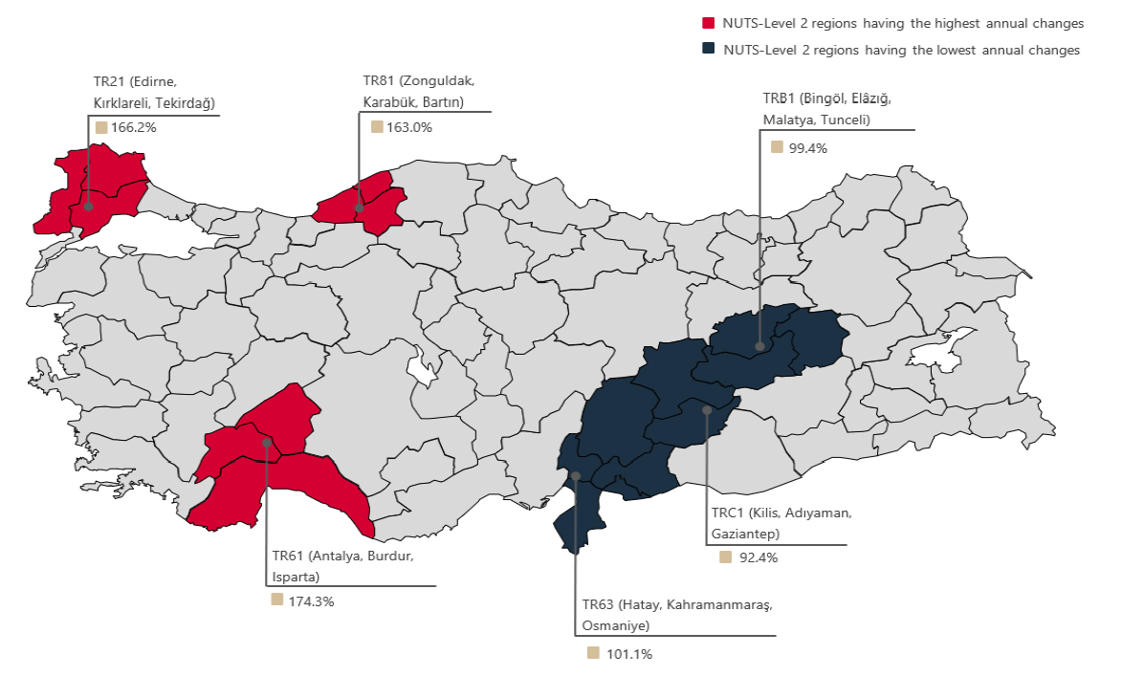
Source: The Central Bank of the Republic of Turkey, Residental Property Price Index, 2023.

Cities with the Highest and Lowest Annual Rent İncreases – March 2023
Cities | 2022 March m² Price | 2023 March m² Price | Annual Current Rent Increases (%)
Türkiye Average | 37,7 | 97 | 157
Malatya | 11,6 | 47,2 | 307,7
Trabzon | 12 | 42,3 | 251,7
Kahramanmaraş | 15,5 | 48,6 | 212,5
Denizli | 18,8 | 58,3 | 211,1
Ordu | 14,3 | 43,3 | 203,2
İstanbul | 53,9 | 122,2 | 127
Van | 16,1 | 36 | 123,5
Erzurum | 10,5 | 23,5 | 123,4
Diyarbakır | 17,5 | 37,1 | 111,9
Muğla | 103,5 | 176,5 | 70,4
Source: sahibinden.com, Betam

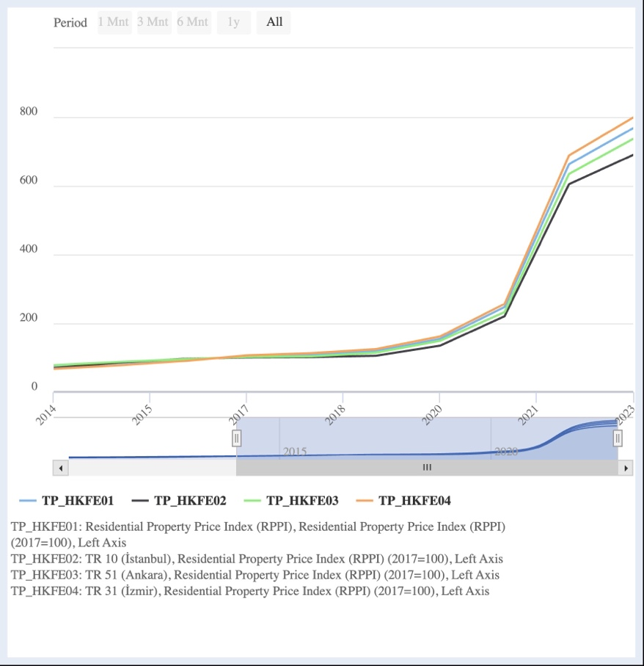
Source: Turkish Central Bank, Residential Property Price Index, 2023.

- Please describe which households, persons or groups are at particular risk of being exposed to housing affordability in your country, region, or city. (Please provide data on housing affordability disaggregated on the basis of household size, form of tenure (living in self-owned housing, rental, other), type and quality of housing (e.g. living in formal or informal housing); location (region, urban, rural), type of household (with or without children, single parent households), income, employment status, gender, disability, age, nationality, ethnicity, religious affiliation or immigration status.)

The fact that the right of housing has become commodities all over the world with the effect of neoliberalization is getting deeper with the specific dynamics of Turkiye in Turkiye. There are certain groups and individuals who are exposed to in accessing affordable housing in Turkey. These are low-income families, disadvantaged women, children, youth, LGBTI+s and immigrants. There are some studies and practices that are not enough in Turkey for low-income families. The situation of being exposed is deeper for the homeless, the disabled, the elderly, LGBTI+s, ethnic/religious groups, women, youth, earthquake victims and immigrants. In the 2023 Earthquake Situation Detection Report prepared by the Migration Research Association, the forms of discrimination based on housing experienced by immigrants are given wide coverage. In addition, discrimination experienced by LGBTI+s in accessing affordable housing is getting deeper. Since legal studies on the right to housing of all segments of society are lacking in Turkey, so data that on this discrimination are only included in the studies of CSOs.

- May certain specific groups or persons, such as persons experiencing homelessness, living in informal settlements, students, asylum seekers or refugees, potentially be left out in data collection in relation to housing affordability?

Since there is no specific housing policy and rights-based strategy for these segments, individuals or groups meet the need for shelter in informal ways. Therefore, these groups cannot take part in data collection processes unless a rights-based monitoring study is carried out. The main studies involving these individuals and groups are generally field studies conducted in NGOs. Unfortunately, these also have a limited capacity, so a holistic data collection cannot be carried out unless they are.

Causes and Consequences of housing unaffordability.
- What are main reasons why housing is unaffordable to certain persons or groups in your country? Please provide if possible, as well links to (scientific) studies that have analysed such reasons.

Türkiye’s urbanisation problem and the chronic migration problem due to regional inequalities have always ensured that the housing problem is on the country’s agenda. While some attempts to pinpoint the sources of the current housing or shelter crisis place the root of the problem with the economic crisis, it is not sufficient to say that the basic cause of the problem is the economic crisis alone. The economic crisis has made the problem deeper and chronic. However, the true cause of the problem is that historically, the state and its regulatory institutions and organs have proved unable to provide an effective solution to the problem and to develop permanent policies and practices to this end. Another cause of the problem may be that the right to housing is seen as a costly budget item for the state. From a rights-based perspective on the housing crisis in Türkiye, it may confidently be said that neither the government nor a broad segment of society view the situation as a fundamental human rights crisis. Although the right to housing is guaranteed in the constitution, there is no effective legislation to realise this right.
An examination of the situation following major events in Türkiye in the past ten years shows that the housing crisis has constantly become worse. At both the national level and the local and regional level at which we carry out activities, both relevant civil society organisations and representatives of organisations actively working in the field are of the opinion that the steps taken by the central government following the earthquakes of February 2023, the economic crisis and the Covid-19 pandemic have been focused on capital-centred solutions and have overlooked vulnerable groups. The approach in Türkiye to the country’s most chronic problem has been to provide temporary responses to the crisis caused by urbanisation. Instead of viewing the right to housing as a social right which should be made basically available to citizens, housing is viewed as a commodity with focus on its exchange value.
Although there is a gap at the legislative level, work on affordable housing may be followed-up through the practices and undertakings of relevant ministries. Perhaps the most significant of all work carried out over the past 20 years is the Integrated Urban Development Strategy and Action Plan 2010-2023 (KENTGES). This plan is important for two reasons. The first reason is that the work is undertaken at the governmental level. The second reason is that comprehensive debate on and solution proposals for the housing problem of the past 20 years in Türkiye was undertaken with the participation of many academics, experts, representatives of professionals’ organisations, civil society organisations and ministry bureaucrats and civil servants. Preliminary work on KENTGES began in 2007, with work commencing under the Ministry of Public Works and Settlement in 2008. Following a series of activities in 2008-2009, the plan was finally ratified with decision 2010/34 on October 25th 2010 and entered into effect as the Integrated Urban Development Strategy and Action Plan 2010-2023 (KENTGES) upon publication in issue 27749 of the Official Gazette on November 4th 2010. 151 institutions and 500 experts contributed to the development of KENTGES. The plan makes local administrations responsible for 28% of the actions it contains and the central government for 72%, while the implementation of actions is monitored by the Monitoring and Steering Board consisting of high level administrators appointed by the relevant ministries. The Urbanisation Summit (2009) which was held during the process of establishment of KENTGES was attended by a total of 296 participants (of which 6 were academic, 103 were civil servants from various ministries and public institutions, 49 were representatives of professionals’ and civil society organisations, 27 were private sector representatives and 31 were ministry personnel) featured very constructive debate. This series of work resulted in significant policy proposals to address urban issues and the housing problem in Türkiye. A total of 437 problems, 701 strategies and 1200 action plan options were conveyed to the ministry. Following the communication of the problems and strategies, the targets, strategies and actions for which the relevant ministry and its institutions were made responsible were published for implementation in 2010-2023. Although the right to affordable housing had been voiced by many professionals’ organisations and academics during the Urbanization Summit of 2009 in relation to many matters and problems, this was not reflected to the same extent in KENTGES’s action plans. KENTGES identified a total of 19 targets and connected strategies and actions for the years 2010-2023. Targets 3 and 17 are of special significance for making housing more accessible. Ministries and municipalities were made responsible for the realisation of these two targets.

Source: Strategy and Action Plan Foreseen by Target 3 of The Integrated Urban Development Strategy and Action Plan 2010-2023 (KENTGES)

TOKİ, universities, municipalities, Province Special Administrations, the Ministry of the Interior, General Directorate of Deeds and Cadastre and professionals’ chambers were made responsible for implementing the strategies for Target 3. Another KENTGES target relevant to affordable housing is Target 17, which is “Taking necessary measures for those in need and disadvantaged groups to benefit from urban services”. The Ministry of Transport, the Presidency of the Administration for the Disabled, municipalities, Province Special Administrations and CSOs were made responsible for the achievement of this target. These institutions were expected to reorganize urban service areas to the benefit of disadvantaged groups, develop standards and carry out their work based fundamentally on the principles and bases developed in international documents. The greatest responsibility for the targets and strategies lies with the Ministry of the Environment, Urbanization and Climate Change. Indeed, as an affiliate of the ministry, TOKİ is the flagship institution undertaking responsibility. The Presidency of Housing Development Administration (TOKİ) was established in 1984 with the Law 2985 on Mass Housing to ensure the production of affordable and suitably priced social housing. The 1984 law states the aim and resources of TOKİ as: “The provision of necessary public support for meeting the housing requirement that abides by the principles established for the resolution of the housing problem in Türkiye and the necessary services being delivered by an administration specifically established to this end”. In the law, the target group was established as “Low- and middle-income group families who cannot own housing under present market conditions”. Therefore, TOKİ is the first institution that needs to be examined in terms of affordable housing. From its establishment in 1984 to 2004, there was a fall in the number of residences for which TOKİ provided credit. TOKİ provided credit for 140,813 residences in 1987; 113,300 in 1990; 12,631 in 1999 and 1335 in 2004. TOKİ produced 43,145 units of housing between 1984 and 2022 and provided credit covering changing proportion of the cost for 940,000 units. Given that the urban population rose from 53% of the total in 1985 to 64% in 2000, it may be said that then number of units of housing supported by TOKİ was quite low for the period.
TOKİ’s main period of activity began once it became the pillar institution for the construction sector in Türkiye following a series of transformations after 2004. While the greater prominence of the construction sector during this period is not a strategy that is unique to Türkiye or the AKP government, it is observed that the development was prioritized by the AKP government. Increasing weight of the construction sector emerged as a model of economic growth or as an economic strategy in many countries with the global trend of construction drawing an increased proportion of finance investment. The interdependence of housing and finance led to many social and economic problems, underlying which was housing becoming a commodity traded for profit and lost its status as a fundamental human right. Under such circumstances, while conditions for housing resulting from it being a right and its required qualities are not met in order to keep costs down, the free market results in increasing housing prices and rents. Lower- and middle-income groups who cannot afford housing prices are driven to the peripheries of cities. The financialization of housing has also led to all plots in cities being turned over to construction through urban transformation projects, with no room left for any other uses. In 2017, the UN Special Rapporteur published a report on the financialization of housing and its human rights impacts. In addition to analyzing the effects of this process, the report was especially significant in that it called on member states to review their relationships with national and international financial organizations and reminded them of their human rights obligations.
In Türkiye, the symbol of the state declining to own up to its obligations and the best example of the alliance of finance and real estate became TOKİ, which itself is the state institution tasked with providing social housing. Instead of its task of producing social housing, which is its raison d’être, TOKİ assumed a structure that acted as a private company drawing on public resources in search of public value, by establishing companies in housing providing resources for urban transformation and industrial projects and trading in the real estate market through its subsidiary Emlak Konut Real Estate Investment Company. In its TOKİ Assessment Report of 2019, The Union of Chambers of Turkish Engineers and Architects protested this expansion process under the headline “End of the Legend of Robin Hood: TOKİ Now Building ‘Smart Homes’ for the Rich”. In its 2019 report, TOKİ stated that of its total housing production, the proportion of those qualifying as social housing was 86.27%. While this proportion may seem quite high at first sight, many studies have shown that a large proportion of these housing units are not affordable. In addition, the data should be assessed with a view to the fact that TOKİ produces different types of “social housing”. The housing that actually qualifies as social housing is produced under the Low-Income Group Projects. All other projects employ a payment system resembling mortgages, with payment spread out over a long term and annual increases paired with the annual increase to public employee salaries.

Source: TOKI (2019)

Housing for lower income groups has been constructed since 2009 in cooperation by TOKİ and the Directorate-General of Social Aid (SYGM) that is affiliated with the Ministry of Family and Social Services. While TOKİ undertakes the construction process, the SYGM identifies beneficiary low income households as per article 56 and amended article 45 and 64 of the Law 5434 on the Pensioner’s Fund, article 47 of the Law 5510 on Social Securities and General Health Insurance, and the provisions of the Law 2330 on Compensation and Monthly Salaries in Cash. A significant point to observe is that no specific definition of disadvantaged groups applies due to the very narrow criteria in the Regulation on Interest-Free Housing Credit for Social Security Holders and Pensioners Covered by the Law 506 and the Regulation on Interest-Free Housing Credit for the Families of Martyrs, Those on Disability Retirement due to War or Duty and Widows and Orphans, which the SYGM and TOKİ reference. This means that those with the right to apply constitute a very small group within disadvantaged groups.

- What percentage of land is owned or otherwise controlled by the State or other public entities, as contrasted with private entities (both for profit and not for profit)? Please explain if there are any policies or laws which seeks to control the price of land, prevent land speculation including its supply and finance?

According to Article 4 of the Regulation on Land and Parcels Arrangements, public regulation may make a public deduction of up to 45% for the partnership share, according to the usage decisions in the zoning plan. Local governments in Turkey are authorized to prepare the zoning plan and manage the plots and lands according to these plans. Article 18 of the Law on Land Development and Control No. 3194 is as follows:

“Municipalities shall be authorized to combine land and landlots with or without buildings within the limits of the land development plan with one another, with residues left over from the roads or with places owned by public entities or municipalities without consent of the property owners or beneficiaries, subdivide the same again into blocks or plots or subdivide again in compliance with the land development plan, or distribute to the beneficiaries on the basis of individual, joint or divided co-property ownership and register ex officio. If the places concerned are outside municipal boundaries and adjacent areas, such authority shall be exercised by the governorship.”

With the amendment made in the Law No. 1164 on Land Production and Evaluation in 2004, the "Mass Housing Administration" was appointed to prevent land speculation in Turkey and to prevent excessive price increases in land prices.

- How many households have, during the last ten years been evicted because of their non-payment of housing costs? Please provide, if possible, more information on the socio-economic profile of the concerned households.

There has been an astronomical increase in housing eviction cases in Turkey recently. However, statistical institutions have not determined criteria within the scope of evacuation in HOUSING AND HOUSEHOLD WORKPLACE RENTS WITH THE TURKISH LAW ON OBLIGATIONS NO 6098. Therefore, it is impossible to come across definitive data on this context. However, related news shows that this situation has increased especially in the last 3 years (post-pandemic).

Home Ownership Rate By İncome Groups İn Turkey, 2010-2021 (%)
Year | Lowest 20% | 20%-40% | 40%-60% | 60%-80% | Highest %20
2010 | 51,3 | 53,0 | 58,5 | 61,8 | 70,4
2011 | 51,4 | 52,3 | 56,1 | 64,0 | 68,6
2012 | 52,7 | 52,9 | 58,1 | 63,8 | 68,7
2013 | 52,4 | 54,4 | 57,7 | 62,4 | 69,2
2014 | 53,9 | 53,5 | 58,8 | 61,6 | 68,7
2015 | 54,1 | 53,6 | 55,9 | 61,4 | 67,6
2016 | 51,7 | 53,1 | 56,2 | 61,6 | 68,3
2017 | 51,6 | 52,6 | 56,4 | 60,8 | 66,9
2018 | 50,5 | 51,4 | 54,7 | 60,4 | 68,2
2019 | 46,1 | 52,7 | 55,5 | 60,8 | 68,7
2020 | 48,3 | 50,9 | 52,3 | 59,8 | 67,3
2021 | 46,0 | 52,3 | 52,8 | 60,5 | 66,1
Source: TurkStat, Income and Living Conditions Survey, BETAM

- How many individuals, households or groups have, during the last ten years, been rendered homeless because of inability to afford housing? Please provide a breakdown of the socio-economic characteristics of such individuals.

There has been a large increase in homelessness rates in Turkey recently. It is estimated that 70,000 people are homeless in Turkey, especially due to migration, and high inflation. After the earthquake that deeply affected 11 cities in Turkey, according to the statements of UN experts, approximately 1,500.00 people are homeless. However, due to the lack of certain criteria and the lack of regular data collection in this area, a concrete profile and number cannot be reached.

- Please describe how housing unaffordability impacts the capacity of individuals and families to enjoy their other human rights including rights to work, health, education, and access to personal security in all its dimensions.

As a fundamental human right, the right to housing and shelter should be guaranteed by the state and public institutions through policy documents and legislation for the welfare of all sections of society and the access to this right of relevant groups should be regularly monitored. The failure to do so contributes to the solidification of social and economic inequalities. The Housing Problem Study: Current Situation in Istanbul and Recommendations report by the Istanbul Planning Agency shows that of the approximately 6,400,000 units of housing in Istanbul, 1,800,000 are unoccupied. It is therefore clear that the problem is not the lack of housing but the lack of accessible and affordable housing.

The limitation to the right to accessible housing can become a double form of injustice against both lower income groups and disadvantaged groups. Many vulnerable groups, especially the LGBTI+, ethnic groups, women and minorities encounter discrimination beginning from the house hunting phase. When they finally secure housing that does not meet their needs, they have to live in unhealthy, damp housing that Is not earthquake proof. The report prepared by the CSO Centre for Spatial Justice (MAD) using data from the Turkish real estate website sahibinden.com and applying the UN’s seven criteria for “adequate housing” shows that as criteria are introduced one by one, the number of adequate housing units for rent declines significantly. After filtering the search for rental housing in Istanbul on March 15th 2021, for criteria such as rent price, surface area, age of the building, floor, heating and the availability of a balcony there remained only 804 advertisements out of the initial 38,829.

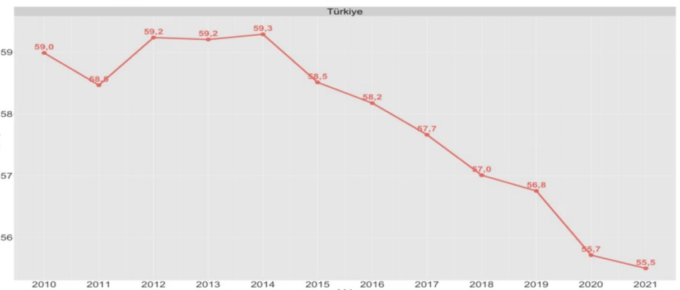

Source: Centre for Spatial Justice, Searching for Livable Housing at sahibinden.com Report

The production and distribution of adequate, accessible, safe housing with basic services for all should fall within the mandate of governments and authorised organs appointed by the government ass a requirement of the welfare state. The failure to meet this requirement may result in poverty and unemployment, barriers to access to education, discrimination, safety and health problems, social polarisation and homelessness; as is clearly seen in the example of Türkiye.

Possible problems with access to education may result from difficulties households without a permanent shelter space face in sending their children to school regularly. Increasing distance between the residence and the school results in increased financial costs for the household, presenting another significant obstacle to regular school attendance. Furthermore, in Türkiye, access to fundamental rights such as education, healthcare and social rights is based on the address of residence. In Istanbul, only 2% of adverts for rental housing meet the criteria for adequate housing. These units of housing are in just three districts of Istanbul; namely Silivri, Sancaktepe and Pendik. This indicates that adequate housing is concentrated in the periphery of the city, which leads to long commute times to the centre. The same study found that a person who lives in Pendik (the periphery) and works in Levent (centre) would have to commute for nearly two hours a day using public transport. Such circumstances result in even those urban residents who can secure housing that meet the criteria for adequate housing cannot equally access and benefit from shared goods and services in the city due to long commute times. This is a problem for accessing the right to the city.

Damp and unhygienic housing with limited access to the right to health result in many inequalities, in addition to the unequal enjoyment of the right to housing. Students who protested the lack of access to and inequalities in the right to housing with the Barınamıyoruz Movement have shown that the issue is directly related to the right to education and the right to access education.

Following 18 months of distance education due to Covid-19 measures, the return of students to on-site education in September 2021 once more revealed how difficult it had become to access affordable housing in Türkiye. The 700,000 student accommodation places offered by the state in Türkiye fall far short of meeting the needs of 8.5 million university students and the increases of between 70% and 290% in rents resulted in students experiencing shelter problems. In the protests that began in Istanbul and spread to larger cities such as Kocaeli and İzmir, students spent several nights in parks to draw attention to their shelter issues. When the student’s state scholarships were rescinded in retaliation, they were faced with a double violation of their right to shelter as well as the right to education that is connected with shelter. The lack of access to affordable housing increases the risk of health problems for vulnerable groups. Discrimination in access to affordable housing results in social unrest. As witnessed in Türkiye with higher inflation and rents following the pandemic, landlords request high rents for their property, thereby developing a mechanism of economic exclusion. According to the Knight Frank Global House Price Index Quarter 4 2021 report, Türkiye led the world with 59.6% housing price growth. Results for Quarter 3 2022 of the same index show that house price growth in Türkiye was 189%. With steeply rising inflation following the pandemic, access to adequate housing has become increasingly difficult, laying the ground for various economic and social problems. Vulnerable groups therefore seek to live in outskirts of cities to meet their shelter needs more amenably. However, it must be underlined that this behavior is the result of public institutions not regulating the field or choosing not to regulating the field. Living in the outskirts or without a home results in basic social services in some parts of cities not being provided equitably. One of the main obstacles to accessing social support mechanisms in Türkiye is the requirement that applicants must be officially registered as habitants of the district where they apply for services. This applies to central government organisations such as social aid centres and the Foundation for Social Aid and Solidarity, as well as municipal social support mechanisms. Furthermore, as social aid is assessed on a household basis, several families occupying the same household have a lower probability of benefiting from social support.

In Türkiye, the insufficiency of TOKİ’s practices and the data show that housing is far from affordable for lower income groups and the poor. It must be said that disadvantaged groups who are invisible to official institutions have an even worse experience of the process. TOKİ is tasked with offering affordable payment terms and implementing other facilitating measures for disadvantaged groups. The problem lies with TOKİ’s definition of disadvantaged groups. According to its definition “TOKİ prioritises a certain proportion of housing in social housing projects for disadvantaged groups (persons with disabilities, families of martyrs, those on disability retirement, old age pensioners)”. This is a very narrow definition of disadvantaged groups. The same situation applies to data production. State institutions and organisations present data with this narrow definition of disadvantaged groups, although there might be slight differences. Therefore, we have to rely on CSO activities and monitoring reports for data and information on wider groups.

Laws, policies, programmes and practices aiming to ensure that housing is affordable to all without discrimination
- Please share an overview of the laws, policies, programmes and practices adopted in your country/region/city to ensure that housing is affordable for all without any discrimination, Please, provide links to relevant official texts. (e.g. affordable housing, social and energy cost subsidies, preferential mortgage, building support schemes, provision of social and public housing, of serviced land for self-construction, rent containment and rent control measures, taxation, measures to reduce housing vacancy, multi-stakeholder initiatives by State, local Governments, construction industry, housing providers, tenant unions etc).
- Please share an assessment of the success, limitations or potential failures of the above mentioned laws and policies in your country/region/city, including any studies or independent evaluation reports related to them. Who has benefited from them, who has not? What has worked well, what - less? What lessons can be learned? What could potentially be replicable in other countries/regions/cities?

The Specialists’ Commission Report featured in the Eleventh Development Plan prepared by the Ministry of Development identifies important points regarding housing policy in Türkiye. It then lists information regarding the development plan for housing policies. The strategies and policies that are proposed are similar to the policies proposed at the Urbanisation Summit of 2009 in many respects. Both documents propose that relevant state institutions apply the new urban paradigms and strategies and suggestions for human rights that are taken up in principle from international documents. Despite this intensive work at the policy document level, the housing problem in Türkiye grows by the day. The major and consecutive Covid-19, economic and earthquake crises have exacerbated the problem.
The measures so far taken against these crises fall far from providing solutions. The fundamental problem is that the measures do not target a structural transformation and seek panacea through temporary arrangements. Policies on the right to housing implemented since 1982 have been limited to the clause in the constitution that states mass housing is to be supported. There needs to be more comprehensive work on the right to housing and urban life more generally. More important still is that decisions taken should be realised at the level of legislation and the implementation of principles and bases in international documents by the relevant ministries. A board or institution to be formed to audit and monitor this process should not be limited to government officials, as was done under KENTGES, but include the active participation of non-state actors such as professionals’ organisations, labour unions, universities and civil society organisations. However, the practice in Türkiye is completely to the contrary. Over the last 20 years, non-state actors have been gradually removed from decision-making mechanisms. Decision-making instead rests with the public administration that acts under the direction of the markets, or companies themselves. Since 2002, the state’s and cooperatives’ share in the production of housing has gradually declined. While the state and cooperatives accounted for 34% of the housing construction sector in 2002, in 2022 they accounted for just 9%. While there are many reasons for this contraction, the underlying cause is the financialization of housing. The current crisis has grown with state subsidies for the private sector and the widespread strategy of privatising public services. This process can be better understood as a desire to produce surplus value that includes all authorised institutions of the state. An apt example of this transformation in addition to TOKİ is the Structure Auditing System. With an amendment to the Law 4708 on Structure Auditing and the Regulation for Implementation, audits by professionals’ organisations were prevented. This resulted in private structure auditing firms not fulfilling their responsibilities for effective auditing, resulting in inadequate housing and buildings that are not earthquake-resistant. The painful consequences were felt with the earthquakes of February 6th 2023.

In conclusion, to solve the housing crisis and the problem of affordable housing in Türkiye, the state needs to adopt policies that view housing as a right and public service and not as something to be traded on the market for a certain amount of profit over the cost of production. In addition, non-state organisations must actively participate in the policy formulation process and the provision of public services. Despite the problems and solution proposals being repeatedly identified in the Urbanisation Summit of 2009 and the Eleventh Development Plan, they have not been addressed or implemented. The current situation presents an acute problem.

For detailed information see: https://www.voaturkce.com/a/yilda-ev-sahibi-olma-orani-dustu/6922201.html
For detailed information see: https://betam.bahcesehir.edu.tr/wp-content/uploads/2022/12/ArastirmaNotu265.pdf.
The Assocation for Migration Research, Earthquake and Migration Due Diligence Report, 2023.
TR Ministry of Public Works and Settlement Urbanisation Summit 2009 / Ankara May 4th-7th 2009
Targets and strategies: https://webdosya.csb.gov.tr/db/kentges/editordosya/kentges_tr.pdf
KENTGES official website: https://kentges.csb.gov.tr/kentges-nedir-i-7119
TOKİ 2019 Report, p. 18.
Ibid.
United Nations Human Rights Office of the High Commissioner Special Rapporteur Financialization of housing and the right to adequate housing (2017) https://daccess-ods.un.org/tmp/1820170.43232918.html
Union of Chambers of Turkish Engineers and Architects, TOKİ Assessment Report (2009).
Akalın, Mehmet. Turkey’s Social Housing Policy and TOKİ’s Social Housing Applications
Turkiye Ministry of Family and Social Services. https://www.aile.gov.tr/sss/sehit-yakinlari-ve-gazilere-yonelik-hizmetler-dairesi-baskanligi/faizsiz-konut-kredisi
the Regulation on Land and Parcels Arrangements, 2020. https://www.mevzuat.gov.tr/File/GeneratePdf?mevzuatNo=34305&mevzuatTur=KurumVeKurulusYonetmeligi&mevzuatTertip=5
The Law on Land Development and Control No. 3194 https://www.mevzuat.gov.tr/mevzuatmetin/1.5.3194.pdf
Law No. 1164 on Land Production and Evaluation https://www.mevzuat.gov.tr/mevzuatmetin/1.5.1164.pdf
For example: https://www.hurriyet.com.tr/ekonomi/ev-sahibi-kiraci-davalarinda-astronomik-artis-ocak-2023e-sure-veriliyor-ev-sahipleri-cok-pisman-42111868 https://www.ghdernegi.com/news/baz-ev-sahipleri-mahkemenin-yolunu-tuttu-kira-davalarnda-buyuk-arts/
Independent Turkey, the article of Ali Kemal Erdem. https://www.indyturk.com/node/302696/türkiyede-tahmini-70-bin-evsiz-var-yüzde-95inin-erkek-olmasının-sebepleri-neler
The UN in Türkiye, 1.5 Million Now Homeless in Türkiye After Quake Disaster, Warn UN Development Experts. https://turkiye.un.org/en/220232-15-million-now-homeless-türkiye-after-quake-disaster-warn-un-development-experts
Bayhan, Bahar. Toplumsal Talebin Bir Ekseni Olarak Konut Hakkı, 2022 https://blog.insanhaklariokulu.org/toplumsal-adalet-talebinin-bir-ekseni-olarak-konut-hakki/
For two examples, see: https://bianet.org/english/women/245816-transphobic-discrimination-goksu-basaran-not-given-a-house https://bianet.org/bianet/toplum/209865-munferid-bir-olay-olarak-kurde-ev-kiralamamak
For detailed information see: https://mekandaadalet.org/sahibinden-comda-yasanabilir-konut-aramak/#top
For detailed information see: https://mekandaadalet.org/sahibinden-comda-yasanabilir-konut-aramak/#top
Bayhan, Bahar. Toplumsal Talebin Bir Ekseni Olarak Konut Hakkı, 2022 https://blog.insanhaklariokulu.org/toplumsal-adalet-talebinin-bir-ekseni-olarak-konut-hakki/
For relevant news items see: Barınamıyoruz Hareketi Twitter Hesabı https://twitter.com/barinamayanlar , #Barınamıyoruz nöbetleri | "Ülkeyi yönetenler rant peşinde" https://bianet.org/english/youth/250794-those-who-govern-the-country-are-after-unearned-income , https://www.dw.com/en/students-sleep-in-parks-to-protest-rising-rents-in-turkey/a-59386060
For detailed information see: Yurtsuzlar eylemine katılan öğrencilerin kredisi kesildi https://www.gazeteduvar.com.tr/yurtsuzlar-eylemine-katilan-ogrencilerin-ogrenim-kredisi-kesildi-haber-1550338
Eleventh Devolopment Plan 2019-2023, https://www.sbb.gov.tr/wp-content/uploads/2022/07/Eleventh_Development_Plan_2019-2023.pdf For the Housing Policy https://www.sbb.gov.tr/wp-content/uploads/2020/04/KonutPolitikalariOzelIhtisasKomisyonuRaporu.pdf.
Urbanisation Summit of 2009 and 2017 https://kentges.csb.gov.tr/kentlesme-surasi-2009-i-284
KENTGES, https://kentges.csb.gov.tr/kentges-nedir-i-7119
TurkStat, 2022 Building Permits by Building Ownership Statistices 2002-2022

