A place to live in dignity for all: Making housing affordable
Questionnaire
Adequate Housing Organization

Overview:
According to The Central Bureau of Statistics CBS-2021, Sudan total population is 45,678,376, around 2.7 million are nomad and only one third of the population live in urban areas. Sudan is struggling civil armed conflicts, political instability, natural disasters and shocks, and referring to UN-Habitat in 2017, 12.6 % of the population was IDPs, refugees & returnees. The country is characterized by lower middle income, as 25.2% of the population below the extreme poverty line and 36.1% below the global poverty line (CBS-2017). According to the World Bank data, GDP per capita (current US$) increased from 1982.80$ in 2011 to 3188.80$ in 2017 and declined to 751.80$ in 2021 and the inflation has dramatically increased over the past years from 18.1% in 2011 to 382.8% in 2021, owing to currency depreciation (1). The unemployment rate is projected to be 27.7% in 2023 according to The International Monetary Fund (IMF), which means the majority of populations (young nature population) are low-incomes and poor, that all of whom cannot afford food, access to clean water and secure housing, their chances of education and health services are almost zero or limited, the number of acutely food-insecure people reached 9.8 million (2). The majority of the poor are rural dwellers, however the number of the urban poor is rapidly increasing (15% of the poor reside in Khartoum), yet to mention, high incomes in rural areas cover only human basic needs in urban areas. Residential/ spatial segregation is one of the main characteristics of housing in rural and urban areas in Sudan (settlements in cities and regions are distributed on ethnical basis), owing to continues struggle around resources, unbalanced development polices and political hegemony of the ethnics that settle in the primate regions (legacy issues), thereby, wealth quintiles and social classes based on ethnical hierarchy and there is a huge gap between rural and urban areas and between states, owing to marginalization and inequality between dwellers(3). That is noticeable when comparing development indicators, for example; water and sanitation between states (figure1):
Figure1: (CBS-2014)

Jurisprudence, legislation and policies
The right to adequate housing and housing issues are low priority in Sudan and its consequences on the households’ enjoyment of adequate standard of living are not considered when setting development polices. Political instability since 70 years ago is the root cause of the lack of jurisprudence and legislation of land and housing in Sudan, as the country had never developed jurisprudence or legislation to ensure the right to adequate housing. The Land Resettlement and Registration law of 1925 (4) is the primary legal reference for land rights and registration, and The National Fund for Housing and Reconstruction is the primary formal entity dealing with housing supply in Sudan, while the role of public sector or a ministry for housing is missing most of the time. There are several forms of legal land tenure and that widen the scale of informal developments, legal disputes between landowners and investors are norm in many areas in Sudan as the customary land possession and traditional land regulations are not usually effective in mediation and consultation. Sudanese Building Rental Law 1991(5) and Parable Rent jurisprudence are raising a great debate between owners and renters as there is no legal maximum rent value and the courts rely on broker’s evaluation (nearest broker to the property) when deciding the house rent price (conflict of interest), the article No: 11 of the law decide the method of eviction when renters failed to pay the rent price (6).
Financial polices and investment legislation prioritize private real-estate developers and foreign capitals (7), the budget allocated for housing of the general budget is less than 3% or zero, and the government depends most of the time on liquefaction of white lands, hence financialization of housing is the trend in the country. The social housing system is not applied in the country. Referring to inequality and political hegemony, polices, institution and processes of the government are not designed to improve access to land or generating incomes as they are not relevant to the needs and resources of the social protection seekers (poor and vulnerable usually depend on aids and shelters provided by the UN entities, international fund and NGOs).
However the high urbanization rates, urban planning policies are set to re-plan or remove slums and informal settlements (reaction) and not to deal with causes & consequences, upgrading or future oriented planning (legacy issue), owing to urban sprawl under the pressure of poverty. Slums and informal settlements are exposed to eviction according to judicial decision; some cases will be reviewed later in this report. Dwellers of the informal settlements are usually IDPs who forced to flee attacks and armed conflicts from marginalized states (usually have the same ethnical roots), particularly Darfur, Kordofan and Blue Nile, in addition to refugees from Ethiopia, Eritrea and South Sudan.
Data and trends on housing affordability
Housing affordability had never been measured in Sudan and the central bureau of statistics (CBS) never provides housing affordability index (HAI). However some indicators of housing characteristics is provided by Multiple Indicator Cluster Survey (MICS-2014) which was carried out by CBS Sudan in collaboration with other official and UN entities as part of the global MICS programme, round 5. The survey sampled 18,000 household, interviews were successfully completed in 15,801 households all states of Sudan with an overall response rate of 98%. Housing indicators comprise data of houses conditions, ownership of dwelling, services and household survey in relation with wealth quintiles. Data available on: https://mics.unicef.org and CBS. Related economics data are available at World Bank and Central bank of Sudan official websites. The lack of data in Sudan limits the ability to measure housing affordability, thus, this report tracks households living costs, housing indicators, affordability of services, housing supply and other economic and demographic factors in order to assess the state of housing affordability in the country.
Household living costs and housing indicators:
Households in Sudan rely on crop farming, animal husbandry, wages and salaries, own business enterprise, property income, remittances/aid, and pension to secure their living costs. About 90% of the agricultural households are rural, while 70% of urban households rely on either wages and salaries or business income (8). According to the latest household survey (MICS-2014), most of the Sudanese own their homes, especially in rural areas, as the highest ownership was in households in North Darfur at 94.4% and the lowest was in White Nile at 91.0% (not considering the type of tenure). However, high ownership rate does not indicate affordability as a right to adequate housing, because, 50% of the affordable houses constructed with nondurable materials and about 10% of the population (middle income) seeks low-cost durable houses(9). Most definition of poverty cannot be entirely separated from housing conditions, size and location, a housing characteristics (formal and informal units) survey result of a sample of 5000 households in urban areas shows that only 30.2% have finished floors, 50.8% have finished walls and 50.5% have finished roof (MICS- 2014). Moreover, the size of the house does not meet the adequate area that matches the needs of all dwellers, as the average household size is 5.68 persons, while the mean number of persons per room is 3.06, which means habitability is unaffordable for the majority (health & privacy). For example; only 40.5% have 2 bedrooms for sleeping, 36.5% 3 bedrooms for sleeping and 22.3% have one bedroom for sleeping in urban areas, on the other hand, open spaces and yards are common to be used for sleeping and cooking in rural area, according to statistics, 14.9% of houses is Sudan have no kitchen. Considering gender inequality, due to religious and cultural factors, women in Sudan are deprived from their cultural, economical, social and political rights, and customary practices restrain women from owning land or even live in a separate house without men (relatives). Slums are very noticeable around the country in urban and rural areas; about 12 million live in slums in urban areas in 2014 according to SDG indicators and UN statistics, and a wide range of urban poor are living in under construction buildings or empty plots. Slum attributes could be realized in some old quartets of the cities as the low standards of built environment, high density, irregular roads and plots, rudimental building materials and structures, unimproved sanitation facilities like pit latrines and open manholes...etc are norm in the cities and they are still remained as formal/legal settlements. Which means the majority of dwellers are under risk of natural disasters and climate conditions (heat, cold, rain…etc). The number of flood-affected people increased by 54% compared with 2015-2019 average, about 14.6 million dwellers (1.16 refugees) were projected to be in need in 2022, which is the highest in ten years (10). Photos below show example of legal/formal owned houses in Sudan, captured by Adequate Housing Organization team.
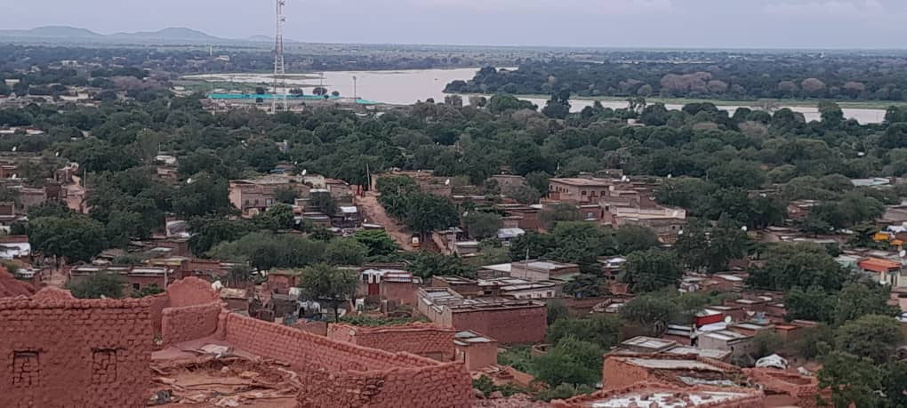
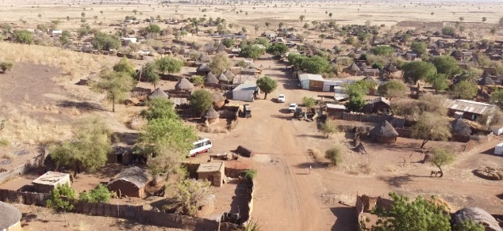

Aldaraot village- Gadarif state- February 2023
Ginaina city- West Darfur state- August 2022

The demand of renting units is increasing in urban areas especially among the poor as ownership ratio declined from 88 % in 2009 to 82% in 2014(11). Relying on own calculations based on real estate brokers survey, legal claims and eviction cases, in 2011 rent price was between 400-600 SDG for local houses and 800-1200 SDG for apartments (at the edge of cities and near small markets), and was between 2000- 2500 for the higher class (near to city centre and better services). The rent price was more than doubled between 2014-2017, and reached 10.000-20.000SDG and 40.000-50.000SDG respectively in 2019. During and after Covid-19 pandemic and due to the high rates of inflation and shocks, the rents price jumped to 100.000-150.000 SDG (at the edge of cities and near small markets) to 200.000-350.000 SDG (higher class) in 2023. According to ministry of finance, the value of the Sudanese pound deteriorated from 2.8 SDG in 2011 to 445 SDG in 2021 and 600 SDG in March 2023 according to the Central Bank of Sudan, while the minimum wage according to the ministry of finance is 7130 SDG in 2023.
According to National Students Welfare Fund press release and declarations, the number of dormitories in Sudan is 169 dorms as following; 1) public housing of capacity averaged 5persons per room and the housing fee is 10% of the operational cost for each student, 2) shared housing of capacity averaged 4persons per room and housing fee between 50% to 70% of the operational cost and 3) economical cost (investment) 1-2 persons per room. In 2022 the housing fee for Khartoum university students raised to 60.000SDG while it was 5000SDG in the past years.
Affordability of services:
Dwellers have to pay almost 100% of services cost, that comprise the construction of the system and monthly fees. Following inflation and shocks, there is an annual increase in services tariff and the local authorities usually refer this to the high cost of operation and production. However, only rich people could afford a secure access to clean water, improved sanitation facilities and electricity, and the service is unaffordable for the vast majority of Sudanese dwellers. The table below shows the availability of the services (MICS-2014):
Area | Water | Electricity | Sanitation
Urban | 78.3% | 76% | 69%
Rural | 63.5% | 31.7% | 28%
Nomad | - | - | -
Total | 68% | 45% | 40.9%
According to MICS-2014, 58.2% of Sudanese dwellers use solid fuels as the primary source of domestic energy to cook. Liquefied Petroleum Gas (LPG) is not offered as a public service and not available through a pipe network system, people had to buy and refill their own gas tubes (cylinders), and only 58.8 of urban dweller have access to (LPG), the cost of refill is 3500SDG and the new cylinder is 10.000SDG in Khartoum markets in March 2023, the cost is higher in the other regions. Figure2 shows household members using LPG, according to MICS-2014:

Figure2
Pit latrine and septic tank systems are the most common forms of waste water treatment in Sudan and about 5% of urban households depend on open defecation (CBS-2014). The cost of the septic tank (not the whole system) is around 800$ in Khartoum in March 2023. In 2015 water tariff increased by 100% for housing sector and increased by 300% in 2023 than 2022, according to the local authorities. Only 31.3% rural household members have access to improved water source, versus 63%of members in urban households. 25.5% of uneducated household heads have improved water source on premises while 77.5 % for household head with higher education, figure-3 shows drinking water availability versus wealth index & Figure-4 shows sanitation facilities according to MICS-2014.

Figure3 Figure4
Only about 45% of the households in Sudan have access to electricity according to CBS-2015, which is higher than the number of premises with electricity meter connection is 2.2 million people (32% of the households) according to Sudanese Electricity Distribution Company Ltd (SEDC) (illegal connections (not registered) or more than on household could use the same meter connection). Accessibility of electrical coverage is 67% among the forth rich and the richest quintiles of the households, and is widely varies among the States (Northern, Khartoum and Gezira states are the richest) (12), and tariff average is 1%-3% of households living costs while the affordability rang is 5% according to World Bank and the International Energy agency(13). In 2012 the tariff increased by 250% from 2011 and in 2023 the tariff increased by 600% from 2022 for the housing sector according to local authorities.
Housing supply:
The key players in housing industry in Sudan are; the National Fund for Housing and Reconstruction, the states funds in collaboration with the Ministry of Planning and Public Utilities of Sudan, the Social Security Investment Agency (the main bodies that represent the government in the sector), and the privet sector of national and foreign contractors, real-estate developers and banks, in addition to the International organizations working for the IDPs and refugees shelters.
The actual groups in need for housing in the country are; young families, slums and informal settlements’ dwellers, IDPs, refugees, and homeless in addition to group housing for students (dormitories), elder people and housing for vulnerable groups as people with special needs and women & children protection shelters. The statistics regarding the number of population in need for housing depends on legal, demographical and geographical factors. It is difficult to measure supply deficit when there is no housing affordability index (HAI) or census, and the available data is usually biased or incomplete as it is produced by the key players (suppliers). housing suppliers investments are -most of the time- oriented to fourth and richest quintiles and the low-cost units provided by the Khartoum Housing and Development Fund are usually poor constructed, lack services and facilities, are usually at the edge of the cities and far from the markets and public services, one of the National Fund for Housing and Reconstruction projects namely “Green valley housing project” was constructed at a flood-borne area and most of the houses collapsed in rainy seasons.
Corruption on land speculations is the trend in Sudan as many of the developing countries, and accordingly the price of the meter square increased following the economic shocks. Land and construction cost have dramatically increased over the past ten years while the purchasing power has deteriorated following the macroeconomic shocks and political instability. In 2022, land price in Khartoum averaged US$1500/m2 added to 2.6% of the property value for registration procedures (14), and relying on own calculations based on construction market survey, construction cost average is US$400/m² for load bearing housing and US$1000/m² for R/C column & slab houses in 2021. Housing finance access through banking system is weak and had stopped by authorities several times, and according to MICS-2014, only 2.4% of rural households have bank accounts and 11.1% of urban households have bank accounts. The military coup in 2021 had a great impact on the economic and social life in the country, and on October 2022 the ministry of finance decided to rely on local revenues in the general budget (press release and declarations), which add immense pressure on household as the rental income taxes increased accordingly. Referring to the increasing unemployment rate especially among youth, the number of low-income households in urban areas far exceeds the affordable housing units available, and a household head may spend most of his life to secure a durable house.
National and international NGOs are the main entities working for vulnerable groups in Sudan, but, however the increasing number of refugees and IDPs due to armed conflicts and natural disasters, the well constructed camps and shelters available are less beyond the actual need, as only 6% of refugees live in adequate dwellings, 32% live in semi-apartment shelters such as Tukuls and the rest 62% live in substandard and inadequate shelters (15).
For all of the above, housing affordability decreased in Sudan over the past 10 years for the vast majority of the population (poor and low-incomes) and it is less affordable for the dwellers of the marginalized regions that affected by political/ethnical hegemony and conflicts, namely; grater Darfur, grater Kordofan, Blue Nile and eastern states, women and their children suffer the most.
Consequences of housing unaffordability
The right to adequate housing is influential in the enjoyment of cultural, social, political and economical rights. As mentioned earlier in this report, housing unaffordability affected wide range of the Sudanese population, especially; vulnerable groups, marginalized groups and the poor. The causes are mainly related to conflicts, political instability, macroeconomic crises and shocks. Unaffordability is directly related to habitability, cultural adequacy and accessibility, as the house cost determine to what extent dwellers can access opportunities, especially when lack polices and regularities that guarantee equality and improve access to adequate housing for vulnerable and minorities.
Consequences on the country economic and politics
As we reviewed earlier in this report, the key players in housing industry (land & construction) in Sudan tend to accumulate capitals and increase investments through housing markets mechanisms, this large- scale of financialization cause to set housing as a commodity more than a social/human right and increase the gap between richest and lower quintiles. As houses sellers hold the power they increase the demand; hence not only buyers struggle as rents typically rise with housing price. Eventually, unaffordability causes to widen the household debt to income ratio, and the more they spend in housing, the less left to be spent on goods and services, which has a significant impact on the country economy. And due to the of lack of polices and jurisprudences that guarantee housing affordability, and due to the economic crises, the struggle between owners and renters has became more intense that the violence cases increased, one of the cases; a blind 70 years old lady (owner) murdered in July 2022 by the renter who couldn’t afford the rent price (news& media).
“Moderate poverty among renters increased from 25 percent to 52 percent yet increased only moderately from 47.8 percent to 51.8 percent among owners. Extreme poverty even declined among owners—from 18.8 percent to 15.5 percent—while it increased by a factor of nearly four among renters (from 3.8 to 14.5 percent)” (16)
The growing socioeconomic inequality in Sudan, followed by the polarization between owners and renters in their preference about policies and regularities and considering spatial/residential segregation, policy makers and politicians are, in some way, one of the important key players in housing industry in the country. There is a growing evidences that housing sector is where dirty money is concealed in Sudan during the past 30 years. The very big difference between the poorest and richest related to ability and purchasing power for the options and alternatives, slums and informal settlements is hazardous places (safety and health) and dwellers are at a risk of being exposed to eviction and homelessness. In February 2021, Khartoum state police implemented the “Flash Lighting Campaign” No: 19 targeting “areas of fragility” in Bahri and evict 1500 Rakoba (traditional hut), 120 fixed houses and confiscation of building materials (press release & news). This type of eviction campaigns happen regularly in Sudanese cities and the targeted areas (informal settlements), which are usually classified as crime zones by legal authorities, are allocated for investment (housing compound).
Rent disputes and the cases of eviction because of unaffordability of housing increased during the last 5 years in Sudan following the increase in living costs and economic crisis. Access to data related to cases and claims is limited; however this report reviewing rent disputes in Khartoum East administrative unit as a study case, which is one of the administrative units of Khartoum city, the capital of Sudan. Khartoum East administrative unit is 52/km² and comprises about 11 big residential quarters (find attached map). No recent statistics available but in 2018 the population of Khartoum East was 206.192 while the total population of Khartoum was 6.8 million according to CBS. According to official document obtained with the judge permission from Khartoum East partial court for the purpose of this report on 11 April 2023, from 2018-2022, rent disputes averaged 3443 cases annually and eviction notice because of non-payment of housing cost averaged 1344 cases annually. The cases are: parable rent claims, eviction notice because of non-payment of housing cost and eviction for urgent need. Eviction notice for urgent need means the owner needs the property for his own use or his relative (son/sister). The table below shows statistics of rent disputes in Khartoum East administrative unit during the last 5 years:
Year | Total rent cases | Eviction for non-payment | Eviction for urgent need | Parable rent claims
2018 | 3399 | 1090 | 853 | 1450
2019 | 3119 | 1349 | 650 | 1120
2020 | 2700 | 1380 | 780 | 450
2021 | 4392 | 1565 | 984 | 1843
2022 | 3603 | 1335 | 746 | 1522

The cases have increased the most in 2021 during the political unrest and military cop, the period also witness economic shocks, many investors flee and the international fun had stopped, the total number of cases in the year reached 4392 case, figure no:5. Yet to mention the vast majority of the dwellers of the study case area are on the middle, fourth and richest quintiles.

Students are facing eviction from dormitories for not paying housing fees regularly in Sudan, for example; in March 2023, students had been evicted by force (Khartoum local authorities) from Ibrahim Malik dormitories in Khartoum under the pretext of maintenance, according to judicial decision in favour of National Students Welfare Fund which is the supervisor of the national dormitories in Sudan (press release) and according to students, the eviction because of their non-payment the increase of housing fees which is far more expensive than their families capabilities. Most of the dormitory dwellers are rural comers, low incomes and their chances to find alternative shelter is almost zero, Yet to mention, eviction notice is usually between 1-10 days and some students are special needs and in need for assistance to move.
Consequences on household
Denial of choices and opportunities, a violation of human dignity” (UN 1998), and according to Maslow theory, people will be consumed by their basic needs as a priority. Housing (safety) is a priority for human after food and health (physiological needs), and referring to the deterioration of the purchasing power and shocks, the majority of household cannot afford their living costs and many modified their eating habits, and hence, the household standard of living deteriorated and their efforts to secure food and affordable housing minimize their opportunities to education and health. The wide trend towards privatisation of public services like schools and public health facilities, have added immense pressure on household members and according to UNICEF; 6.9 million is the dropout during schools in the country in 2023. Urban sprawl and the horizontal integration as a result of the current urban planning policies caused to increase the construction and operational cost of the services systems. Unaffordability of services affect the quality and sustainability of adequate shelter, and with big attention to educational level of households, alternatives are often unhealthy and not safe, and that is affecting not only the health and well being, but also the human dignity, people under this kind of pressure are less able to apply political pressure or to claim their rights, and actually, those are the main reasons behind armed conflicts in Sudan.
“Marginalization is both a condition and a process that prevents individuals and groups from full participation in social, economic, and political life enjoyed by the wider society”(17).
Urban planning policies and regulations are not serving the poor who cannot afford minimum plot size, as the improved facilities and infrastructures raise the cost of land and transportation. In Khartoum (Capital & primate city), physical features like bridges, highways (with no transit stops and turn), one-way roads, no public transport roads, buffer zones (squares &green areas) and even boundaries and walls, are often used to divide neighbourhoods and limits the extent to which higher class and lower class residential quarters integrate (urban planning polices). Hence, minorities and low income people excluded from infrastructure equipment, services and their social, educational and employment opportunities minimized. For example; many workers who would accept minimum-wage jobs in the higher class zones find difficulties to physically access those jobs, especially, when they cannot afford a car. And as the good public services and private investments located in higher class areas, best schools in Khartoum are often located in higher class residential quarters , which exclude lower class quarters’ dwellers (long way access) from better education opportunities for their children even if they can afford the high tuition fees of those schools (18). People with special needs forced to pay more to access adequate housing units in well planned areas that matches their needs (elevators, pathways, habitability, transportation...etc).
Programme and practices aiming to ensure that housing are affordable to all without discrimination
The country lack social protection programs and housing policy that ensures affordability. The formal practices and programs that oriented towards marginalized groups and minorities are less beyond the expectations, however The government of Sudan with active engagement within Intergovernmental Authority on Development (IGAD) has recently made durable solution commitments with 41 partners include UN agencies, international/national NGOs and The Sudanese Red Crescent for refugees, IDPs and returnees who are projected to be 926,245 in 2023 (19). The program will focus on: a) providing non-food assistance (NFA) to crisis affected population and b) enable crisis affected population to access adequate shelter (durable shelters, construction materials, training...etc (20). According to UNHCR, the country monitoring results indicates increasing in providing shelters and NFA for affected groups, still a housing policy and legislations is needed to enhance and expand the role of Government of Sudan and the national entities. Peace agreements usually allocate fund for housing and post-conflict rehabilitation, however the fund management entities were poor monitored and the implemented projects are much less the amount of money awarded (the number of beneficiaries is relatively low).
Demographic polices and citizenship policies in the past 10 years are controversial due to the ethnical conflicts and struggle around resources, as the political polarization within the tribes settling on the common borders with the neighbouring countries, especially Chad, Ethiopia, Egypt and South Sudan, is influential in land disputes and security of tenure, yet to mention the struggle around agricultural land and pastures. Thereby, the opportunities of constructing affordable housing decreased while the number of housing seekers increased (communities, returnees, IDPs and refugees).
Housing finance policies are one of the biggest problems facing the urban poor. In developing countries poor households do not have acceptable collateral and guarantees for financial institutions as the loan decisions based on borrowers’ credit risks (21). The Sudanese Real- Estate Bank established as a public company in 1967 to finance housing for public sector employees and low-incomes. However the finance services are not valid through The Bank any more, according to studies, it was influential in improving access to credit for the urban low-incomes (analysing the risks was unclear without household living costs surveys and housing census). Formal banks have proved reluctant to lend to such schemes as they are often unclear in analyzing risks involved and lack loan management systems (22). Housing fund projects held by multi-stakeholder initiatives, community and cities alliance are effective in financing housing for the poor, one of the successful experiences is The Community-Led Infrastructure Finance Facility (CLIFF) which was established to provide slum dwellers with access to affordable housing finance instead of giving one-off grants. Currently operating in 14 countries and has supported 70 housing and infrastructure projects between 2010- 2014, the project promotes greater community cooperation and encourage gender equality (23). Sustainability of housing affordability is directly related to the policies and processes of improving livelihood and generating incomes for the poor.
Conclusion
This report was trying to demonstrate that adequate housing unaffordability is affecting wide range of population and their opportunities to live in dignity in Sudan, as a result of lack of policies, jurisprudence and practices that guarantee human and housing rights. There is a risk on social peace and development that unless urgent action is taken to improve access to affordable adequate housing and land security of tenure (adequate housing) with due consideration to the poor, vulnerable and minorities, and the key element for this is the Political Will. Opportunities for implementing new polices could not be realistic without housing census and affordability index (HAI). The methodology of tracking affordability in this report could hopefully enable the UN Special Rapporteur on the right to adequate housing, policy makers, stakeholders and researcher for change towards National Sustainable Housing Policy.
References:
- African Development Bank (ADBG)-Sudan Economic outlook 2023
- Norwegian Refugee Council (NRC)-Sudan-annual report-2021
- Arabic reference, Arwa Kamal-Housing poverty in Sudan- towards national sustainable housing policy-Blogger-2020- http://arcarwakamal.blogspot.com/2020/09/blog-post.html?spref=fb
- Redress, ending torture, seeking justice for survivors, https://redress.org/Sudan-legal-resources/
- Ibid
- Ibid
- The Sudanese laws of encouraging investment 2013, 2021, Ministry of Investment, http://www.sudaninvest.org.
- World Bank report No: AUS0001487- Poverty and Inequality in Sudan: 2009–2014
- Africa Housing Finance- Sudan, Yearbook 2022.
- Norwegian Refugee Council (NRC) annual report, in 2021
- World Bank report No: AUS0001487- Poverty and Inequality in Sudan: 2009–2014
- World Bank & ESMAP report titled: From Subsidy to Sustainability Diagnostic Review of Sudan Electricity Sector-June 2019
- Ibid
- According to Africa Housing Finance- Sudan, Yearbook – 2022
- UNHCR- Sudan, Country refugee response plan- January-December 2023, http://reporting.unhcr.org/document/4206
- World Bank report No: AUS0001487- Poverty and Inequality in Sudan: 2009–2014).
- Niyara Alakhunova, Oumar Diallo, Isabel Martin del Campo and Whitney Tallarico- May 2005- Defining Marginalization: An Assessment Tool- A product of the partnership between four development professionals at the Elliott School of International Affairs & the World Fair Trade Organization-Asia. Page: 10
- Arabic reference, Arwa Kamal-Housing poverty in Sudan- towards national sustainable housing policy-Blogger-2020- http://arcarwakamal.blogspot.com/2020/09/blog-post.html?spref=fb
- UNHCR- Sudan, Country refugee response plan- January-December 2023, http://reporting.unhcr.org/document/4206
- Ibid
- Geoffrey Payne and Michael Majale- 2004- The Urban Housing Manual- Making regularity framework for the poor- UK: Earthscan- London-Sterling, VA. Page: 59.
- Ibid
- World habitat award, http://world-habitat.org
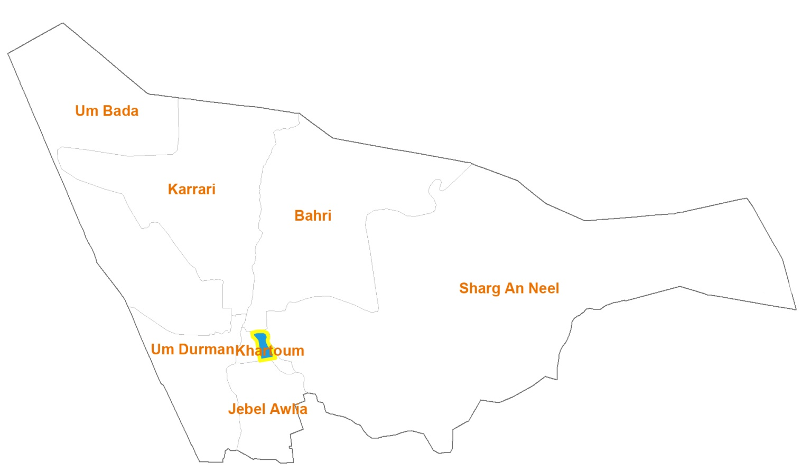
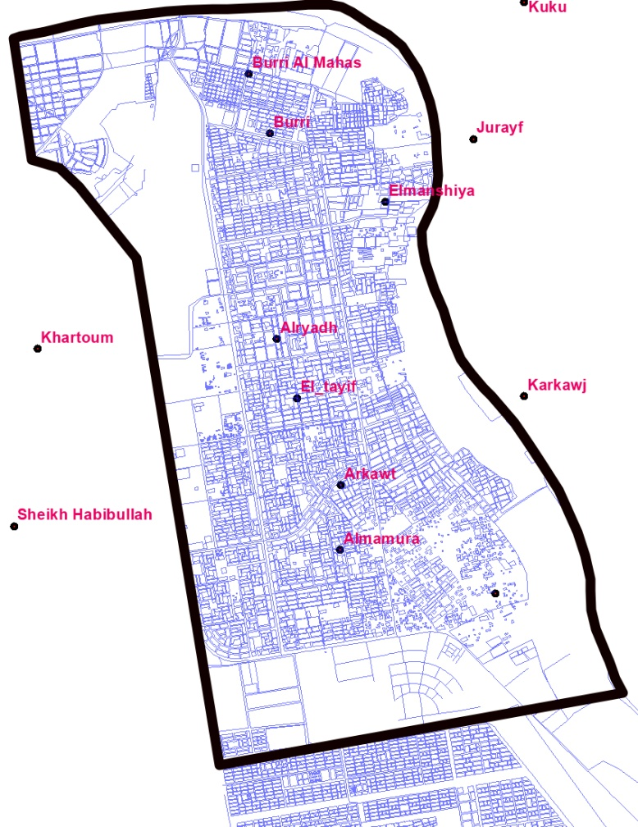
Khartoum East administrative unit
The map of Khartoum

