**QUESTIONNAIRE**

**Contact Details**

|  |  |
| --- | --- |
| Type of Stakeholder (please select one) | Member State  Observer State  Other (please specify) Civil Society Organisation |
| Name of State  Name of Survey Respondent | Equal Education Law Centre |
| Email | robyn@eelawcentre.org.za |
| Can we attribute responses to this questionnaire to your State publicly*?  *On OHCHR website, under the section of SR health | Yes No  Comments (if any): |

# 

# Key Questions

1. **What are the major factors that challenge quantitatively and qualitatively adequate access to food and nutrition in your country and/or community (including external to your country)? Taking into consideration the underlying determinants of health, in what ways do they contribute to health inequities?**

*Insufficient social spending due to austerity budgeting*

The South African government has implemented budget cuts in an effort to reduce public borrowing – budget cuts which are largely targeted toward decreasing social spending. A reduction in social spending disproportionately impacts the most vulnerable, marginalised and poor population groups in South Africa, such as those who rely on social grants or free public services. The inevitable consequence of this will be a widening of already vast levels of inequality.

Despite 55% of South Africans living below the poverty line,[1] and the huge number of ECD institutions who cater to learners from poor families, “only 33% of early learning programmes, or 668 518 children, received the subsidy in 2021.”[2] There are nearly seven million young children in South Africa who are of ECD-going age (excluding Grade R), and approximately 60% (4.2 million) of these children live in poverty. Of the 7 million children of ECD-going age, 3.2 million are not in any form of ECD programme, and of those who do have access to ELPs, 2.9 million children are in unregistered programmes – only 11% (800 654) children attend registered ELPs. For those learners who are lucky enough to benefit from State ECD subsidies – only 25% of children who need it - meals provided by ECD institutions can sometimes be their main and most stable source of nutrition.

While funding for Early Childhood Development (ECD) sector has shown some signs of improvement, the per child per day subsidy, which is meant to support access to ECD services for learners from low-income families, has not increased in nominal terms since 2019, at R17 per child per day for ECD centres and R6 for non-centre based programmes.[3] This means that in real terms, taking inflation into account, this already wholly inadequate subsidy has actually *decreased*.[4] Aside from covering the costs of staff, rent and equipment, this subsidy also covers food for learners – only 50% of this subsidy can be allocated to food, which amounts to R8.50 per day. The inadequacy of this subsidy is further highlighted when considering that many learners in Early Learning Programmes (ELPs) attend centres from 7am to 6pm, and that this R8.50 subsidy is expected to cover the cost of food for learners for the entire day. According to the Budget Justice Coalition, “Erosion of its real value at a time when food inflation is as high as 13% will likely translate into reduced nutritional support for children under 5 years of age - the group most in need of adequate nutrition to prevent malnutrition and stunting.”[5]

Similarly, many school going children in public primary and secondary education systems rely on the National School Nutrition Programme (NSNP) as their main or even sole source of nutrition. The NSNP provides school meals to over 9 million learners in under-resourced schools. In 2023, the budget for the NSNP increased by 9.1%. This is above the headline CPI, with National Treasury declaring a food inflation rate of 7%. However, StatsSA -- the national statistical service of South Africa – recorded a 13.8% increase in food prices.[6] The consequence of the NSNP budget not rising in accordance with food prices is that the quality and/or quantity of food provided to learners is likely to decrease.

The purpose of feeding schemes in learning institutions is to augment a child’s nutrition, and not to provide their sole or main source of nutrition. Unfortunately, the latter is frequently the case.

*Inadequacy of Social Grants*

South Africa has an unemployment rate of 32.7% extremely high levels and extremely high levels of poverty.[7] This has a direct impact on food security for children, as many families rely heavily on the social welfare provided by the State, like the Child Support Grant (CSG). The CSG is supposed to cover the cost of food and clothing for a child, but in practice covers neither. There is an increasingly large gap between the CSG and the food poverty line (the minimum nutritional requirement) - with the CSG at R500 per month and the food poverty line at R663 per person per month, even if the subsidy was entirely spent on food, it would still not be enough.

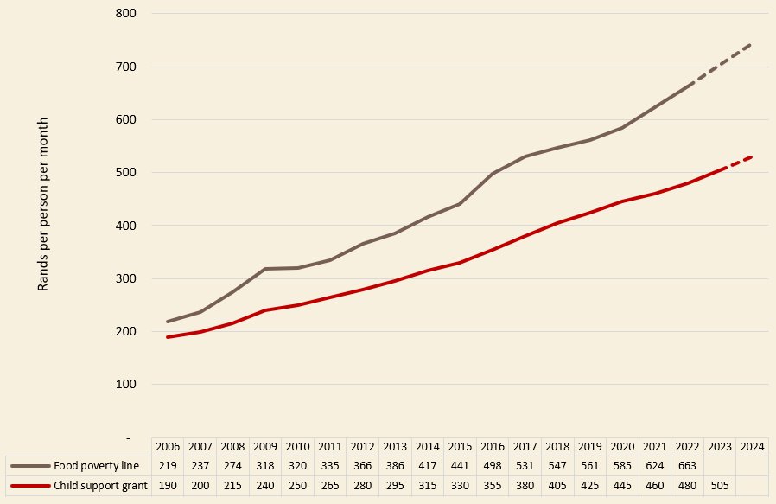

*TABLE 1: Source: Budget Justice Coalition, ‘FOA Submission on the 2023 MTEF’. Presented in the Public Hearings on the 2023 Division of Revenue Bill, 13 March 2023*

With National Treasury (NT) using headline CPI to determine inflationary increases for social grants like the CSG, the way in which inflation unequally impacts the rich and the poor remains unaccounted for.[8]

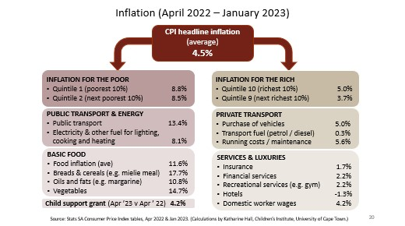

*TABLE 2: Source: Budget Justice Coalition, ‘FOA Submission on the 2023 MTEF’. Presented in the Public Hearings on the 2023 Division of Revenue Bill, 13 March 2023*

*Ambiguity Regarding the Right to Nutrition as part of ECCE/ECD*

Whilst the content of right to basic education has been substantially fleshed out by the South African courts, with courts confirming that part of the right is inclusive of the right to nutrition, it is still unconfirmed whether the State has a duty to provide nutrition to learners in the ECD/Early Childhood Care and Education sector. The consequence of this is that there is no public programme to ensure that meals are provided to children in Early Learning Programmes (ELPs). However, in April 2022, the ECD sector transitioned from the Department of Social Development (DSD) to the Department of Basic Education (DBE). The DBE has taken steps toward piloting a nutrition scheme for young children in ELPs. Whilst this is a step in the right direction, because it is only a pilot programme, majority of children in ECD programmes will not benefit from this.

1. **What legislative or regulatory measures (such as those related to nutrition standards, labelling, marketing, procurement in institutional settings including – but not limited to – schools and prisons, and fiscal measures) have been considered or adopted in your country and/or community to improve food and nutrition, especially for persons in vulnerable situations? Where relevant, how are those measures being enforced?**

The following will exclusively discuss legislative and regulatory measures regarding nutrition provided to learners in schools, specifically through the implementation of the National School Nutrition Programme (NSNP). Regulation and enforcement of the NSNP food scheme has historically been weak. Almost all regulation of the NSNP takes the form of guidelines – guidelines that are largely very outdated, referring to outdated legislation, and provide very little uniformity in how schools should implement the programme and how government officials should monitor and enforce the delivery as well as quality of the programme. To this end, Equal Education Law Centre (EELC) represented Equal Education (EE), a grassroots democratic movement of learners, parents and post-school youth, in a court case against the Department of Basic Education (DBE) and provincial MECs which sought the continuation of school meal provisioning through the NSNP during the COVID-19 lockdown. Through gathering the testimony of EE’s learner members who received meals through the NSNP, EELC learnt that the quality and quantity of the food provided was often extremely inadequate, and that not all learners who qualified for NSNP meals were receiving them. Following judgment in favour of EE, provincial education MECs were ordered to provide monthly reports to EE on the quality of meals as well as the success of the rollout – in other words, how many learners who qualified for meals had actually received them. Following this, whilst still not up to scratch, regulation and monitoring of the feeding scheme substantially improved. Below is an outline of some of the key guidelines issued by the DBE relating to the NSNP.

*Food Specifications*

The Department of Basic Education (DBE) has developed a policy document entitled “Food Specifications – for products marketed to the National School Nutrition Programme”.[9] This document aims to maintain and improve the quality and standard of food that is given to learners through the NSNP and to provide guidance to service providers.

It outlines applicable regulations and legislation that apply to those who procure, provide and cook meals for learners. This is inclusive of regulations and laws related to tenders and procurement, agricultural production standards, marketing, quality management. It must be noted that this document is extremely outdated. The document further sets out definitions, general, nutritional, physical, microbiological, packaging, labelling, delivery, storage, and shelf-life requirements for each category of food.

*Implementation and Oversight*

The Conditional Grants Framework allocates specific responsibilities to national and provincial governments in the implementation of the NSNP. Provincial Education Departments (PEDs) are responsible for ensuring the implementation of the programme and the delivery of school meals to every qualifying leaner, whilst the national Department of Basic Education (DBE) plays an oversight role.

*Health and safety*

The DBE has provided an NSNP Safety Directory which provides guidance on how to ensure that school meals are prepared in a hygienic manner, on safe premises, and result in reduced waste that does not negatively impact the environment. This document is not only used for guidance but also for monitoring by PEDs, districts, schools and food handlers.[10] It deals with the following topics:

* Safe food transportation
* Personal hygiene
* Kitchen hygiene
* Kitchen safety
* Food handling
* Food storage
* Waste management

*Guides for Schools*

The DBE has developed a guideline for schools that implement the NSNP.[11] This guideline explains the importance of the programme, which learners get meals, what should be included in the meal, when to feed learners, the management structure of the programme, how the programme should be implemented as well as guidelines on communication and reporting by schools to Provincial Education Departments and the DBE.

* 1. **What proactive steps or good practices can you report on taken by the State to engage in activities to strengthen people's access to and utilization of resources for food security in this regard?**

*ECD and Nutrition*

In 2023, the State allocated more money to the ECD sector, specifically increasing the ECD Conditional Grant for 2024/25 by 51% and set to increase again by 24% in the 2025/26 financial year.[12] Part of this conditional grant is used for the per child per day subsidy, and whilst the cost of the subsidy remains concerningly low, the increase allocated funds means that the number of learners in ELPs that are subsidised by the State could grow by 20%. Whilst this is a step in the right direction, it is not necessarily a big enough one because the bar from which the sector is progressing is extremely low.[13]

This conditional grant will also fund the nutrition support pilot for ELPs. This pilot programme has a budget of R300 million in the 2024/25 financial year and R400 million in the 2025/26 financial year.[14] One of the goals of this pilot programme is to test for a results-based nutrition delivery model. The context in which a nutrition programme would work within ELPs varies to the context in which the NSNP feeding scheme is delivered because a large majority of ECD/ECCE institutions are privately run and many, serving the poorest communities, are unregistered.

*Provision of School Meals During the COVID-19 Pandemic*

The NSNP is a feeding that was introduced in 1994 as a means to improve the ability of learners to learn effectively by reducing malnutrition, stunting, hunger and improving school attendance. Today, it provides school meals to over 9 million vulnerable learners. The programme provides meals to learners in under-resourced no-fee paying schools and is thus an example of effective ‘pro-poor’ spending.

When the COVID-19 pandemic hit South Africa, schools were shut down and the State decided to halt the NSNP school feeding scheme. Upon learners returning to school, some learners were learning entirely remotely and others were learning on a rotating/platooning schedule – in other words, they attended school either every other week or every other day. Learners who were learning from home were not receiving their meals through the NSNP. In response, Equal Education (EE), a movement of parents, learners, and post school youth, represented by the EELC, took the DBE to court where it was held that the DBE had a constitutional obligation to continue to fully implement the NSNP, regardless of where learners were learning from.[15] The judgment confirmed that the right to basic education was inclusive of the right to basic nutrition:

*“It is . . . literally a lifesaving programme for the poorest of the poor child by*  *providing them with at least one nutritious meal a day while being educated. A*  *programme that must be saluted. . . On the Departments own documents the*  *stance that the nutritional aspects of the NSNP is just a by-product of their duty*  *to educate is simply wrong. The Department’s own policy statements reflect*  *basic nutrition as component to basic education. State policy is instructive on*  *the content of the right to education and in the policies the provision of basic*  *nutrition is inextricably linked to the fulfilment of basic education.”[16]*

Even though the continuation of the NSNP feeding scheme throughout the COVID-19 lockdown in South Africa was court mandated, it is an example of good practice by the State of ensuring access to basic nutrition for under-resourced learners.

1. World Bank (2020) ‘Poverty & Equity Brief: Sub-Saharan Africa – South Africa’. Found at https://databankfiles.worldbank.org/public/ddpext_download/poverty/33EF03BB-9722-4AE2-ABC7-AA2972D68AFE/Global_POVEQ_ZAF.pdf
2. Scholtz, K. & Selebalo, H. (2023) ‘Limited State Subsidisation Remains a Key Challenge to Delivering Quality Learning Programmes’. Daily Maverick. Found at https://www.dailymaverick.co.za/article/2023-03-20-limited-state-subsidisation-remains-a-key-challenge-to-delivering-quality-learning-programmes/
3. Wills, G., Kotze, J., & Kika-Mistry, J. (2021) ‘A Sector Hanging in the Balance: Early Childhood Development and Lockdown in South Africa’. RISE Working Paper 20/055. Found at https://riseprogramme.org/sites/default/files/2020-11/RISE_WP-055_Wills_Kotze_Kika-Mistry.pdf
4. For comparison, the average spending per primary school learner per day is R96.
5. Budget Justice Coalition, ‘FOA Submission on the 2023 MTEF’. Found at https://budgetjusticesa.org/media/bjc-foa-submission-on-the-2023-mtef/
6. StatsSA Consumer Price Index Tables, April 2022 & January 2023
7. Mukherjee, P. (2022) ‘South Africa’s unemployment drops again after years of job gains’. Reuters. Found at https://www.reuters.com/world/africa/south-africas-official-unemployment-rate-dips-327-fourth-qtr-2023-02-28/#:~:text=Unemployment%20fell%20to%2032.7%25%20in,Risenga%20Maluleke%2C%20Statistician%2DGeneral.
8. StatsSA Consumer Price Index Tables, April 2022 & January 2023 (Calculations by Katherine Hall, Children’s Institution, University of Cape Town), as referenced by Budget Justice Coalition, ‘FOA Submission on the 2023 MTEF’. Found at <https://budgetjusticesa.org/media/bjc-foa-submission-on-the-2023-mtef/>.
9. Department of Basic Education (2015) ‘Food Specifications – for the products marketed to the National School Nutrition Programme’. Found at https://www.education.gov.za/Portals/0/Documents/Publications/NSNP%20Food%20Specification%20Guidelines.pdf?ver=2015-04-07-161503-357
10. The Department of Basic Education (2014) ‘The NSNP Safety Directory’. Found at https://www.education.gov.za/Portals/0/Documents/Publications/NSNP%20Safety%20Directory%202012.pdf?ver=2014-03-04-151020-380
11. The Department of Basic Education (2009) ‘National School Nutrition Programme: A Guide for Secondary Schools’. Found at https://www.education.gov.za/Portals/0/Documents/Publications/NSNP%20Guide%20to%20Secondary%20Schools.pdf?ver=2014-03-12-164514-790
12. Division of Revenue Bill, GG No. 48017 of 10 February 2023
13. Budget Justice Coalition, ‘FOA Submission on the 2023 MTEF’. Found at <https://budgetjusticesa.org/media/bjc-foa-submission-on-the-2023-mtef/>.
14. Division of Revenue Bill, GG No. 48017 of 10 February 2023
15. Equal Education (2020) “Timeline for the National School Nutrition Programme Court Case”. Found at https://equaleducation.org.za/2020/08/03/timeline-for-the-national-school-nutrition-programme-court-case/
16. Equal Education & Others v Minister of Basic Education 2020, Gauteng High Court. Found at https://eelawcentre.org.za/wp-content/uploads/judgment-equal-education-and-others-v-minister-of-basic-education-and-others-22588-2020.pdf