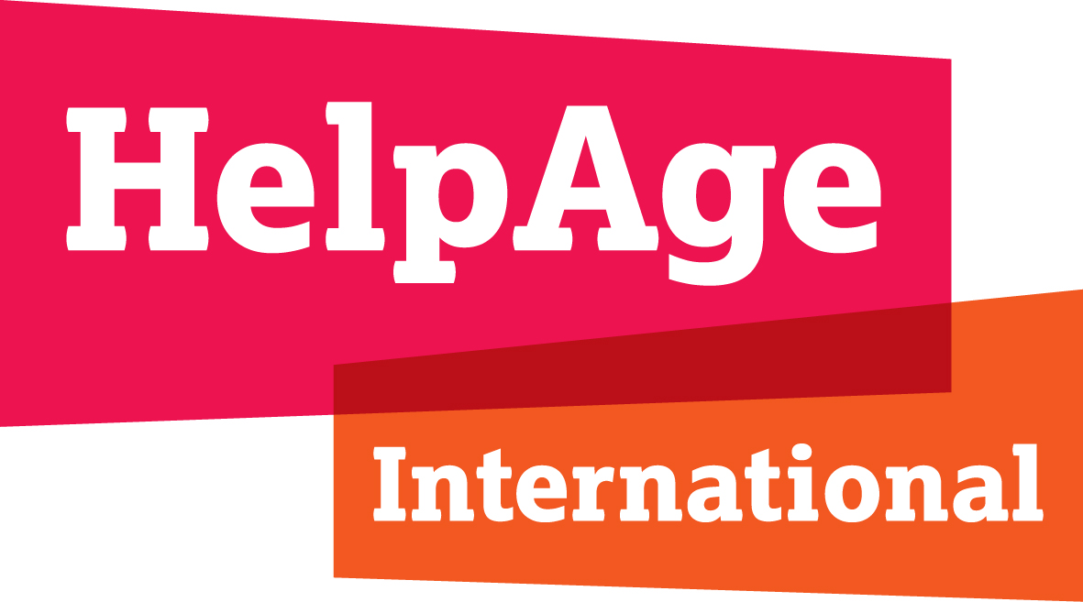

  - HelpAge International inputs on examples of a Human Rights-Based Approach to Universal Health Coverage
March 2023

In 2022, HelpAge International published the UHC report, "Achieving Universal Health Coverage fit for an ageing world", which outlines how we can harness the opportunity Universal Health Coverage presents to reorient health and care systems to meet the needs of older people and effectively promote healthy ageing across the life-course.
The report outlines three key components needed to achieve UHC fit for an ageing world and uphold the rights of all older people, the third of which is that models of UHC adopt a rights-based approach.
The following paragraphs describe more in detail what applying a rights-based approach to models of UHC entails in practice.

Models of UHC adopt a rights-based approach, ensuring the voices of all groups, including older people, are heard within system and service design, delivery, monitoring and evaluation.
An equity-based approach to UHC means reaching the furthest behind first. This demands that we consider the diversity of older people when designing policies and programmes and engage them to identify who is most at risk of being left behind and how we can most effectively tailor UHC to meet their needs and fulfil their rights.
Human rights principles must be upheld in all areas of service design, delivery, monitoring and evaluation, including:

Participation
Health and care systems are everybody’s business and must engage individuals, communities, civil society and private sector. All groups of older people must be able to participate in system and service design, with support if necessary, to ensure that their voices are heard and that they have agency and influence in decision making processes at all levels.

Accountability and transparency
Those involved in provision, commissioning and policy-making for health and care must be accountable and transparent in all areas of system and service design, delivery, monitoring and evaluation. Effective and transparent feedback, complaints and redress mechanisms must be in place and accessible to all.

Non-discrimination and equality
All older people must be able to enjoy equitable access to services which meet their specific needs without discrimination of any kind. Older people have intersecting identities based on their age, gender, functional ability, ethnicity, religion and many other grounds. Each of these identities must be considered and respected, and the needs of different groups of older people must be responded to effectively in system design and in service delivery. An equity-based approach to UHC means reaching the furthest behind first. This demands that we consider the diversity of older people when designing policies and programmes and engage them to identify who is most at risk of being left behind and how we can most effectively tailor UHC to meet their needs and fulfil their rights.

Empowerment
All older people must have the information and support they need to understand their rights in relation to health and care and how to claim these rights. Older people must be given a voice in decision making processes at all levels and be informed and empowered to exercise their rights in relation to the care they receive, including their right to choice, independence and autonomy. Where they exist, substitute decision making regimes must be abolished and systems and policies for supported decision making should be developed to ensure that all groups have appropriate information, training, advocacy and support, in line with their rights, needs and preferences.

Legality
The right to health and the right to long-term care and support should be included in legislation. A human rights-based approach to policy and practice should be embedded into the work of all public authorities and all health and care providers. Legislation and regulation should be in place to ensure services are delivered in line with human rights law, with explicit prohibition of discrimination on the basis of age or any other grounds, and clear processes for taking effective action against any breaches of these rights. This includes but is not limited to UN Declaration of Human Rights; Covenant on Economic, Social and Cultural Rights; the Convention on the Rights of Persons with Disabilities (CRPD); and the Convention on the Elimination of All Forms of Discrimination Against Women (CEDAW).

https://www.helpage.org/what-we-do/healthy-ageing/achieving-universal-health-coverage-fit-for-an-ageing-world/

