Submission to OHCHR for the High Commissioner’s report on human rights implications of and good practices and key challenges of equitable and universal access to and distribution of COVID-19 vaccines
3 October 2022

Submitting organisations:

Harm Reduction International (HRI) is a leading NGO dedicated to reducing the negative health, social and legal impacts of drug use and drug policy. HRI promotes the rights of people who use drugs and their communities through research and advocacy to help achieve a world where drug policies and laws contribute to healthier, safer societies.
HRI is an NGO in Special Consultative Status with the Economic and Social Council of the United Nations.
Contacts: 61 Mansell Street, E1 8AN, London (UK) | giada.girelli@hri.global
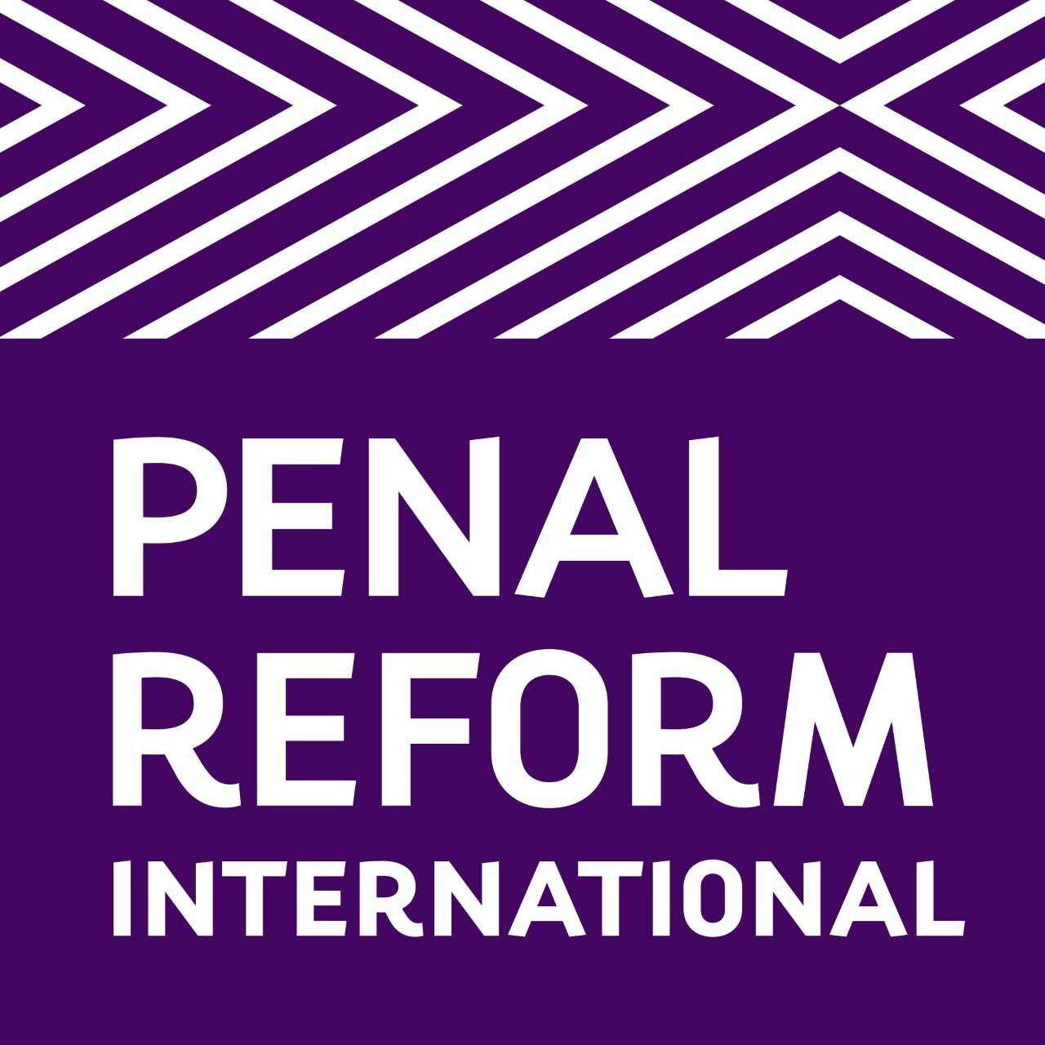
Penal Reform International (PRI) is a non-governmental organisation working globally to promote criminal justice systems that uphold human rights for all and do no harm. We work to make criminal justice systems non-discriminatory and protect the rights of disadvantaged people. We run practical human rights programmes and support reforms that make criminal justice fair and effective.

PRI enjoys ECOSOC Special Consultative Status since 1993. Registered in The Netherlands (registration no 40025979), PRI operates globally with offices in multiple locations

Introduction

Approaching the third year since the WHO declared a Public Health Emergency of International Concern and consecutive pandemic, the spread of COVID-19 remains a global threat to public health, exacerbating existing inequalities and negatively impacting the enjoyment of human rights. Although vaccination coverage is central to achieving the strategic goals for COVID-19 response set out by the WHO, equitable and universal access to and distribution of COVID-19 vaccines remains a challenge, disproportionately impacting marginalised communities globally. As of May 2022, almost one billion people in lower-income countries remained unvaccinated, and only 57 countries had vaccinated 70% of their population (nearly all of them high-income countries). People who use drugs and people deprived of liberty have been historically marginalised and invisibilised in the design and implementation of public health strategies and policies, and global pandemic responses were no exception. Although both groups are at high risk of contracting the virus and having health complications, they remain mostly invisible to policymakers and the international community, leading to limited access to COVID-19 vaccines and treatments.

This submission will focus on challenges, practices and opportunities related to the inclusion and prioritisation of people who use drugs and people in prison in the design, planning, and rolling-out of COVID-19 vaccination programs.

- Universal and equitable access to COVID-19 vaccines for people who use drugs

People who use drugs should be prioritised for COVID-19 vaccination, as they are at high risk of infections and adverse outcomes if contracting the virus. Despite limited data on COVID-19 prevalence among this population, evidence indicates that people who use drugs, particularly people who inject or smoke, face more significant risks of infection and elevated risk of adverse outcomes if contracting the virus compared to the general population, associated - among others - with pulmonary and respiratory complications, compromised immune system as a consequence of the prolonged drug consumption. Additionally, people who inject drugs can have underlying medical conditions that increase the risk of COVID-19, such as HIV, viral hepatitis, and tuberculosis.

Evidence and best practice indicate that a human rights approach to vaccination should integrate harm reduction services, particularly community-led initiatives, in design and implementation, as they may help reach people who use drugs that would not otherwise access health services due to discrimination and criminalisation. As stated in the WHO global COVID-19 vaccination strategy, countries should “integrate COVID-19 vaccination efforts in all available delivery platforms, especially for adults through a primary health care approach”. Harm reduction services have proven to be “key interventions to reach public health goals such as reducing mortality and morbidity, including the elimination of HIV and hepatitis because they can reach people who use drugs where they are and deliver tailored services”. Similarly, including harm reduction services in vaccination planning and delivery could help increase vaccine coverage, as they are recognised and legitimised by their clients, which may promote adherence to medical treatments and vaccination programs. This is particularly important in light of relevant rates of vaccine hesitancy among people who use drugs in certain countries.

Additionally, due to the people-centred approach and the focus on community-led initiatives, harm reduction services could support people with HIV and people who use drugs when the public health system is overwhelmed or under high pressure. Despite harm reduction services being affected or disrupted during the pandemic, they proved resilient: organisations and community-led networks adapted quickly to maintain service coverage, adopted COVID-19 prevention measures, adjusted services delivery, and introduced innovative integrated methods to provide support, information and access to harm reduction services. COVID-19 prevention and mitigation measures, including vaccination, are more likely to be accepted among people who use drugs when delivered and supported by harm reduction services.

Structural factors such as stigma and discrimination can limit the healthcare engagement of people who use drugs, leading them to disengage or actively avoid institutional healthcare settings. Similarly, barriers to accessing health services can also undermine people’s uptake of COVID-19 vaccines. In contrast, harm reduction services are based on providing non-stigmatizing and non-judgmental environments where people who use drugs are treated with dignity and respect. Trust in service providers makes them a valued source of health-related information. Therefore, harm reduction services can improve engagement with the health system and vaccination programs.

- COVID-19 vaccination of people in prisons and prison staff

People in prison continue to be left behind in COVID-19 responses despite facing heightened risk of infection and illness due to cramped and unsanitary living conditions and lack of hygiene supplies in many detention facilities, as well as the poorer health status of prison populations compared to the general population. At the same time, prisons are frequently overcrowded and facilities are cramped, and often with poor ventilation; people in prisons live, work, eat, and sleep in close proximity to one another. In addition, prison populations have limited access to testing and personal protective equipment (PPE) and, in some cases, to clean water and handwashing facilities. Low health status of prison populations, coupled with prison health services that are often inferior in availability and quality to those in the community, seriously aggravate the risk and potential impact of COVID-19 in prisons; with specific groups experiencing unique vulnerabilities.

Several international, regional, and national institutions have published guidance on COVID-19 vaccinations which recommend that people in prison should be considered in national vaccination programme. Nevertheless, the inclusion of people detained and working in prison as an at risk/ priority group in national vaccination plans has been contentious, leading to piecemeal and often insufficient implementation.

Research by HRI and PRI published in December 2021 reveals widespread lack of transparency and lack of information regarding planned and implemented vaccinations among both people detained and staff: official government vaccination plans or other resources outlining national vaccination plans could only be obtained for 131 out of 177 countries surveyed. Often, these vaccination plans are rather sparse in information, and official information was particularly scant for African countries. This lack of clear and explicit mention, and of dedicated strategies for detention settings is in itself concerning, as it signals a failure of authorities to account for the unique vulnerabilities of people in prisons and the connection between prison and public health; and it is in itself a violation of the right to health.

In countries that have adopted and made vaccination plans publicly available, there is considerable variance in approaches when it comes to the inclusion and/or prioritisation of people in prison and prison staff. Despite some caveats and variations, four approaches to prisons can be distinguished:
- Countries which explicitly prioritised prisons, including prison populations as a higher-risk group (51 explicitly prioritised people in prison, 66 explicitly prioritised prison staff);
- Countries which included prisons within plans or roll‐out, but not as a (high) priority group;
- Countries which provide equivalence for prison populations or staff with the group that individuals would fall within in the community; and
- Countries which have not specifically referred to prisons, prison populations or prison staff at all in national vaccination programmes.

A notable difference between the inclusion and consideration of people detained compared to prison staff emerges when focusing on the degree of prioritisation accorded to these populations in plans which explicitly mention them: among countries with available vaccination plans, 30% included prison staff in the highest priority for vaccination, whereas only 16% of countries included people detained in the first priority group. People imprisoned were also more likely to fall into low priority categories: this is the case for 67% of countries for which vaccination plans are available, compared to 38% of countries which mentioned prison staff in low priority groups.

As regards the roll-out of vaccinations, as of 30 September 2021, available figures indicated that vaccination of people in prison had commenced in 120 countries, while in a further 47 countries there was not enough information to confirm that roll-out had begun. In comparison, for prison staff vaccinations were confirmed to have started in 94 countries, with the situation in the remaining 79 countries unclear. There is significant variance in vaccination plans for prisons among countries and regions, attributable to considerable differences in national vaccination plans, availability of vaccines, size of prison populations, and vaccine rollout logistics. As of September 2021, available figures indicated that in only 20 countries, 80% (or more) of the prison population had received at least the first dose of a COVID-19 vaccine.

Finally, vaccine hesitancy appeared to be higher in prisons than in the general population in countries such as Finland, Greece, Jamaica, and Trinidad and Tobago, among others; raising concerns regarding the availability, accessibility, and quality of targeted, evidence-based information on COVID-19 vaccines received by people in prison and on the opportunities provided to make an informed and evidence-based decision regarding vaccination.

Recommendations:

- People living with HIV, people who use drugs and people detained in prison should be explicitly included as a high priority in national COVID-19 vaccination plans and vaccination roll-out on the basis of their increased risk of infection. In cases where it is not possible to offer vaccinations to all people in these categories, higher risk groups should be prioritised based on their age and health factors, such as underlying medical conditions. All decisions on vaccine allocation should be based on the right to health and public health considerations, and not discriminate based on a person’s status of being detained nor the crime for which they are accused or convicted;

- People working in prisons, including healthcare staff, security staff and administrative staff, must be considered at increased risk of COVID-19 infection and therefore be prioritised in vaccination allocation;

- For targeting people with HIV and people who use drugs, harm reduction, particularly community-led services (outside and in detention) should be included in the design and implementation of vaccination programs;

- OHCHR should visit prisons and harm reduction services to monitor the availability, accessibility and implementation of COVID-19 vaccination plans;

- Disaggregated data about vaccination rates should include people who use drugs, people in detention and prison staff. Particularly, authorities should collect, make public, and regularly update data on COVID-19 vaccinations among people in prison and prison staff, disaggregated by sex, age, and other demographic characteristics;

- COVID-19 responses should be reviewed, with meaningful participation of civil society and affected communities, and strengthened to prevent further outbreaks of the virus and used to inform government pandemic or emergency management and response plans, which should be human rights-based and include the outbreak of transmissible diseases within the community or in places of detention;

- The responsibility for prison health should be that of the Ministry of Health or its equivalent and should be transferred out of the penitentiary administration. The management and coordination of all relevant agencies and resources contributing to the health and wellbeing of people in prison must be a whole-of-government responsibility to ensure better protection of the right to health for people in detention and greater financial investment.

https://www.who.int/news/item/30-01-2020-statement-on-the-second-meeting-of-the-international-health-regulations-(2005)-emergency-committee-regarding-the-outbreak-of-novel-coronavirus-(2019-nco)
https://www.who.int/director-general/speeches/detail/who-director-general-s-opening-remarks-at-the-media-briefing-on-covid-19---11-march-2020
https://www.who.int/publications/m/item/who-preparedness-and-response-progress-september-updae
https://www.who.int/emergencies/diseases/novel-coronavirus-2019/covid-19-vaccines
Wang, Q.Q., Kaelber, D.C., Xu, R. et al. “COVID-19 risk and outcomes in patients with substance use disorders: analyses from electronic health records in the United States”. (Mol Psychiatry 2021) 26, 30–39, available at https://doi.org/10.1038/s41380-020-00880-7
Dunlop, A., Lokuge, B., Masters, D. et al. “Challenges in maintaining treatment services for people who use drugs during the COVID-19 pandemic”. Harm Reduct J (2020) 17-26. https://doi.org/10.1186/s12954-020-00370-7; Vasylyeva, T. I., Smyrnov, P., Strathdee, S., & Friedman, S. R. “Challenges posed by COVID-19 to people who inject drugs and lessons from other outbreaks”. (Journal of the International AIDS Society, 2020) 23(7), e25583. https://doi.org/10.1002/jia2.25583; Wang, Q.Q. et a “COVID-19 risk and outcomes in patients with substance use disorders: analyses from electronic health records in the United States”. (2021)
WHO “Global COVID-19 vaccination strategy in a Changing World” July 22’ update, (2022). available at https://www.who.int/publications/m/item/global-covid-19-vaccination-strategy-in-a-changing-world--july-2022-update
HRI and UNODC “Tailoring Vaccination Campaigns and COVID-19 Services for People Who Use Drugs Technical Guidance” (2022) available at https://www.hri.global/contents/2219 p-7
HRI and UNODC “Tailoring Vaccination Campaigns and COVID-19 Services for People Who Use Drugs Technical Guidance” p-14
HRI and UNODC “Tailoring Vaccination Campaigns and COVID-19 Services for People Who Use Drugs Technical Guidance” p-6
HRI and UNODC “Tailoring Vaccination Campaigns and COVID-19 Services for People Who Use Drugs Technical Guidance”
Unless specified, all information in this section is from HRI and Penal Reform International, “COVID-19 vaccinations for prison population and staff: Report on global scan” (2021). https://www.penalreform.org/resource/covid-19-vaccinations-report-on-global-scan/
Among others, see UN Subcommittee on Prevention of Torture and Other Cruel, Inhuman or Degrading Treatment or Punishment, Follow-up advice of the Subcommittee to State parties and national preventive mechanisms relating to the coronavirus disease (COVID-19) pandemic, UN Doc. CAT/ OP/12 (18 June 2021), https://undocs.org/CAT/OP/12; Comité Nacional para la Prevención de la Tortura, ‘Recomendación sobre la inclusión efectiva de las personas privadas de la libertad en el plan de vacunación COVID-19’, Recomendación CNPT 2/2021 (22 April 2021), https://cnpt.gob.ar/wp-content/uploads/2021/04/Recomendacionvacunacion-PPL-CNPT-230121.pdf; WHO (2021), ‘Advocacy Brief: Why people living and working in detention facilities should be included in national COVID-19 vaccination plans’ (Copenhagen: WHO Regional Office for Europe), https://www.euro.who.int/en/health-topics/health-determinants/prisons-and-health/ publications/2021/why-people-living-and-working-in-detention-facilities-should-be-included-in-national-covid-19-vaccination-plans-advocacybrief-2021.

