10 March 2022

Ms. Irene Khan
UN Special Rapporteur on freedom of opinion and expression
United Nations
Geneva, Switzerland

Via email: hrc-sr-freedex@un.org

Dear Ms.Khan:

On behalf of the Southern Poverty Law Center, one the largest US civil and human rights organizations, I write to provide the below responses to your recent call for input on challenges to freedom of expression and opinion in times of armed conflict and other disturbances.

SPLC was founded in 1971. Since that time, SPLC’s mission has been to stamp out racism, hate and extremism. Our Hate Watch and Intelligence Project divisions conduct the most comprehensive and up-to-date tracking and monitoring of active hate and extremist groups in the US. SPLC is recognized as a national leader on issues of hate and extremism due to its depth of expertise and groundbreaking work.

In 2021, SPLC tracked 733 hate and extremist groups. Many of these groups are well-organized and armed. After reaching a historic high of 1,020 in 2018, the number of hate groups listed by the SPLC has fallen for the third year in a row, to 733 in 2021. Rather than demonstrating a decline in the power of these ideologies, however, the decreasing numbers of organized hate groups suggest that the extremist ideas that mobilize them now operate more openly in the political mainstream, leading adherents to feel less need to organize smaller and more clandestine groups amongst themselves. While the overall number of hate groups declined in 2021, some groups experienced rapid growth, as well as increased influence and access to the political mainstream. The most dramatic rise happened within the Proud Boys, a “Western chauvinist” men’s organization with a long history of violence. In 2021, the SPLC documented 72 active Proud Boys chapters across the country, up from 43 the year before.

The growth of a mainstream reactionary right-wing movement in 2021 is inextricably linked to the powerful racial justice movement that mobilized many Americans in 2020. The movement for Black lives forced the country to reckon with the realities of systemic anti-Black racism and police violence. Unfortunately, its widespread resonance also ignited fear in the hard right, which mounted counter-efforts, including the spread of disinformation and misinformation, to maintain and strengthen white supremacy. Former-President Trump and other reactionaries capitalized politically on demonizing the movement, and falsely painted Black Lives Matter activists, Democrats and the left broadly as an existential threat to the country. “The left-wing cultural revolution,” Trump said in a September 2020 speech, “is designed to overthrow the American Revolution.”

Fear of changes to the social status quo, in which white people hold a privileged place, has helped fuel the mainstreaming of the “great replacement” myth – a conspiracy theory in which white people are being systematically replaced by non-white immigrants at the hands of leftists, Democrats, “multiculturalists,” Jewish people and others. The myth is central to the white nationalist movement, which in 2021 included 98 hate groups. Since 2018, extremists inspired by the great replacement theory have committed terror attacks in Pittsburgh, Pennsylvania; Christchurch, New Zealand; Poway, California; and El Paso, Texas. But as hard-right actors weaponize America’s demographic changes to instill fear and resentment, the myth has spread beyond terrorist manifestos and into American living rooms.

Misinformation and disinformation spread through radio and cable television programs, social media platforms and other forms of digital communication is a principal driver behind increasing political violence and instability in the US. In 2021, Tucker Carlson, whose Fox News show is the most-viewed cable news program in the country, openly promoted the great replacement conspiracy. “In political terms, this policy is called the great replacement, the replacement of legacy Americans with more obedient people from faraway countries,” he said on air in September. His words opened space for others, including elected officials such as Rep. Matt Gaetz of Florida, who tweeted that Carlson was “CORRECT about Replacement Theory as he explains what is happening to America.” Officials in border states, where white nationalist and antigovernment groups have “intercepted” and interrogated migrants, have especially tried to ramp up fear of white replacement to undercut their political opposition. Republican Texas Lt. Gov. Dan Patrick said on Fox News that Democrats are using immigration to “take over our country without firing a shot.”
After a series of deadly far-right attacks during the Trump presidency, the Department of Homeland Security recognized in a 2020 threat assessment that white supremacist extremists are, and will remain, “the most persistent and lethal threat to the Homeland.” The report, along with later statements by the Biden administration, marked a larger shift within law enforcement and intelligence agencies away from foreign terrorist groups, which became the single-minded focus of federal counter-extremism efforts following the 9/11 attacks.

Partially as an attempt to evade authorities and antifascist infiltrators, neo-Nazi groups, whose numbers dipped from 63 groups in 2020 to 54 in 2021, organized in more decentralized fashion. Prominent voices in the movement now encourage members of neo-Nazi online communities to maintain anonymity and congregate in diffuse online communities rather than join public-facing groups with names and membership vetting procedures. Extremists not associated with a defined group have still been arrested, showing the strategy has returned mixed results.

Though increased attention of civil authorities has created major challenges to the white power movement, it’s clear that the criminal legal system, on its own, cannot adequately address the problem of far-right hate and extremism and its use of disinformation, misinformation, and violent rhetoric. A large subset of the movement remains concentrated on influencing mainstream politics, and nearly every indicator suggests the political ground is fertile for their appeals unless diverse communities working together build resiliency through prevention, organizing and education.

Some white nationalist organizations, such as Nick Fuentes’ America First Foundation, want to exert power over the GOP and convince its members to openly embrace white nationalism. Others are attempting to build infrastructure to challenge mainstream institutions, including the National Justice Party (NJP). Founded in 2020 by several longtime activists in the white power movement, NJP has become a hub for the movement. The group hosts meetings throughout the year where representatives from a number of white nationalist groups can come together and collectively organize. An October 2021 meeting gathered about 150 attendees.

One of those groups is Patriot Front, which has 42 chapters nationwide. In 2021, Patriot Front held multiple “flash” demonstrations around the country and, according to leaked internal communications, defaced George Floyd and Black Lives Matter murals. Patriot Front, like many extremist groups, frequently uses mainstream social media to spread their propaganda. During a December demonstration in Washington, D.C., that included about 100 members marching through the National Mall, a Patriot Front member created a fake Twitter account to bring their action to mainstream attention: “HAPPENING NOW: About 500 men with riot shields are marching in #WashingtonDC,” the account tweeted, gaining more than 1,000 retweets.

Extremists easily get around bans on social media platforms, often simply creating new usernames and continuing to post. They also find ways to make algorithms work to amplify their content, like including using specific words or hashtags repeatedly to make them appear under the “Trending on Twitter” section. During the January 6 insurrection, for instance, members of the far right used Twitter to spread the lie that antifa attacked the Capitol – a conspiracy later repeated by elected officials on the House floor. More broadly, platforms such as Twitter and Facebook have failed for years to adequately enforce their own terms of service. Both companies operate under a libertarian ethos, allowing white supremacist and other hateful and dangerous content on their platforms. They have invested inadequate resources into meaningful content moderation despite repeated promises to do so, and they tend to only remove extremist content or individuals after heavy public pressure.

Hate groups and other extremists do not solely rely on mainstream social media platforms to spread their message – they are increasingly using “alt-tech” platforms that are often advertised as “free speech” alternatives to places like Twitter and Facebook. On these platforms, users don’t have to worry about content moderation. These include video platforms like Bitchute and Odysee and social media sites like Gab. The startup Chthonic Software helped create a monetized streaming site for Nick Fuentes and other extremist livestreamers after many were banned from other sites in the aftermath of Jan. 6.

Gab has for years been a haven for racist and anti-Semites. The man who is charged with killing 11 people at the Tree of Life synagogue in Pittsburgh, Pennsylvania, in 2018 was a user and posted on the site immediately before the attack. In the past year, Gab CEO Andrew Torba has expanded the services offered on the platform to create what he calls a “parallel society.” “At Gab when we recognize a problem in the world, like Big Tech censorship and the anti-White, anti-Christian, and anti-American woke economy, we don’t just sit around and complain about it like our useless politicians do,” Torba posted to Gab’s website in June. “We take action and start building.” The company recently launched an ad platform and has begun offering a payment processor. The services Gab, Chthonic and others offer suggest that the white power movement is building increasingly resilient online services, which can allow extremists to spread and monetize their content while remaining impervious to public pressure or government regulation.

More detailed information on all of the above is available in SPLC’s recently released Year In Hate & Extremism report. SPLC, other experts, and members of Congress discussed the findings in an online discussion that is available to view here.
The most damaging political disinformation campaign in US history has been conducted by former President Trump and, at his urging, spread widely and almost constantly by his far-right adherents. Even before the 2020 election, Trump began to implement a plan to falsely claim, in the event he lost, that the election was stolen through various types of fraud. These false claims were amplified by far-right Trump supporters in every conceivable forum, and the constant drumbeat of inflammatory lies not only fueled the violent insurrection on January 6 but has contributed to a shocking increase in tolerance for political violence in general. The propensity of extremist groups for political violence and antigovernment thought is now widely accepted on the right, according to a poll the Southern Poverty Law Center and Tulchin Research jointly conducted. Forty-one percent of Republicans agreed with the statement that “some violence might be necessary to protect the country from radical extremists,” according to the poll. Over half of Republicans also said they believed the country is headed towards a civil war. The poll also found 70% of Republicans believe the government has become “tyrannical.”
The months long campaign to deny the election results culminated in Trump’s Dec. 19, 2020, tweet encouraging followers to attend a “Stop the Steal” rally in D.C. on January 6, which extremist groups and other Trump supporters saw as a “call to arms. At least 40 members of the Proud Boys have been charged in relation to their role in the Jan. 6 insurrection. Their growth suggests the country has become alarmingly fertile ground for their brand of authoritarian politics. The Proud Boys regularly engage in political violence. SPLC Intelligence Project senior research analyst Cassie Miller provided the committee with testimony regarding the Proud Boys’ violent history inside the hard-right movement.
On March 8, 2022, the SPLC Action Fund submitted to the Senate Judiciary Committee a statement detailing the rise in US hate crimes and outlining critical steps the US must take, including more comprehensive and complete hate crime data collection and reporting, vigorous implementation of the COVID-19 Hate Crime Act, more funding and support for victim assistance and building community resistance, and expanding rather than curtailing anti-racism education and prevention initiatives. State legislatures across the US are adopting laws that restrict teaching about racism in schools.
Within months of taking office, the Biden administration announced a number of actions directed at addressing hate and extremism, including some that are directly relevant here:
- In June 2021, the Biden administration published its National Strategy for Countering Domestic Terrorism. The document focuses on racial and ethnic hatred as substantial underlying causes of domestic extremism and broadly outlines approaches to addressing the threat of domestic terrorism.
- In May 2021, DHS launched the Center for Prevention Programs and Partnerships, a grant program that funds prevention programs aimed at helping communities avoid online radicalization of at-risk individuals. For example, a recent grant to Boise State University supports the school to “develop a pilot program that builds an alternate reality game (ARG) that engages users in the democratic values underlying a number of historical markers and public exhibits in the State of Idaho.” According to the Anti-Defamation League, the prevalence of video game usage and its vulnerability to exploitation by extremists makes finding ways to reach gamers an important goal worthy of investment.
I hope that this submission will prove useful to you as you prepare your scoping report. Please do not hesitate to contact me if you have any questions or if there is any further information we can provide.

With best regards,
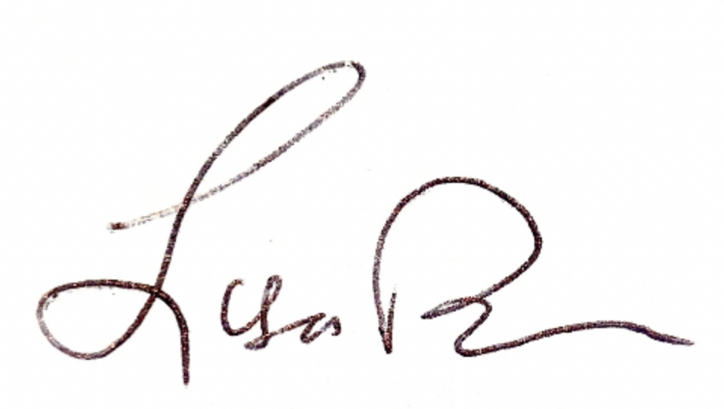
LISA W. BORDEN
Senior Policy Counsel, International Advocacy

