**Special Rapporteur on extrajudicial, summary or arbitrary executions**

**Call for input: Deaths in custody**

**Submitted by**

**Ambika Satkunanathan**

**6 March 2023**

1. **Existing practices for data gathering, analysis and reporting of deaths in custody, including the use of statistics and the disaggregation of data (e.g. by different categories and causes of deaths in custody; place of occurrence (e.g. on remand, in prison, in hospital, etc.); types and legal status of affected populations, etc.), including figures of deaths in custody documented in recent years.**

Deaths in prison custody

The Department of Prisons (DOP) issues an annual report on prison statistics which details information on different categories of persons admitted to prison in the preceding year, and includes *inter alia* details such as their personal characteristics (age groups, region, occupation) and details of offences for which they were sentenced (length of sentences, etc.).

The statistics report also contains the number of deaths that occurred in prisons in the preceding year – but information on the cause of death, or any other information pertaining to the circumstances of the death are not provided. When the Human Rights Commission of Sri Lanka (HRCSL) conducted its national study of prisons, it found that for instance, the preliminary inquiry conducted in prison does not outline the cause of death, as revealed by the Judicial Medical Officer (JMO), nor investigate the factors that led to the death. This prevents the administration from identifying causal factors that place incarcerated persons at risk, and hence no resultant steps are taken to mitigate the risk and avoid similar deaths from occurring in the future.[1]

The HRCSL observed that the manner in which information is recorded by prisons in the case of a death in custody is piecemeal. It does not aim to provide a complete and comprehensive account that enables lessons to be learnt, patterns to be identified, and practices devised to address them, particularly in the case of unnatural deaths.

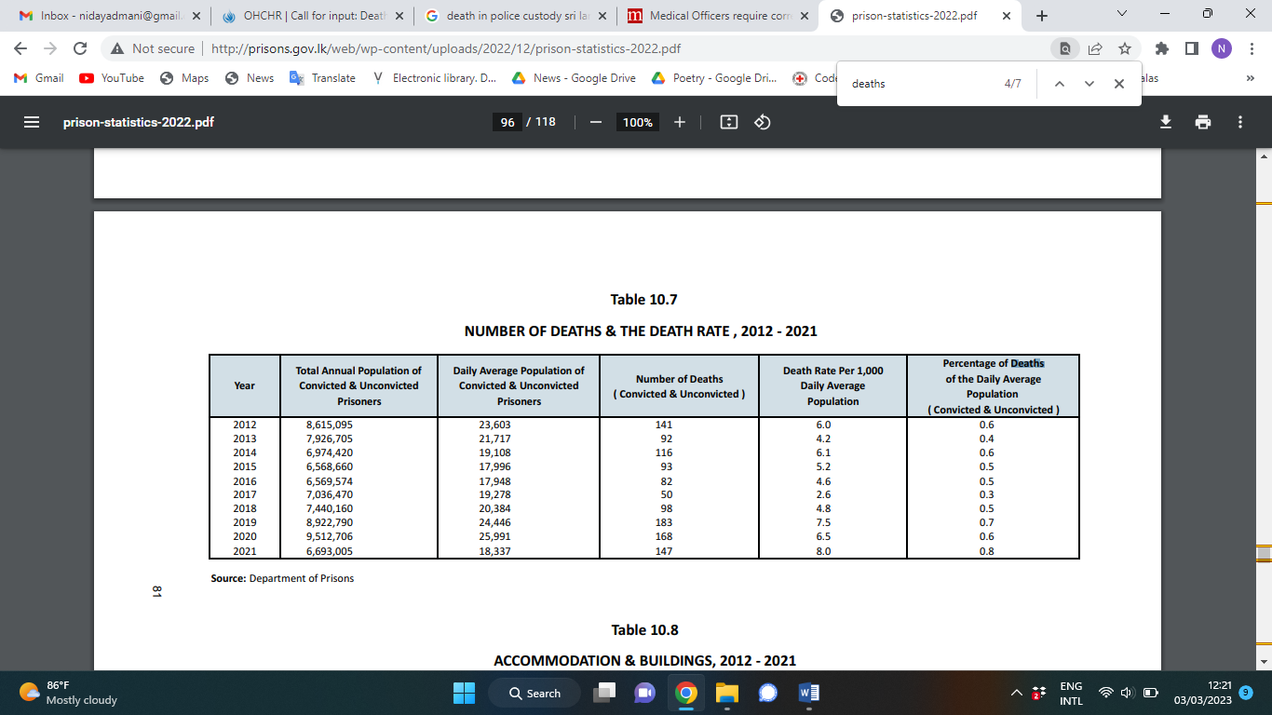

Source: Department of Prisons Statistics Report 2022 - <http://prisons.gov.lk/web/wp-content/uploads/2022/12/prison-statistics-2022.pdf>

Deaths in police custody

The police department does not issue statistics on the number of deaths that occur in police custody. Information on deaths in custody is reported by the media based on reports issued by the police spokesperson. Since the year 2020, the author has monitored a series of deaths that occurred during police custody, where persons are taken by the police to a particular area, allegedly to retrieve evidence, and the detained person attempts to escape and/or grab the firearm of an officer, resulting in the police opening fire and shooting the detained person. This author has recorded at least eight such cases since 2020[2].

The HRCSL posts the statistics of complaints it receives every calendar year of custodial deaths on its website.[3]

1. **Measures in place, including policies and good practices for investigating, documenting and preventing deaths in custody, in particular:**

* **Which legal provisions and requirements exist for cases of deaths in custody? (e.g. is an investigation into a death in custody mandatory or discretionary? Who is responsible for the decision and for the investigation?)**

The following sections of the Code of Criminal Procedure Act (No. 15 of 1979) govern the duty of the magistrate to inquire into deaths in custody:

“371. (1) When any person dies while in the custody of the police or in a mental or leprosy hospital or prison, the officer who had the custody of such person or was in charge of such hospital or prison, as the case may be, shall forthwith give information of such death to a Magistrate of the Magistrate’s Court within the local limits of whose jurisdiction the body is found, and such Magistrate shall view the body and hold an inquiry into the cause of death.

(2) For the purposes of an inquiry under this section a Magistrate shall have all the powers which he would have in holding an inquiry into an offence.

372. (1) The Magistrate or inquirer holding an inquiry prescribed under this Chapter shall record the evidence and his finding thereon.

(2) The place in which an inquiry of death under this Chapter is held shall be a place open to the public. But a Magistrate or inquirer conducting an inquiry of death may on special grounds of public policy or expediency in his discretion exclude the public at any stage of the inquiry from the place in which the inquiry is being held.

373. (1) The Magistrate or any inquirer empowered in that behalf by the Minister shall, if he considers it expedient, call upon the Government medical officer of the district, or any other medical practitioner, to hold a post-mortem examination of the dead body, and to report to such Magistrate or inquirer regarding the cause of death.

(2) For the purposes of the post-mortem examination under subsection (1), the Magistrate may, if the dead body has already been buried, cause that body to be disinterred.”

In cases where the death in custody may be due to torture, family members of the deceased may file a fundamental rights petition with the Supreme Court under Article 126 of the Constitution of Sri Lanka alleging a violation of the implied right to life (Article 13(4) of the Constitution) and the right against torture guaranteed by Article 11 of the Constitution.

Under the Convention against Torture and other Cruel, Inhuman or Degrading Treatment or Punishment Act, No. 22 of 1994, any person who attempts to commit, aids and abets to commit or conspires to commit torture, shall on conviction after trial by the High Court be punishable with imprisonment between seven to ten years and a fine between Rs. 10,000 and Rs. 50,000. In cases where a death in custody may have occurred due to torture, complaints under the Convention Against Torture Act against the officer responsible have to be lodged at a police station and a Special Investigations Unit (SIU) which functions under the direct supervision of the Inspector General of Police (IGP) will be responsible to conduct the investigation. In cases where such a death occurs in police custody, police officers would then be responsible for an investigation against a member of their own department. This can cause bias and conflict of interest because the Special Investigation Unit functions within the police department hierarchy.

In practice, investigations into custodial deaths rarely result in persons being held accountable. The progress of investigations is not made public and accessing information is unlikely to yield results. Families also file complaints with the Human Rights Commission of Sri Lanka but the Commission’s investigations are often hampered by lack of cooperation of the police, particularly not providing required information to the Commission.

There also exists a conflict of interest in the functions of the Attorney Generals Department, which is the office responsible for criminal prosecutions under the Convention Against the Torture Act, which are undertaken based on investigations conducted by the police officers. The same entity also functions as the advisor to the government and has also in many instances appeared for state officials named as respondents in fundamental rights petitions, including in cases filed alleging torture.

In fundamental rights petitions where the Court has found a violation of the right against torture by a member of the police department, judges have directed the Attorney General’s Department to institute action against the respondent under the Convention Against Torture Act and the Penal Code. The state authorities found responsible may also be required to pay compensation. However, such investigations have rarely been initiated by the Department of their own accord. As noted by the Committee Against Torture in its Concluding Observations:

‘Although the (Human Rights) Commission forwards all allegations of torture to the Attorney General’s Office for prosecution, the Office does not open ex officio investigations into those complaints, but rather refers them to the police for further investigation. Similarly, the Committee notes the State party’s confirmation that prosecutors generally do not launch investigations into torture ex officio, but rather only act in cases where a complaint of torture is first submitted to the police and investigated by them.’[4]

Deaths in prison

The HRCSL in the report of the first national study of prisons provided a detailed description of the procedure followed by prison authorities when deaths occur in prison.

As mentioned in the [report](https://www.hrcsl.lk/wp-content/uploads/2020/01/Prison-Report-Final-2.pdf), Section 97 of the Prisons Ordinance states that in case any Magistrate or inquirer shall hold an inquest on the physical remains of any incarcerated person who has died while in custody, no prison officer or prisoner or person engaged in any trade or dealing with the prison shall be an assessor at such inquest.

Section 396 of the Department Standing Orders require that on the death of an incarcerated person, the Superintendent of the Prison should inform the Magistrate of the Court within the limits of whose jurisdiction the prison is situated to hold an inquiry into the cause of death. The Commission highlighted that a judicial investigation is carried out for every death in prison whereby evidence is called from witnesses (incarcerated persons/officers) etc.

The police station in the jurisdiction within which the prison falls is also required to be informed, after which it reports the death to the relevant court. The magistrate then visits the prison and conducts an investigation/inspection. The remains of the deceased cannot be moved until the conclusion of the visit of the magistrate. However, the Commission observed that in several instances, a person who may have died in custody was taken to hospital as the prison officers are not qualified to declare a person dead, and therefore key evidence may have been compromised when the person was removed from the location in which they were found. Similarly, the HRCSL also reported that in some instance of deaths in prison, the magistrate did not visit the prison immediately and delays of up to even a full day were recorded. Until the magistrate visits the prison, the prison officers are in charge of the remains of the deceased and in cases of deaths due to violence, the prison authorities may be able to tamper with key evidence until the arrival of the magistrate.[5]

HRCSL highlights that in instances where the cause of death was not conclusively determined, there was no indication whether further investigations were conducted to ascertain the cause of death. When inquired about this, one prison stated it was not their duty to ascertain the actual cause of death, which they stated lies with a court. This, however, does not absolve the prison administration from efficiently and accurately maintaining their documentation on the judicial investigation, and conclusion in the case so a complete record of the case and resultant investigative findings is in the possession of the prison and the DOP.

The Commission observed that the manner in which information is recorded by prisons in the case of a death in custody is piecemeal. It does not aim to provide a complete and comprehensive account that enables lessons to be learnt, patterns to be identified, and practices devised to address them, particularly in the case of unnatural deaths.

Deaths in police custody

Limited information exists in the public domain regarding the procedure for an investigation into a death that occurs in police custody. While the procedure outlined above under Section 373 of the Code of Criminal Procedure would be followed, it is unclear what institutional safeguards are in place to prevent police officers from tampering with evidence until the magistrate arrives at the scene.

* **Investigation procedures and accountability mechanisms for deaths in custody (e.g. administrative, judicial or other investigatory body? External oversight?)**

The HRCSL reported that a preliminary inquiry is also conducted by the prison internally whereby a senior officer of the prison records the circumstances of every death that occurs in prison custody. A file is maintained and copies are sent to the Prison Headquarters, which includes all documents pertaining to the death, including statements from witnesses, documents from the hospital, etc. However, as highlighted above, several issues with the internal investigation process were observed by the Commission, including the instances where the General Hospital is recorded as the place of death, even though the person may have died in a prison ward.

The HRCSL states it was informed by prison officers of the largest prison in Sri Lanka that if the doctor certifies it was a natural death, a ‘detailed’ preliminary inquiry would not be conducted; if the circumstances of the death suggest it was due to unnatural causes, then further statements from witnesses will be obtained.

The HRCSL is mandated to monitor the welfare of persons in custody and can exercise unfettered access to any place of detention without prior notice. The Commission can also conduct an inquiry and investigate into complaints of fundamental rights violations[6], including the right against torture, inhuman and degrading treatment. The Commission is therefore mandated to undertake an inquiry in cases of suspected unnatural deaths in custody. However, the Commission only responds in cases where a complaint into death in custody is lodged by a complainant such as a family member of the deceased, or conducts a suo moto investigation into a case of unnatural death in custody if/when the Commission becomes aware of such death. Since the detaining authorities are not required to and do not inform the Commission when deaths in custody occur, the Commission is not able to conduct investigations into every death.

Apart from the Human Rights Commission of Sri Lanka, a separate investigatory body to maintain external oversight of deaths of persons in custody does not exist.

* **What is the level of forensic medical involvement in the investigation of deaths in custody (e.g. is a full post-mortem investigation required in every death in custody)?**

A post-mortem will be conducted by the Judicial Medical Officer in every case of death in prison. The Magistrate will issue the order for a post-mortem to be conducted after inspecting the physical remains of the deceased. The remains of the deceased will be handed over to the family of the deceased following the completion of the post-mortem examination. As mentioned in the report of the HRCSL prison study, a full post-mortem examination is conducted for every death that occurs in prison. The report also states that post-mortem examinations are conducted even in the case of Muslim prisoners who usually do not prefer to dissect the remains, and a person who has been terminally ill for a long period of time”.[7]

However, as indicated by Section 373 above, the magistrate is not required to call for a post-mortem examination by law, and “shall, if he considers it expedient” call for a post-mortem examination.

The report of the prison study of HRCSL states that when the Cause of Death Forms issued by the Institute of Forensic Medicine and Toxicology were examined, it was noted that the response for the question ‘Immediate Cause of Death’ (in the Form, the JMO has the option to write the cause/probable cause of death under three types: immediate cause of death/underlying cause of death/contributory causes for death) was often “under investigation”. In on prison, the death record logbook stated ‘an open decision was given’ in the cause of death column in one case.

* **Availability and use of national or international protocols? (e.g. do investigations follow the United Nations Principles on the Effective Prevention and Investigation of Extra-Legal, Arbitrary or Summary Executions (1989) and/or The Minnesota Protocol on the Investigation of Potentially Unlawful Death (2016)?)**

There is no information to suggest that the abovementioned international protocols are followed during investigation process, or that detaining authorities are even aware of the principals outlined in the two protocols. For instance, as outlined by Section 17 of the United Nations Principles on the Effective Prevention and Investigation of Extra-Legal, Arbitrary or Summary Executions (1989), a written report on the findings of the investigations into deaths in custody should be made public. However, this is not followed as a practice in Sri Lanka by the responsible state institution, and where the police department is concerned, even the total number of deaths in custody that occur each year are not released to the public.

Furthermore, as required under the Minnesota Protocol on the Investigation of Potentially Unlawful Deaths, there is limited participation of the family of the victim in the investigation process, and provision of support and counselling to families of victims is non-existent.

* **Are there procedures in place for facilitating the participation of victims’ families and their access to effective remedies?**

There is no information to suggest that victim’s families are able to participate in the investigation process, nor that any support or counselling is provided to the families of victims of torture.

The families of victim may seek remedies by lodging a fundamental rights petition with the Supreme Court or a complaint with the Human Rights Commission of Sri Lanka.

1. https://www.hrcsl.lk/wp-content/uploads/2020/01/Prison-Report-Final-2.pdf
2. https://docs.google.com/spreadsheets/d/1tY-fpw6bOaCtylhEkU7nq7ZC8UyYGRGG/edit#gid=976172112
3. https://www.hrcsl.lk/reports/331/
4. Concluding observations on the fifth periodic report of Sri Lanka, Committee Against Torture – November 2016
5. National Study of Prisons (2020), *Human Rights Commission of Sri Lanka,* chapter: Death in Prisons. <https://www.hrcsl.lk/wp-content/uploads/2020/01/Prison-Report-Final-2.pdf>
6. Section 10 of the Human Rights Commission Act (No. 21 of 1996)
7. National Study of Prisons (2020), *Human Rights Commission of Sri Lanka,* chapter: Death in Prisons. <https://www.hrcsl.lk/wp-content/uploads/2020/01/Prison-Report-Final-2.pdf>