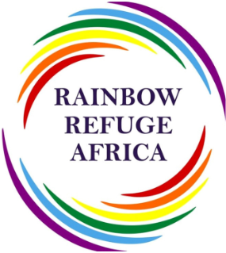

Author: Henry Wackam Homsi

Organization: Rainbow Refuge Africa

Address: 357 Visagie St, Pretoria Central, Pretoria, 0002/South Africa

**Rainbow Refuge Africa input: Beyond Discrimination, Unveiling the Lethal Impact of Violence and Persecution on LGBTQI+ Lives in Africa.**

**Purpose:** To inform the report of the Special Rapporteur, to be presented at the 79th session of the General Assembly.

The LGBTQI+ community in Africa faces significant challenges due to ongoing human rights violations. They face increased risks of violence, including unlawful arrest, due to their sexual orientation, sex characteristics, and gender identity. This issue is further exacerbated by forced displacement, as they flee fear of persecution, imprisonment, and even death.

Despite global progress, the LGBTQI+ community in Africa faces significant discrimination and persecution. Laws criminalizing homosexuality and non-conforming sexual or gender behavior persist in countries like Ghana, Botswana, Uganda, the Democratic Republic of Congo, Cameroon, and Nigeria. These laws often result in severe penalties and suppression of LGBTQI+ rights advocacy.

These oppressive legislation is often justified as preserving "African values," despite evidence disproving the notion that LGBTQI+ identities are foreign to Africa. Access to proper healthcare and legal representation is also lacking.

Former Special Rapporteur Agnes Callamard urges action against gender-sensitive killings of LGBTQI+ individuals, emphasizing the need to address targeted violence on the African continent. Rainbow Refuge Africa is dedicated to protecting the rights and wellbeing of displaced LGBTQI+ individuals seeking asylum in South Africa.

Rainbow Refuge Africa is a non-profit organization that uses evidence-based approaches to advocate for the rights of LGBTQI+ asylum seekers and refugees in South Africa. Their work is based on analysing articles, laws, community interviews, and stakeholder engagements. Their goal is to create a more inclusive environment for these individuals, ensuring their lives and dignity are protected.

Individuals who seek freedom to express themselves without fear of persecution are behind statistics and legislative debates. Their stories highlight the urgent need for collective action to combat discrimination and ensure respect and dignity for all, regardless of sexual orientation or gender identity.

**Criminalisation of same-sex relations-An Alarming Trend in Violent Hate in Africa.**

The LGBTI association ILGA reports that 33 out of 54 African states have laws criminalizing same-sex acts.

United Nations (UN) have laws that criminalise same-sex acts (see Map 1).

The most recent criminalization is Section 145 of the Penal Code Act in Uganda, which imposes penalties for consensual same-sex sexual relations. This has led to arrests, prosecutions, and displacement of LGBTQI+ community members seeking refuge in progressive countries like South Africa.

Despite a progressive constitution and bill of rights, many LGBTQI+ individuals still face stigma and prejudices in countries like Namibia, Zimbabwe, DRC Congo, and South Africa. Almost half of the 67 countries worldwide criminalizing consensual same-sex conduct are located in Africa, with South Africa being a beacon of hope due to its laws and policies that explicitly protect people based on sexual orientation and gender identity.

LGBTQ+ individuals in Africa face discriminatory laws and social attitudes, often seeking asylum in South Africa. Uganda's Anti-Homosexuality Act (2023) introduces severe penalties for various aspects of homosexuality, including the death penalty for aggravated homosexuality and a 20-year prison sentence for the promotion of homosexuality. Article 14 of the law mandates individuals to report any suspicion of homosexual acts or offenses to the police, highlighting the challenges LGBTQ+ individuals face in seeking asylum and a brighter future in their home countries.

community on the continent, thanks to its laws and policies that explicitly protect people based on sexual orientation and gender identity. Many LGBTQ+ individuals from across Africa, where discriminatory laws and social attitudes prevail, seek refuge in South Africa, often enduring significant challenges in pursuit of asylum and a brighter future.

**In May, Uganda enacted the Anti-Homosexuality Act (2023)**, which imposes severe penalties for various aspects of homosexuality, including the death penalty for aggravated homosexuality and a 20-year prison sentence for the promotion of homosexuality. Six states (Kenya, Ghana, Namibia, Niger, Tanzania, and Uganda) have taken steps to tighten their anti-homosexuality laws, and others could follow suit.

**The Botswana government has deferred the Panel Code Amendment Bill No.29 of 2022, a homosexuality bill, to allow for a thorough examination of constitutional issues raised by the Church**. The bill aims to amend Section 164(a) and (c) of the Penal Code, which criminalizes carnal knowledge between two adults against the order of nature. The Evangelical Fellowship Botswana (EFB) has made public demonstrations against decriminalizing same-sex relations. The EFB has argued that the bill will open floodgates of immorality as it seeks to legalise homosexuality. The bill's deferral comes after EFB drew up a petition against the amendment, arguing that it would open floodgates of immorality and abomination in the nation. The LGBTIQ+ community will have no choice but to wait for the bill to be debated in Parliament.

**Factors Leading to violent Hate and killing of LGBTQI+ persons in Africa**

Hate and killing of LGBT individuals in African countries are driven by social stigma, criminalization of same-sex relations, and diverse sexual orientations and gender expressions. 30 LGBTQI+ individuals and 15 asylum seekers shared reasons for hate and killing, including the criminalization of consensual same-sex relations, gender discrimination, and the criminalization of consensual same-sex relations.

While ongoing violence and discrimination faced by LGBTQI+ people across Africa. Shows brutal reality of hate crimes and killings targeting this community demands urgent action and a collective effort to create a more inclusive and safe environment.

Adding to Several factors that contribute to these tragic situations. The lack of visibility and understanding surrounding LGBTQI+ identities fuels prejudice and fuels a climate of fear.

Rigid cultural norms and interpretations of religious teachings can further marginalize us as individuals.

Furthermore, the legal and political landscape often fails to protect LGBTQI+ people.

And as the legal and political landscape in many African countries also fails to protect LGBTQI+ people, with the criminalization of same-sex relationships emboldening violence and discrimination. Reason being that weak law enforcement and a lack of government support for LGBTQI+ rights contribute to an atmosphere of impunity for perpetrators of hate crimes.

As criminalization of same-sex relationships in many African countries emboldens violence and discrimination.

For the brutal reality of hate crimes and killings targeting this community highlights the urgent need for a collective effort to create a more inclusive and safe environment for all individuals.

By addressing these issues, we can build a more just and equitable Africa where everyone feels safe and respected, regardless of their sexual orientation or gender identity.

The violence and discrimination faced by LGBTQI+ people across Africa are a pressing human rights issue that demands immediate action and solidarity. The lack of visibility and understanding surrounding LGBTQI+ identities perpetuates prejudice and creates a climate of fear for these individuals.

We have several factors contributing to the ongoing challenges, marginalization and violence against LGBTQI+ and promote a more just and equitable society for people in Africa, it is crucial to take action in key areas:

* Weak law enforcement and a lack of government support for LGBTQI+ rights creates an atmosphere of impunity for perpetrators.
* Socioeconomic factors also play a role beginning with poverty and limited opportunities which exacerbate social tensions and scapegoating of marginalized groups, including LGBTQI+ people, such poverty and limited opportunities, can exacerbate social tensions and contribute to the scapegoating of marginalized groups, including LGBTQI+ individuals.
* Limited access to education about sexual orientation and gender identity further perpetuates misconceptions, prejudiceand stigma against the LGBTQI+ community.
* Working together to dismantle the systems and attitudes that perpetuate violence against LGBTQI+ people.
* Starting in some key areas for action to repeal discriminatory laws as criminalization of LGBTQI+ relationships as it only serves and fuels violence. For that we need legal frameworks that protect all individuals as it is essential to advocate for legal frameworks that protect the rights of all individuals, regardless of sexual orientation or gender identity.
* Promoting education and understanding educational initiatives that can challenge misconceptions and foster tolerance for LGBTQI+ identities can help combat prejudice and discrimination.
* Strengthening law enforcement Effective investigation and prosecution of hate crimes are essential and critical to deterring future violence and ensuring accountability for perpetrators.
* Empowering LGBTQI+ communities while supporting LGBTQI+ organizations and creating safe spaces for us to thrive is essential and crucial in promoting resilience and empowerment.
* Advocating for government action as governments have a responsibility to promote inclusivity and combat discrimination against LGBTQI+ individuals for that civil society and international partners can play a vital role in advocating for policy changes and greater protection of LGBTQI+ rights.
* Ending the shame culture towards being an LGBTQI+ individual through reeducating society about how social stigma is the main reason as its not hate towards LGBTQI+ was sociologically implemented through colonialism
* Providing successful examples of LGBTQI+ family structure where they are able to raise kids and taking their natural role supporting their families and having a family
* Rigid cultural norms and interpretations of religious teachings often serve to further stigmatize and discriminate against LGBTQI+ individuals.

By addressing these issues and working together to dismantle the systems and attitudes that perpetuate violence against LGBTQI+ people, we can strive towards a more inclusive and safe Africa where everyone feels respected and valued, regardless of their sexual orientation or gender identity.

Lastly we had:

1. Community violence (07 cases)
2. Family abuse and rejection (05 cases)
3. Brutality and arrests by security forces (10 cases)
4. Death threats (08 case)

**Map depicting the legal landscape and societal attitudes towards sexual orientation across Africa.**

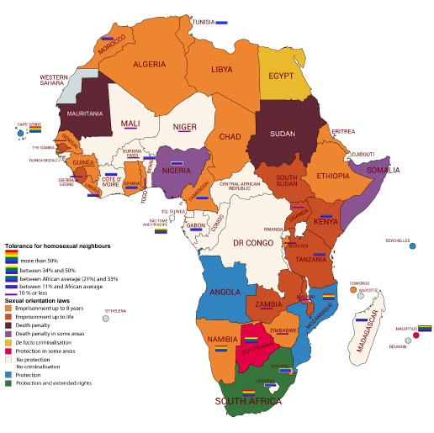

***Data source:*** *the International Lesbian, Gay, Bisexual, Trans and Intersex Association (ILGA), 2019;*

***Afrobarometer,*** *2016 (**% of respondents who said they would 'strongly like,' 'somewhat like' or 'not care' if*

*they lived next door to homosexuals, in 33 surveyed countries).*

**Sources:**

<https://www.parliament.go.ug/news/6737/president-assents-anti-homosexuality-act>

<https://www.europarl.europa.eu/RegData/etudes/BRIE/2019/637949/EPRS_BRI(2019)637949_EN.pdf>

<https://www.mambaonline.com/2024/05/03/rising-deadly-hate-crimes-against-lgbtqia-community-in-namibia/>

<https://www.ohchr.org/en/press-releases/2024/04/uganda-turk-dismayed-ruling-upholding-discriminatory-anti-gay-law>

<https://www.mmegi.bw/news/govt-succumbs-to-church-pressure-against-lgbtiq-rights/news>