  

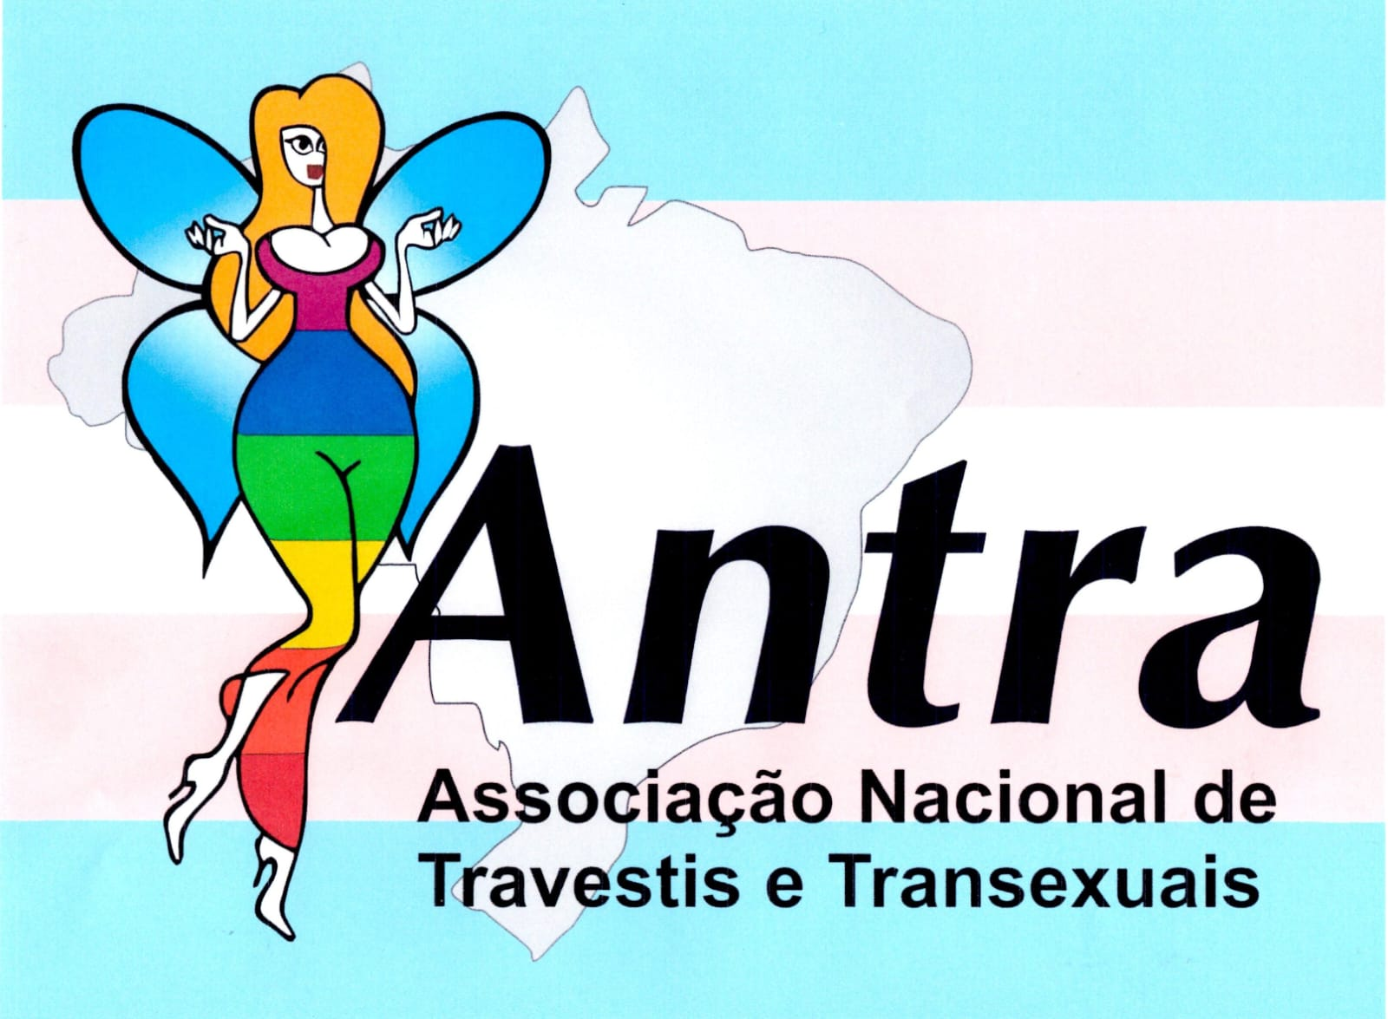 ****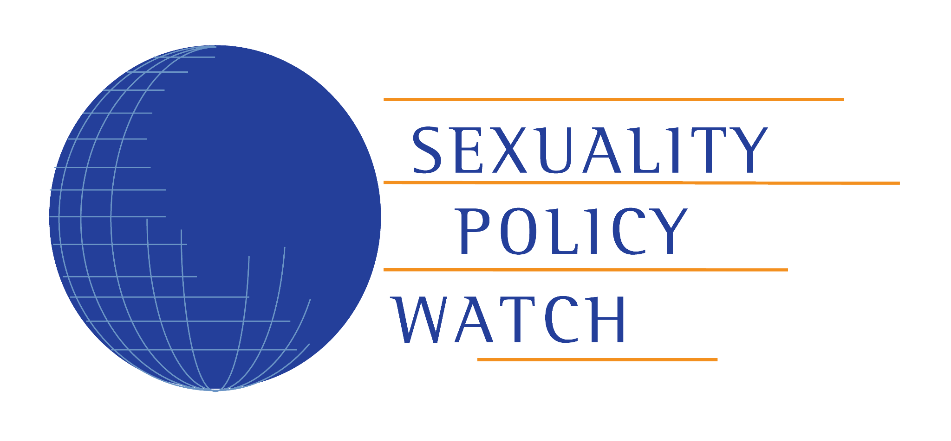

Brazil, 29 May 2024

**Dr. Morris Tidball-Binz**

UN Special Rapporteur on extrajudicial, summary or arbitrary executions

OHCHR-UNOG

8-14 Avenue de la Paix

1211 Genève 10, Switzerland

*Ref.: Call for inputs on killings that may be or are the result of actual or perceived sexual orientation, gender identity or sex characteristics*

It is with great honour and appreciation that the the **Sexuality Policy Watch - ABIA**; the **National Association of Travestis and Transsexuals (ANTRA)**; the **Human Rights and LGBT+ Citizenship Research Group at Universidade Federal de Minas Gerais (NUH/UFMG)**; **the** **Program for Brazil and the Southern Cone of the Center for Justice and International Law (CEJIL);** the **Human Rights Systems Center at Universidade Federal do Paraná (NESIDH/UFPR)**; **Public Defender's Office of the State of Paraná/Brazil**, a permanent institution essential to the jurisdictional function of the Brazilian State, responsible for the promotion of human rights and the defence of individual and collective rights (article 134 of the Brazilian Constitution and Complementary Federal Law no. 80/1994), through its **Specialised Nucleus on Citizenship and Human Rights and Specialized Center for Promotion and protection of women's rights**; hereby offer their submission on matters related to the killing of LGBTIQA+ persons in Brazil, as a contribution to the forthcoming thematic report of the UN Special Rapporteur on extrajudicial, summary or arbitrary executions to be presented at the 79th session of the United Nations General Assembly.

1. **Profile of LGBTIQA+ killings in Brazil**

In Brazil, an estimated 7 to 9% of its population (roughly 10 to 15 million people) self-identify as members of the LGBTIQA+ community.[1] Official records for 2021 and 2022 indicate 176 and 163 murders of LGBTIQA+ individuals respectively, although data from eight out of 27 states remain undisclosed.[2] On the other hand, civil society estimates suggest that 273 LGBTIQA+ persons were violently murdered in 2022, equating to approximately one such tragedy every 32 hours.[3] Brazil ranks among the countries with the highest recorded rates of LGBTIQA+ murders in 2022.

Furthermore, this has taken place in a context where we have seen the advance of a strongly organised anti-trans (trans-exclusionary) agenda that aims to roll back trans rights, notably through the intense dissemination of fake news and hatred on social media platforms, which, without appropriate official responses from these platforms, ends up causing deleterious impacts on the trans community; Not only through directly inciting offline violence, but also driving many young trans people to self-extermination[4].

Approximately 2% of Brazil’s adult population identify as gender-diverse and/or trans.[5] According to Transgender Europe, Brazil has been leading in the number of transgender individuals murdered for the past 15 years.[6] In 2023 alone, 145 trans persons were killed, which means there were about two murders every five days – an increase compared to the 2008 to 2023 average of 126 transgender murders per year.[7]

In 2022, firearms were responsible for 74 LGBTIQA+ killings (27.11%), while 48 (17.58%) resulted from stabbings.[8] Mendes and Silva’s research shows that cold weapons and guns are the most common methods used to target gay men and transgender people. However, many homicides involve beatings, suffocation and other forms of cruelty.[9] It is precisely in this context that the normative dimensions of gender, sexuality, and extermination practices intersect and thus contribute to the production of a highly vulnerable experience for LGBTIQA+ people.

Of the 273 LGBTIQA+ killings in 2022, 159 victims identified as *travestis* (individuals with a non-conforming female gender identity) and transsexual women.[10] Between 2020 and 2023, approximately 77.5% of murdered trans individuals were black or indigenous.[11] Moreover, in 2022, one-third of the victims fell between the ages of 20 and 29.[12] These statistics underscore the intersectionality of sexual orientation, gender identity and sexual characteristics (SOGISC) with other social markers such as gender, race and age.

1. **Lack of public policies and legislation that criminalise, reduce or prohibit LGBTIQA+ killings**
2. *Lack of official data*

The incompleteness and unavailability of official data on LGBTIQA+ murders in Brazil demonstrate an intentional albeit veiled policy of not producing this data, as well as denouncing a lack of interest in recognizing specific violence against LGBTQIA+ individuals, as well as addressing and searching for solutions regarding hate crimes and homicides against these individuals.[13] The unsafe and hostile social context towards LGBTIQA+ persons in Brazil has prompted the *Instituto Brasileiro de Geografia e Estatística*[14] (*IBGE*) to warn that numbers reported in an initial survey of the homossexual/bissexual population may potentially be higher than data indicates, due to underreporting by interviewees themselves.[15] At the time, specific information about trans or gender diverse people was not included.

Concurrently, the absence of official data is a recurring issue that hampers the implementation of targeted public policies. For instance, the most recent census conducted by *IBGE* did not gather any information on SOGISC, claiming the need for further studies on how to collect such data, [16] despite engaging with civil society organisations months prior to discuss methodologies for producing SOGISC statistics.[17] Furthermore, there is a ‘blackout’ regarding SOGISC in police reports throughout Brazil: eight out of 27 states did not disclose information on LGBITQ+ murders in 2021 and 2022.[18] Despite the National LGBTIQA+ Secretariat announcing an upcoming ‘milestone’ in LGBT+ data collection,[19] implementation is still pending.

One of the central aspects of the problem lies in the fact that gender, sexuality, sexual orientation, and gender identity require techniques for interpreting and approaching phenomena that, strictly speaking, seem to be beyond those implemented by public policy bodies and equipment in the country.

When we consider homicides involving gender and sexuality, theoretically and methodologically, it is possible to maintain that the State has a database with precarious quality of information, which both undermines the validity of the procedure for counting victims and interferes with the identification of factors associated with lethal events. There is lost and poorly catalogued information and problems in the convergence between police data and data from other sources.[20]

There is a historical absence of official data, with numerous information gaps at the federal governance level hindering the creation and implementation of public policies aimed at protecting and promoting the citizenship of LGBITQ+ people.[21] This point of view has been reiterated by researchers at the *Fórum Brasileiro de Segurança Pública*[22], who emphasise how compiling data on violence against LGBTIQA+ individuals could inform governmental operational strategies and illuminate the profile of the crimes, victims and perpetrators,[23] thereby facilitating the formulation of more effective public policies. Although this absence is historical, it has become more acute in recent years due to the rise of far right extremism in Brazil.[24]

1. *Lack of public policies*

In Brazil, the main technical challenge to implementing public policies for the LGBTIQA+ lies in data availability.[25] The *LGBTQIA+ em Pauta* research highlighted challenges related to physical (intersectionality between SOGISC and racism, murder of trans individuals, homicide of lesbians, domestic LGBTIQA+ violence, and torture perpetrated against LGBTIQA+ persons deprived of liberty), verbal (hate crimes and SOGISC-based violence), institutional (absence of data and underreporting of LGBTIQA+ violence cases, and inadequate allocation of trans persons in the penitentiary system) and structural (SOGISC discrimination in public spaces and frailty of reporting mechanisms for LGBTQIA+ violence cases) violence.[26]

According to the Atena Program, in 2023, 19 out of 27 states did not have a specific LGBTIQA+ plan or program; the North region had the lowest ratings in the development, creation and structuring of general LGBTIQA+ public policies; and the South region had the lowest ratings in the creation and enhancement of LGBTIQA+ councils and structuring of LGBTIQA+ plans/programs.[27] The absence of public policies for LGBTIQA+ was particularly pronounced between 2019 and 2022 during far right president Jair Bolsonaro’s term, with the dismantling of LGBTIQA+ policies,[28] such as removing LGBTIQA+ persons from the National Secretariat for the Promotion and Defence of Human Rights’ jurisdiction and the dissolution of the Promotion of LGBT Rights Department and the National Council for Combating Discrimination.[29]

Recents research shows that trans people preferer to stay home (when they have one) for fear of being attacked[30], and violence on public transport prevents them from accessing the city for fear of violence[31]. There have been recurrent posts on social media showcasing instances of human rights violations, such as expulsions from gender-segregated public spaces like toilets and dressing rooms. Furthermore, there have been observed organised attacks on government profiles when these government officials publish acts or any kind of measure that could be interpreted as trans-inclusive[32]. The ongoing debate on the risk of fake news and the spread of hate speech on social media has not yet properly incorporated the need for protecting LGBTQIA+ people in the virtual environment, in order to avoid causing mental health impacts and starting a process of social exclusion due to the risk of exposure to violence.

Recently the social media platform *X* (previously *Twitter*) was required to resume measures to protect trans people on the platform by a decision of the Brazilian courts[33]. These measures had been relaxed without any justification from the platform, even though the platform had released research showing that 88% of mentions of trans people on the platform were related to transphobia[34]. However, responses to complaints are still struggling to meet the requirements of the aforementioned Supreme Court’s decision.

During president Lula’s third term (from 2023 onwards), the *Conselho Nacional dos Direitos das Pessoas LGBTQIA+[35]* was established, and measures for the promotion of LGBTIQA+ rights were adopted, although none were directly related to violence and public security.[36] The Ministries of Justice and Human Rights have announced the formation of a task force for the collection and processing of official data on cases of homophobia in Brazil, as well as the improvement of procedures for receiving reports, providing assistance and referring victims in all states,[37] but its implementation is still pending.

There were between 7 to 9 states whose police force systems’ forms had no fields for registering victims as LGBTIQA+, depending on the type of crime, and in which the official data captured about 50% fewer deaths of LGBTIQA+ individuals than unofficial data.[38] The Human Rights Ministry has recently established a Monitoring Committee for the National Strategy to Combat Violence against LGBTQIA+ Persons[39], but currently there are no targeted public policies in place to protect young black *travestis*, the group most vulnerable to LGBTIQA+ violence.[40]

1. *Lack of legislation*

Brazil still has not implemented effective legislation against violence toward LGBTIQA+ people. From 1988 to 2021, 38 bills related to homotransphobia were proposed, with 9 of them dedicated to protection against hate crimes. However, most of these propositions are generic or lack normative density, relying on a merely punitive approach by addressing LGBTIQA+phobia in a piecemeal rather than structural manner.[41] None of the bills were approved thus far. The federal legislative effort to protect LGBTIQA+ individuals is marked by numerous dismissals, omissions, slow progress, failures in voting, and the strength of conservatism.[42]

As a result, the Brazilian constitutional court (*STF*) recognised legislative inaction for failing to enact a law criminalising acts of homotransphobia, subsequently recognizing them as crimes of racism.[43] The court acknowledged Congress’ delay in criminalising acts contrary to the fundamental rights of LGBTIQA+ individuals due to their sexual orientation and gender identity.[44] This decision made homotransphobia an imprescriptible, non-bailable crime.

Despite this advancement, notwithstanding that it was highly contested for not following legislative due procedure, other obstacles still prevent the effective protection of LGBTQIA+ individuals. For instance, the Attorney General at the time attempted to overturn the *STF*’s decision through an inadequate judicial remedy under the pretext of protecting the exercise of religious, artistic, and professional freedom.[45] Moreover, a 2021 study identified 34 barriers related to structural issues, lack of transparency and opacity of the State, institutional procedures, legal recognition and the COVID-19 pandemic for the recognition of the criminalisation of homotransphobia in Brazil.[46]

Furthermore, while legislative inaction persists, crimes against LGBTIQA+ individuals (that is interpreted as social racism crimes) grew by 54% in 2022[47] and 257 violent deaths of LGBTQIA+ people were recorded in 2023[48] demonstrating the annual increase in violations against the LGBTIQA+ population and the ineffectiveness of criminalization. Conversely, in 2023, trans journalist Dani Avelar noted a surge in anti-trans (trans-exclusionary) bill propositions, with a new one introduced almost daily, potentially exacerbated by the proliferation of transphobic political discourse.[49] Currently, there are at least 77 municipal and state anti-trans laws in force, with over two-thirds enacted in 2022, alongside 293 anti-trans bills proposed in 2023 alone.[50]

Furthermore, it is also necessary to note the violations that LGBTQIA+ population suffers at prison system. In addition to physical violence, they are subject to double criminalization, as well as serving custodial sentences, they are accused in internal administrative proceedings for non-compliance with standards of behaviour and dress code. According to research on the violence of the use of institutional mechanisms in prisons against the LGBT+ population, in some regions, there is the practice of using recriminalization processes for behaviours and the use of clothing[51].

**Conclusion**

In light of the provided information, we hope to have helped the SR to reflect and assess how a person’s actual or perceived sexual orientation, gender identity or sex characteristics, paired with State’s omission and inaction, can lead to extrajudicial, summary or arbitrary executions in Brazil.

As we hope to demonstrate with this input, the absence of public policies, including legislation, for the protection of the LGBTIQA+ population directly and indirectly contributes to the murder of these individuals and to the underreporting of these occurrences, which in turn reinforces obstacles in the development and implementation of effective policies.

We are looking forward to the SR’s report, and we thank the opportunity to contribute to the mandate.

**Karollyne Nascimento**

Ombudswoman for the Public Defender's Office of the State of Paraná

E-mail: ouvidoria@defensoria.pr.def.br

Phone: +55 41 9776-4005

**Bruna Benevides**

Political Articulation Secretary of the National Articulation of Travestis and Transsexuals (ANTRA)

E-mail: presidencia.antra@gmail.com / bruna-marx@hotmail.com

Phone: +55 21 98850-5315

**Antonio Vitor Barbosa de Almeida**

Public defender

Public Defender’s Office of the State of Paraná - Specialised Nucleus on Human Rights and Citizenship (NUCIDH/DPPR)

E-mail: nucidh@defensoria.pr.def.br

Phone: +55 41 9252-5471

In collaboration with **Derek Assenço Creuz -** Public Defender’s Office of the State of Paraná - Specialised Nucleus on Human Rights and Citizenship (NUCIDH/DPPR)

**Marco Aurélio Máximo Prado**

PhD in Social Psychology and Post-Doctoral Researcher at the University of Massachusetts (Fulbright scholarship)

Researcher of the Human Rights and LGBT+ Citizenship at Universidade Federal de Minas Gerais (NUH/UFMG)

E-mail: mamprado@gmail.com

Phone: +55 31 99201-3211

**Sonia Corrêa**

Associate Researcher at ABIA

Co-Coordinator of the ABIA Observatory on Sexuality and Politics

E-mail: scorrea38@gmail.com

**Helena Rocha**

Co-director of the Program for Brazil and the Southern Cone of the Center for Justice and International Law (CEJIL)

**Melina Girardi Fachin**

Associate Professor at UFPR Law School

Researcher at the Center for Constitutional Studies-CCONS at UFPR

Coordinator of the Human Rights Systems Center-NESIDH at UFPR

E-mail: melinafachin@gmail.com

Phone: +55 41 99925-8528

**Mariana Martins Nunes**

Public Defender

Public Defender's Office of the State of Paraná - Specialized Center for Promotion and protection of women's rights (NUDEM/DPPR)

**Helena Grassi Fontana**

Public Defender

Public Defender's Office of the State of Paraná - Specialized Center for Promotion and protection of women's rights (NUDEM/DPPR)

1. Datafolha (2023), *Pesquisa do Orgulho*. Available at: https://d9kmngv9gxhb0.cloudfront.net/static/pesquisadoorgulho.pdf. Accessed on 17 January 2024; Spizzirri, Giancarlo et al. (2022), "Proportion of ALGBT adult Brazilians, sociodemographic characteristics, and self-reported violence", *Scientific Reports*, 12: 11176.
2. Fórum Brasileiro de Segurança Pública (FBSP) (2023), “*Anuário Brasileiro de Segurança Pública*”, São Paulo: FBSP. Available at: https://forumseguranca.org.br/wp-content/uploads/2023/07/anuario-2023.pdf?data=160124. Accessed 29 January 2024.
3. Acontece Arte e Política LGBTI+; ANTRA (Associação Nacional de Travestis e Transexuais); ABGLT (Associação Brasileira de Lésbicas, Gays, Bissexuais, Travestis, Transexuais e Intersexos) (2023), *Mortes e violências contra LGBTI+ no Brasil: Dossiê 2022*, Florianópolis: Acontece, Antra, ABGLT. Available at: https://observatoriomorteseviolenciaslgbtibrasil.org/dossie/mortes-lgbt-2022/. Accessed 17 January 2024.
4. Gênero e Número (2023). *Mulheres trans e travestis jovens concentram casos de autolesões.* Available at: https://www.generonumero.media/reportagens/autolesao-mulheres-trans-e-travestis/. Acessed on 24 may 2024;
5. Spizzirri, Giancarlo et al. (2021), “Proportion of people identified as transgender and non-binary gender in Brazil”, *Scientific Reports*, 11: 2240.
6. “Trans Murder Monitoring 2023 Global Update”, *TransRespect*, 13 November 2023. Available at: https://transrespect.org/en/trans-murder-monitoring-2023/. Accessed 18 April 2024.
7. Benevides, Bruna G. (2024), “*Dossiê Assassinatos e Violências contra Travestis e Transexuais Brasileiras em 2023*”, Brasília: ANTRA. Available at: https://antrabrasil.files.wordpress.com/2024/01/dossieantra2024-web.pdf. Accessed 30 January 2024.
8. Acontece Arte e Política LGBTI+; ANTRA; ABGLT, *Mortes e violências*.
9. Mendes, W. G.; Silva, C. M. F. P. (2020), “Homicide of Lesbians, Gays, Bisexuals, Travestis, Transexuals, and Transgender people (LGBT) in Brazil: a Spatial Analysis”, *Ciência & Saúde Coletiva*, 25(5): 1709-1722. Available at: https://doi.org/10.1590/1413-81232020255.33672019. Accessed 18 April 2024.
10. Acontece Arte e Política LGBTI+; ANTRA; ABGLT, *Mortes e violências*.
11. Benevides, *Dossiê*.
12. Acontece Arte e Política LGBTI+; ANTRA; ABGLT, *Mortes e violências*.
13. FBSP, *Anuário*.
14. Brazilian Geography and Statistics Institute, free translation.
15. Lisboa, V. (2022), *“Preconceito afeta produção de dados sobre LGBTI+: Pesquisadores falam sobre o tema no Dia do Orgulho LGBTI+”*, *Agência Brasil*, 28 June 2022. Available at: https://agenciabrasil.ebc.com.br/geral/noticia/2022-06/preconceito-afeta-producao-de-dados-sobre-lgbti. Accessed 18 April 2024.
16. Saraiva, A.; Carneiro, L. (2023), *“Censo não contempla comunidade LGBTQIAPN+, admite IBGE”*, *Valor Econômico*, 27 October 2023. Available at: https://valor.globo.com/brasil/noticia/2023/10/27/censo-no-contempla-comunidade-lgbtqiapn-admite-ibge.ghtml. Accessed 18 April 2024.
17. Belandi, C. (2022), *“IBGE recebe sociedade civil para discutir produção de estatísticas sobre gênero e orientação sexual”*, *Agência IBGE*, 12 September 2022. Available at: https://agenciadenoticias.ibge.gov.br/agencia-noticias/2012-agencia-de-noticias/noticias/34881-ibge-recebe-sociedade-civil-para-discutir-producao-de-estatisticas-sobre-genero-e-orientacao-sexual. Accessed 18 April 2024.
18. FBSP, *Anuário*.
19. Xavier, C. (2023), *“Governo prepara “marco histórico” na coleta de dados LGBT+”*, Vermelho, 17 March 2023. Available at: https://vermelho.org.br/2023/05/17/governo-prepara-marco-historico-na-coleta-de-dados-sobre-populacao-lgbt/. Accessed 19 April 2024.
20. Benevides, B; Simpson, K (2018), *Mapa dos assassinatos de Travestis e Transexuais no Brasil em 2017*, Brasília: ANTRA. | Kahn, T; Hanashiro, O (coord)(2016), *Projeto: pesquisa e análise de dados vinculados ao campo da segurança pública e sistema penitenciário*. FBSP. | Cerqueira, D; Lima, R (coord) (2017). *Atlas da Violência 2017*, Brasília: IPEA.
21. Vaz, J. C. et al. (2021), *LGBTQIA+ em Pauta*, São Paulo: OIPP/GETIP/EACH. Available at: https://drive.google.com/file/d/1NSNDO5OJ9L09Q7SvPjdDzgHwQyLuQhWn/view. Accessed 18 April 2024. This research has identified 43 ‘information gaps’ at the federal level in work and social assistance, education, health and public security.
22. Brazilian Forum on Public Security, free translation.
23. Figueiredo, C.; Araújo, M. (2021). *“Dados incompletos afetam retrato da violência contra LGBTI+ no Brasil”*, *Brasil de Fato*, 12 January 2021. Available at: https://www.brasildefatope.com.br/2021/01/12/dados-incompletos-afetam-retrato-da-violencia-contra-lgbti-no-brasil. Accessed 18 April 2024.
24. See *e.g.* Feitosa, C. (2021). *“Do “Kit Gay” ao “Ministério da Família”: a desinstitucionalização das políticas públicas LGBTI+ no Brasil*”, *Cadernos de Gênero e Tecnologia*, 14(43): 74-89. Available at: https://periodicos.utfpr.edu.br/cgt/article/view/11487. Accessed 18 April 2024.
25. Cerqueira, D.; Bueno, S. (coord.) (2023). *Atlas da Violência 2023*, Brasília: IPEA. Available at: https://www.ipea.gov.br/atlasviolencia/arquivos/artigos/9350-223443riatlasdaviolencia2023-final.pdf. Accessed 19 April 2024.
26. Vaz et al., *LGBTQIA+ em Pauta*.
27. *Programa Atena - Ministério de Direitos Humanos e Cidadania*, 09 March 2023. Available at: .https://encurtador.com.br/loKX9. Accessed 19 April 2024.
28. Feitosa, *Do “Kit Gay”*.
29. "Bolsonaro retira população LGBT de diretrizes de Direitos Humanos", Poder360, 02 January 2019. Available at: https://www.poder360.com.br/governo/bolsonaro-retira-populacao-lgbt-de-diretrizes-de-direitos-humanos/. Accessed 19 April 2024; Nomura, Bruno (2022), “Retrocesso e sucateamento: a política LGBTI+ do governo Bolsonaro”, *Diadorim*, 27 October 2022. Available at: https://adiadorim.org/reportagens/2022/10/retrocesso-e-sucateamento-a-politica-lgbti-do-governo-bolsonaro/. Accessed 19 April 2024.
30. Jornal Hoje (2023). *Pesquisa mostra que pessoas trans saem menos de casa por medo de serem agredidas.* Available at: https://g1.globo.com/jornal-hoje/noticia/2023/01/28/pesquisa-mostra-que-pessoas-trans-saem-menos-de-casa-por-medo-de-serem-agredidas.ghtml. Accessed 24 May 2024.
31. Correio Braziliense (2023). *Violência nos transportes afasta comunidade trans do convívio social.* Available at: https://www.correiobraziliense.com.br/cidades-df/2023/07/5110999-violencia-nos-transportes-afasta-comunidade-trans-do-convivio-social.html. Accessed 24 May 2024.
32. Diadorim (2023). *Comitiva do Antra é agredida em comentários na rede do Ministério das Mulheres. Available at: https://adiadorim.org/noticias/2023/01/comitiva-da-antra-e-agredida-em-comentarios-na-rede-do-ministerio-das-mulheres/. Accessed 24 May 2024.*
33. Metrópoles (2023). *Justiça determina que X restabeleça medidas de combate à transfobia*. Available at: https://www.metropoles.com/brasil/justica-determina-que-x-restabeleca-medidas-de-combate-a-transfobia. Accessed 24 May 2024.
34. Gay Blog. *88% das menções no Twitter a pessoas trans são sobre transfobia, revela pesquisa*. Available at: https://gay.blog.br/noticias/88-das-mencoes-no-twitter-a-pessoas-trans-sao-sobre-transfobia-revela-pesquisa/. Accessed 24 May 2024.
35. National Council for the Rights of LGBTQIA+ Persons, free translation.
36. Silva, C. (2023), “Governo cria Conselho Nacional dos Direitos das Pessoas LGBTQIA+”, *Carta Capital*, 07 April 2024. Available at: https://www.cartacapital.com.br/politica/governo-cria-conselho-nacional-dos-direitos-das-pessoas-lgbtqia/. Accessed 19 April 2024; Pimentel, Carolina (2023), “Governo anuncia iniciativas por direitos de população LGBTQIA+”, *Agência Brasil*, 27 June 2024. Available at: https://agenciabrasil.ebc.com.br/direitos-humanos/noticia/2023-06/governo-anuncia-iniciativas-por-direitos-de-populacao-lgbtqia. Accessed 19 April 2024.
37. Virginia, L. (2023), “Por falta de dados, governo Lula quer criar banco sobre crimes contra LGBTI+”, *DCM*, 14 May 2023. Available at: https://www.diariodocentrodomundo.com.br/por-falta-de-dados-governo-lula-quer-criar-banco-sobre-crimes-contra-lgbti/. Accessed 19 April 2024.
38. Cerqueira; Bueno, *Atlas*.
39. Almeida, D. (2024), “Comitê irá monitorar políticas contra violências a pessoas LGBTQIA+”, *Agência Brasil*, 06 April 2024. Available at: https://agenciabrasil.ebc.com.br/direitos-humanos/noticia/2024-04/comite-ira-monitorar-politicas-contra-violencias-pessoas-lgbtq. Accessed 19 April 2024.
40. Cerqueira; Bueno, *Atlas*.
41. Romfeld, V. S. (2022). *“Viado bom é viado morto?” LGBTfobia no Brasil e possibilidades de instrumentalização do Direito Penal*, Thesis - PhD in Law, Universidade Federal do Paraná: 237-260.
42. Ramos, M. M.; Nicoli, P. A. G. (2023). "Existe um direito legislado da antidiscriminação para pessoas LGBTQIA+ no Brasil hoje?", *Revista Direito e Práxis*, 14(3): 2030-2056.
43. The Brazilian constitutional court (*STF*) has interpreted LGBTIphobia as social racism and, under this hypothesis, cases of this type can be criminalized. However, this measure has not led to a reduction in the number of deaths and murders of LGBTQI+ people.
44. STF, Ação Direta de Inconstitucionalidade por Omissão 26, Plenário, 13 June 2019.
45. Moura, R. M. (2022). “O novo round no Supremo sobre a criminalização da homofobia”, *Veja*, 24 March 2022. Available at: https://veja.abril.com.br/politica/o-novo-round-no-supremo-sobre-a-criminalizacao-da-homofobia. Accessed 24 April 2024.
46. Bulgarelli, L. et al. (2021). "*LGBTIfobia no Brasil: barreiras para o reconhecimento institucional da criminalização*", São Paulo: All Out; Instituto Matizes.
47. Lucca, B. (2023). “Crimes contra LGBT+ enquadrados na lei do racismo crescem 54% em 2022”, *Folha de São Paulo*, 20 July 2023. Available at: https://www1.folha.uol.com.br/cotidiano/2023/07/crimes-contra-lgbt-enquadrados-na-lei-do-racismo-crescem-54-em-2022.shtml. Accessed 24 April 2024.
48. G1 Bahia (2024). Brasil registra 257 mortes violentas de pessoas LGBTQIA+ em 2023, uma a mais que 2022, e segue como o país mais homotransfobico do mundo. Available at: https://g1.globo.com/ba/bahia/noticia/2024/01/20/mortes-violentas-de-pessoas-lgbtqia-na-ba-2023.ghtml. Accessed 27 May 2024.
49. Avelar, Dani (2023), “Brasil tem um novo projeto de lei antitrans por dia, e 'efeito Nikolas' preocupa'”, *Folha de São Paulo*, 20 March 2023. Available at: https://www1.folha.uol.com.br/poder/2023/03/brasil-tem-um-novo-projeto-de-lei-antitrans-por-dia-e-efeito-nikolas-preocupa.shtml. Accessed 26 January 2024.
50. Avelar (2024), Op cit.
51. Prado, M.A.M. et all (2023) *Os usos dos processos administrativos disciplinares na Ala LGBT+ da Penitenciária Jason Soares Albergaria*. Relatório de Pesquisa. NUH: Universidade Federal de Minas Gerais.Available at: https://www.nuhufmg.com.br/wp-content/uploads/2023/10/2023-Os-usos-dos-PADs-LGBT-.pdf Accessed 26 January 2024.