**Contribution to the call for input on gender-based killings of women and girls**

**Introduction**

Dr Rowland Seymour is an Assistant Professor in Mathematics at the University of Birmingham. Dr Helen McCabe is an Associate Professor in Political Theory at the University of Nottingham and leads the work on forced marriage at the University’s Rights Lab. We are submitting evidence on forced marriage related femicide in the UK.

1. **Executive Summary**
   1. Our evidence is about forced marriage related femicides in the UK, data gathering and barriers to investigate forced marriage related femicide.
   2. Forced marriage is a serious issue in the UK and the UK Government has recently extended the definition of forced marriage to safeguard potential victims.
   3. The data the Government collects is insufficient to identify women and girls vulnerable to forced marriage and related femicide. The existing mechanisms the UK Government uses suffer from undercounting issues and do not explicitly count forced marriage related femicides.
   4. There is no statutory definition of honour-based abuse, which is a barrier to identifying and prosecuting forced marriage related femicides.
2. **Existing practices for data gathering, analysis and reporting of deaths that may be, or are, characterised as femicide**
   1. The UK Government defines forced marriage as a marriage where one or both parties do not consent to the marriage and are pressured or abused into the marriage. It is illegal under the Anti-social Behaviour, Crime and Policing Act 2014. In February 2023, the UK Government extended the definition of a forced marriage to include any marriage involving a child under the age of 18, even if pressure or abuse is not used. The change in definition was due to the Marriage and Civil Partnership (Minimum Age) Act 2022.
   2. The Government’s Forced Marriage Unit was set up to safeguard victims of forced marriage and lead on forced marriage policy and outreach. The Unit recognises that women are most at risk of forced marriage – in 2021 74% of victims were female. In 2021, 51% (82) of the cases they dealt with concerned those aged 21 and under, and 18% (21) concerned victims aged 15 and under (Forced Marriage Unit, 2022).
   3. Producing statistics is vital to identifying those vulnerable to femicide resulting from forced marriage and creating a coherent strategy to support those vulnerable to femicide. The UK Government has two methods for gathering data on forced marriage.
   4. The Unit releases statistics annually summarising the number of cases it dealt with and broad characteristics of the victims. However, the method the Unit uses to collect and publish statistics has changed in 2019, 2022, and 2021. This means it is not possible to compare statistics over these years and understand what characteristics make individuals vulnerable to forced marriage. Additionally, the Unit does not collect data about the risk of femicide or any such threats made to victims.



* 1. Many of the safeguarding responsibilities and mechanisms in the UK lie in the remit of local authorities. Although the Unit does provide regional level information (e.g. forced marriage cases in London), the data does not provide sufficient regional level information to empower local authorities to develop coherent support strategies for potential victims in their own areas. We have produced the first ward level estimates of forced marriage and are using these estimates to support local stakeholders in the county of Nottinghamshire to safeguard women and girls at risk of forced marriage and any resulting femicides (Seymour et. al., 2023).

Figure 1: Estimated risk of forced marriage in the county of Nottinghamshire, UK.

* 1. The UK Government’s second method for identifying who is vulnerable to forced marriage is severely limited by undercounting. The Home Office release statistics on so called ‘honour-based’ abuse offence (Home Office, 2021) annually by compiling police records in England and Wales. This does contain information about assaults and threats to kill but is not broken down by victim gender or type of honour-based abuse. This means it is not possible to obtain the number of femicides or forced marriage related femicides. Additionally, the UK Government has long been aware of the issue of unreported crimes. It set up the Crime Survey for England and Wales in 1984 to understand the scale of crime and who is affected by crime, independently of police records. Recently the Survey showed that only four in ten crimes are reported to the police.
  2. The lack of regular and meaningful statistical releases from the Unit suggests the Government is not using data to develop or validate a coherent strategy on safeguarding vulnerable adolescents from femicide forced marriage.
  3. Our research considered a third data gathering method. By analysing calls to national helplines for forced marriage, we identified schools as a key place where adolescents vulnerable to forced marriage can be safeguarded. Karma Nirvana run a national helpline for victims of forced marriage. The Helpline received over 20,000 calls in 2020, 3,705 connected to forced marriage, of which 578 referred to new cases. We analysed how call volumes to the helpline changed during the pandemic (McCabe et. al., 2022; Geere et. al., 2022). Calls remained stable during the first lockdown, but then surged immediately after schools and colleges reopened to all students (see Figure 2).
  4. 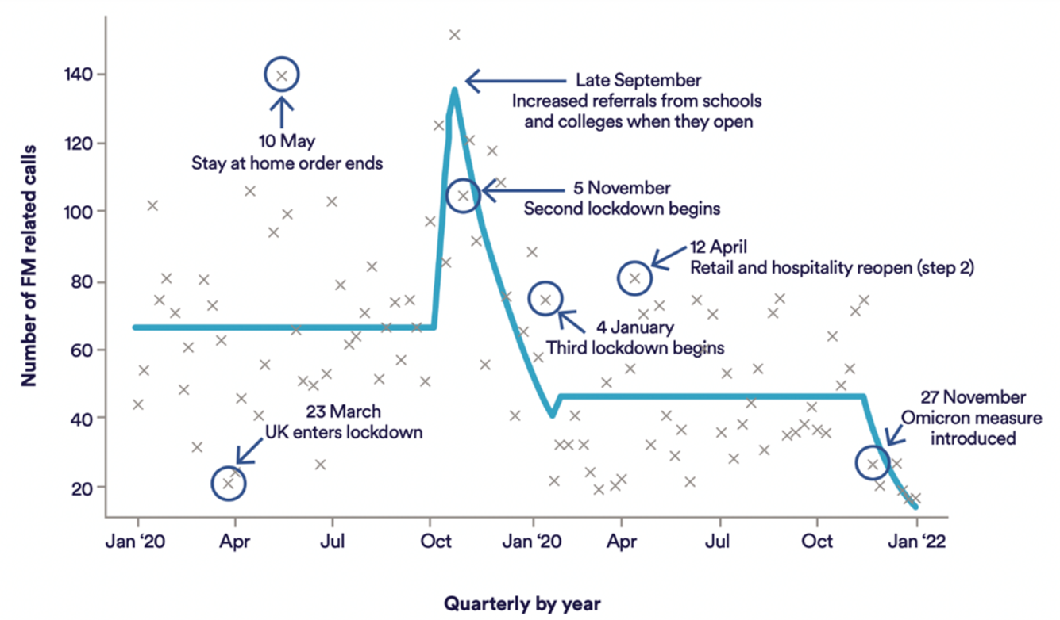Despite this increase when schools reopened, very few cases of vulnerable adolescents are referred to Karma Nirvana through schools and colleges. This is surprising as schools have a statutory safeguarding duty. Combing the lack of referrals from schools with the spike in calls when schools reopen suggests that schools are providing a valuable network for vulnerable adolescents to ask for support (McCabe el. al., 2022). As such, any strategy safeguarding girls vulnerable to forced marriage related femicide should involve schools and services that act within educational establishments.

Figure 2: The number of calls received by Karma Nirvana related to forced marriage from January 2020 to January 2022. The blue line shows a change point analysis to identify when the volume in calls changed significantly. Reproduced from McCabe el. al. (2022).

1. **Any challenges or barriers observed in the adoption of special investigation procedures or protocols to investigate femicides**;
   1. There is currently no statutory definition of honour-based abuse (HBA), with service providers most often turning to the Crown Prosecution Service (CPS) definition. This is a barrier to investigating femicide resulting from forced marriage.
   2. Forced marriage is a complex phenomenon that can be driven not only by gender norms and connected perceptions of acceptable behaviour, but also poverty, healthcare, education and employment. The CPS definition can thus accurately describe many, but not necessarily all, cases of forced marriage in the UK.
   3. The change in definition of forced marriage introduced in the Marriage and Civil Partnership (Minimum Age) Act 2022 presents an opportunity to protect women and girls vulnerable to forced marriage related femicide. We have supported Members of the UK Parliament to table written questions to understand the work of the Government’s Unit in preparation ofr the Act coming into force (HC Deb 2 Sep 22 45473; HC Deb 2 Sep 22 45683; HC Deb 2 Sep 22 45681; HC Deb 2 Sep 22 61025). The answers to the parliamentary questions showed there is i) currently no public information about improving the quality of the Unit’s statistics, ii) a commitment to better understanding vulnerability to forced marriage but no information about how this commitment will be met, and iii) no evaluation for how the Unit’s work is carried out. It is not clear what strategy the Unit is taking to support implementation of the Marriage and Civil Partnership (Minimum Age) Act 2022.
2. **Recommendations**

Our recommendations are:

* 1. Improve reporting of the number of cases the FM Unit supports. In particular, to use the same data collection methods and definitions across several years. This will allow the identification of people vulnerable to FM across the UK, and to build a long-term and coherent strategy.
  2. Make local level data on vulnerability to FM available. This will support local stakeholders to develop targeted and coherent strategies to safeguard victims against FM related femicide. Adopt a statutory definition of HBA which covers relevant forms of FM, and which is recognised by survivors.
  3. Improve understanding of FM, including where it is, and is not, a form of HBA across government agencies, police, local government, education providers, and all other key stakeholders.
  4. Ensure that the implications of the Marriage and Civil Partnership (Minimum Age) Act 2022 are well-understood and included in relevant policy (particularly at the Department for Education, and by education providers).
  5. **Bibliography**

Forced Marriage Unit. 2022. Forced Marriage Unit Statistics 2021. GOV.UK. Retrieved November 1, 2022, from [https://www.gov.uk/government/statistics/forced-marriage-unit- statistics-2021/forced-marriage-unit-statistics-2021](https://www.gov.uk/government/statistics/forced-marriage-unit-%20statistics-2021/forced-marriage-unit-statistics-2021)

Geere, N., Hernandez, F., Severn, K., Seymour, R., McCabe, H. 2022. Analysing Calls to UK Forced Marriage Helplines. Retrieved November 1, 2022, from [https://www.nottingham.ac.uk/research/beacons-of-excellence/rights- lab/resources/reports-and-briefings/2022/august/analysing-calls-to-uk-forced-marriage- helplines.pdf](https://www.nottingham.ac.uk/research/beacons-of-excellence/rights-%20lab/resources/reports-and-briefings/2022/august/analysing-calls-to-uk-forced-marriage-%20helplines.pdf)

Home Office. 2021. Statistics on so called ‘honour-based’ abuse offences in England and Wales 2020 to 2021. Retrieved November 1, 2022, from [https://www.gov.uk/government/statistics/statistics-on-so-called-honour-based-abuse- offences-england-and-wales-2020-to-2021/statistics-on-so-called-honour-based-abuse- offences-england-and-wales-2020-to-2021](https://www.gov.uk/government/statistics/statistics-on-so-called-honour-based-abuse-%20offences-england-and-wales-2020-to-2021/statistics-on-so-called-honour-based-abuse-%20offences-england-and-wales-2020-to-2021)

McCabe, H., Seymour, R., Bonner, A., Coggins, H., Lott, N., Collins-Taylor., Brown, R. C. 2022. The impact of Covid-19 and Covid-related restrictions on forced marriage: Data report. Retrieved November 1, 2022, from [https://www.nottingham.ac.uk/research/beacons-of- excellence/rights-lab/resources/reports-and-briefings/2022/may/the-impact-of-covid-19- and-covid-related-restrictions-on-forced-marriage.pdf](https://www.nottingham.ac.uk/research/beacons-of-%20excellence/rights-lab/resources/reports-and-briefings/2022/may/the-impact-of-covid-19-%20and-covid-related-restrictions-on-forced-marriage.pdf)

Seymour, R. G., Nyarko-Agyei, A., McCabe, H. R., Severn, K., Kypraios, T., Sirl, D., Taylor, A. 2023. arXiv:2212.01202. Comparative Judgement Modeling to Map Forced Marriage at Local Levels