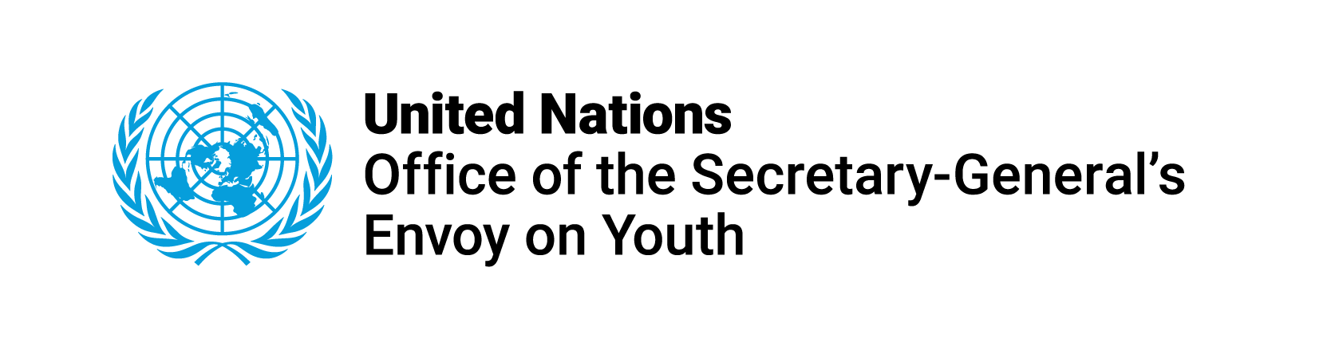

**5th phase of the World Programme for Human Rights Education**

**Submission from the United Nations Office of the Secretary-General’s Envoy on Youth**

In response to the Human Rights Council Resolution [A/HRC/RES/51/2](https://documents-dds-ny.un.org/doc/UNDOC/GEN/G22/523/19/PDF/G2252319.pdf?OpenElement), adopted on 6 October 2022, and in support of the process to establish the focus of the 5th phase of the World Programme for Human Rights Education, the Office of the Secretary-General’s Envoy on Youth (OSGEY) hosted a virtual consultation with youth representatives on 23 May 2023. Through this consultation, young participants expressed their thoughts, concerns, and aspirations, shedding light on the target sectors and focus areas they believe should be prioritized in the scope of the 5th phase of the World Programme and informing OSGEY’s submission to the process.

Young people who took part in the consultation vocalized their wholehearted support for the focus of the 4th phase of the World Programme for Human Rights Education on youth. With that in mind, OSGEY underscores the work and progress of the 4th phase of the World Programme, which is co-coordinated by the United Nations Office of the High Commissioner for Human Rights (OHCHR), the United Nations Educational, Scientific, and Cultural Organization (UNESCO), and OSGEY.

At the same time, and as highlighted in the Secretary-General's Policy Brief on [Meaningful Youth Engagement in Policymaking and Decision-making Processes](https://www.un.org/sites/un2.un.org/files/our-common-agenda-policy-brief-youth-engagement-en.pdf), launched in April 2023, *“young people have become a driving force for societal change through social mobilization – pushing for climate action, seeking racial justice, promoting gender equality and demanding dignity for all (…) When it comes to participation in public policymaking and decision-making, however, youth remain almost invisible*.*”* Hence, the importance of meaningfully engaging young people in all their diversity and at all levels of policy and decision-making is pivotal, including to achieve the 2030 Agenda for Sustainable Development and the vision of the Universal Declaration on Human Rights.

In the scope of the 5th phase of the World Programme for Human Rights Education, it is necessary to continue to build on the current phase of the World Programme by highlighting the role of youth as rights holders and key actors in realizing human rights. In relation to the 4th phase, the 5th phase should be strengthened in a direction that calls for a paradigm shift that moves beyond viewing young people as passive beneficiaries of human rights education, and acknowledging them as the active human rights defenders, changemakers, leaders, educators, and advocates that they are.

There is no better way to reach youth than through youth themselves, since young people have a prominent role in educating and influencing their peers, raising awareness about human rights, mobilizing their communities, creating innovative solutions to problems, and bringing about positive change. Their ability to connect with their peers, parents, communities, and environments enables them to generate ripple effects that extend far beyond their immediate circles, amplifying the impact of their endeavors online and offline. With that in mind, human rights education for youth can only be done effectively if it is also done with and by youth.

During the consultation, young participants also repeatedly brought up young human rights defenders as key changemakers in their communities, while simultaneously emphasizing the challenges they experience particularly for being young. In the first-of-its-kind [Global Report on Protecting Young People in Civic Space](https://www.un.org/youthenvoy/wp-content/uploads/2021/06/Global-Report-on-Protecting.-Young-People-in-Civic-Space.pdf), launched by the OSGEY and partners in 2021, it was highlighted that young people face multiple and intersecting sociocultural, financial, political, and legal barriers, threats, and challenges, many of which are human rights violations, to meaningfully and safely engage in civic space - online and offline. Both the Global Report and young participants in the 23 May 2023 consultation noted that human rights education is key in ensuring young people are safe when exercising their rights, especially their right to freedom of speech and freedom of peaceful assembly and association. In light of this, the 5th phase of the World Programme for Human Rights Education should emphasize on the intersections between human rights, education, and protection, particularly from an age-specific lens and focusing on young human rights defenders, educators, advocates, and more.

Moreover, the role of non-formal and informal human rights education with, for and by youth should also be strengthened. In the [Youth Declaration on Transforming Education](https://www.un.org/sites/un2.un.org/files/2022/09/tes_youthdeclaration_en.pdf) launched in September 2022 as part of the Transforming Education Summit, almost half a million young people from over 170 countries collectively outlined their views, recommendations, and commitments on the futures of education. In the Youth Declaration, young people called upon decision-makers to *“recognize and invest in non-formal education programs and organizations, particularly those that are youth-led, as an integral part of the right to education and a key approach to promoting the development of personal and collective values and civic engagement of children and youth”* (Article 15). This demand was echoed by young participants of the 23 May 2023 virtual consultation.

Finally, and as highlighted by young participants in the consultation, the thematic focus of the 5th phase of the World Programme for Human Rights Education should encompass a diverse range of concerns, including but not limited to gender equality, freedom of expression, digital rights, children's rights, political participation, climate action, sexual and reproductive health and rights, and others, while a crucial emphasis should be given to on fostering synergies among them.

In conclusion, human rights education with, for and by youth is key to achieve a world in which the human rights of every young person are realized; that ensures every young person is empowered to achieve their full potential; and that recognizes young people’s agency, resilience and their positive contributions as agents of change – as envisioned in the [United Nations system-wide Youth Strategy, Youth2030](https://www.unyouth2030.com/_files/ugd/b1d674_9f63445fc59a41b6bb50cbd4f800922b.pdf). Strengthening the scope of the 4th phase of the World Programme in the framing of 5th phase of the World Programme for Human Rights Education will be pivotal toward making this vision a reality.