A REPORT:

HOW CLIMATE CHANGE CAN HAVE AN IMPACT ON THE REALIZATION OF THE EQUAL ENJOYMEN OF THE RIGHT TO EDUCATION BY EVERY GIRL

Acasia Broomes

Trinidad & Tobago

Research Officer

OJT- Santa Rosa First Peoples Community

Geo-7 Fellow

Human Rights Council resolution 54/19.

Office of the United Nations High Commissioner for Human Rights, United Nations Office at Geneva, CH 1211 Geneva 10, Switzerland

March 1st, 2024

According to the UK Foreign, Commonwealth and Development Offices 2021, 12 years of safe and quality education for all children, and specifically girls, is one of the most cost-effective and impactful social economic investments governments and donors can make. The educating of girls is linked with economic development, climate change mitigation and resilience, encouraging peace and strengthening health and education outcomes for children. According to Global Partnership for Education currently there are 130 million girls worldwide that are not in school. More than 10 million children between 5 and 14 years old are absent from classrooms across Nigeria, according to UNICEF. For girls, the statistics are even bleaker (CNN 2023). This is due to gender inequality which impacts girls worldwide.

Before we can answer the question for the report on the harmful impact of climate change inclusive of those on environmental degradation on the realization of the equal enjoyment of the right to education by every girl we must first answer two main question: “What is climate change?” and “What is environmental degradation?”

Climate change according to Climate Change and Knowledge Portal in lament terms is the significant variation of average weather conditions for examples the weather becoming significantly warmer, wetter or drier over a period of several decades or longer. However, for the purpose of this report we would use the definition provided by the United Nations. According to the United Nations climate change is defined as long-term shifts in temperatures and weather patterns. These shifts were considered to be natural due to changes in the sun’s activity or large volcanic eruption, however, since the 1800s, human activities became the main driver in the shifts of climate change, this was done mainly due to the burning of fossil fuels like coal, oil and gas. The burning of these fossil fuels creates greenhouse gas emissions that creates a blanket like cloud wrapping around the Earth, thus trapping the sun’s heat and raising core temperatures.

CEDRA (2009) states environmental degradation (ED) is the consequence of past and present generations using up or damaging natural resources faster than nature can restore them, such that few, if any, of those resources remain for the next generation. Environmental degradation impacts may include, for example: destruction of forests, causing soil degradation and threatening agricultural livelihoods, building of dams or diverting rivers upstream causing water shortages and increased workloads to collect water, destruction of coastal protection such as mangroves, leading to exposure to storm damage, waterlogging of soils, and relocation of communities, lastly smoke and air pollution from factories using chemicals causing increased ill health.

This report seeks to focus on how these two issues intensifies already existing barriers faced by girl being able to access, their right to an equal education. In addition, is there further reduction in availability and the quality of education for girls and more so, how is society adapting to the needs of these girls in their plight to their right to enjoy an education.

The impacts of climate change and environmental degradation can be seen worldwide and in many sectors important to society, such as human health, agriculture and food security, intense drought, water scarcity, deforestation, energy and biodiversity and ecosystems. One of the major research gap when examining the impact of climate change and environmental degradation, is the impact it has on women and girls, in particular girls on their right to equal enjoyment of an education. *See Figure1 (Appendix 1) and Figure 2 (Appendix 2).* In addition, there is a need to study on how these to factors further exacerbates already existing barriers for girls to their equal enjoyment of the right to education.

The harmful impact of climate change particularly to girls is deemed to be severe and long lasting, which most likely reverses the advancement already made in acquiring the right to education and hindering advances made to gender equality over the recent years.

In order to understand the impact of climate change and environmental degradation on girls’ right to an equal education it is essential to firstly understand the gendered impact of climate change on girls. While girls and boys are equally exposed to climate change and its impacts their experiences are vastly different. Women and girls account for the vast majority of the world’s poor and are highly dependent on natural resources for their livelihoods. Due to gender norms girls are less likely to be taking part in politics, community and household decision making and less likely to be economically independent. Thus, due to a lack of protective mechanisms to safeguard their rights or even given rights in some instants they are susceptible to greater impacts of both climate change and environmental degradation.

Girls are initially faced with barriers to their education which are further worsen due to climate and environmental change. There are over twelve main barriers to girls participation in education according to United Nations International Children's Emergency Fund and these span from micro, meso and macro levels.

“Micro-level barriers are those that operate at the girl and household level. These include poverty and financial barriers, physical health barriers (including the disabilities that in LMICs are often related to poverty and are preventable), mental ill health (including that caused by household and community violence and amplified by social exclusion), barriers linked to reproductive biology (and the limited resources that girls have to deal with these), and limited aspirations for education (which are shaped by a complex interplay between household and community factors). Meso-level barriers are those that operate at the community and school level. These include barriers that prevent girls from physically accessing schooling, poor school environments (e.g. schools that are disproportionally staffed by men or lack menstrual health management facilities), discriminatory beliefs and behaviors (especially towards those with disabilities or from marginalized groups), peer pressure and community-level gender norms (that deprioritize girls’ need for education). Macro-level barriers are those that operate at the sub-national and national levels. These include laws, policies and systems, some of which deliberately exclude some girls (e.g. those that prohibit pregnant girls from attending school or limit enrolment to those with citizenship) and others of which fail to be inclusive (e.g. curricula that are not gender-responsive or data management tools that do not disaggregate by sex), as well as the (gender-responsive) financing required for implementation” (United Nations International Children's Emergency Fund 2021). *See Figure 3 (Appendix 3).*

However for the purpose of this report we are going to take a look at a few barriers operating at micro, meso and macro levels. These barriers to girls education according to Plan International care conflict and gender-based violence, child forced marriages (CEFM) and unions, early pregnancy, poverty and financial hardship, cost of school can lead to girls’ education not being prioritized by their caregivers, lack of safe toilets, menstrual products and clean water at school to help manage menstrual hygiene, stigma surrounding menstruation and gender norms and expectations. However, we would pay major attention to five of the barriers stated and how these major barriers are further exacerbated by climate and environmental crises which impact girls’ right to equal enjoyment of education. These root causes exacerbated further affects their right to availability, accessibility, acceptability and adaptability to their education.

The first barrier we are going to study is conflict and gender-based violence and how this barrier is further impacted upon due to climate change and environmental degradation. Gender violence is explained as an act of violence or abuse inflicted on a person or group based on their sex, gender, and or sexual orientation (Bawa and Kaur 2023). Plan International News and Stories Education (2021), ‘Gender-based violence in all of its forms work to hold girls back from accessing quality education. Nowhere in the world are girls free from violence and harassment. No town, city, or country including nowhere online. And in times of crisis or conflict, millions of children see their education disrupted and for girls this has devastating effects. Many are significantly less likely to return to school if they’ve been forced to leave and global lockdowns have drastically exacerbated cases of gender-based violence in the home and online’.

Young women and adolescent girls who are living through or may have lived through climate crises and environmental degradation crises tend to be at greater risk to sexual and gender based violence. There were various studies bringing forth a spike in gender base violence and sexual assault against young women and adolescence girls during and after major weather occurrences such as “natural hazards exacerbate underlying drivers of violence and create environments for abuse to occur” (van Daalen, K.R. Et al 2022). These studies show that due to being exposed to different forms of gender based violence young girls opt to become school drop-outs as these climate and environmental disasters puts added pressure on girls, who often have to leave school to help their mothers manage the increased burden on maintenance of the household. Their availability to their right to an education now becomes infringed upon and their accessibility sometimes can also be affected when they experience intimate partner violence. With intimate partner violence, young girls are often denied access to school as a form of punishment and in some cases due to the evidence of physical abuse, refuses to attend school for the fear of social embarrassment.

Another barrier which affects girls’ right to an education and is further impacted upon due to climate and environmental crises is, child, early or forced marriages and unions (CEFMU). Although boys are also affected by early and child marriage, CEFMU particularly has detrimental effects on young girls and women. During the past couple of years there has been efforts to address CEFMU, which saw a reduction in cases, however, research and evidence have confirmed that climate change and other environmental crises are increasing the drivers of child marriages. According to the United Nations Population Fund it is estimated that 12 million girls under the age of 18 are married each year and this number it is now at great risk of rising. Countries such as Africa, India, Bangladesh, Peru and El Salvador with the highest rates of child marriages are also those facing considerable effects of climate change and related environmental degradation. Research have established a connection between contexts such as droughts and flooding and increased child marriages (End Violence Against Children 2022). Child, early and forced marriage and unions are an infringement on the rights of both girls and women in addition to it being a cardinal hinderance to human development. More so, CEFMU robs young girls’ of their human right to a childhood that is protected and pure. Also, CEFMU halts and in some cases derails the accessibility to young girls’ and women education, social engagement and economic empowerment. For millions of girls once they are married their education comes to an abrupt end. Evidence shows that the longer girls stay in school, the lower their chances of child marriage, however, due to the loss of education as a result of climate change and related environmental degradation account for placing children, particularly girls, at higher risk of being married off in childhood.

Early pregnancy among girls is an additional barrier on girls’ education which is further exacerbated by climate and environmental change thus hampering the right to their education. According to Sambo (2009), “teenage pregnancy refers to pregnancies which occur when the girl child is below the age of 18 years. Unwanted, unplanned and out of wedlock”. Early pregnancy has always been a major concern for educators, policy makers, researchers, families and those within communities. It is estimated that approximately 18 million young girls give birth every year. Early pregnancy is caused by numerous factors ranging from gender based violence, poor school performance, economic factors, child, early or force marriages and unions, poverty and absence of sexual education. These factors are further intensified due to extreme weather events (floods, droughts, hurricanes, cyclones, heatwaves, typhoons, and wildfires) caused by climate change as well as deforestation, biodiversity and costal degradation, which are caused by environmental degradation. Due to early pregnancy most teenagers are expelled from their schools and in most instances are not granted the opportunity of being reabsorbed into the school system after their pregnancy. There is also a lesser chance for these same said girls to return to school once they have had their child for the fear of being ostracize by their peers and or having to now nurture their newborn or seek employment to cope with the added financial burden. Research shows early pregnancy is currently rising in countries being precipitated by extreme environmental changes and climate change are causing abrupt end to the educational span of young girls as most tend to be given adult responsibilities before they are ready.

The lack of safe toilets, menstrual products and clean water at school to help manage menstrual hygiene is also another important barrier for girls to their equal enjoyment of the right to education, which is further aggravated by the environmental degradation and climate change. Worldwide most girls reaches the reproductive age naturally and experience menstruation roughly once a month and yet in various places, girls are faced with serious barriers to accessing proper facilities and products for managing their periods.

On a normal basis many girls around the world experience having very little access to sanitary products and proper functional toilet facilities at school, which makes managing their period incredibly difficult. This situation is worsen especially for girls located in climate stricken countries experiencing droughts, floods and environmental degradation such as Africa, India, Peru and Ecuador to name a few according to Plan Organization. This ultimately restricts their movements when they have their period and this affects their attendance and performance at school.

The most important barrier to girls right to their equal enjoyment to an education is gender norms and expectations. This barrier shows the discrepancy among girls and boys and the position society gives them on a normal basis and when in time of crises. During times of crises girls educational rights are thrown out the door as their place is now seen to provide food and supplies for the men and boys. They are now placed as providers to their family alongside their mothers, a role which is placed upon them automatically and therefore education is no longer their right. Studies done areas such as the United States of America, India, Bangladesh and Nigeria shows that there is evidence that after extreme weather events (floods, droughts, hurricanes, cyclones, heatwaves, typhoons, and wildfires shows that young girls ultimately drop out of school in order to assist in providing for their families. This is due to the fact that women and girls bear a disproportionate responsibility for securing food, water and fuel globally during these periods it becomes harder for women to secure income and resources for their families.

There is a call for action for to be taken by governments and policy makers to ensure that the barriers faced by girls in the attainment to their right to education can be reduce and or even eradicated. International organizations has researched and found using three pathways which would create concrete measures to respond to reducing and or even eradicating these barriers.

The first pathway according to United Nations International Children's Emergency Fund (2021) is creating a “core social protection mechanisms such as cash transfers, public works programs, educational stipends, social health insurance/subsidies for healthcare, free/subsidized childcare, nutrition support, and maternity/paternity/ parental leave. Case management for girls with complex needs”. The second pathway is to create programs that interlink with these core mechanisms aimed at addressing attitudes and behaviors from parents and or caregivers as well as providing knowledge of life skills to these girls. Most of all, the third pathway is linked to “policy advocacy and supply-side investments aimed at improving the national, regional and local environments in which girls live and learn” (UNICEF 2021). Through these pathways organization and governments are implementing systems to address these barriers, for instance some organizations are assisting in practical ways. “World Bank interventions aim to tackle these menstrual hygiene challenges. Twenty-five percent of World Bank education projects had components that addressed menstrual hygiene management, provision of sanitary and hygienic toilets, or separate toilets for girls and boys in their schools. For example, project in Tanzania focuses on improving the school environments to ensure girls feel comfortable to stay in school, including creating more separate toilets and water, sanitation and hygiene facilities for girls and boys, running water access (one handwashing facility per 100 students), and incinerators for disposal. The project will also designate an active menstruation counselor at schools and have a separate room available for girls for menstrual hygiene management” (Khan 2022).

Promote comprehensive sexuality education (CSE) to bolster girls’ autonomy and agency. “CSE increases all learners’ self-esteem and knowledge levels, builds self-efficacy, and helps them challenge discriminatory attitudes, gender and social norms, as well as having a positive impact on safer sexual behaviors. CSE programs for all learners that include gender transformative content and teaching methods, and address power relations, support them to question socio-cultural norms around gender and are vital for enabling girls to have autonomy and agency over their own bodies, fertility, sexuality, health and wellbeing” (Generation Equality Forum 2020).

Another aim is to promote education on gender equality thus shifting harmful norms and behavior. “Millions of children and adolescents experience sexual, physical or psychological violence in and around schools, perpetrated as a result of gender norms, discrimination and stereotypes, and enforced by unequal power dynamics” (Generation Equality Forum 2020). This is done by introducing curriculum-based approaches that include content on gender-based violence, rights and power dynamics.

In addition, creating economic rights and justice for girls to be seen and viewed as persons with a voice. “Ensure basic education, 21st century skills and lifelong learning opportunities to create an enabling environment for all girls to access their economic rights, and participate in and co-c2reate just economic systems”(Generation Equality Forum 2020).

As much as we try to research and present information for the impact that climate change as well as environmental degradation may have on exacerbating barriers which affect the rights of girls enjoyment to education there are existing gaps and challenges. This is due to the fact that linkage between education, gender, and climate were forecast by existing sector-specific research and this is done by lived experiences of young girls worldwide. Thus causing gaps and challenges in climate adaptation programs are effective, how effective educational programs adapt in the face of climate and environmental shock and changes, climate adaptation programs disrupt instead of perpetuate discriminatory systems and support climate justice and lastly, the approaches which can be used to educate, advocate and empower these young girls voices in both local and global discussions and decision making for climate and environmental change.

Empowering girls through education plays a highly direct and indirect role to contribute to the climate change agenda. In order to create such “empowerment efforts, initiatives, practices, policy and service frameworks to address climate change, prevent and mitigate disasters, ensure health and education for women and girls, call for an open debate and proposal on the allocation of resources through public budgets at all levels of government, with the purpose of ensuring state infrastructure, good community practices and thus the human rights of women. It is important to highlight the application of methodological approaches and tools for gender budgets and the global framework that sustains them” (Economic Commission for Latin America 2022).

**Appendices**

**Appendix 1**

Figure one gives a visual depiction of how climate change affects girls education in the upper half of the diagram, as well as depicting how having educated girls can bring positivity to climate change in the lower half of the diagram.

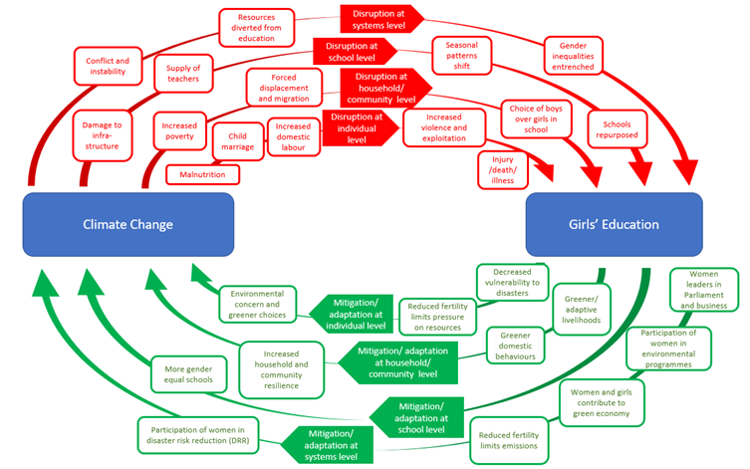

*Figure 1. Gives relation to climate change and girls education and also shows correlation to educating girls and the effects it has on climate change. Source: AGEE.*

**Appendix 2**

The impact of both climate change and environmental degradation on education is illustrated.

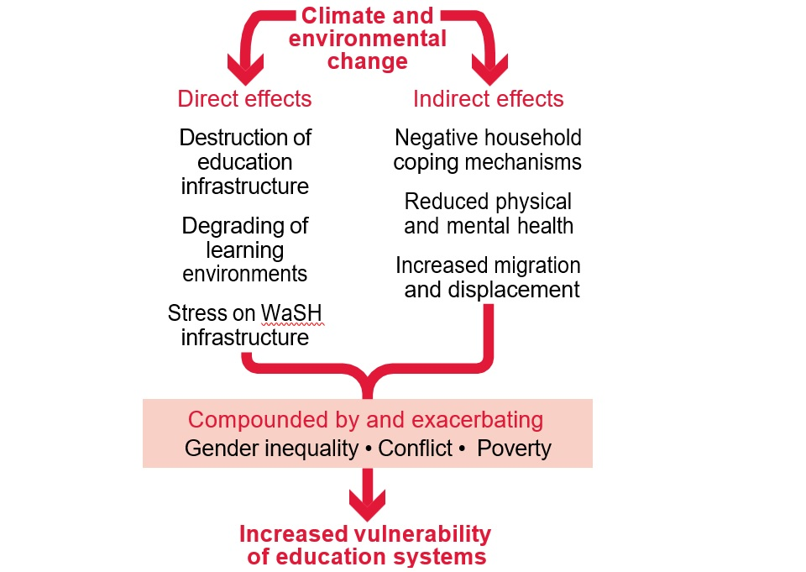

*Figure 2. Gives relation to climate and environmental change both direct and indirect effects upon education. Source: UK Government Publications.*

**Appendix 3**

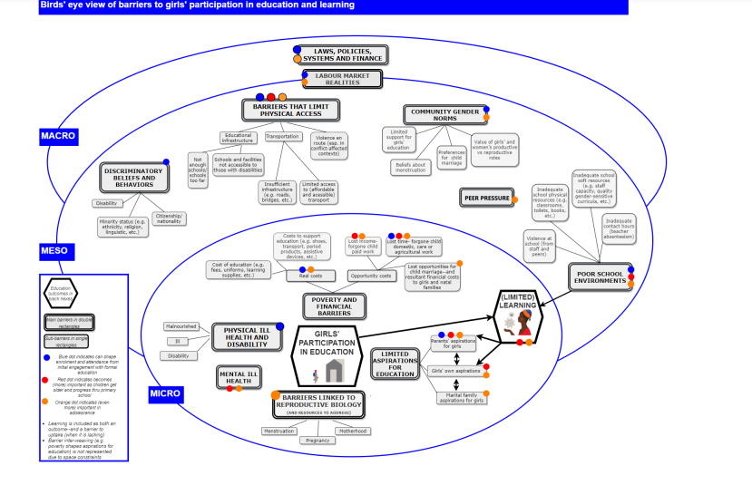

*Figure 3. Linkage of barriers to girls education at the micro, meso and macro level. Source: UNICEF*

**Bibliography**

AGEE (2021). *How does climate change relate to gender equality in education?* <https://www.gendereddata.org/how-does-climate-change-relate-to-gender-equality-in-education/>

Bawa, Adam Gana and Kaur, S. (2023). *Gender-Based Violence: Implications for Girl-Child Education in Some Selected Displaced Persons Camps in Maiduguri.* *Education Research International*, 2023, pp.1–7. doi: <https://doi.org/10.1155/2023/8446724>

Birchall, Jenny (2018). *Early marriage, pregnancy and girl child school dropout | Health and Education Resource Centre*. <https://healtheducationresources.unesco.org/library/documents/early-marriage-pregnancy-and-girl-child-school-dropout>

CEDRA (2009). *Climate change and Environmental Degradation Risk and Adaptation assessment An environmental tool for agencies in developing countries*. <https://www.preventionweb.net/files/11964_CEDRAClimatechangeandEnvironmentalD.pdf>

CNN (2023). *How the climate crisis fuels gender inequality. CNN Special Report.* <https://edition.cnn.com/interactive/2023/11/world/climate-gender-inequality-cnnphotos-as-equals-intl-cmd/#:~:text=Women%20and%20girls%20already%20grapple>

College of Medicine. (2024). *Climate Change Disproportionately Affects Women: Women’s Health Education Program Blog* <https://drexel.edu/medicine/academics/womens-health-and-leadership/womens-health-education-program/whep-blog/climate-change-disproportionately-affects-women/>

Desai, B.H. and Mandal, M. (2021). *Role of Climate Change in Exacerbating Sexual and Gender-Based Violence against Women: A New Challenge for International Law*. *Environmental Policy and Law*, 51(3), pp.137–157. doi: <https://doi.org/10.3233/epl-210055>

Economic Commission for Latin America (2022). *Achieve gender equality and the empowerment of women and girls in the context of climate and environmental change and disaster risk reduction policies*. <https://www.cepal.org/sites/default/files/congo_lac_-_document_eng.pdf>

End Violence Against Children (2022). *2022 ANNUAL REPORT TABLE OF CONTENTS*. <https://www.end-violence.org/sites/default/files/2023-08/2022%20Annual%20Report.pdf>

End Violence Against Children (2022.). *How climate change is driving child marriages | End Violence*. <https://www.end-violence.org/articles/how-climate-change-driving-child-marriages>

Generation Equality Forum (2020). *Recommendations on girls’ education*. <https://www.coalition-education.fr/depotWeb/GEF_Education-Recommendations_June20-pdf.pdf>

Foreign, Commonwealth and Development Office (2022). *Policy Paper: Addressing the climate, environment, and biodiversity crises in and through girls’ education. GOV.UK*. <https://www.gov.uk/government/publications/addressing-the-climate-environment-and-biodiversity-crises-in-and-through-girls-education/addressing-the-climate-environment-and-biodiversity-crises-in-and-through-girls-education>

Haberland, Nicole and Pinchoff, Jessie (2023). *Learning to Adapt: The vital role of education and gender equity in climate justice – Population Council*. <https://popcouncil.org/insight/learning-to-adapt-the-vital-role-of-education-and-gender-equity-in-climate-justice/>

Harris, Sophie (2022). A*n educating girls fight climate change?* WONDER Foundation.

<https://wonderfoundation.org.uk/how-educating-women-and-girls-could-help-fight-climate-change/>

Hassani, Uraidah (2022). *Why we must engage adolescent girls in climate change solutions*. <https://blogs.worldbank.org/climatechange/why-we-must-engage-adolescent-girls-climate-change-solutions>

Hub, Iisd.S.K. (2024.). *Generation 2030: Powering Climate Resilience Through Inclusive Education, Gender Equality | SDG Knowledge Hub | IISD*. <https://sdg.iisd.org/commentary/generation-2030/powering-climate-resilience-through-inclusive-education-gender-equality/>

Igba, D., Igba, C., Nwafor, C., Elom, C. and Mgboro, C. (2018). *Teenage Pregnancy and Girl-Child Education. International Journal of Applied Environmental Sciences,*13, pp.237–248. <https://www.ripublication.com/ijaes18/ijaesv13n3_01.pdf>

International Organization for Migration (2011). *Climate change, environmental degradation*. <https://www.iom.int/sites/g/files/tmzbdl486/files/jahia/webdav/shared/shared/mainsite/microsites/IDM/workshops/climate-change-2011/background_paper.pdf>

Irish Consortium (2022). *Gender Based Violence and its intersection with Climate Change.* <https://www.gbv.ie/wp-content/uploads/2022/03/ICGBV-Policy-Paper-Climate-Change-and-GBV.pdf>

Kearon, L. (2023). *Lack of menstrual hygiene management among women and girls in East Africa*, *Ballard Brief*. <https://ballardbrief.byu.edu/issue-briefs/lack-of-menstrual-hygiene-management-among-women-and-girls-in-east-africa#:~:text=This%20lack%20of%20MHM%20often,lead%20to%20infection%20and%20disease>

Khan, Myra M. (2022). Menstrual health and hygiene: What role can schools play?

<https://blogs.worldbank.org/education/menstrual-health-and-hygiene-what-role-can-schools-play>

Kulyk, H. (2021). *Child, early and forced marriage and unions. Harmful practices that deepen gender inequality in Latin America and the Caribbean*. Gender Equality Observatory. <https://oig.cepal.org/en/documents/child-early-and-forced-marriage-and-unions-harmful-practices-deepen-gender-inequality>

Kwauk, C. (2021). *Why is girls’ education important for climate action?* Brookings. <https://www.brookings.edu/articles/why-is-girls-education-important-for-climate-action/>

Levinson, J., Lawrence, C., Kang, J., Page-Gould, L., Page, A., Yamamoto, E., Mackenzie, M., Lieberman, D., Serrano, S., Leina'ala Seeger, C., Christiansen, J. and Skorinko (2007). *FORGOTTEN RACIAL EQUALITY: IMPLICIT BIAS, DECISIONMAKING, AND MISREMEMBERING*. <https://scholarship.law.duke.edu/cgi/viewcontent.cgi?article=1336&context=dlj>

‌Maemeko, E.L., Nkengbeza, D. and Chokomosi, T.M. (2018). *The Impact of Teenage Pregnancy on Academic Performance of Grade 7 Learners at a School in the Zambezi Region. Open Journal of Social Sciences,* 06(09), pp.88–100. doi: <https://doi.org/10.4236/jss.2018.69006>

Novenario, C. (2023). *Four Ways that Climate Change Impacts Girls’ Education in Africa - Global Center on Adaptation*. Global Center on Adaptation. <https://gca.org/4-ways-that-climate-change-impacts-girls-education-in-africa/#:~:text=The%20Malala%20Fund%20estimates%20that>

Odiri, O.E. and Oboawharhe Eloho Anthonia (2023). *The Aftermath Implications of Teenage Pregnancy on the Girl Child Education. COUNS-EDU: The International Journal of Counseling and Education*, 8(1). doi: <https://doi.org/10.23916/0020230839610>

Pankhurst, C. (2022). *Accountability for Gender Equality in Education Working Paper Girls’ education and climate change: A critical review of the literature*. <https://www.gendereddata.org/wp-content/uploads/2022/07/Girls-Education-and-Climate-Change-Critical-Review-of-the-Literature_FINAL-2.pdf>

Plan International Organization (2023). *Climate change and girls’ education*. *Tech Report.* <https://plan-international.org/uploads/2023/11/Climate-Change-and-Girls-Education_TechReport_Nov2023.pdf>

Plan International Organization (2023). *Climate crisis has severe impact on girls’ education - report*. <https://plan-international.org/news/2023/11/20/severe-impact-climate-crisis-girls-education/>

Plan International Organization (2021). *What are the barriers to girls’ education?* Plan International Australia. <https://www.plan.org.au/news/education/barriers-to-girls-education/>

Plan International Organization (2020). *Child, Early and Forced Marriage and Unions Policy Brief.* <https://plan-international.org/uploads/2022/02/glo-cefmu_policy_brief-final-io-eng-jan21-1.pdf>

Plan International. (n.d.). *5 ways climate change is disrupting girls’ lives*. <https://plan-international.org/case-studies/5-ways-climate-change-is-disrupting-girls-lives/>

Rodriguez, L. (2019). *7 Barriers to Girls’ Education Around the World*. Global Citizen. <https://www.globalcitizen.org/en/content/barriers-to-girls-education-around-the-world/>

Sambo (2009). Child Development and Personality. New York: Harper and Row Publishers.

Sivakami M, Maria van Eijk A, Thakur H, et al. Effect of menstruation on girls and their schooling, and facilitators of menstrual hygiene management in schools: surveys in government schools in three states in India, 2015. *J Glob Health*. 2019;9(1):010408. doi:10.7189/jogh.09.010408

The Wellspring Foundation for Education. (n.d.). *What are Barriers to Girls’ Education?* https://thewellspringfoundation.org/resources/barriers-to-girls-education/.

United Nations International Children’s Emergency Fund (2023). *Climate change impact on adolescent girls*, *UNICEF Middle East and North Africa*. https://www.unicef.org/mena/reports/climate-change-impact-adolescent-girls

United Nations International Children’s Emergency Fund (2021). *Mapping Social Protection Pathways for Girls’ education.* https://www.unicef.org/media/115131/file/Mapping%20Social%20Protection%20Pathways%20for%20Girls’%20Education%20FINAL.pdf.

United Nations Population Fund (2020) *COSTING THE THREE TRANSFORMATIVE RESULTS*. https://www.unfpa.org/sites/default/files/pub-pdf/Transformative_results_journal_23-online.pdf.

United Nations Women (2022). *Explainer: How gender inequality and climate change are interconnected*. UN Women. https://www.unwomen.org/en/news-stories/explainer/2022/02/explainer-how-gender-inequality-and-climate-change-are-interconnected

Unterhalter, E. (2019). *The Many Meanings of Quality Education: Politics of Targets and Indicators inSDG4.* *Global Policy*, 10(S1), pp.39–51. doi:https://doi.org/10.1111/1758-5899.12591

van Daalen KR, Kallesøe SS, Davey F, et al (2022). Extreme events and gender-based violence: a mixed-methods systematic review. Lancet Planet Health. 2022;6(6):e504-e523. doi:10.1016/S2542-5196(22)00088-2

Wiggins, Sarah (2009). *Cedra - climate change and environmental degradation.* https://www.preventionweb.net/files/11964_CEDRAClimatechangeandEnvironmentalD.pdf

World Economic Forum (2021). Climate change: How is it affecting girls’ education? *weforum.org*. https://www.weforum.org/agenda/2021/11/climate-change-girls-education-gender-equality/

‌