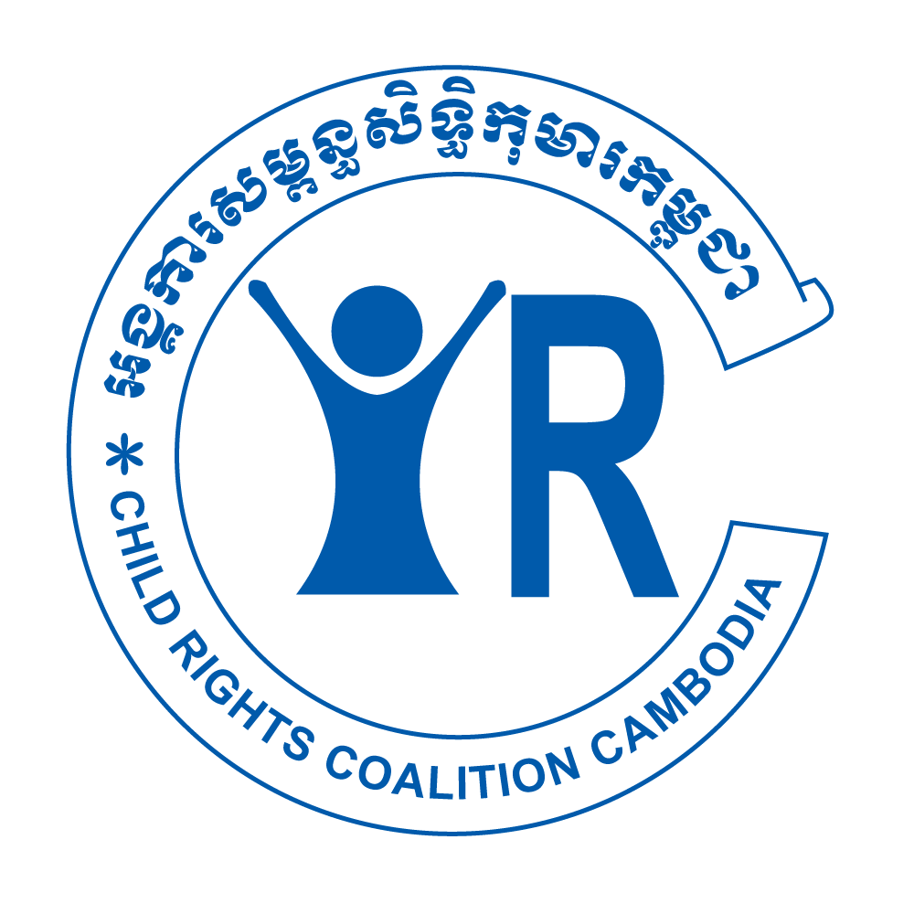
Civil Society Input from Cambodia
Call for input to the OHCHR Report on how climate change can have an impact on the realization of the equal enjoyment of the right to education by every girl
Input from Child Rights Coalition Cambodia (CRC-Cambodia), Child and Youth-Led Networks (CYLNs), ActionAid International Cambodia (AAC) and Live & Learn Cambodia
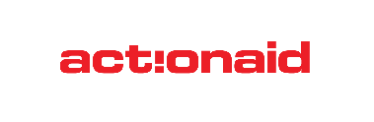
Children in Cambodia are at a high risk of exposure and vulnerability to the impacts of climate change. According to the 2021 UNICEF Children’s Climate Risk Index Cambodia is in the top third (46 out of 163 countries) with high exposure to water scarcity, riverine flooding, and vector-borne disease. Weaknesses in provision of essential services, including education, especially in rural and remote areas, increase children’s vulnerabilities to climate change. However, comprehensive, and robust information on the impact of climate change, including disasters, on children is missing (UNICEF SitAn, 2023:15).
This input is developed as a collaborative civil society effort, considering recent developments and literature and it is informed by the perspectives of 15 girls living in areas and communities particularly affected by climate change. See Annex 1 for more information about CSO contributors to this input and Annex 2 for links to a child-friendly report on the consultations with girls as well as a shorter version of this input. Annex 3 includes an anonymised statement/testimony of an indigenous girl on the multiple impact of climate change on her life, but also how this could be dealt with. Annex 4 provides a list of references.
Girls’ Education and Climate Change in Cambodia
Despite the continuous progress in the development and implementation of comprehensive national education policies, plans and programs, including in respect of gender equality (2022 CDRI), significant gaps persist both in access and quality.
1. Access: Overall school enrolment, attendance and completion rates are improving. However, approximately 10% of children are not enrolled, because schools are not available or not inclusive (CRC-Cambodia, 2023:9), issues in obtaining identity documents (WPM, 2022:129) etc. Moreover, most children still do not complete basic education. In 2021, 87.4% completed primary school, but only about half of them finished lower secondary school. Student dropout is particularly high in rural and remote areas. (UNICEF SitAn 2023:9-10)
1.1. Drop out - Gender Disparities
Although dropout rates of boys and girls seem similar, the reasons and consequences of dropping out differ. While boys are more likely to take on paid employment (often migrating abroad) or get into an informal apprenticeship, girls are more likely to leave school because of marriage or to support their family at home, e.g. with care work. This reduces girls' opportunities to develop their full potentials and puts their autonomy at serious risks. (NGO-CEDAW, 2023:31-32)
According to the 2021-22 Health and Demographic Survey, almost 1 in 5 young women were married before the age of 18 and 2% of adolescent girls were married by age 15 (CDHS, 2022). Research in other countries shows surge in child marriage following weather-related natural disasters (SRSGVAC, 2023:9).
Girls who took part in the consultations for this input confirmed that the amount of household work can increase because of climate change, especially so for the oldest daughters. This can be particularly disruptive for their education in case of frequent floods and droughts and can lead to drop out when families struggle with livelihood - both in rural (Plan 2023) and urban poor areas (STTO 2023).
“This year, it is hotter, and rainfall is less. This affects animals (pigs are sick and chickens die). Furthermore, I have not enough money to support my daughter’s education, and rice and water for daily consumption.” (mother, Plan International, 2023:16)
A 17-year-old girl from an indigenous community who sells vegetables from her home said, “I dropped out of school because my parents couldn’t afford to send me anymore. I’m the oldest child in the family and I had to earn more income to support my siblings by picking vegetables and working on the farm.” (WPM, 2022:96)
Finally, the increasing risk of natural disasters, their short- and long-term impact, is adding mental burden and increasing domestic violence, including against children.
“I remember that four years ago, during the rainy season, there was flooding that destroyed all of our crops. My father was very sad and stressed. He ended up drinking alcohol, fighting with my mum and using violence against me and my siblings. He cursed me and blamed me for something I didn’t know, and I didn’t do, again and again.
I felt very sad and almost couldn't stand it. It affected my physical and emotional wellbeing. I decided to stop going to school so that I could work to support the family and to pay our debt.” (see annex 3 for the full statement/testimony)
1.2. Infrastructure and Distance
Initiatives such as “One Commune, One Lower Secondary School” improved the access to secondary schools including for girls, at least in some areas (CDRI 2023:8).
Despite continuous investment into school infrastructure, WASH remains a frequent barrier for girls’ education. Both younger (12-15 yo) and older girls (16-18 yo) who took part in the consultations for this input highlighted -
- insufficient number of toilets,
- lack of water (especially in the dry season) and lack of soap,
- lack of privacy (no door to close/lock).
The consultations with girls confirmed that some girls are not going to school during menstruation because of the issues related to toilets. Studies highlight the correlation between menstrual poverty, including poor WASH and increased school absenteeism and dropout rates among girls in Cambodia (Nich Chea 2015 and UNICEF 2021).
The information gathered in the consultation with girls is backed by the 2023 UNICEF WASH report, according to which, almost 40% of public schools in Cambodia do not provide any, whereas 30% provide only limited and 23% basic sanitation service. The situation is equally concerning in respect of drinking water and hygiene. Moreover:
- WASH facilities in schools are not functional due to lack of water during droughts and heatwaves.
- Children in schools may experience negative health impacts due to latrines becoming unusable and the lack of related hygiene behaviours (UNICEF WASH, 2023:35-39)
National Minimum Requirement Guidelines on Water Sanitation and Hygiene in Schools (MoEYS, 2016) are NOT sensitive to climate change. They, for example, don’t take into consideration issues such as lack of water and therefore should be revised.
Additional issues related to school infrastructure raised by girls during consultations are related to
- transport to schools - unsafe roads, disruption during the rainy season (heavy rains, storms, floods) and
- lack of adaptations of school facilities to extreme weather, for example heat waves (Morn et al, 2023)
“It is so hot, and it makes us sweat. I don’t feel I am concentrating on my study because there is no fresh air.” (Bopha, 16 years old, Plan International 2023:17)
Issues related to infrastructure are particularly affecting girls living in remote, rural and poor urban areas (STTO 2023), their access to secondary education, and especially indigenous and minority girls (WPM 2022) who live in some most deprived areas in the country without basis infrastructure and essential services (WPM 2023:82, Wright et al. 2022:206). Areas already hit by climate change.
A 15-year-old girl from the floating village in Kampong Chhnang said, “I think that girls including myself lack money, time, and there isn’t even a proper school where we can really get a quality education. I want to have a proper school, clean water, and electricity in our community.” (WPM, 2022:115)
1.3. Minority and indigenous girls face multiple barriers to education (WPM, 2022). The multilingual-education (MLE) program has increased access to nearly 5,000 indigenous children, including girls. However, only a weaker form of the MLE designed for quick transition and assimilation into the majority language has been supported by the Government so far (Wright et. al. 2022).
2. Quality: The overall learning outcomes of students in Cambodia are concerningly low. Although girls and boys performed at similar levels on average, according to the 2022 PISA-D assessment, only 1 of 10 students achieved the minimum foundational skills (mathematics, reading, science). (OECD, 2022:2-3)
Majority of schools struggle with shortages of staff. 59% of students who took part in 2022 PISA-D assessment were in schools whose principal reported that the school’s capacity to provide instruction is hindered by a lack of teaching staff and 27% in schools whose principal reported issues with inadequate or poorly qualified teaching staff (OECD, 2022:7)
In addition to overall poor quality of education, girls are also affected by anachronistic norms and stereotypes which inhibit development of their full capacities and agency. “Although the books currently in use are more gender neutral than the previous batch, still many gender stereotypes remain in the official learning materials of public schools.” (VVOB, 2019:8)
This reflects broader social issues related to gender roles including in respect of climate action and decisions in the families, schools, communities etc. (See point 1.1 in relation to family.) Girls who took part in the consultations for this input reported barriers for girls' participation leading to their exclusion from the decision-making process in schools, local or national level. For example, neither children’s nor girls’ knowledge, attitudes and practices are sought or considered as part of the Third Study on Understanding Public Perception of Climate Change in Cambodia (KAP3:2020) nor in any policy development related to climate change so far.
Girls lack safe, inclusive, and respectful spaces to 1) form their views about issues and solutions and 2) gain experience and confidence in expressing their views. This makes girls less confident in general and especially in expressing their concerns, views, and ideas in public. One of the key barriers for their participation is their lacking knowledge about their rights, including participation and environmental rights, but also lack of understanding of climate change, its causes, and consequences. This lack of knowledge is related to the quality of education.
3. Environmental and Climate Change Education in Cambodian Schools
3.1. Policy level: Increasing children’s understanding and developing their skills to enable their contribution to (direct) climate action is included in the objectives of key national policies related to climate change and education. For example, Updated Nationally Determined Contribution (NDC) includes: Upgrading curriculum and training methodologies, including libraries, to include climate change subjects for primary schools
1. Develop and implement supplementary documents (from primary to secondary)
2. Increase the number of Eco-schools from 10 to 1000.
3. At least 8000 schools across the country will increase awareness about climate change thought Khmer, Science and Social study subjects (RGC, 2020:111-112)
Environmental education figures prominently also in Cambodia’s Education Roadmap 2030 among the goals for all education levels as well as for pre- and in-service teacher training. Moreover, for the upper secondary education level, the Roadmap explicitly calls to go beyond the cognitive and towards social, emotional, and behavioural learning dimensions.
3.2. Implementation level: Cambodia has a long track record in promoting environmental education through various initiatives, programmes, and including development of practical guidance for education practitioners. Notable examples:
- Local Life Skills - optional subject
Already in 2005, a status report was developed to provide a basis for further development of Environmental Education. The optional subject Local Life Skills was recognized as a key opportunity to integrate topics related to environmental education and it has remained so until today (see UNICEF 2023). A module Environmental Issues to support this was developed (in collaboration with Live and Learn) in 2013, and approved by the Ministry of Education, Youth and Sport (MoEYS) in 2014. A number of CSOs are supporting schools to use this opportunity and include topics related to climate change.
- ECO-SCHOOLS
The Ministry of Environment (MoE) and MoEYS developed the National Guidelines and Eco-Schools Programme in 2016, Based on the ASEAN Guidelines on Eco-schools (2011). The number of schools taking part remains low. To promote this programme an implementation handbook was published in 2021. The Handbook is both for pre-service and in-service teachers at basic education levels.
- Safe School Guidelines - keeping children safe including from disasters
To strengthen implementation of the Child Friendly Schools Framework (MoEYS, 2007, revised in 2012), especially its components related to safety, the Safe School Guidelines were adopted by the MoEYS in 2023. The Guidelines are aligned with the ASEAN Common Framework for Comprehensive School Safety and aim to support educational decision makers and practitioners in creating climate change resilient and safe schools. They were developed in collaboration with civil society organisations based on practice backed by academic research.
The practical and comprehensive guidance includes for example advice for building flood resistant schools, disaster risk management, starting with child-centred risk assessments etc. Increasing awareness and skills of children and school staff through mainstreaming and stand-alone climate change education is an important component of this Guide.
- An issue emphasised by CSOs is fragmentation and proliferation of guides and manuals, but also lack of adequate resources for their implementation at all levels. Schools are often lacking capacities (OECD, 2022:7), and without a coordinated, nation-wide rollout of these materials, their implementation remains dependent on civil society support (Chen et al. 2021).
3.3. Outcome level:
“The effectiveness of awareness-raising interventions including introducing climate change textbooks and MoEYS targeting school-aged children are not yet known.” (KAP 2020:6) Children, girls and boys of different ages and from different parts of Cambodia report that they do not feel adequately supported to understand climate change and to engage in action related to climate change meaningfully.
“I don’t feel I am prepared enough for the extreme weather changes as I lack knowledge about this issue.” (Leakhena, 16 years old, Plan International 2023:22)
In their submission for CRC General Comment 26, children from Cambodia raised issues related to sufficiency and adequacy of their environmental and climate change education. Content is limited and sensitive topics avoided in schools (eg. deforestation). Teaching methods and materials used are not child-friendly to enable learning. There is a lack of connection to their everyday lives and the issues their communities face. Examples of children’s community action have been documented (CRC-Cambodia, 2023:39). These are sometimes supported by schools, usually more engaged teachers and often in collaboration with local CSOs. The biggest gap in education of girls and boys is related to their environmental rights and especially their rights to participate in environmental decisions in schools, local and national level. Beside lack of opportunities and lack of awareness of these rights, girls emphasise that they lack knowledge about root causes, short and long consequences of climate change but also about national and local policies and plans to deal with these.
Children, including girls, involvement in such decision making in Cambodia is supported by civil society. A notable example is CRC-Cambodia’s facilitation of children, including girls, consultations for CRC GC26. Girls and boys from Cambodia were also consulted in translation of the GC26 child-friendly version into Khmer - which can be used as an excellent tool for environmental and climate change education in schools.
4.Recommendations
- Increase the annual budgets allocated to the relevant line ministries and sub-national administrations to ensure the financial, technical, and human resources necessary to fully implement gender equality policies and action plans, including in education, and to improve the quality and efficacy of awareness raising activities aimed at eliminating gender stereotypes and discrimination against girls and women.
- Build capacities of educational institutions to ensure they are fully inclusive of all children, without discrimination of any kind, including gender.
- Mainstream gender-responsive pedagogy in the pre-service training of teachers and provide coordinated, thorough, and nationwide support to teachers in its application in their daily teaching.
- As per the CRC’s 2022 Concluding Observations (para 19(c)) ensure that all children, including Khmer Krom, ethnic Vietnamese and migrant children, have access to birth registration and identity documents.
- As per CRC’s 2022 Concluding Observations (para 10) make sure that data collected on the impact of climate change is child sensitive and disaggregated by age, sex, disability, nationality, geographic location, ethnic origin and socioeconomic background, in order to facilitate analysis on the situation of all children. Ensure that such data and indicators on children’s rights are shared among the ministries concerned and used for the formulation, monitoring and evaluation of child rights sensitive climate change policies, programmes, and projects.
- Collaborate with civil society, universities, and other research centres to make sure the information on climate change impact on children, including on girls, is based on scientific research and includes both quantitative and qualitative data. Promote child rights-based approach to such research (Lundy & McEvoy, 2011).
- Specifically recognize in law children’s right to a safe, healthy and sustainable environment in line with CRC GC26. Take steps to address gaps, especially in the procedural elements of this right, including access to information, the right to participate in decision-making, and access to justice and effective remedies, including the secure exercise of these rights free from reprisals and retaliation.
- In line with CRC GC26 para 55 and build safe, healthy, resilient, gender-responsive and sustainable infrastructure for effective learning, including classrooms with adequate cooling and access to sufficient, safe and acceptable drinking water and sanitation facilities.
- Standardise and align the curriculum for environmental and climate change education with CRC GC26 (para 53 & 54). Ensure that teachers are systematically trained and supported with appropriate training tools.
- Mainstream Safe School Guidelines (MoEYS, 2023) in the pre-and in-service training of teachers and provide coordinated, thorough, and nationwide support to teachers and school management in their application. Allocate adequate resources for the implementation of the Safe School Guidelines, including for participatory monitoring and data collection with children with different identities and backgrounds.
- Building on the CESCR’s 2023 Concluding Observations (para. 13(a)), ensure that all future action plans, policies, and initiatives related to DRR, climate change and a safe, healthy, and sustainable environment explicitly recognize children as a diverse, intersectional group of rights holders and as agents of change.
- As per the CRC’s 2022 Concluding Observations (para. 18(b) and 39(a)), facilitate the meaningful participation of children with diverse backgrounds and vulnerabilities in the review, development, implementation, monitoring, and evaluation of any forthcoming climate change policy.
Contact Persons
Lay Yan, CRC-Cambodia Executive Director: ed@crc-cambodia.org
Smiljana Frick, Child Rights Consultant: smiljanafrick@gmail.com

Annex 1

 | Child Rights Coalition Cambodia (CRC-Cambodia), formerly the NGO Coalition on the Rights of the Child (NGO CRC), was founded in 1994.It is an alliance of 60 local/national and international non-governmental organisations focused on child rights. The coalition has a long history of working in Cambodia to promote and protect children’s rights, including advocating and ensuring support for the Convention on the Rights of the Child (CRC) through awareness-raising, monitoring its implementation, cooperating with member organisations, and networking with relevant agencies.
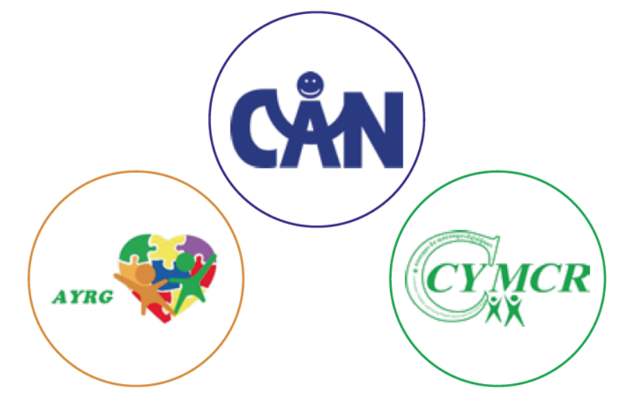 | CRC-Cambodia is coordinating 3 Child and Youth-Led Networks (CYLNs) with the main aim to empower them to work together to influence authorities at different levels and hold them accountable for realising children’s rights:  - Adolescent and Youth Reference Group (AYRG)  - Cambodia Children and Young People Movement for Child Rights (CCYMCR) and  - Child Advocacy Network (CAN).
 | ActionAid International Cambodia (AAC), established as a full Country Programme in 2004, strives for a world where everyone enjoys dignity, prosperity, and freedom. We're a global justice federation working to achieve social justice, gender equality and poverty eradication.
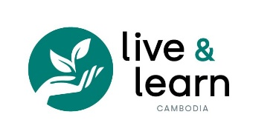 | Founded in 2004 and registered as a local NGO in 2005, Live & Learn Cambodia works with communities in challenging livelihoods, including women, youth, children, people with disabilities and indigenous communities. Our mission is to empower Cambodians with innovative solutions to achieve a sustainable livelihood and environment.

Annex 2
Additional products from the process of work on this input thanks to the fruitful consultations with girls.
Child Friendly Report - Results of the Consultations with Girls, Jan-Feb 2024
- English Version 27 Feb EN CFV Report.pdf
- Khmer Version: Jamboard
Fact Sheets - Developed based on the CRC-Cambodia’s UPR Template:
- Girls’ Education and Climate Change
- Girls Participation in Decision-Making Processes

Annex 3
Climate Change Impact on the life and environment of an indigenous girl from Cambodia.
Anonymised statement/testimony of a girl from Cambodia given in a public event related to climate change and violence against children in 2022.

I live with my parents in a rural area located at the northeast of Cambodia on the border shared with Lao far away from the capital of Cambodia.
[The] majority of the population [in Cambodia], including different ethnic groups live in rural parts and depend on agriculture for their source of income. The wet season is oppressive and overcast, the dry season is muggy and partly cloudy, and it is hot year-round.
My parents are farmers, they grow some crops such as rice and cashew nuts.
Currently, I’m studying in grade 11. I am also a member of a child club.
Our living conditions are poor. Sadly, a seasonal drought and flooding has destroyed our crop and that eventually made us poorer and in debt.
Because of all this, my father started to drink alcohol and always argue with my mother. It has become his habit.
I remembered that four years ago, during the rainy season, there was flooding that destroyed all of our crops. My father was very sad and stressed. He ended up drinking alcohol, fighting with my mum and using violence against me and my siblings. He cursed me and blamed me for something I didn’t know, and I didn’t do, again and again.
I felt very sad and almost couldn’t stand it. It affected my physical and emotional wellbeing.
I decided to stop going to school so that I could work to support the family and to pay our debt.
I was one of the lucky ones. A focal person from the Commune Committee for Women and Children (CCWC) and a local organisation reached out to my family and spoked to my parents about the value of education, positive parenting, and how to build a good future for children.
With some guidance and support from local authorities, especially the focal person from the CCWC, my parents decided to stop me from working and instead send me to a vocational skill training center run by the Department of Women Affairs at the provincial town. I learned different life skills and attended a sewing class at that center.
I also received some financial support. I received almost 13$ per week from the local organization.
I sent the money to my parents so that they can spend it on any necessity and pay off debt.
Sometime after, my brother talked to me about whether I would like to continue my studies or not. Since I still want to study, I finally decided to continue my study in grade 8 until now, I am currently in grade 11.
Since I am also a member of the Child Club, I have had the opportunity to attend different meetings and trainings.
I learned different topics such as Getting to know myself, Women in leadership, Reproductive health, Child protection, Violence against children, and Child rights. I am able to share what I have learned among my child club members and other children in the community, especially on child rights and how to protect themselves from violence and other abuse.
My father also started attending different training courses and gained better knowledge about child protection, child rights, violence against children, disaster, and climate change. As a result, I am happy to say that now, my father has stopped drinking alcohol and never commits any violence against us. He loves the family, encourages us to study hard, and always spends time listening to us about our studies. Now he has started using his new skills and adapting his plantation based on the season.
I would like to take this opportunity to call on everyone to act together to stop all violence against children and girls, during normal times and/or when there is a disaster. There can’t be any excuse for violence. I would also like to call on everyone, especially governments and parents, to send their children to school and continue educating them in positive ways so that children can grow up healthy.

Annex 4 Reference list
2005 Ministry of Environment (MoE) and Live and Learn: Cambodia’s Environmental Education Status report. Online: https://livelearn.org/assets/media/docs/resources/Cambodia_EnvEdu_report.pdf
2011 Lundy L. & McEvoy L.: Children’s rights and research processes: Assisting children to (in)formed views. Online: https://journals.sagepub.com/doi/abs/10.1177/0907568211409078
2013 Ministry of Education, Youth and Sport (MoEYS): Local Life Skills: Environmental Issues. Online: https://drive.google.com/file/d/1YwJoWo3YdK2TxYcBMah9Eqx3LZJ5KJzU/view?usp=sharing
2015 Nich Chea: Higher Education in Cambodia: Poor Rural Female Students' Challenges, Motivations and Coping Strategies. Online: https://gupea.ub.gu.se/bitstream/handle/2077/39995/?sequence=1
2016 Ministry of Education, Youth and Sport (MoEYS): National Minimum Requirement Guidelines on Water Sanitation and Hygiene in Schools. Online: http://www.fitforschool.international/wp-content/ezdocs/Minimum_Requirements_on_WinS_in_English_v_022017.pdf
2019 VVOB: The role of gender-responsive pedagogy to tackle violence against and between children in Cambodian schools. Online: https://cambodia.vvob.org/sites/cambodja/files/the_role_of_genderresponsive_pedagogy_to_0.pdf
2020 Royal Government of Cambodia (RGC): Updated Nationally Determined Contribution (NDC). Online: https://unfccc.int/sites/default/files/NDC/2022-06/20201231_NDC_Update_Cambodia.pdf
2020 Ministry of Environment (MoE), National Council for Sustainable Development (NCSD): A Third Study on Understanding Public Perception of Climate Change in Cambodia: KNOWLEDGE, ATTITUDES, AND PRACTICES (KAP3). Online: https://ncsd.moe.gov.kh/resources/document/KAP3_EN
2021 Ministry of Education, Youth and Sport (MoEYS), Ministry of Environment (MoE) and VVOB: Eco-School Handbook to implement green school guidelines. Online - Khmer Version Only: https://cambodia.vvob.org/kh/download/eco-school-handbook-implement-green-school-guidelines
2021 Chen T., Thau S. and Pel P.: Safe school programs and disaster risk reduction in hazard-prone primary schools in Cambodia. Online: https://rupp.edu.kh/CJBAR/files/Vol-3-Issue-2/8-PP-Vol3-Issue2.pdf
2021 UNICEF: The Children’s Climate Risk Index (CCRI). Online: https://data.unicef.org/resources/childrens-climate-risk-index-report/
2022 National Institute of Statistics (NIS), Ministry of Health (MoH) & The DHS Program: Cambodia Demographic and Health Survey 2021-22. Online: https://dhsprogram.com/pubs/pdf/FR377/FR377.pdf
2022 OECD: PISA 2022 Results Factsheets Cambodia. Online: https://www.oecd.org/publication/pisa-2022-results/webbooks/dynamic/pisa-country-notes/371ebd4a/pdf/cambodia.pdf
2022 UNICEF Cambodia: Menstruation is Part of Life and Should be Treated as Such. Online: https://www.unicef.org/cambodia/stories/menstruation-part-life-and-should-be-treated-such-0
2022 UN Committee on the Rights of the Child; Concluding observations on the combined fourth to sixth periodic reports of Cambodia. Online: https://tbinternet.ohchr.org/_layouts/15/treatybodyexternal/Download.aspx?symbolno=CRC%2FC%2FKHM%2FCO%2F4-6&Lang=en
2022 UN Special Representative of the Secretary-General on Violence Against Children (SRSGVAC) The Climate Crisis and Violence Against Children. Online: https://violenceagainstchildren.un.org/sites/violenceagainstchildren.un.org/files/the-climate-crisis-and-violence-against-children.pdf
2022 Women Peace Makers (WPM): Making the Space. Voices from the girls of Cambodian minority communities. Online: https://wpmcambodia.org/wp-content/uploads/2022/04/makingthespace.pdf
2022 Wright W.E., Boun S. and Chan V.: Implementation of multilingual mother tongue education in Cambodian public schools for indigenous ethnic minority students. Online: https://www.degruyter.com/document/doi/10.1515/eduling-2022-0002/html?lang=en
2023 Cambodia Development Research Institute (CDRI): Gender Gap Reversal in Learning and Gender-Responsive Teaching in Cambodia. Online: https://cdri.org.kh/storage/pdf/Wp141_Gender%20Gap%20Reversal%20and%20GRP_1690449269.pdf
2023 CRC-Cambodia: Fourth Universal Periodic Review (UPR). Submission on the Child Rights Situation in the Kingdom of Cambodia. Online: https://drive.google.com/file/d/1lEdknGyaN5aeilUzseVFvOorqHORkZvP/view?usp=drive_link
2023 Morn M., Vongchanh K. and Chan S.: Descriptive Results of the Preliminary Design Approach of the Survey on Heat Stress Among Primary School Students in Cambodia. Online: https://www.jetir.org/papers/JETIR2310339.pdf.
2023 Ministry of Education, Youth and Sport (MoEYS). Safe School Guidelines. Online: https://drive.google.com/file/d/1Uz87n8dtsnPmDwFyIfznbdu-EORl5DKX/view?usp=sharing
2023 NGO-CEDAW: Monitoring Report for 2022. Online: https://ngocedaw.org/wp-content/uploads/2023/12/2022-CEDAW-Monitoring-Report-EN.pdf
2023 Plan International: Real Choices, Real Lives. Climate Change and Girls Education_Synthesis Report. Online: https://plan-international.org/uploads/2023/11/Climate-Change-and-Girls-Education_Synthesis-Report_Nov2023_.pdf
2023 Sahmakum Teang Tnaut​ Organization (STTO): Environmental Issues and urban poor communities: A Comparative Study of Awareness, Perceptions and Solutions. Online: https://teangtnaut.org/environmental-issues-and-urban-poor-communities-a-comparative-study-of-awareness-perception-and-solutions/
2023 UN Committee on Economic, Social and Cultural Rights (CESCR): Concluding observations on the second periodic report of Cambodia. Online: https://tbinternet.ohchr.org/_layouts/15/treatybodyexternal/Download.aspx?symbolno=E%2FC.12%2FKHM%2FCO%2F2&Lang=en
2023 UN Committee on the Rights of the Child (CRC): General comment No. 26 on children’s rights and the environment with a special focus on climate change. Online: https://www.ohchr.org/en/documents/general-comments-and-recommendations/crccgc26-general-comment-no-26-2023-childrens-rights
2023 UNICEF Cambodia: An Analysis of the Situation of Children and Adolescents in Cambodia. Online: https://www.unicef.org/cambodia/media/7286/file/SITAN%20Cambodia%202023.pdf
2023 UNICEF Cambodia: Education Case Study. Schools as Platforms for Climate Change Education. Online: https://www.unicef.org/media/138731/file/Schools%20as%20platforms%20for%20climate%20action%20(Cambodia).pdf
2023 UNICEF Cambodia: National Workshop to develop a Climate Rationale for WASH Services in Cambodia. Online: https://www.unicef.org/cambodia/media/7956/file/Workshop%20report%20Climate%20Rationale%202023.pdf

