Call for Input: Report on how climate change can have an impact on the realisation of the equal enjoyment of the right to education by every girl

Introduction

This comprehensive analysis explores the intertwining relationship between the impacts of climate change and the equal enjoyment of the right to education for every girl in Jordan. This issue must be treated as threefold. Firstly, there is the question of environmental degradation and harmful impacts of climate change. In the context of Jordan this mostly takes form as droughts, extreme temperatures, flash floods and storms which are all direct consequences of climate deregulation. Secondly, we must analyse the gender paradigm of climate change. Research demonstrates that women are more vulnerable to climate catastrophes than men. Thirdly, comes the question of the equal enjoyment of the right to education. By addressing the points given in the annex we will observe how Jordan suffers from a reduction in female participation in education and how climate change plays a role in this.

Jordan is the fifth most water scarce country in the world with its population having access to an average of 100 cubic metres of water per capita each year, well below the 500 cubic metre water scarcity level. Climate change has only further escalated this issue making it more difficult especially for rural households to access water. It is predicted that by 2025 the access to water will fall to 90 m3 per capita.[1] In the last decades Jordan has also suffered an irregularity in precipitation patterns further stressing agriculture. These consequences of climate change, which also include a rise in severe flooding and landslides, disproportionately affects the poorest the most since they have less economic means to be resilient to these devastating climate events. This is especially the case in Jordan whereas the rural poor are the most impacted by droughts and water scarcity.[2] What a research brief published by the UNFPA Jordan also demonstrated was that as well as affecting disproportionately the poor, climate change affects disproportionately women over men. One of the reasons is that women constitute 70% of the population living in absolute poverty[3], and another is due to the specific issues faced by women worsened during climate related instabilities.

One of the ways in which women are affected more by men in Jordan is in relation to education and their equal enjoyment of the right to education. We will look here specifically at primary and secondary schools and the availability, accessibility, acceptability and adaptability of these schools to girls living in Jordan and how these have been affected by climate deregulation.

Data regarding primary and secondary enrolment in Jordan is not very reliable and there are not enough statistics produced on this question. Nonetheless, this call for Input will mostly rely on the data of the World Bank that was collected from the UNESCO Institute of Statistics. This data states that in 2004 92%(net) of girls were enrolled in primary school in Jordan. In 2018 (the latest statistic) this number had fallen to 80%. Although the trend is similar when including enrollment of boys in primary education it still shows a significant drop of school attendance for girls in this timeframe. In terms of secondary school enrollment the World Bank identified that in 2004 the net rate was 80% and this fell to 63% in 2018[4]. In terms of completion rate of lower secondary the rate fell to 83.1%. We must be conscious that there is no available data regarding the enrollment rates now or in recent years and thus it may not accurately represent the enrollment rate of girls in Jordan today. Therefore, there is a significant need for more accurate and precise data to be produced regarding this question. There must also be data that looks at which parts of society are the least enrolled such as rural compared to urban statistics, whether students are Jordanian or Syrian or Palestinian refugees, but also whether areas with higher water scarcity suffer from lower levels of attendance.

Nonetheless, with regards to this data, the question now poses regarding why has there been such a significant fall in female school enrollment rates in Jordan in the last 20 years.

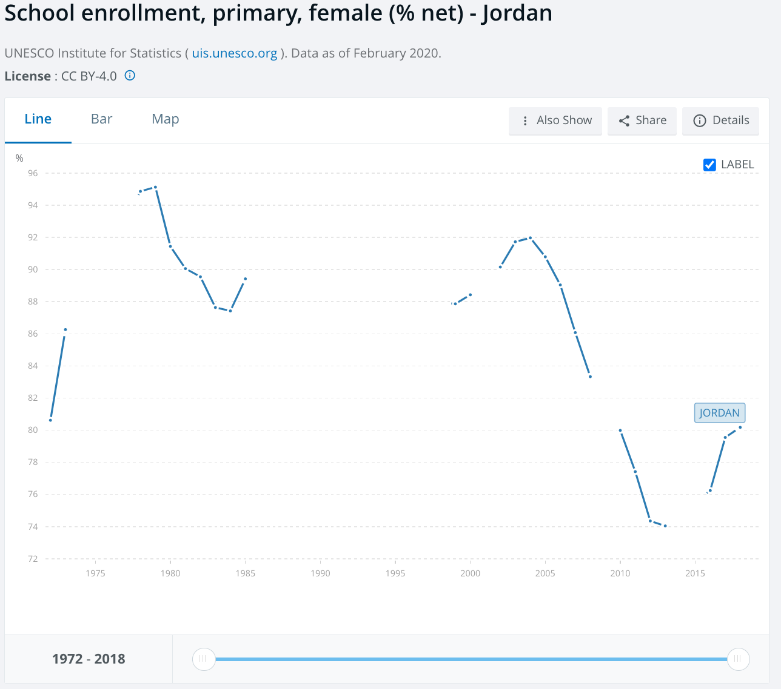

Data From World Bank

An inequality in the right to education in Jordan can be mostly explained by societal norms and different negative coping mechanisms to external phenomenons such as climate change. Still today Jordan society is still very detrimental to women’s rights maintaining them in a marginal position with strict gender roles. This is one of the main reasons for why the participation of women in the labour force in Jordan is 14.7% as of 2022 compared to 62.5% for men. Even though more women than men complete upper secondary school and higher education this does not result in a woman having more access to the official labour force. They are still confined to domestic and caretaking roles or to informal work. This has the effect of lack of incentives for families to invest in their daughter’s education compared to their son’s. This is especially the case for poor households for whom it is an economic strain to send all their children to school due to lack of transportation as well as the absence of the potential domestic and informal and unpaid work that the daughter would have done if out of school. In Jordan and in the region a very common negative coping mechanism of economic difficulties is child marriages. Although, according to the 2010 Personal Status Law the legal age of marriage is 18, judges in Shari’a courts can approve marriages from the age of 15.[5] As of 2021 more than 25% of children are married before the age of 18 and around 10% before the age of 15.[6] This number is even higher for Syrian refugees for whom it reaches more than 30%.[7] It is shown that the Syrian civil war has significantly aggravated the number of child marriages among those still living in Syria as well as refugees. There are significant studies demonstrating how instabilities whether they be political, social, economical or environmental provoke a rise in child marriages. These child marriages are the highest reason for school dropouts.[8] Thus we must here highlight the importance that this phenomenon has in the link between instabilities, possibly caused either directly or indirectly by climate change. We strongly recommend the Office of the High Commissioner of Human Rights to give utmost importance to this link and to focus on ways to both prevent child marriages happening in the first place and provide spaces to accompany girls in situations of marriage to continue their education. In terms of the role of the Jordanian government, they should increase the availability as well as adaptability of the education system to ensure that sending their daughter to school does not endure a financial burden on the household as well as ensuring that girls have access to quality education permitting them to join the labour force after graduation.

Another reason identified by UNICEF that causes girls to drop out from education is a lack of adequate infrastructure especially in regards to sanitation. Only one third of all schools in the Kingdom have basic sanitation and it is considered as the second worst country in the MENA region in terms of coverage of basic sanitation in schools.[9] In 2017 the government put in place a program called WASH to introduce requirements and guidelines for schools however there are still many schools that do not meet these requirements.[10] Schools suffer from a severe lack of water as well as bathrooms that are clean and separate for girls and boys. The lack of such infrastructure is even more present in the governorates of Irbid and Mafraq which experienced a large influx of refugees from Syria. These are also governorates with low access to water, 11% of schools receive water 4 times a month or less. The impact this lack of infrastructure has on girls is for the most part linked to menstruation. Due to the lack

of gender specific and clean toilets as well as reliable access to water, adolescent girls face very difficult conditions during their period with many missing a few days of school a month as a consequence. In 2019 UNICEF interviewed young girls who talked about the “anxiety of changing a period pad in her school’s unisex bathroom” and how many of them would miss up to a week a month of school thus falling behind in class.[11] Of course we must take into account the societal factors which make it impossible for girls to talk about menstruation to their teachers. Nonetheless the scarcity of water exacerbated by climate change worsens the ability for girls to access adequate sanitation in schools and in consequence reduces their presence and results in some dropping out.

In conclusion, the Ministry of Education of Jordan must ensure a development of the adaptability and availability of schools to meet the needs of female students as well as reducing the cost of education. There must also be an inclusion of this need for school’s adaptability in Jordan’s Climate and Water Strategies.

Bibliography

Jordan News | Latest News from Jordan, MENA. “School Dropout Is Higher among Girls — Ex-Minister - Jordan News | Latest News from Jordan, MENA,” October 16, 2022. <https://www.jordannews.jo/Section-106/Features/School-dropout-is-higher-among-girls-ex-minister-23219>.

Jordan Times. “Study Highlights Link between Child Marriage and High School Dropout Rates among Girls,” March 18, 2023. <https://jordantimes.com/news/local/study-highlights-link-between-child-marriage-and-high-school-dropout-rates-among-girls#:~:text=The%20highest%20reason%20cited%20for,education%20at%2012%20per%20cent>.

Jordan Times. “Climate Change to Hit Impoverished Jordanians the Hardest, Streamlining Funding Process Vital to Build Resilience,” September 6, 2022. <https://jordantimes.com/news/local/climate-change-hit-impoverished-jordanians-hardest-streamlining-funding-process-vital#google_vignette>.

Jordan Times. “Child Marriage on the Rise Again — Survey,” January 20, 2021. https://jordantimes.com/news/local/child-marriage-rise-again-%E2%80%94-survey.

Jordan Times. “UNICEF Warns of Impact of Water Scarcity on Children’s Well-Being,” July 11, 2021. https://www.jordantimes.com/news/local/unicef-warns-impact-water-scarcity-childrens-well-being#google_vignette.

“National Water Strategy 2023-2040.” Jordan: The Ministry of Water and Irrigation, 2023. https://www.mwi.gov.jo/EBV4.0/Root_Storage/AR/EB_Ticker/National_Water_Strategy_2023-2040_Summary-English_-ver2.pdf.

“QRF FACT SHEET GENDER AND EDUCATION IN JORDAN.” Jordan: Queen Rania Foundation, May 2018. <https://www.qrf.org/sites/default/files/2019-07/gender_and_education_in_jordan_en_condensed.pdf>.

ReliefWeb. “Understanding the Social Processes Underpinning Child Marriage: The Impact of Protracted Displacement in Jordan January 2020 - Jordan,” October 9, 2020. <https://reliefweb.int/report/jordan/understanding-social-processes-underpinning-child-marriage-impact-protracted>.

UNFPA Jordan. “Climate Change and Gender-Based Violence in Jordan.”, 2022. https://jordan.unfpa.org/sites/default/files/pub-pdf/unfpa_research_brief_on_gbv_and_cc_final_march_8_0.pdf.

UNICEF Jordan. “Water Stress in Jordan - Executive Summary,” n.d. <https://www.unicef.org/jordan/water-stress-jordan-executive-summary>

UNICEF Jordan. “WASH in Schools,” n.d. https://www.unicef.org/jordan/water-sanitation-and-hygiene/wash-schools.

UNICEF Jordan. “Breaking the Cycle of Silence - Menstruation Matters,” n.d. <https://www.unicef.org/jordan/stories/breaking-cycle-silence-menstruation-matters>.

World Bank Open Data. ‘World Bank Open Data’. Accessed 25 February 2024. <https://data.worldbank.org>.

1. “National Water Strategy 2023-2040.”
2. ‘Climate Change to Hit Impoverished Jordanians the Hardest, Streamlining Funding Process Vital to Build Resilience’
3. “Climate Change and Gender Based Violence in Jordan.” p.3
4. ‘World Bank Open Data’
5. “Understanding the Social Processes Underpinning Child Marriage: The Impact of Protracted Displacement in Jordan January 2020 - Jordan.”
6. “Child Marriage on the Rise Again — Survey.”
7. Ibid.
8. “Study Highlights Link between Child Marriage and High School Dropout Rates among Girls.”
9. “WASH in Schools.”
10. Ibid.
11. “Breaking the Cycle of Silence - Menstruation Matters.”