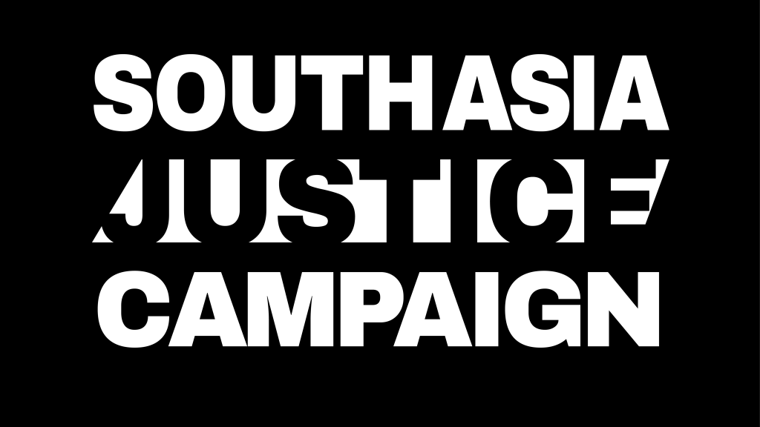
2nd February 2024
South Asia Justice Campaign (SAJC) welcomes this opportunity to contribute to the Special Rapporteur on the Right to Education’s upcoming report to the 56th HRC academic freedom and freedom of expression in educational institutions.
This submission focuses on India, which has witnessed a steady deterioration in democratic performance besides in the human rights of religious minorities and dissenters under the current majoritarian Bharatiya Janata Party (BJP)-led government. Academic freedom too has seen a decline in India, with the country being among the bottom 30% on Academic Freedom Index, covering 179 countries.
General framework
1. How is academic freedom defined and protected in the constitution or laws of your country, and what are possible limitations or restrictions? Please provide the original citation and source, as well as a summary of relevant judicial practice, if any.
Academic freedom is not defined in Indian law or Constitution, and does not find a mention in State legislation, and is broadly perceived as a “subset of the constitutionally guaranteed freedom of speech”. Education is the joint responsibility of the central government and state governments, as a result a plethora of central and state legislations related to education exist, none guaranteeing Academic Freedom and only one state legislation mentioning it. Scholars assert that the jurisprudence of academic freedom is extremely limited in India. India endorsed ICESCR in 1979 and the exceptions specified by the Indian Government do not include any under Article 15.3. India is committed to the provisions of the article, as also to the General Comment No. 25 issued in April 2020, though none of the principles enunciated in these documents, or indeed in the UNESCO declaration of 1997, are referenced in the laws and regulations governing higher education in India. .
Scholars have studied three key policy documents to eke out the notion of academic freedom in India. These are the University Education Commission Report 1949, The National Education Commission Report 1966, and The Yashpal Committee Report on Higher Education 2009.
Article 19 of the Constitution of India which is about freedom of expression is not an absolute law. It is limited by caveats on criminalisation of obscenity (Section 292), acts intended to hurt religious sentiments (Section 295A), and speech that promotes enmity between religions (Section 153A) and sedition (Section 124A). Sovereignty and integrity of the country is often invoked to limit freedom of expression (Kamdar,2018). These laws tend to form the “backbone of India’s current apparatus of censorship” (Acharya, 2016, p.158). For sedition charges to be proved no ‘conspiracy to use force’ needs to be proved. Section 124A considers spoken and written words or signs that bring or attempt to bring “hatred or contempt” towards the government (“Section 124A: The Most Anti-National Thing”, 2019) as sedition. Section 124A was invoked by the ruling BJP party to arrest student leader Kanhaiya Kumar in 2016, as well as to file a complaint against Amnesty International in 2019 (“JNU Sedition Case,” 2019; “Sedition Case Against Amnesty,” 2019).
Some studies have argued that in order to safeguard academic freedom in India, certain
specific sections within the Indian Penal Code (Section 124A, Section-153A, Section-292, Section-295A) should either be repealed or reformulated so that they are not amenable to misuse by the government. Recently, the entire Indian Penal Code has been replaced by a new code which largely perpetuates these punitive provisions.
In May 2018, the UGC issued a controversial directive, requiring universities to follow the Civil Service Conduct Rules for their employees (UGC F.No. 22-9/2017(CU), 1 May 2018) despite the existence of judicial ruling (Dr. Suchitra Mitra and Another v Union of India) stating that teachers are not civil servants, and associated regulations do not apply to them. This regulation hinders teachers’ capacity to express criticism against the government and its policies or write, speak, or publish without permission, and any political permission beyond voting is prohibited. Facing pushback from academics, the government clarified its position, stating that these rules will not be implemented in universities with its own ordinances, but the UGC order remains.
2. Are academic staff, teachers, students all entitled to academic freedom? Does this differ by level of education? Please explain.
The University Education Commission Report-1949 clearly states the need to “resist the trend towards government domination of education process” and urges state-aid not to be confused with “state control over academic policies and practices” (Radhakrishnan, 1962, p.42). All the three reports emphasize the need for teachers to have the freedom to teach the subject matter of their choice, speak and write about significant national and international issues (no matter how controversial), and view any attack on free speech and dissent within universities as distorting the idea of what a university stands for (Kothari, 1970; Radhakrishnan, 1962; Yashpal Committee Report, 2009).
Most of these reports which discuss academic freedom talk only of teachers in higher education i.e. university and college teachers. The only students whose academic freedom is mentioned are research scholars. There is little discussion or indeed controversy on academic freedom of school level teachers.
3. What do you consider to be (a) the main challenges to academic freedom, and (b) gaps in the legal framework for protecting academic freedom?
Apart from what has been mentioned above the main challenges to academic freedom emanate from:
- Centralization:
- The Ministry of Education and the University Grants Commission (UGC) exercise a great influence on higher education, as heads of public universities are selected by the government and indicators determining recruitment and promotions are determined by the UGC, alongside designing model syllabi and conducting examination to allocate doctoral research funding. The UGC possesses disciplinary and punitive powers over public and private universities, and acts as a regulator to maintain uniformity in teaching, examination, research and curricula.
- Bureaucratization
- Opacity in faculty hiring and career advancement (promotions) processes. These are often used to put in place an unofficial system of punishment against those exercising academic freedom and rewarding those who toe the government or official lines.
- Misinterpretation of institutional autonomy to mean that university administrations get an inordinate amount of control over academic decisions and regulate the same without consultation with teachers or students
- Precarity of academic employment (contract employment) and funding restrictions putting pressure on professors to perform all of their tasks threaten academic freedom

- Politicization: the decline of academic freedom in recent years is correlated to the erosion of democratic freedoms, and overall targeting of criticisms against the current majoritarian Bharatiya Janata Party government. As such:
- University teachers would like the protections that government servants enjoy (like security of tenure) as a pre-condition for academic freedom but the restrictions on speech of government officials cannot be imposed on them. However in many instances, universities have been forced and have succumbed to adopting Central Civil Services (Conduct) Rules, 1965 (CCS Rules) for teachers too. This includes severe restrictions/penalties on critiquing government programmes and policies. There is a lack of legal clarity in the terms of employment vis-a-vis conduct rules in public universities. Academics and professors are being sacked, suspended, or forced to resign for being critical against the government, expressing dissenting views against the establishment, or belonging to a minority community. Involvement of academcis and university staff in on-site activism (peaceful demonstrations or protests) attracts punitive measures from university administration such as a disciplinary order, refusal to approve taking up fellowships abroad, denial of sabbatical leave or promotion, in some cases, holding back retirement benefits.

- The student wing of the Bharatiya Janata Party, Rashtriya Swayamsevak Sangh (RSS)- affiliated Akhil Bhartiya Vidyarthi Parishad (ABVP) is a radical organisation that is often at the forefront of attacks against academics critical of majoritarian/cultural nationalist agendas. They have been known to police syllabi of text-books, conference agendas and other cocurricular/corporate life on campus. This also includes censoring menus and culinary choices on campus to follow Hindu majoritarian preferences. ABVP is well known for violence against faculty. Their actions in campuses led several academics to be suspended, or forced to resign and change postings:
  - In December 2019, Professor Firoze Khan was appointed to the Sanskrit Vidya Dharma department of Banaras Hindu Central University. ABVP opposed the appointment on the grounds that his religious identity as Muslim made him ineligible to teach Sanskrit, and after reaching a compromise solution, Professor Khan resigned this position to join another department to teach the same subject.
  - Gilbert Sebastien, assistant professor of International Relations at the Central University of Kerala, was suspended in May 2021 after an ABVP complaint contesting his description of the RSS and BJP as ‘proto-fascist organizations’ in an online class.
  - ABVP also exerted pressure to prevent the appointment of historian Ramachandra Guha, as Shrenik Lalbhai Chair Professor of Humanities and director of the Gandhi Winter School at the School of Arts and Sciences at the Ahmedabad University in 2018.

- There is a great deal of pressure which is felt by minority institutions especially Christian and Muslim minority institutions. Legal contestations in St Stephen’s College of University of Delhi, Jamia Millia Islamia (JMI) and Aligarh Muslim University (AMU) offer a lens into the specific challenges faced by these minority institutions. Recent controversies, including debates over curriculum choices, admission policies and entrance exam methods, reservation/affirmative action policies, and faculty/principal or Vice-Chancellors appointments, underscore the intricate dynamic between academic freedom, minority rights, and public expectations.
- Minority universities in states and those run by private entities also face hostile environment. This is exemplified in the case of Jauhar University which has become a target of the Uttar Pradesh government following the government’s tirade against its founder, an opposition politician called Azam Khan.
- Many Muslim teachers have been targeted by ABVP and other affiliated groups in private universities where the administrations have failed to protect them. For example, Sharda University professor who was suspended for a question in exam and Jindal Global University professor for her pedagogy and classroom lecture.
- Harsh vetting process for academics participating in online conferences by the Ministry of External Affairs, and overall denial of visas for scholars coming from countries considered sensitive by India or scholars critical of the government.
- Disruption or cancellation of seminars, lectures, gatherings and film screenings by universities or as a result of ABVP’s mobilization. Examples includes suspension of Professor Rajshree Ranawat (Jodhpur)- for inviting feminist academic Professor Nivedita Menon for a lecture of nationalism (February 2017), in 2019-20, denials of permission by the universities to hold debates on what authorities consider ‘sensitive topics’ i.e Dalit rights, religious rights of minorities, gender, or on specific regions (Northeast, Kashmir, Central India) in anticipation of ABVP’s opposition, and cancellation of the screening of the BBC documentary on the role of PM Modi in Gujarat pogroms (2002), in several universities in 2023
- Use of anti-terrorism laws (Unlawful Activities Prevention Act) and provisions (sedition) to curtail freedom of speech and thought: the colonial-era sedition law has been repeatedly invoked since 2016 targeting students and teachers discussing sensitive topics or regions in India. The UAPA is instrumentalized to target scholars and students involved in human rights work and peaceful protests. Anand Teltumbde, Hany Baby, both defenders of Dalit right and Shoma Sen from the Bhima Koregaon case (2018), alongside students and scholars involved in the anti-Citizenship Amendment Act movement are still in custody and awaiting trial.
Autonomy of educational institutions
4. Please explain the autonomy and self-governance enjoyed by educational institutions at the different tiers of education. Please explain what autonomy and self-governance entail. Are there restrictions on police or military personnel entering educational institutions? If so, please share the rules.
Campus integrity and security is one of the most important aspects of autonomy of educational institutions. There is no legal provision in India which ensures sanctuary status to Indian universities. Despite jurisprudence affirming the principal (Vijaykumar vs State of Kerala, “Considering the college is a ‘temple of learning’, any action of the police inside the college campus shall, as far as possible, be with the knowledge of the principal”, there have been several cases of police violence, against agitating/protesting students on various campuses especially in so called minority university, Aligarh Muslims University and Jamial Millia Islamia.
Funding
6. How is funding, including for research, regulated? Is the process transparent, and are there any guarantees put in place to ensure respect for academic freedom?
There is much skewedness in funding of higher education too. Less than 50% of the central government’s expenditure on higher education is allocated to the central High Education Institutes (HEI) in which 97.4% of students in centrally funded institutions are enrolled. The remaining 51.1% of central government funding goes to so called professional training institutions like the IITs (Institute of Technology) and IIMs (Institute of Management), which account for just 3% of student enrolment. By establishing ‘world class educational institutes’ (UGC 2016) and granting autonomy to certain institutions, that do not fall under the UGC’s purview, the government has created a dual system with some institutions benefitting autonomy that the rest of the universities cannot access as a result of the centralized, standardized and bureaucratic process imposed by the UGC.

Freedom of expression in teaching and access to books
9. Do teachers and professors, at all levels of education, enjoy freedom of expression in their own teaching? Are there any limitations imposed, such as remaining “neutral” or forwarding a particular perspective, e.g. on religious and political matters?
History and Social Sciences faculties have been impacted the most in attempts to curtail academic freedom as both disciplines form the spaces where Hindu nationalist ideology and politics of the BJP and RSS, are played out. Any opposing or critical view are heavily scrutinized to prevent any deviance from their beliefs.
10. Please explain the extent to which teachers and professors at different education levels can choose school manuals and other books/resources for teaching, and the reasons for any restriction in this regard. Have any specific books/materials been banned, including from school libraries, and alternatively is some material mandatory? If so, why?
Some books and articles on Muslims’ contributions to Indian history, Dalits and Adivasis or gender issues have been taken off syllabi under pressure of the ABVP and the NDTF (National Democratic Teachers’ Front).

Roberts Lyer, K., Saliba, I., & Spannagel, J. (2022). University Autonomy Decline: Causes, Responses, and Implications for Academic Freedom (1st ed.). Routledge. https://doi.org/10.4324/9781003306481
Jayal, N.G., 2022. Academic Freedom in India. In University Autonomy Decline (pp. 64-91). Routledge.
The Statement of Objects and Reasons of Karnataka State Universities Act (2000) mentions the need to “confer academic freedom and autonomy conducive for adoption of new methods in teaching, learning and research for achieving eminence and excellence.”

