**Academic freedom and freedom of expression in educational institutions**

**Questions**

**General framework**

1. How is academic freedom defined and protected in the constitution or laws of your country, and what are possible limitations or restrictions? Please provide the original citation and source, as well as a summary of relevant judicial practice, if any.

Russian Federation law protects academic freedom as a part of the freedom of creative work. The Constitution of the Russian Federation, Article 44 (1992, with amendments in 2020) states that:

*1. Everyone shall be guaranteed the freedom of literary, artistic, scientific, technical, and other types of creative activity and teaching. Intellectual property shall be protected by law.*[1]Russia is a federative state, but only 23 of 83 subjects of the Russian Federation have the same article in the regional constitution.[2]

The Federal Law “About Education in the Russian Federation” touched on the question of academic freedom, mentioning the basic principles of education (Article 3):

*9) autonomy of the educational organizations, the academic rights and freedoms of pedagogical workers and students…*

Article 47 of this Law is describing these rights and freedoms in detail. They include

*1) freedom of teaching, free expression of their opinion, freedom from interference in professional activities;*

*2) freedom to choose and use pedagogically justified forms, means, and methods of teaching and education;*

*3) the right to creative initiative, the development, and application of the author's programs and methods of teaching and education within the limits of the implemented educational program, a separate subject, course, or discipline (module);*

*4) the right to choose textbooks, teaching aids, materials, and other means of teaching and education under the educational program and in the manner established by the legislation on education;*

*5) the right to participate in the development of educational programs, including curricula, academic calendars, work schedules of subjects, courses, disciplines (modules), methodological materials, and other components of educational programs;*

*6) the right to conduct scientific, scientific-technical, creative research activities, participate in experimental and international activities, developments, and implement innovations."*[3]

Because constitutionally, academic freedom is defined within the freedom of expression, constitutional restrictions of academic freedom are the same as freedom of speech, which is guaranteed p. 1, Article 29 of the Constitution of the Russian Federation. Therefore, there are exclusions from such protection, listed on p.2 of the same article:

*“Propaganda or agitation that incite social, racial, national or religious hatred and enmity are not permitted».* Freedom of research could also be restricted because of security measures: part 2, article 29 of the Constitution of the Russian Federation guarantees freedom of information, but with a restriction regarding state secrets:

*«A federal law shall determine the list of data comprising state secrets»[4]*

Decisions of the Constitutional Court of the Russian Federation on the freedom to teach and study are limited to several questions. Only a few decisions of the Constitutional Court are devoted to this question. The reference to academic freedom could be found in the discussion of university autonomy and the working agreement of the professors.

An important finding is that although academic autonomy is not mentioned in the text of the Constitutional Court, it “*is the fundamental principle of the activities of universities and is one of the legal principles that determine state policy in the field of education and the relationship between the state and universities[5]*. The same position was repeated in the other decision - as a dissent opinion of Judge K. Aranovskiy, where he connects academic autonomy with the protection of academic rights[6]

Most of the legal practice around Russian Academia is concerned with the working contracts and disputes regarding the conditions of the work agreement and its duration. Although all these cases mostly touched on the question of labor law, the Constitutional Court has made critical comments about the academic rights of the faculty. In the Decision on A. Podakov case (2022) Constitutional Court mentioned the peculiarity of the University lecturers’ profession, which is based on the “...creative atmosphere, including due to academic traditions”. The court stated that implementing the constitutional freedoms of scientific creativity and teaching is possible only on the condition of a stable long-term working contract [7]. In the recent case (Alebastrova, 2023), the Court confirmed this position [8]

2. Are academic staff, teachers, and students all entitled to academic freedom? Does this differ by level of education? Please explain.

"The Law 'On Education' enumerates a broad set of rights for teachers, staff, and students. However, the set of rights significantly varies. In the case of teachers and scientific staff, it concerns a full set of rights, understood as academic rights and freedoms – 'the right to teach,' 'the right to research,' 'the right to participate in the management of an educational or research organization,' as well as “the right to criticize the institution” – the place of their work. The rest of the employees of scientific and educational institutions, designated as 'others', do not possess academic rights and freedoms. As for the students, their set of rights significantly differs.

Article 34, Law on Education, consists of a list of the academic rights of students (a total of 29), mostly related to the right to education (a right to choose educational organization, individual plan of education, selection of elective courses), free use of the library and other information resources, right to participate in the research and scientific projects, free scientific publications, also right to

«*Respect for human dignity, protection against all forms of physical and psychological violence, insults to personality, protection of life and health*» and

«*Freedom of conscience, information, free expression of one's views and beliefs*»[9]

Thus, lecturers, research fellows, and students possess academic rights. Still, the content of it is very different.

3. What do you consider to be (a) the main challenges to academic freedom and (b) gaps in the legal framework for protecting academic freedom?

**a)** The challenges stretch from the general, which include: the vagueness of the laws that can indirectly restrict research and teaching and the lack of the rule of law, to those linked directly to how higher education is organised in Russia and in particular its excessive centralisation (universities depend on the state for funding, teaching licenses, accreditation; state institutions also play a significant role in nominating university rectors effectively restricting institutional autonomy). There are also multiple specific laws that may be used to target scholars for undertaking specific research or teaching themes. In particular: the “fake news law”; up to 15 years imprisonment for disseminating “false information about the use of the Russian military” (Criminal Code, 207.3); the “no discrediting of the use of the Russian military” law (Criminal Code, 280.3); support for restrictive mechanisms (e.g. sanctions) punishable under Criminal Code, 284.3; administrative fines for comparing the Soviet Union with Nazi Germany. Specific laws can lso be applied to target entire institutions. For instance the Free University (also known as the Free Moscow University), an online tertiary education platform launched in 2020 smf established in response to academic freedom violations and over-bureaucratisation of the state tertiary education sector (this university’s manifesto declared the enjoinment of academic freedom as its key tenet and offered a course on academic freedom). In 2023, the Prosecutor General's Office of the Russian Federation declared the Free University an “undesirable organization” and - since participation in the activities of such an organization can lead to prosecution - the Free University suspended its activities on the territory of the Russian Federation.

In addition to those, there is the expectation on part of the management of public universities for their academic staff to remain “politically neutral” and for univetrsities to remain “outside of politics”, which boils down to scholars and students being expected not to express political views and/or participate in any political or civic activity. There is also growing fear amongst academic staff of student surveillance of the teaching delivery and content. Taken together, these aspects contribute to creating the atmosphere of fear (for ones job or promotion prospects, for the students and their wellbeing) and result in excessive propensity to self-censor.

**b)** various forms of constitutional legal protection for academic rights and freedoms exist in international practice, particularly within the European educational space. Russia belongs to the type of countries where academic freedom is not present in the Constitution, but its main provisions are outlined in the Education Law.

Nonetheless, it would be possible to improve the situation by protecting academic rights and freedoms and academic autonomy in the legislative sphere.

First and foremost, there is no definition of academic autonomy in the Constitution; the definition by the Constitutional Court, which mentions academic autonomy, does not refer to a specific article of the Constitution, which does not allow for linking academic autonomy to the specific text of the Constitution.

At the same time, no decisions by the Constitutional Court directly address issues of academic freedom and its violations. It is vital to consider that Russia is a federation, and the various federal subjects may have different views on articulating academic freedom and autonomy; however, this difference in the constitutional law of the subjects of the Russian Federation needs to be made present.

Finally, more than the mere listing of academic freedoms in the law is needed to answer the question of who is responsible for their protection in educational institutions, which bodies are responsible for protecting academic freedom, and how this freedom can be protected. In this regard, the Education Law could be improved toward better European and international standards.

**Autonomy of educational institutions**

4. Please explain the autonomy and self-governance enjoyed by educational institutions at the different tiers of education. Please explain what autonomy and self-governance entail. Are there restrictions on police or military personnel entering educational institutions? If so, please share the rules.

The law “On Education in the Russian Federation” defines academic autonomy in Article 28th.

*1. An educational organization has autonomy, which means independence in the implementation of educational, scientific, administrative, financial and economic activities, development and adoption of local regulations following this Federal Law, other regulatory legal acts of the Russian Federation, and the charter of the educational organization.*

*2. When implementing educational programs, educational organizations are free to determine the content of education, choose educational technologies, and choose educational and methodological support unless otherwise established by this Federal Law.*

Russia has 724 universities in total, 213 of which are non-governmental.

Russian universities are legally split into three groups: kazennoye (governmental), budget, and autonomous educational institutions. The first group - the military and some judiciary education and training centers- does not have autonomy and is directly governed by the relevant Ministry, either the Ministry of Defense or the General Prosecutor's office. Most of the Russian universities are budgetary institutions that possess some level of autonomy, mainly in the budget sphere. Autonomous organizations have the highest level of autonomy, but it is about 10 percent of all Russian higher educational institutions. All non-governmental organizations are autonomous organizations as well. All autonomous organizations can develop their charters and create internal governance bodies. Only autonomous organizations have a supervisory board responsible for most management duties; it regulates financial plans, and procurement approves the rector. Autonomous organizations can create their own rules for enrollment, salaries, and financial plans. The previous two groups have a low level of autonomy.

“Kazennoye” (government) cannot own the property, and unspent public funding and all income generated should be sent to the founding ministry. Budgetary organizations use the public funds scheme (since 2015 - based on the KPI rate) as autonomous, but most of the decisions on the budget spending are up to the ministry. Thus, the level of autonomy is different based on the legal type of the institution.

All higher educational institutions should follow the state educational standards in education and establish a minimum wage for employees. Some universities have an exclusive right to establish their own educational standards, allegedly higher than those of federal universities. Also, all Russian universities can select staff and determine the conditions of their hiring.

Academic Councils mainly represent the self-governance of Russian universities. After the educational reforms in 2012, most Russian universities changed their Charters, and the Academic Council lost its previous opportunity to approve the rector's appointment. Some universities - in return for the substantial financial investment from the Russian budget in the frame of academic excellence programs - have decided to substitute the previous procedure of rector election for the rector’s appointment by the Ministry. At the same time, the personnel of the Academic Council was seriously changed, with a decreasing percentage of elected academics and a higher level of managers ex officio. Finally, new Charters of Russian Universities seriously restricted the discretion of the Academic Council, and its participation in the decision-making process has been declined. Nevertheless, academic councils can still participate in the discussion devoted to the content of education (syllabus, new programs) and serve as a final step in the academic selection.

The V-dem Index for Russian institutional autonomy demonstrates that institutional autonomy seriously declined in the last ten years, dropping into the ten years to the minimum for all the time of Russian independence and closer to the situation of the late 80th USSR.

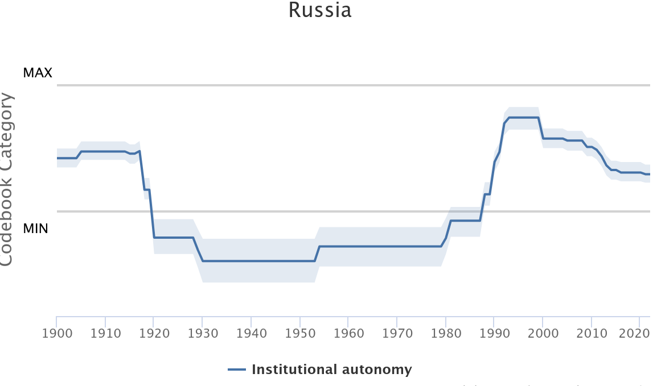

Source - V-DEM 2023[10]

5. Please provide examples of institutional guidelines/codes of conduct developed to ensure respect for academic freedom, including from external public or private actors.

A number of universities adopted ethical codes that touch upon academic freedom. For instance, the ethical code of the Higher School of Economics stipulates that “In expert-analytical and applied research activities, no one, including the initiators and customers of work, can prescribe the methods to be used, predetermine the results and conclusions, no matter in whose interests they are made”.[11] There are no institutional mechanisms, however, to ensure the implementation of those principles. The Tomsk State University’s ethical code emphasises “freedom of creativity” in the pursuit of research, but it does not employ the term “academic freedom”.[12] The ethical code of the Ural Federal University asserts that “upholding academic freedoms” is one of key aims of the code but it does not elaborate on ways to protect university staff from actors willing to transgress those freedoms.[13]

**Funding**

6. How is funding, including for research, regulated? Is the process transparent, and are there any guarantees put in place to ensure respect for academic freedom?

The federal budget remains the main funding source for the Russian HE sector, with region-level funding playing a supplementary role. The state funds a proportion of places at universities (close to 590,000 places in 2022). According to the law adopted on 30 May 2022, the number of those places is to increase by 30%.[14]

Funding for research has increasingly been distributed in the form of grants and open competitions. The Russian Science Foundation (Rossiiskii Nauchnyi Fond) is the main funder. The funding is provided on the basis of open competitions, directed at different categories of researchers. The process of awarding grants seems to be transparent. The information about all the projects supported by the Foundation is available online. However, the Foundation’s regulations do not mention academic freedom or measures to protect it. In addition, given the political situation in Russia since February 2022, it may be expected that certain topics for research are not accepted by the Foundation, but this would take a form of either informal restrictions, or - more plausibly - of self-censorship on the part of scholars applying for funding.

7. Which rules and regulations protect academic freedom from interferences by commercial actors and financial sponsors at different tiers of education? Please explain

Commercial actors and financial sponsors other than the state and state budget have a limited role in the tertiary education sector and research. This is restrictive in and of itself as the state is the dominant player in funding academic activity with limited sources of alternative funding.

**Surveillance**

8. Please explain whether and the extent to which academic staff and students, at all levels of education, are subject to surveillance by public authorities, for example through on-site cameras or online scrutiny. Has this led to undue restrictions to academic freedom and freedom of expression in educational institutions?

Based on the results of an interview-based research (results still unpublished), academic staff in disciplines such as the humanities and social sciences is weary of student surveillance of their teaching delivery and content. In addition, on-site cameras have been placed at most campuses but their reach (whether they are in classrooms) varies across different institutions. One of the most recent examples is the Ufa University, which introduced video surveillance across all university complex, including in lecture halls.[15]

**Freedom of expression in teaching and access to books**

9. Do teachers and professors at all levels of education enjoy freedom of expression in their teaching? Are any limitations imposed, such as remaining “neutral” or forwarding a particular perspective, e.g. on religious and political matters?

The Constitution of the Russian Federation guarantees freedom of expression:

article 29.1 “Everyone shall have the right to freedom of thought and speech.” Freedom of expression can be restricted to protect society from the “propaganda of social, racial, national, religious or language superiority.” The study of every scientific discipline and its professional standards also have specific limits for teachers. Most Russian universities have to follow state educational standards, which limit freedom of teaching in a certain way.[16]

The level of academic freedom as freedom of expression is decreasing in Russia, especially after the annexation of Crimea.

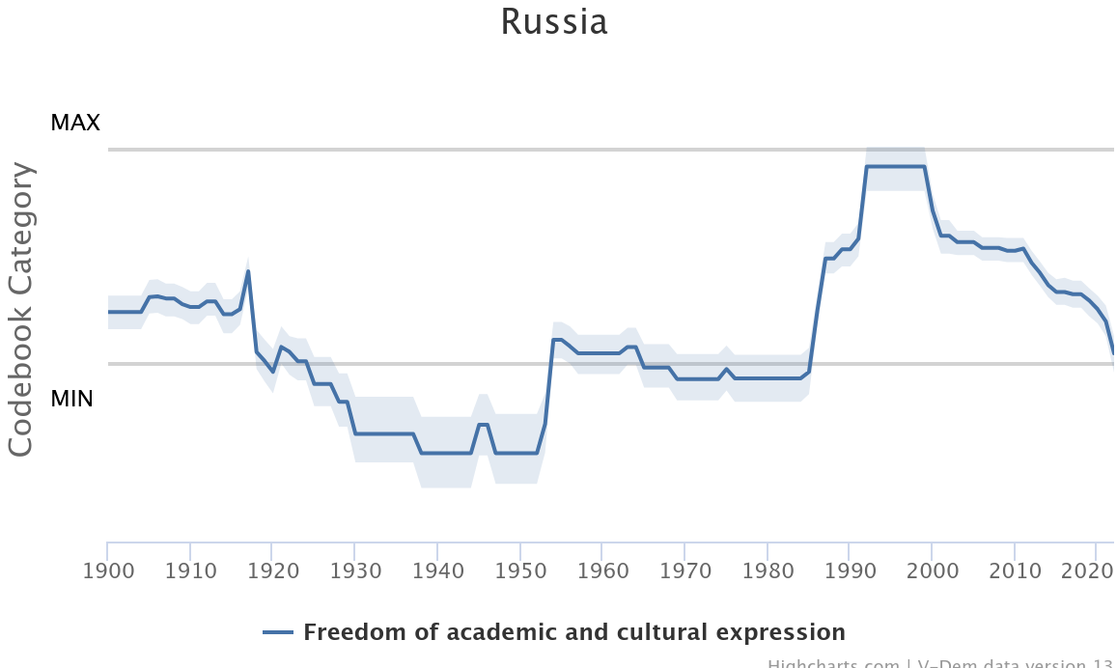

Source - V-DEM 2023

For legal studies, international relations, and political science, it is prohibited to call this action “annexation” - only “reunification”. Everything connected with the Ukrainian crisis had to be thought of only following the official position of the Russian Federation. Russian authority has put substantial pressure on gender studies[17], and LGBT studies is simply impossible in current Russia because of the de-facto re-criminalization of LGBT in the country.[18]

Because of the Russian full-scale aggression against Ukraine in 2022, the new legal restrictions imposed affected academic freedom and severely restricted freedom of speech as well as academic freedom in the country. [19] Numerous students and academics have been persecuted because of their public anti-war protests in the auditorium or on social pages. [20] New mandatory educational courses in history and “bases of the Russian statehood’[21], introduced in 2023, provide a one-sided, non-critical narrative about Russian history, especially - about the so-called “special military operation” (aka full-scale war against Ukraine). Late October 2023 the Russian Ministry of Higher Education and Science has recommended “avoiding open discussion of any negative political, economic, and social trends” in Russia during academic activities[22].

Finally, new amendments to the “foreign agent” law consist of a direct ban on teaching for those who are declared “foreign agents.”

10. Please explain the extent to which teachers and professors at different education levels can choose school manuals and other books/resources for teaching and the reasons for any restriction. Have any specific books/materials been banned, including from school libraries, and alternatively, is some material mandatory? If so, why?. [23]

University lecturers can choose the educational manuals freely. On the contrary, the schoolteachers are in a different situation: Russian legislation consists of conflicting statements concerning this freedom.

Following the Law on Education, all teachers can select educational materials freely. Article 47 of the Law states that

*Teaching staff enjoy the right to choose textbooks, teaching aids, materials, and other means of training and education under the educational program and in the manner established by the legislation on education (clause 4, part 3, article 47 of Federal Law No. 273-FZ “On Education”).*

At the same time, the Ministry of Education approved the “federal list of educational literature,” from which teacher has a right to choose, and schoolteachers have no right to use the educational materials not listed in the official compendium of the Ministry of Education. Besides that, the learn book's variation tends to decrease yearly.

What about HEI, there are books banned if they are published by “undesirable organizations” (i.e., Soros Foundation) either written by “foreign agents” or devoted to the “LGBT,” which is considered as “LGBT-propaganda.” In this case, the University could be punished, as it happened with the European University at St. Petersburg.[24]

1. Constitution of the Russian Federation (as amended up to Federal Constitutional Law No.1-FKZ of March 14th, 2020)<https://www.wipo.int/wipolex/en/legislation/details/21035>
2. Dubrovskiy, Dmitry. Academic freedom in the European Higher Education Area – preliminary observations Academic Freedom in Post-Pandemic World. 2023 OSUN Global Observatory on Academic Freedom. June 2023 <https://www.researchgate.net/publication/373419587_Academic_Freedom_in_a_Post-Pandemic_World>
3. The Federal Law of the Russian Federation of December 29, 2012 No. 273 «On Education in the Russian Federation» (with the amendments entering into force on 01.09.2020) <https://www.consultant.ru/document/cons_doc_LAW_140174/?ysclid=lrt73vq9tx695075902>
4. Constitution of Russian Federation (as amended up to Federal Constitutional Law No.1-FKZ of March 14th, 2020)<https://www.wipo.int/wipolex/en/legislation/details/21035>
5. Postanovlenie Konstitucionnogo Suda RF ot 27.12.1999 N 19-P "Po delu o proverke konstitucionnosti polozhenij punkta 3 stat'i 20 Federal'nogo zakona "O vysshem i poslevuzovskom professional'nom obrazovanii" v svjazi s zhalobami grazhdan V.P. Malkova i Ju.A. Antropova, a takzhe zaprosom Vahitovskogo rajonnogo suda goroda Kazani" [Resolution of the Constitutional Court of the Russian Federation dated December 27, 1999 N 19-P “In the case of verifying the constitutionality of the provisions of paragraph 3 of Article 20 of the Federal Law “On Higher and Postgraduate Professional Education” in connection with complaints from citizens V.P. Malkov and Yu.A. Antropov, as well as a request from the Vakhitovsky District Court of Kazan"] <http://doc.ksrf.ru/decision/KSRFDecision30360.pdf>
6. Postanovlenie Konstitucionnogo Suda Rossijskoj Federacii ot 14 nojabrja 2018 goda № 41-P po delu o proverke konstitucionnosti stat'i 46 Federal'nogo zakona «Ob obrazovanii v Rossijskoj Federacii» v svjazi s zhaloboj grazhdanki I.V. Sereginoj [Resolution of the Constitutional Court of the Russian Federation of November 14, 2018 No. 41-P in the case of verifying the constitutionality of Article 46 of the Federal Law “On Education in the Russian Federation” in connection with the complaint of citizen I.V. Sereginа] <http://doc.ksrf.ru/decision/KSRFDecision363389.pdf>
7. Postanovlenie Konstitucionnogo Suda Rossijskoj Federacii ot 15 ijulja 2022 goda № 32-P po delu o proverke konstitucionnosti chastej pervoj i vos'moj stat'i 332 Trudovogo kodeksa Rossijskoj Federacii v svjazi s zhaloboj grazhdanina A.A. Podakova. [Resolution of the Constitutional Court of the Russian Federation of July 15, 2022 No. 32-P in the case of verifying the constitutionality of parts one and eight of Article 332 of the Labor Code of the Russian Federation in connection with the complaint of citizen A.A. Podakov] <http://doc.ksrf.ru/decision/KSRFDecision621255.pdf>
8. Postanovlenie Konstitucionnogo Suda Rossijskoj Federacii ot 24 oktjabrja 2023 goda № 49-P po delu o proverke konstitucionnosti chastej tret'ej i chetvertoj stat'i 58, chasti vtoroj stat'i 67 i chastej pervoj, vtoroj i devjatoj stat'i 332 Trudovogo kodeksa rossijskoj federacii v svjazi s zhaloboj grazhdanki I.A. Alebastrovoj [Resolution of the Constitutional Court of the Russian Federation of October 24, 2023 No. 49-P in the case of verifying the constitutionality of parts three and four of Article 58, part two of Article 67 and parts one, two and nine of Article 332 of the Labor Code of the Russian Federation in connection with the complaint of citizen I. A. Alabastrova] <http://doc.ksrf.ru/decision/KSRFDecision714551.pdf>
9. The Federal Law of the Russian Federation of December 29, 2012 No. 273 «On Education in the Russian Federation» (with the amendments entering into force on 01.09.2020) <https://www.consultant.ru/document/cons_doc_LAW_140174/?ysclid=lrt73vq9tx695075902>
10. <https://v-dem.net/data_analysis/CountryGraph/>
11. <https://www.hse.ru/info/code-of-conduct#freedom>
12. <https://www.tsu.ru/upload/medialibrary/d5b/codex.doc>
13. <https://urfu.ru/fileadmin/user_upload/common_files/employee/other/Kodeks_ehtiki.pdf>
14. <https://www.universityworldnews.com/post.php?story=2022061011025625>
15. <https://uust.ru/media/eduInfo/1398_29.05.2023.pdf>
16. Platonova, Daria, and Dmitry Semyonov. "Russia: The institutional landscape of Russian higher education." *25 years of transformations of higher education systems in post-Soviet countries: Reform and continuity* (2018): 337-362.
17. Titarenko, Larissa, Elena Zdravomyslova, Larissa Titarenko, and Elena Zdravomyslova. "Gender studies: The novelty at the Russian academic scene." *Sociology in Russia: A Brief History* (2017): 125-140.
18. Russian parliament passes law banning 'LGBT propaganda' among adults. Reuters, November 24, 2022. <https://www.reuters.com/world/russias-parliament-passes-law-banning-lgbt-propaganda-among-adults-2022-11-24/>
19. Milanovic, Marko. Legal Death of Free Speech in Russia. *EJIL: Talk! Blog of European Journal of International Law.* March 8th, 2022.<https://www.ejiltalk.org/the-legal-death-of-free-speech-in-russia/>
20. Dubrovskiy, Dmtiry. Podolskaya, Verena. Rossija: Narushenija akademicheskoj svobody v 2023 godu Cocial'no-politicheskij kontekst i presledovanija uchenyh i prepodavatelej [Russia: volation of the academic freedom in 2023, Social and political context and persecutiion of academics]. CISRUS, 2024. <https://cisrus.org/ru/rossiya-narusheniya-akademicheskoj-svobody-v-2023-godu/>
21. Compulsury Statehood course for all undergrads. University World News. December 17th, 2022 <https://www.universityworldnews.com/post.php?story=20221216145937536>
22. Ministry of Defense. @DefenseHQ. October 29th, 2023. <https://twitter.com/defencehq/status/1718567172807802902?s=46&t=GsMOwID-2MzYTk-2E0jWmw>
23. Russia New restrictions for “foreign agents’. Human rights Watch. December 1st, 2022. <https://www.hrw.org/news/2022/12/01/russia-new-restrictions-foreign-agents>
24. ‘You can resist much more than it seems’ St. Petersburg librarians on Russia’s book bans and the ways they fight back. Meduza, January 5th, 2024. <https://meduza.io/en/feature/2024/01/05/you-can-resist-much-more-than-it-seems>

   