Ms Farida Shaheed
Special Rapporteur on the Right to Education
Office of the High Commissioner for Human Rights – OHCHR
Geneva
Per email: hrc-sr-education@un.org
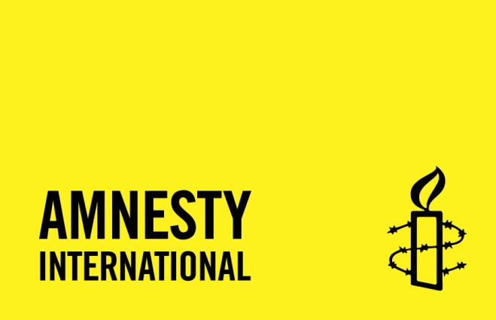
Bern, 27. April 2023
Amnesty International Switzerland's written submission in response to the Special Rapporteur on the right to education questionnaire on the right to education
Dear Ms. Shaheed,
- Amnesty International Switzerland welcomes the opportunity to submit information to the Special Rapporteur on the right to education for her next report on the challenges and opportunities that the Right to Education presents.
- Amnesty International Switzerland has a long-standing human rights education programme in Switzerland targeting schools at the secondary level and teachers’ training institutions for compulsory education.
- Our submission will therefore focus on the implementation of human rights education within the framework of the right to education of children in Switzerland and concentrate on questions 1 and 8 of the Special Rapporteur’s call for contributions’ questionnaire.
Assessing the achievements made by the mandate of the Special Rapporteur on the right to education over the last 25 years
- Question 1: In your country, are education issues approached through the lens of the human right to education, and if so, with what challenges and results? In your view, what is the added value of such an approach in your work?
- For Amnesty International Switzerland, human rights education is an unconditional part of the right to education, both as a stand-alone subject and as a means to develop a human rights culture and perspective in the education system.
- As provided under Art. 29.1 of the Convention on the Rights of the Child (CRC), “education of the child shall be directed to: [inter alia] (a) the development of the child’s personality, talents and mental and physical abilities to their fullest potential; [and] (b) the development of respect for human rights and fundamental freedoms”.
- The Committee on the Rights of the Child further explained that children should not only learn about human rights as a topic, but also learn about human rights through their implementation in practice and by experiencing them in school.
- From our perspective, effective implementation of the right to education from a human rights perspective should therefore systematically and holistically integrate human rights education.
- In Switzerland, this is not yet the case. Interviews with representatives of 13 teachers training institutions (out of the existing 16 institutions in Switzerland) show that while human rights education is included in the framework curricula of the three language regions, teachers are not trained appropriately and generally feel ill-equipped to teach this topic or integrate it in their practice. This lack of training leads to a reluctance from teachers to include human rights topics in schools. There seems to be a common perception that human rights either concern only “other people in other countries” or are a “political issue” which should therefore not be addressed in schools, since these should remain “politically neutral”.
- Fully integrating human rights education as part of the right to education from a human rights perspective would help depoliticise the issue in Switzerland and support a more systematic training of teachers.
Main challenges and crucial issues for the future
- Question 8: In your view, what are the main challenges in your country in implementing the right to education?
- In federal States, such as Switzerland, a key challenge remains the devolved responsibility between the confederation and constituent States e.g. the 26 Swiss cantons, when it comes to human rights obligations and State accountability.
- Art. 62.1 of the Swiss Constitution provides that “The Cantons are responsible for the system of school education.” International recommendations, such as the latest 2021 CRC Concluding Observations on human rights education, which are addressed to the federal level, are often difficult to implement consistently in practice.
- The Special Rapporteur should explicitly recall that international human rights obligations undertaken by federal States fully bind them and that devolution of responsibility regarding the implementation of the right to education to constituent States cannot justify failure to perform.
Best regards,
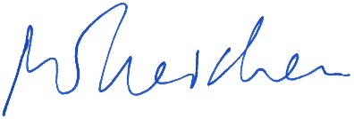
Michael Ineichen
Head of Advocacy

See paragraphs 15, 16 and 19 of General Comment No.1 (2001) on the aims of education of the Committee on the Rights of the Child, CRC/GC/2001/1, 17 April 2001, accessible at: https://undocs.org/CRC/GC/2001/1
See the project report “Strengthening the network of human rights education in Switzerland”, October 2022, conducted by Ms Anja Meyer in collaboration with Amnesty International Switzerland.
Swiss federal Constitution, accessible at: https://www.fedlex.admin.ch/eli/cc/1999/404/en#art_62
See, for instance, para 40 (a) and (b), of the Concluding observations of the Committee on the Rights of the Child on the combined fifth and sixth periodic reports of Switzerland, 22 October 2021, CRC/C/CHE/CO/5-6, accessible at: https://undocs.org/CRC/C/CHE/CO/5-6
See Art.26 of the Vienna Convention on the Law of Treaties and para. 17-21 of the final report of the Human Rights Council Advisory Committee on the “"Role of local governments in the promotion and protection of human rights”, 7 August 2015, A/HRC/30/49, accessible at: https://www.ohchr.org/en/HRBodies/HRC/RegularSessions/Session30/Documents/A_HRC_30_49_ENG.docx

