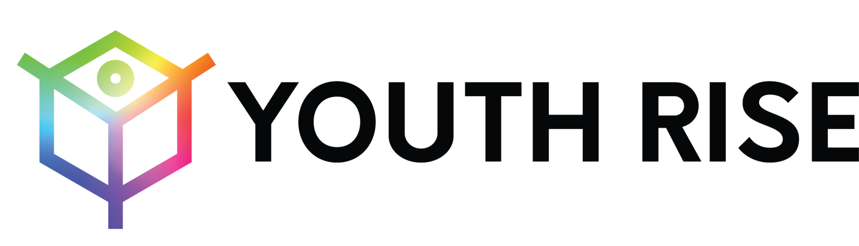

Submission to the United Nations High Commissioner for Human Rights

Human Rights Threats and Violations Suffered by Young People Who Use Drugs

May 2023

Submitting organisation:

Youth RISE (Resources, Information, Support and Education) is an international youth-led network of young people who use drugs and advocate for the rights of young people who use drugs. Youth RISE mobilizes youth to be engaged in full spectrum harm reduction and drug policy reform to promote health and human rights.

Word count: 1496

Contact details for this submission:

Ruby Lawlor, Executive Director
ruby@youthrise.org
106 Esker Park, Lucan, Dublin, Ireland
Introduction
We welcome the opportunity to provide this submission to the UN High Commissioner for Human Rights ahead of its report on human rights challenges in drug policy. While the international drug control conventions aim to protect the health and welfare of humankind, young people are among the most affected by severe, systemic human rights violations, as a consequence of overly punitive interpretations of these conventions. Youth RISE’s submission to the OHCHR details the human rights violations faced by young people who use drugs (YPWUD) as a result of the punitive War on Drugs and other intersecting policies.
Findings
Young people who use drugs (YPWUD) are routinely subjected to the traumas of arbitrary detention, extortion, police violence, torture and ill-treatment in the name of drug control. These measures violate international juvenile justice standards outlined in the Beijing and Havana Rules, which stipulate that the primary goal of juvenile justice should be to divert youth from the criminal justice system. For example, in Tunisia, between 2017 and 2018, the number of convictions under the updated version of Law 52, slightly decreased from 2922 to 2574, but there remains a severe issue of prison overcrowding. From 2017 and 2019, more than half of the people in detention were in preventive detention, including 2504 people in preventive detention related to consumption or traffic of drug use, with an estimated 60% of them for consumption (https://www.asf.be/wp-content/uploads/2021/02/Policy-brief_VF_diffusion-FB.pdf). In Italy, since 1990, over 1,000,000 individuals have been reported to the prefects for cannabis-related offenses. The majority of these reports (72.8%) target cannabis users, with only minimal numbers for other substances. The disproportionate focus on cannabis users raises concerns about discrimination and a lack of proportionality in law enforcement efforts. Furthermore, the number of sanctions has increased significantly, exacerbating the impact on affected individuals, particularly young people (https://filtermag.org/criminalization-italy-marijuana-hash/).
The consequences of a criminal record for young people are life-altering, ranging from discrimination and stigmatization to isolation from family and community, diminished access to education, employment, housing, and well as financial instability, as found in the 2018 report to the Human Rights Council by OHCHR. There is also a disconnect in the age that youth can be convicted/receive a criminal record and the age at which you can access harm reduction (https://idpc.net/publications/2021/04/taking-stock-of-half-a-decade-of-drug-policy-an-evaluation-of-ungass-implementation).
Simultaneously, young people's ability to exercise our right to independent and informed decision-making on our health, free of coercion, violence and discrimination is limited by age of consent laws and the context of punitive drug measures. Available evidence demonstrates that YPWUD are systematically excluded from accessing healthcare services due to unfavorable eligibility criteria including age of consent laws, which determine the age that a person can consent to and access health services. In some countries, YPWUD under the age of 18 cannot access harm reduction services, HIV testing, and SRHR interventions without the consent of their legal guardian. This is troubling, as YPWUD sometimes experience family rejection. Hence, they are discouraged from seeking the health and support services they require. Age of consent policies seek to protect youth, but they pose a barrier to accessing services and may result in poor health outcomes for youth. The situation is particularly bad for adolescent girls and young women who use drugs (YWUD), who are also subjected to gender-based discrimination. Research examining national age of consent laws for HIV testing in Sub-Saharan Africa show a 74% increased likelihood of HIV testing among adolescents between 15 to 18 years in instances where the age of consent for testing is reduced to under 16 years compared to countries where it is 16 years or higher (https://youthrise.org/resources/uhc-report/).
Young people are often forced or coerced into treatment services they do not need, and harm reduction and treatment services tailored to the needs of young people are severely lacking. Further, evidence-based and human rights compliant education on substances and substance use is very limited. Despite their unique risks and needs, young people who inject drugs are highly underserved by harm reduction programs and care services in general. They have difficulties in obtaining information, paraphernalia for safer injection, opioid agonist treatment, HIV testing, counseling and treatment. Criminalization of drug use and stigma further contribute to their fear of accessing services https://youthrise.org/resources/harm-reduction-services-for-young-people-who-inject-drugs/).
The Convention on the Rights of the Child creates an obligation to take all appropriate measures, including legislative, administrative, social and educational measures, to protect children from drug-related harm. As interpreted by the UN Committee on the Rights of the Child, appropriate measures must be rights-compliant, and effective, and include the development of accessible and child-sensitive harm reduction services and drug dependence treatment, providing accessible, appropriate, and evidence-based information to children about drugs, and refraining from criminalizing children because of their drug use or possession of drugs for personal use. Despite this, some states still consider article 33 to support involuntary detention of minors for the purposes of fulfilling their treaty obligations (https://www.cmaj.ca/content/192/5/E121).
Drug prevention based on creating fear, random drug testing in school settings, and expulsion from education for drug use are measures against the International Standards of Drug Prevention, and both the rights of the child and broader human rights standards. A number of countries conduct mandatory drug testing in schools and other educational settings; in many cases, authorities resort to the police to administer such tests. For example, in Sweden at least 4,000 underage people were subject to a drug test in 2019 alone. In some cases, a positive test has led to suspension or expulsion from school. Several studies show that drug testing in schools is an inappropriate response to drug use by students, and can constitute unlawful restrictions on the right to education, as well as a barrier to employment and other life opportunities later in life. According to the OHCHR, mandatory drug testing in educational settings may be inconsistent with the principle of the best interest of the child, and ‘raises human rights concerns’, including a possible arbitrary interference with the child’s privacy and dignity, the violation of their bodily integrity, and, when conducted frequently, degrading treatment. Mandatory drug testing efforts may also be counterproductive, with people switching to less detectable (but sometimes more harmful) substances. A large random study provided evidence that it can be detrimental to effective prevention methods based on building trust between students and teachers, and the UNODC has noted that there is no evidence that drug testing is an effective prevention strategy.307 In addition to drug testing, in some countries it is not infrequent for the police to conduct drug searches in schools – for instance, in Belgium the number of police interventions related to drugs in schools increased more than tenfold between 2007 and 2017, the latter having seen an average of four such interventions per day (https://idpc.net/publications/2021/04/taking-stock-of-half-a-decade-of-drug-policy-an-evaluation-of-ungass-implementation).

The number of women incarcerated for drug offences is increasing, while women access drug services at a very low rate. It’s also important to highlight how YWUD, including young young transgender and gender non-conforming people (https://youthrise.org/wp-content/uploads/2021/08/Young-Women-Who-Use-Drugs-Position-Paper-1.pdf&sa=D&source=docs&ust=1684689881729485&usg=AOvVaw3FnWbp3bL1N07HM2JYsv8b), people of colour, members of ethnic and religious minorities, Indigenous Peoples, sex workers, and people experiencing homelessness are especially vulnerable, and face increased barriers to access health and justice in contexts where their identities are criminalized, oppressed and/or discriminated against (https://youthrise.org/wp-content/uploads/2022/12/Young-Sex-Workers-Who-Use-Drugs.pdf&sa=D&source=docs&ust=1684689899050396&usg=AOvVaw3Ji6_7QgSGZXKcPh3qDXAf).

Recommendations
In light of the above, we urge the UN High Commissioner for Human Rights to provide in his report the following recommendations to Member States and to stakeholders:
- End the criminalisation of drug use. Prohibition creates several obstacles to engaging young people who use drugs in care, and promotes stigma and the violation of human rights;
- Institute strengths-based client-led support programmes for young people who use drugs in need and replace punitive approaches to drug use;
- Remove policies and laws related on age restrictions that affect access to harm reduction services and commodities, SRHR and health care;
- Remove parental consent requirements on health care services, including SRH services, and establish effective confidentiality guarantees;
- Clarify for member states the importance of consent-based drug dependence treatment for minors & their broader obligations to protect children under broader human rights frameworks
- End drug testing and police drug searches in schools;
- Increase the use of alternatives to imprisonment (in line with the Bangkok Rules);
- Expand provision of youth friendly, gender sensitive harm reduction services for young people who use drugs (incorporating comprehensive SRHR, GBV and counselling services attuned to the needs of young women);
- Include YPWUD in the design and implementation of harm reduction services;
- Create frameworks for acknowledging and protecting the rights of young women under-18 who use drugs and are involved in the sex industry and their needs.

