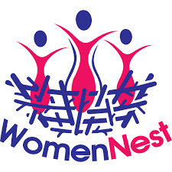
Submission to the United Nations High Commissioner for Human Rights

Title: Kenya Narcotics, Drugs and Psychotropic Substances (Control) (Amendment) Act, 2022: The Continued criminalisation of People Who Use Drugs in Kenya: health injustice!
May 2022

Submitting organisation: Women Nest Kenya
Women Nest Kenya is a non- governmental organisation started and governed by women who use drugs, harm reduction and human rights activists with the mission of empowerment of women who use drugs to achieve health and human rights.

Word count: 1001

Contact details for this submission:
Name: Dr. Catherine Mwangi
Email: catherine.mwangi@womennest.org
Introduction
We welcome the opportunity to provide this submission to the UN High Commissioner for Human Rights ahead of its report on human rights challenges in drug policy. Kenya continues to criminalise people who use drugs and despite advocacy by people who use drugs, harm reduction activists and advocates, in 2022, the President of Kenya signed into law The Narcotics, Drugs and Psychotropic Substances (Control) (Amendment) Act , 2022 which:
- Like the Principal Act, spelled out prison terms and fines for people for using drugs
- Introduced punishment for law enforcement and public service officers for ‘abetting’ crimes related to drugs….It is feared that this will make police, judiciary and other public servants who were already sensitised on harm reduction and were supportive of it, to stop the support in fear of being apprehended as they will be breaking the law by supporting harm reduction.
- Introduces the element of ‘court appointed treatment programme.’ Which takes away the freedom of the people who use drugs to access treatment services of their choice.
Findings
Article 12 of the International Covenant on Economic, Social and Cultural Rights recognises the Right of everyone to the enjoyment of the highest attainable standard of physical and mental health. In Kenya, this Right is domesticated in The Constitution of Kenya 2010, Article 43 (1) (a) which guarantees each Kenyan citizen the right to access the highest attainable standard of health including reproductive health care.
UNAIDS in The Global AIDS Strategy 2021-2026 underscores that people who inject drugs have 29 times higher risk of contracting HIV. The agency also reiterates the role of punitive laws and policies in keeping people away from services and in propagating stigma and discrimination. One of the priority actions is to create an enabling legal environment by removing punitive and discriminatory laws and policies, including laws that criminalize … drug use or possession for personal use.
One of the main challenges that affects Kenya’s Ministry of Health (MoH) and civil society efforts to ensure people who use drugs access harm reduction services, is criminalisation of drug use. Needles and Syringes are distributed by the MoH and civil societies organizations in the backdrop of a criminalising environment which greatly underscores the effectiveness of the program. For example when police raid dens, injecting paraphernalia including needles, syringes, alcohol swabs and others materials are also destroyed as people who inject drugs(PWID) run away from the site. Kenya National AIDS and STIS Control Council (NASCOP) in the Third National Behavioural Assessment of Kenya Populations in Kenya, 2018 reports that overall, 44 percent of PWID had experienced violence from law enforcers while injecting drugs in the six months preceding the study.
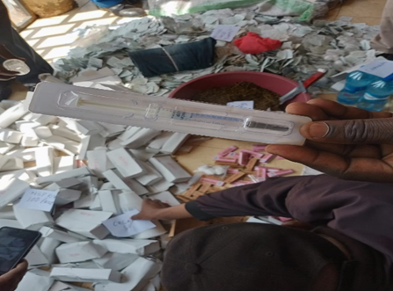
Injecting paraphernalia strewn on the ground in a drug using den after a police raid: Source: Kenya National Police Service Twitter Page: https://twitter.com/NPSOfficial_KE/status/1539861266512191491
With the new amendment of law and maintaining of these penalties for drug use, people who use and inject drugs, will continue to be a ‘hidden population’ which makes achieving 90-90-90 among them a challenge.
The amendment states as follows: 3. Section 3 of the principal Act is amended by deleting subsection (2) and substituting therefore the following new sub-section:
(1) (a) in respect of cannabis, where the person satisfies the court that the cannabis was intended solely for his own consumption, to imprisonment to a term of not more than five years or to a fine of not more than one hundred thousand shillings; (b) in respect of a narcotic drug or psychotropic substance, other than cannabis, where a person is in possession of less than one gram, to a fine of not less than five million shillings, or to imprisonment to a term of not less than five years, or to both such fine and imprisonment; and (c) to, in addition to the sentences in paragraph (a) and (b) respectively, committal to appropriate court appointed treatment programme or to voluntary submission to a rehabilitation programme for a period not less than six months where the court deems fit.
Women who use drugs are the most impacted by the criminalisation of drugs. They not only have higher rates of HIV and HCV but also due to stigma and discrimination (fueled by criminalising laws) their access to Sexual and Reproductive health is limited. They experience Gender Based Violence in the hand of multiple perpetrators including intimate partners, men who use drugs, drug peddlers, casual sex clients, police among others. They hardly ever report these cases due to their extreme vulnerability and fear of arrest for drug use. This evidenced in these research publications https://harmreductionjournal.biomedcentral.com/articles/10.1186/s12954-019-0307-5 https://pubmed.ncbi.nlm.nih.gov/34391389/

Recommendations
UNAIDS in The Global AIDS Strategy 2021-2026 recommends that countries create an enabling legal environment by removing punitive and discriminatory laws and policies, including laws that criminalize … drug use or possession for personal use…
- In light of the above, we urge the UN High Commissioner for Human Rights to provide in his report the following recommendations to Member States and to stakeholders:
  - Decriminalisation of drug use and possession for personal use for achievement of the right to health by people who use and inject drugs
  - Remind member states that women who use drugs are most disproportionately affected by criminalisation of drugs and that punitive drug laws entrench and aggravate gender inequality.

