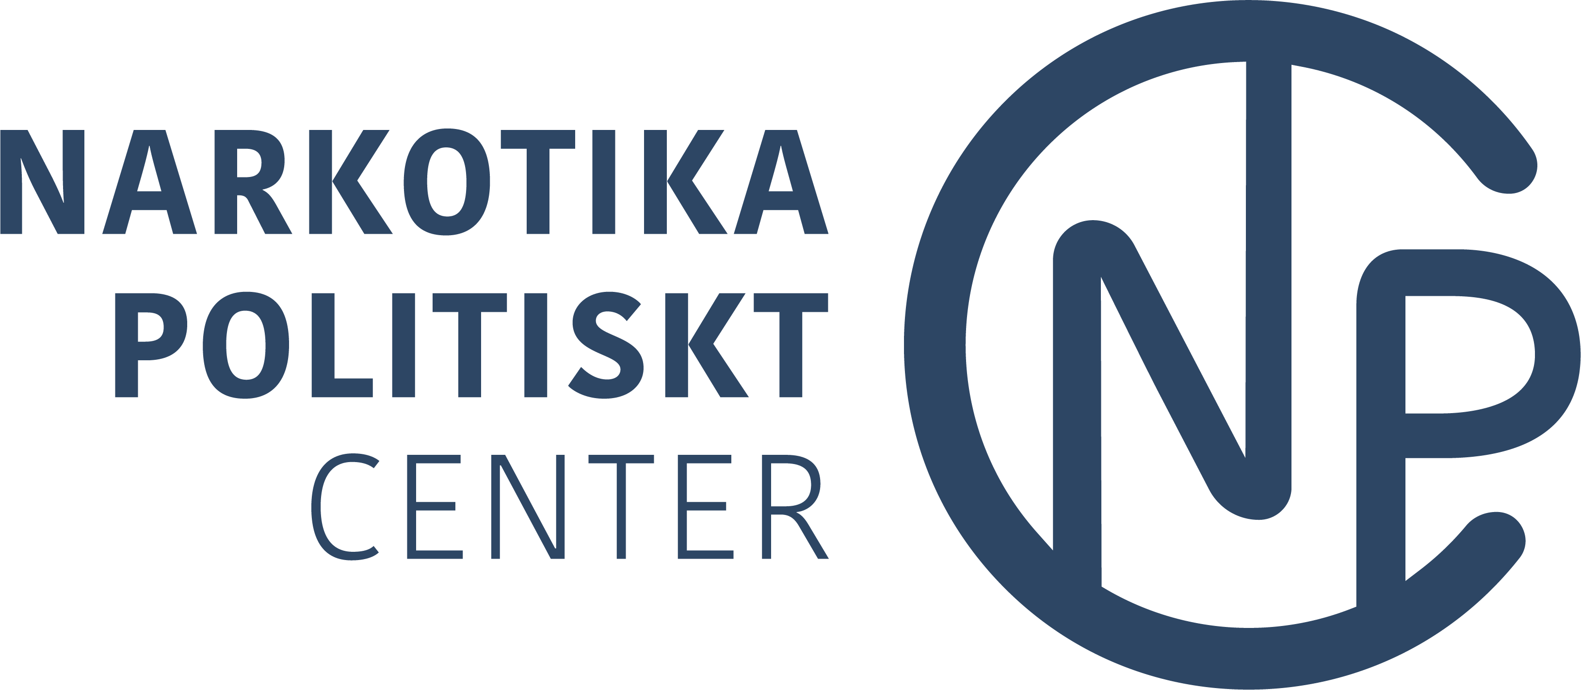
Human Rights Challenges in addressing and countering the world drug problem

The Swedish Drug Policy Centre (Narkotikapolitiskt Center) welcomes the opportunity to contribute to the OHCHR with regard to the Human Right Challenges faced globally. The Drug Policy centre consists of 16 member organisations with a broad experience in health promotion, prevention, treatment and peer support.

The international debate concerning the world drug problem provides insights and showcases the realities that various regions face when it comes to illicit substances, their effects, and their consequences on people and their communities. Unfortunately, today the discussions surrounding a Human Rights framework within drug policy have become a polarised international debate – with on one hand, Human Rights being depicted as the “Right to use drugs”, and on the other “A drug-free life” as a Human Right. This polarisation offers cause for concern, as the narrative tends to centre on a structural level and fails to recognise the realities of people on the ground.

Furthermore, available research and statistic mainly stem from the western world and tends to overlook the different realities faced by people who use drugs from other parts of the world. There is an urgent need to highlight relevant research from other regions, to support the implementation of monitoring and evaluation frameworks for existing programmes, and include a broader perspective within the drug policy discussion.

Human Right to Health
It is widely recognised that Human Rights “are inherent to all human beings, regardless of race, sex, nationality, ethnicity, language, religion, or any other status”. A particular fundamental Human Right is the right to health. WHO reiterates that “health is a legal obligation on states to ensure access to timely, acceptable, and affordable health care”. Every person deserves the right to security, access to health care services, and obtain medical care while ensuring the respect of their dignity. It is imperative that the responsibility and capacity of all human beings are fortified in developing and protecting the right to best-practice and evidence-based health care and is not enabled, equipped, or empowered to undermine good, physical, and psycho-social health. Thus, it is important to note that the Human Right to health is strengthened by sustainable and evidence-driven prevention, ensuring equal access to adequate treatment, and promoting recovery and recovery-oriented systems of care.

The Essence of Prevention, Treatment, and Recovery/Rehabilitation
In a “post-covid era” riddled by ongoing and emerging conflicts, we are seeing an increase in illicit trafficking across borders, increased accessibility of illicit substances, and consequently an increase in people who have problematic drug use and addiction. Simultaneously, models of legislation and other permission models continue to drive rather than diminish demand and are further advocated for. Alongside the rise of commercialisation accompanying legalisation, the normalisation of use is enhanced and the perception of risk is affected.

The above-mentioned development is causing concerns and challenges the Human Rights to Health. Although not all persons who use drugs develop a substance use disorder, the percentage of people facing a substance use disorder is steadily increasing. Whereas providing relevant and adequate services is essential in ensuring fulfilling the Human Right to health, access to such services strongly varies around the world. Hence, the mentioned narrative of a person’s right to use drugs or not does not highlight the realities of many countries that lack fundamental services for drug use rehabilitation treatment. To this extent, prevention that is evidence-driven and gender-sensitive is of utmost importance to ensure that children, youth, families and communities grow healthy and safe. Simultaneously, the fundamental right [and access] to preventive and restorative health must be adhered to while a wide range of treatment and rehabilitation care services, including both opioid substitution treatment and drug-free treatment, are provided with long-term and sustained recovery as the ultimate goal. Besides this, aftercare and additional services need to be put in place as they are essential in supporting the person on their recovery journey – including housing and employment.

Certain subgroups face particular challenges in accessing services. A situation that is exacerbated by discrimination and stigma. We see an urgent need on a global scale to ensure access to adequate treatment and rehabilitation services that are gender-sensitive, trauma informed and age-appropriate. The development of such services should integrate an intersectional approach and be sensitive to the realities and barriers that different sub-groups face whilst being offered in a recovery-oriented system of care. A commitment to strengthen the prevention and treatment of substance abuse is aligned with that of the Sustainable Development Goals Target 3.5.

Protection of and Services for Children
There is an increase in drug use consumption and addiction, especially among the young generation. Many children grow up in an environment where the consequences of close relatives’ drug abuse are constantly present. The risk of developing an addiction is exacerbated by the risk factors associated with parent substance use and dependency. “The impact of parental substance use is reflected in the children’s development outcomes and in their daily lives”. Yet, the need for support of the child and other relatives is often missing both in the drug policy debate and in measures aimed to reduce the harms of narcotic drugs. There is a need for a wide range of interventions aimed at families and children, services for mothers who use substances, and treatment that take the parental responsibilities and children’s needs into account.

Furthermore, primary and secondary prevention efforts, early detection and [age-]appropriate treatment services are crucial to ensure the human rights of children to acquire a healthy and safe development. In accordance to Article 33 of the Convention on the Rights of the Child signing States’ have an obligation to protect children from the illicit use of narcotic drugs and prevent children from being used for the illicit production or trafficking of illicit substances.

Stigma
It is important to highlight the challenge that stigma poses to the fulfillment of Human Rights to Health Care Services. The lack of sensitised treatment and aftercare services, specific barriers faced by various [sub-]groups, stigma, discrimination, etc. tend to be overlooked and ignored. Stigma is manifested on personal, societal, and community levels and often affects people with substance use disorders and their families. It is essential that stigma and discrimination are decreased among society, health care providers, media, communities, institutions, etc. through awareness raising and structural change while promoting voices of recovery and making recovery visible.

Impact of Legalisation
The Human Right to Health through strengthened prevention, access to treatment, and support in the journey of recovery is currently being challenged, not only by the ‘Human Right to use’ discourse but also through the increased platform gained by the Cannabis industry through the legalisation and commercialisation of cannabis in some countries and states. Driven by profit, the industry is fuelling the shift to greater use of cannabis. Products are being marketed in an attractive format and social platforms are being used to target youth and normalise the use of cannabis. This leads to a decrease in perception of risk among youth and increased consumption without explaining nor clarifying the potential health dangers that are associated with the drug.

Learning from policy attempts by the tobacco industry, we believe that the UN should work to keep the Cannabis Industry out of policy rooms, in the same way that the tobacco industry’s possibilities to influence have been limited.

Conclusion
To conclude, a Human Rights approach to the world drug problem means breaking free from the assumption that using drugs is a human right and rather consider the rights of people to a life free from drugs.

It is important that people in various walks of life and different regional contexts are offered services that are non-discriminatory, evidence-based, trauma-informed, gender- and culturally sensitive, and age-appropriate. There is not a ‘one-size fits all’. To ensure the rights are adhered to, further funding and implementation of prevention needs to be encouraged while treatment and aftercare is made accessible and centred around the individual. There are many diversified pathways toward recovery; each individual in need should be allowed to choose among different options in a recovery focussed system of care. All of them must provide people with social integration-oriented interventions supporting them to regain their role in the community and overcome social exclusion and marginalisation.

To ensure a human rights-based drug policy we need to strengthen evidence-driven prevention, provide harm reduction as part of a continuum of care, increase access to treatment, and promote pathways to recovery. This means developing humane and rights-based approaches, such as alternatives to incarceration and sustainable and long-term rehabilitation and reintegration services. We have an opportunity to work toward more humane drug policies without opening for a legalisation of illicit substances.

Signed by the following organisations:

Narkotikapolitiskt Center
Anhöriga Mot Droger
Frisksportens Ungdomsförbund
IOGT-NTO
Junis
KRIS
Studieförbundet NBV
Svenska Frisksportsförbundet
Sveriges Blåbandsförbund
Sveriges Blåbandsungdom
S.L.A.N
Ungdomens Nykterhetsförbund

https://narkotikapolitisktcenter.se/om-oss/
https://www.un.org/en/global-issues/human-rights
https://www.who.int/news-room/fact-sheets/detail/human-rights-and-health
WDR 2018: Booklet 4
Children whose parents use drugs - Pompidou Group (coe.int)
Legalizing cannabis fails to address health risks: UN drugs control board | UN New
World Drug Report 2022

