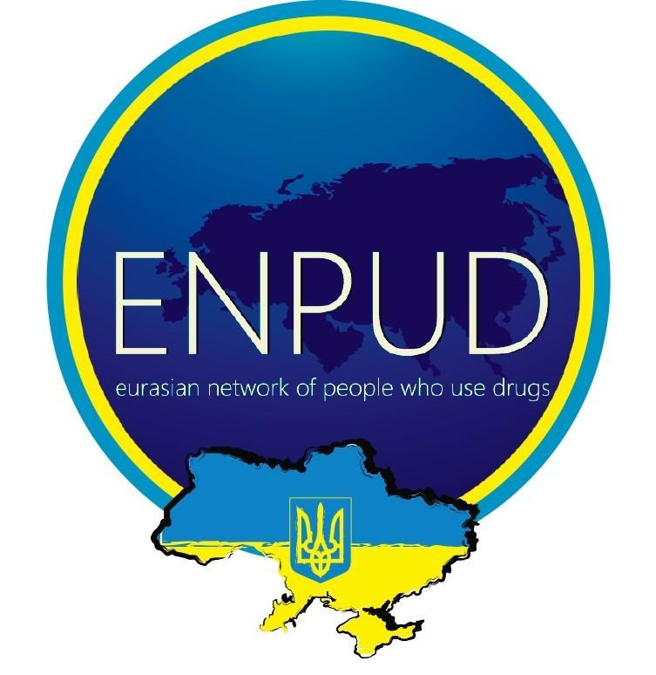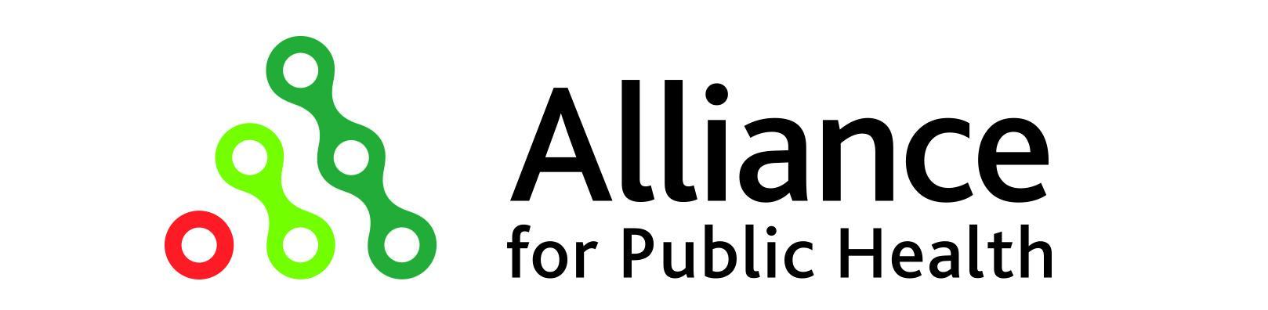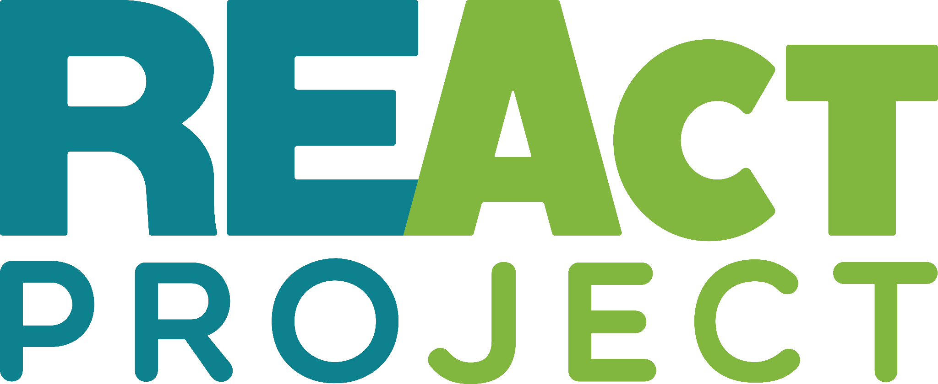

Submission to the United Nations High Commissioner for Human Rights
Criminalization of Psychoactive Substances Use
as a Driver of Systematic Human Rights Violations in Ukraine

May 2023

Submitting organization(-s):
- EURASIAN NETWORK OF PEOPLE WHO USE DRUGS (ENPUD): We work together to build and operate ENPUD through a framework of shared goals and objectives, mutual respect, development, and support. We seek to ensure that people don't become dependent on drugs, and that those who get sick stay alive, healthy, and free.
- The ICF “Alliance for Public Health” is a leading non-governmental professional organization, which has been on a mission since 2003 to make a significant impact on the epidemics of HIV/AIDS, tuberculosis, and viral hepatitis in Ukraine.

Word count: 1483

Contact details for this submission:
Nadiia Semchuk
semchuk@aph.org.ua
ICF “Alliance for Public Health”
24, Bulvarno-Kudriavska Street, Kyiv, Ukraine
Introduction
We welcome the opportunity to present this material to the UN High Commissioner for Human Rights.
International human rights treaties seek to promote respect for human dignity and freedom. The criminalization of personal drug use infringes on human dignity and autonomy, especially when linked to health conditions, such as drug addiction. Criminalized possession of drugs leads to criminalizing personal use, thus placing many people with drug use issues and chronic substance dependence outside the law. According to the UN Special Rapporteur on the Right to Health, "Criminalization of drug use fuels the perception that people who use drugs are unproductive criminals or moral degenerates, which in turn allows disciplinary treatment approaches to proliferate.”
Existing evidence indicates that the criminalization of controlled substances has a discriminatory effect on marginalized communities. Laws imposing incarceration are discriminatory and disproportionate if applicable to drug use offences, e.g.,
- Non-medical use of drugs;
- Possession of any quantity of drugs without the intent to sell; and
- Social distribution of drugs within a limited social group (usually peers).
The report cites real-life examples of egregious human rights violations resulting from criminalization.

Findings
Draconian Drug Laws
In Ukraine, drug use-related behavior is seen as a criminal justice issue. Possession of drugs without the intent to sell is an administrative or criminal offence, depending on the amount of drugs in possession.
The Criminal Code of Ukraine (CCU) (Art 3(3)) defines criminality as well as its punishment and other criminal and legal consequences of the action. For criminal liability, the Ministry of Health (MoH) Order of August 1, 2000, serves to clarify what quantities of illegal drugs may be considered “small,” “large” and “extra-large” (threshold quantities). On July 29, 2010, the MoH adopted amendments to that Order that significantly reduced the legal threshold for “small,” “large,” and “extra-large” quantities of certain types of illegal drugs, including those most commonly used by people who use drugs (PWUD) in Ukraine. The threshold for criminal liability for possession of acetylated opium, one of the most widely used illegal injected drugs in Ukraine, for example, was reduced by a factor of 20. Anyone in possession of as little as 0.005 grams of acetylated opium or heroin faces criminal prosecution and a penalty of up to three years of incarceration. This quantity is so minute that it is approximately equivalent to the amount found in the residue of used syringes.
In 2022, the Code of Administrative Offences was amended. Its Article 44 now provides for a double fine from $22 to $45 or administrative arrest for up to 15 days for the illegal manufacture, purchase, possession, or transportation of illegal drugs or psychotropic substances in small amounts without intent to sell. Moreover, this unjustified increase of responsibility allegedly facilitates the "implementation of the decisions of the European Court of Human Rights.” As a result, both society and participants involved in public discussions were misled as to the purpose and content of the proposed changes.
Under the criminal liability (Article 309 of the CCU) a fine from $445 to $1,345 or correctional labor for up to two years, or arrest for up to six months, or restriction of freedom for up to five years are applied. Similar activities involving illegal drugs in large amounts: a fine from $910 to $2,276 or imprisonment for up to three years.
Based on official data, in 2021, 14,109 offences under Article 309 (CCU) were recorded. A third of all punishments are fines, although, as of the time of the offence, 80 percent of those convicted were unemployed, with no legal source of income. The number of those convicted under Article 309 (CCU) in 2022 was 6,516 (vs. 7,145 in 2021).
There is currently no state drug strategy in Ukraine. The previous strategy for 2013-2020 contained provisions that would decriminalize PWUD, but these ambitious plans have not been implemented. The punitive approach is fully transferred to the new draft CCU.

Unreasonably Broad Definition of the Offence of Trafficking

The sale of drugs and preparations is interpreted too broadly in Ukraine. Any alienation or delivery of drugs is considered drug trafficking, regardless of payment, purpose (earnings, gift), or regularity of activities involved. This entails prosecution for people who handle drugs in the context of drug use rather than those who sell drugs for the purpose of systematic enrichment.
The broad definition of the offence of trafficking provides for the unlimited mandate for police to frame PWUD as drug traffickers. The criminalization of PWUD creates a legal basis for human rights abuses by police. Based on the data of one of the most extensive in-country systems for monitoring human rights violations among key communities vulnerable to HIV, i.e., REAct, PWUD experience arbitrary and unlawful detention on the streets, blackmail and extortion, or use of force by police. Below is just a real-life example of egregious human rights violations that have been documented in Ukraine:
A woman was detained by police on the street and taken to the police station. After establishing that she had been previously prosecuted for drug possession, she was asked to confess to re-committing a similar offence, although she had no illicit substances on her. Once the woman refused to take the blame, the police took her to another room and gave her a severe beating.
Police performance indicators contribute to the excessive focus of police activities on people who use drugs rather than on wholesale drug traffickers. Based on the system of police performance indicators, police officers must detect certain numbers of crimes of trafficking. The broad definition of drug trafficking offence provokes police into framing up charges against PWUD because it is much easier to frame a vulnerable person who uses drugs as a drug trafficker rather than to mount a laborious operation against the real wholesale drug trafficker. Here is an example from ENPUD’s practice, "A police operative spent three months working his way into the confidence of an OST patient who was working as a social worker for a local HIV-service NGO. The operative, presenting himself as a drug addict with cancer, asked this person to get for him his pharmacy-bought drug-containing medication, the cost of which would be reimbursed by the operative against the sales slip. Now this man is facing eight years in prison.”

Harmful impact of punitive criminal laws on drugs

Punitive measures are associated with an increased risk of transmission of HIV, hepatitis, and TB. Fearful of criminal prosecution, PWUD are unable to fully access health or harm reduction services. The estimated number of people who inject drugs in Ukraine is around 300,000, whereas HIV prevalence has remained between 21% and 23% for the last 10 years. HIV prevalence among prisoners also stands at a fairly high 8.9%.
The full-scale war in Ukraine has exacerbated human rights abuses and police stigma against PWUD.,

Recommendations
In light of the above, we call on the UN High Commissioner for Human Rights to provide the following recommendations to Member States and stakeholders in her report:
The imposition of penalties, particularly imprisonment, for drug use or possession is unwarranted. Essentially, no drug use activities should be punishable by criminal or administrative penalties. Less restrictive approaches to drug control need to be introduced, including decriminalization of possession without intent to sell, as well as the decriminalization of social distribution of drugs without the intent of systematic enrichment.
In order to avoid discrimination and disproportionality, the law must recognize the distinction between the circumstances of drug distribution depending on the context in which the transfer or delivery of drugs takes place. There is a difference between distributing limited quantities (e.g., for life purposes) to a small social group on the one hand, and large-scale trafficking for self-enrichment on the other. Only the latter behavior can justify the application of criminal law, especially harsh measures such as detention (whether pre-trial or as part of a sentence after conviction or plea of guilty), with due regard for other attendant circumstances.
To prevent the arbitrary and disproportionate use of penalties, especially detention by drug law enforcement agencies, prosecution, and sentencing, the legal definition of drug trafficking must clearly distinguish it from social distribution in the context of drug use. Such a definition may include the goal of systematic self-enrichment on a scale far more than the basic needs of the suspect and their family.
There is a need to reconsider approaches to the definition of threshold quantities for drug offences used to define small or large quantities. To help establish such critical distinctions, the law may specify threshold quantities of substances, but only to indicate when law enforcement involvement, rather than other social and medical measures, maybe in the best public interest.

MoH of Ukraine Order No. 188 of August 1, 2000 https://zakon.rada.gov.ua/laws/show/z0512-00#Text
MoH of Ukraine Order No. 634 of July 29, 2010 https://zakon.rada.gov.ua/laws/show/z0900-10#Text
https://w1.c1.rada.gov.ua/pls/zweb2/webproc4_1?pf3511=69827
https://zakon.rada.gov.ua/laws/show/2341-14/page13#Text
https://cmhmda.org.ua/wp-content/uploads/2023/01/zvit-shhodo-narkotychnoyi-ta-alkogolnoyi-sytuacziyi-v-ukrayini-2022.pdf
https://supreme.court.gov.ua/userfiles/media/new_folder_for_uploads/supreme/ogliady/Stan_Pravosuddya_Criminal_2022.pdf?fbclid=IwAR0aQ0HZ1sixLo_7evXiBjYF_fEcLXjCzAeFpsN8aqSO2M6LaiC0kF0kQTM
https://supreme.court.gov.ua/userfiles/media/new_folder_for_uploads/supreme/zvi/Analiz_zdisn_pravos_2021.pdf
https://zakon.rada.gov.ua/laws/show/735-2013-%D1%80#Text
https://newcriminalcode.org.ua/criminal-code
https://react-aph.org/en/statistic/ukraine-2022-year/?country_id=566
https://react-aph.org/wp-content/uploads/2022/12/en_analitichnij-zvit-2021-react_red_21.12.2022.pdf
https://enpud.net/
https://aph.org.ua/wp-content/uploads/2021/09/Size-estimation_2020_eng.pdf
https://phc.org.ua/sites/default/files/users/user90/HIV_in_UA_53_2022.pdf
https://www.facebook.com/PUD.Ukraine/posts/pfbid0aU9Hc1rhAoLDS3e5Ns5h4qAVaAQDKa1Q4FNJxv9hqMUNzJ9yVLkCXpjPRoV6Nk2Xl
https://react-aph.org/wp-content/uploads/2022/10/react-system-in-ukraine-challenges-of-war.pdf

