Comments on Draft statement on “non-State actors and enforced disappearances in the context of the International Convention for the Protection of All Persons from Enforced Disappearances”

Contact information
Organization: | Latin American Institute for Collective Justice
Address:
City: | São Paulo
Country: | Brazil
E-mail:
.
The comments in this paper represent the views of experts representing ILAJUC.

Specific comments on the Draft statement on “non-State actors and enforced disappearances in the context of the International Convention for the Protection of All Persons from Enforced Disappearances”:

Article 2 – “For the purposes of this Convention, "enforced disappearance" is considered to be the arrest, detention, abduction or any other form of deprivation of liberty by agents of the State or by persons or groups of persons acting with the authorization, support or acquiescence of the State, followed by a refusal to acknowledge the deprivation of liberty or by concealment of the fate or whereabouts of the disappeared person, which place such a person outside the protection of the law.”
Comment: the article states that non state agents would have to act with the authorization, support or acquiescence of the state. However, the situation in Brazil is sui generis and demands that either a fourth verb be included, or that the following situation be included in the circumstances that the above verbs encompass, since they do not constitute authorization or support, but if the meaning of the verb "acquiesce" has only an omissive meaning, it would be problematic. This is because the Brazilian State not only failed to investigate, meaning to start an investigation, but to conduct a proper investigation in due time and make resources available for the its conduction. This would be exactly related to, for instance, countries like Brazil, where there is currently a government plan to dismantle and weaken environmental agencies that include among their activities, monitoring protected areas or indigenous territories, which (I) affects the safety of environmental and human rights activists and (II) increases the number of invasions for the exercise of illegal activities in these territories and the practice of crimes in these places. This has been a common practice in recent years in Brazil. Statements in official meetings by President Jair Bolsonaro and former Minister of the Environment Eduardo Salles, such as "passando a boiada" (which means to take advantage of the moment people in official positions allows them to do this, besides taking a great number of measures to destroy the environmental protection system in place; supporting the miners, inciting violence, criticising environmental and human rights NGOs). It is important to emphasise that all this has been properly and extensively documented and broadcasted.

Other actions conducted by the government in the last three years encompass: cutting funds and personnel for IBAMA (Brazilian Institute of Environment and Renewable Natural Resources), ICMBIO (Chico Mendes Institute for Biodiversity Conservation) and FUNAI (National Indian Foundation); choosing leaders without experience to conduct very specific areas; non-demarcation of indigenous lands and/or “quilombolas” or Conservation Units. On the part of the legislative branch: approval/attempted approval of anti-environmental bills (licensing, attacks on conservation units and indigenous lands, etc.). These actions have been producing dire consequences, such as large increase in deforestation, illegal mining, attacks on defenders of human and forest rights, indigenous people and environmental inspectors, etc... More can be observed in the image below:
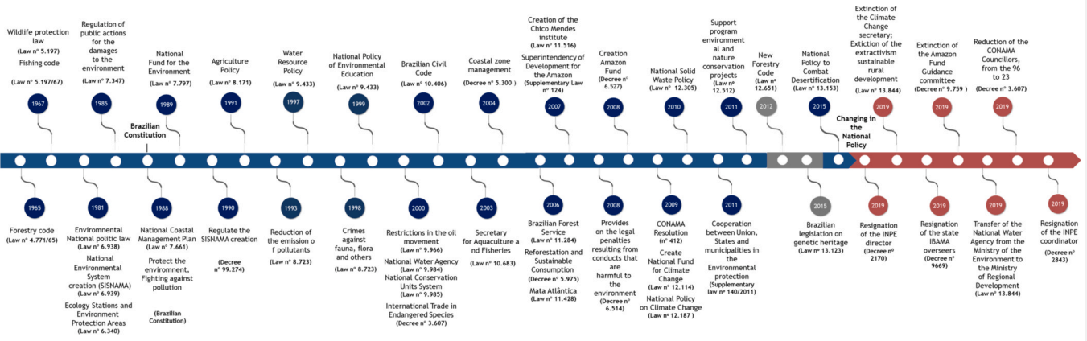

Fig. 1. Timeline of Brazilian environmental laws since 1965. Across the blue line, the main protecting laws along the years, and in the red line the main dismantling decrees from 2019. In gray two laws with positive and negative consequences to the environment.

Article 3 – “Each State Party shall take appropriate measures to investigate acts defined in article 2 committed by persons or groups of persons acting without the authorization, support or acquiescence of the State and to bring those responsible to justice.”

As to the excerpt “Each State Party shall take appropriate measures to investigate acts” – it is important to specify what these necessary measures would be, besides proper investigation.

Article 7 – “1. Each State Party shall make the offence of enforced disappearance punishable by appropriate penalties which take into account its extreme seriousness.
2. Each State Party may establish:
(a) Mitigating circumstances, in particular for persons who, having been implicated in the commission of an enforced disappearance, effectively contribute to bringing the disappeared person forward alive or make it possible to clarify cases of enforced disappearance or to identify the perpetrators of an enforced disappearance;
(b) Without prejudice to other criminal procedures, aggravating circumstances, in particular in the event of the death of the disappeared person or the commission of an enforced disappearance in respect of pregnant women, minors, persons with disabilities or other particularly vulnerable persons.”
Based on the following comments of this draft about this article “Committee thus considers that it is now well-established that in international customary law enforced disappearances as a crime against humanity can be perpetrated by a ‘political organization’ acting without the authorization, the support or the acquiescence of the State” it is important to know the exact meaning of “political organization”.
Based on the comments of the draft, in which the Committee finds that under article 3 of the Convention, disappearances perpetrated without the authorization, support or acquiescence of the State constitute ‘enforced disappearances’ when the disappearance was perpetrated by a ‘political organisation’, and there is a nexus with a ‘widespread or systematic attack against a civilian population’, within the meaning of the definition of crimes against humanity in international criminal law - it is important to emphasise the importance of mentioning that Brazil was the 69th state to ratify the Rome Statute without making any constitutional or legislative changes, having deposited its instrument of ratification on 14/06/2002. Domestically, the treaty was promulgated on 25/09/2002 through Decree No. 4.388. By ratifying, Brazil commited itself to a number of cooperation measures: the Rome Statute provides for the International Criminal Court's prerogative to address requests (to Member States) for the arrest and surrender of individuals for submission to the jurisdiction of the Court.
Regarding the specific Brazilian situation addressed here, the mention to crimes against humanity and the Rome Statute deserves a special attention. According to Antonio Cassesse, crimes against humanity are not isolated or sporadic events, but are part either of a governmental policy, or of a widespread or systematic practice of atrocities tolerated, condoned, or acquiesced in by a government or a de facto authority. Clearly, it is required that a single crime be an instance of a repetition of similar crimes or be part of a string of such crimes (widespread practice), or that it be the manifestation of a policy or a plan drawn up, or inspired by, State authorities or by the leading officials of a de facto state-like organization, or of an organized political group (systematic practice). (…) They are prohibited and may consequently be punished regardless of whether they are perpetrated in time of war or peace, one of their categories being exactly the enforced disappearance of persons, namely 'the arrest, detention or abduction of persons by, or with the authorization, support or acquiescence of, a State or a political organization, followed by a refusal to acknowledge that deprivation of freedom or to give information on the fate or whereabouts of those persons, with the intention of removing them from the protection of the law for a prolonged period of time' (Article 7(2) (i) of the Rome Statute). It may be noted that with respect to this crime the ICC Statute has not codified existing customary law but contributed to the crystallization of a nascent rule, evolved primarily out of treaty law (that is, the numerous treaties on human rights prohibiting various acts falling under this heading) as well as the case law of the Inter-American Commission and Court of Human Rights, in addition to a number of UN General Assembly resolutions. These various strands have gradually contributed to the formation of a customary rule prohibiting enforced disappearance of persons. The ICC Statute has upheld and codified the criminalization of this conduct.
As to the subjective element, Courts have insisted on three points: the intention to bring about a certain result, is normally required; in the case of an accused who, acting as an agent of a system, does not directly and immediately cause the inhumane acts, it is not necessary that he anticipate all the specific consequences of his misconduct, being sufficient for him to be aware of the risk that his action might bring about serious consequences for the victims, on account of the violence and arbitrariness of the system to which he delivers the victim and thirdly, the agent must be cognisant of the link between his misconduct and a policy or systematic practice. This consists of awareness of the broader context into which this crime fits, that is knowledge that the offences are part of a systematic policy of widespread and large-scale abuses. The case law seems to indicate that crimes against humanity may be committed by individuals acting in their private capacity provided they act in unison, as it were, with a general state policy and find support for their misdeeds in such policy.
This meaning has to do with the situation that currently occurs in Brazil, involving government incitement, validation and leniency towards crimes perpetrated involving environmental and human rights defenders in recent times. Some institutions (including a Parliemantary Commission of Inquiry) have already denounced President Jair Bolsonaro of crimes against humanity at the ICC. Among the crimes present in the denunciations, some are strictly related to his conduct related to environmental policies. Also within Brazil itself, several constitutional actions were filed with the purpose of denouncing the dismantling of the environmental protection system (some were even filed by public agencies, such as the Office of the Public Prosecutor). For instance, the Federal Supreme Court in 2022 started a trial of the package of seven lawsuits proposed by various parties and signed by civil society organizations - such as the ISA - Socio-Environmental Institute and APIB - Articulation of Indigenous Peoples of Brazil), which accuse the federal government and the president of omission in environmental preservation, especially in the Amazon.
The dispositions of Articles 29, 30 and 34 regarding the possibility of, after seeking from a State party concerned all relevant information on the situation, urgently bring to the attention of the General Assembly, through the Secretary General of the United Nations, a widespread or systematic practice of enforced disappearances, are very important, since internally, the situation may be out of control, and it is of utmost importance that the international community be aware of the government's failure to promote the necessary investigative procedures and other preventive measures that must be taken to curb the recurring situation of disappearances.

BARBOSA, Luciane Gomes ; ALVES, Maria Alice Santos; GRELLE, Carlos Eduardo Viveiros. « 2021 - Actions againt sustainability - Dismantling of the environmental policies in Brazil » in Land Use Policy 104 (2021) 105384

