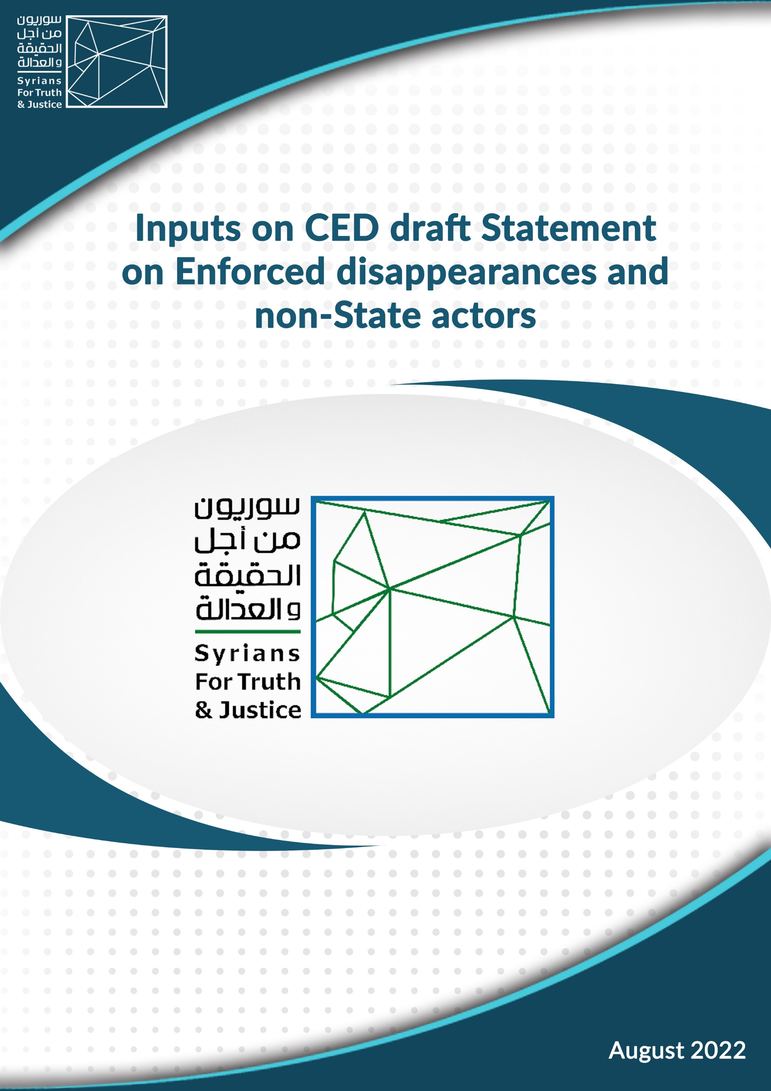

Overview
The organisation Syrians for Truth and Justice is pleased to submit its comment on the Draft statement on “non-State actors and enforced disappearances in the context of the International Convention for the Protection of All Persons from Enforced Disappearances” in response to the UN Committee on Enforced Disappearances’ public consultation.
We thank the work of the committee and wish to participate in its will to broaden the interpretation of enforced disappearances in the context of Non-State Actors’ actions. We wish to draw the committee’s attention on interpreting the Convention as a « living instrument » in light of current settings and developments, especially the evolution of non-international armed conflicts (NIACs) as the dominant form of conflict in the world, the ever-increasing role of private military companies and other transnational non state actors in such NIACs.
Background
Since 2011, the conflict in Syria has been the site of a variety of violations of human rights and international law regulating conflict and abuses at the hands of various perpetrators.
Among these, the practice of enforced disappearances has emerged as a large-scale pattern. Documented as soon as 2012 by Human Rights Watch, 2013 by the Commission of Inquiry, and 2017 by Syrians for Truth and Justice, it has not declined ever since, so much so that in February 2014, the UN Security Council drafted a Resolution 2139 condemning the occurrence of the crime, with little effect. While those violations are framed within the Convention as a crime against humanity, it primarily recognizes « agents of the State or by persons or groups of persons acting with the authorization, support or acquiescence of the State ».
In the Syrian context, as documented by STJ, enforced disappearances, in addition to the Syrian authorities, have often been carried out by non-State actors whose support, authorization or consent of the State is not established. STJ and its partners have been documenting and accounting for enforced disappearances in the Turkish-occupied canton of Afrin substantively, tracking 584 arrests over 2021 perpetrated by Turkish-backed armed groups. In the beginning of 2022, only 122 persons were released while the fate of the 461 others remains unknown. In the first half of 2022, in Afrin alone, 311 people were arbitrary arrested. This monitoring has highlighted the recurrent practice of this crime and the use of non-state groups by the warring powers. In particular, the use of private military groups has been revealed by STJ and has expanded since 2020, with information suggesting this use by Russia and Turkey in the Syrian context.
Comments
Section 3. Enforced disappearances by NSA in the context of Article 3

  - In the qualification under Article 3 of the Convention of NSAs’ actions constituting enforced disappearances, we wonder if there is a need - in the Committee’s view - to add or address the Private Military and Security Companies, in the context of the definition or actual identification of « organized armed groups » (Paragraph 14 of the Statement), considering the evolution of this phenomenon and their regular involvement in NIACs.
  - Pursuant to allow a better framing of the scope of enforced disappearances, we believe that the circumstances detailed under Paragraph 14 of the Statement are enough to identify what constitutes enforced disappearances by non-State actors, and there is no need for any negative identification as stated in Paragraph 15 of the Statement. Moreover, since “kidnapping” or “abduction” are already identified acts in some national legislations, e.g., Syria, this negative identification might be used or “exploited” to limit other acts that might constitute enforced disappearances to these acts through vague justifications or reasons. In any case, since the Committee’s Statement is concerned with enforced disappearances by non-State actors, we don’t see any additional benefit for presenting concepts or circumstances that do not fall within such identified circumstances.
Section 4. Obligations of States parties under article 3
- In light of the conclusion stipulated in Paragraph 7 of the Statement that “the Convention is a living instrument and should be interpreted in the light of present-day conditions”, we encourage the Committee to detail this section, and to emphasize States parties’ obligations under Article 9 of the Convention. Considering the present-day conditions and developments where NIACs are the dominant armed conflict, and the phenomenon of “foreign fighters” and transnational armed non-State actors exists almost in every armed conflict. Such conditions raise concerns about situations where the territorial State is unable to meet its obligations under Article 3 of the Convention, while alleged perpetrators are nationals of other non-territorial States. Such an emphasis would encourage States to deal with enforced disappearances allegedly committed by their nationals abroad seriously and in accordance with their international obligations.
- We encourage the Committee to give special attention and emphasis to Article 24 of the Convention related to the rights of victims of enforced disappearances by non-State actors. Including this in the statement will form an exceptional opportunity to strengthen the victims’ rights and ensure a victim-centered approach not only when enforced disappearances occurs as a State-related violation/crime, but also when committed by non-State actors. This is also very relevant to the same Committee’s perspective that the Convention is a live instrument.
****
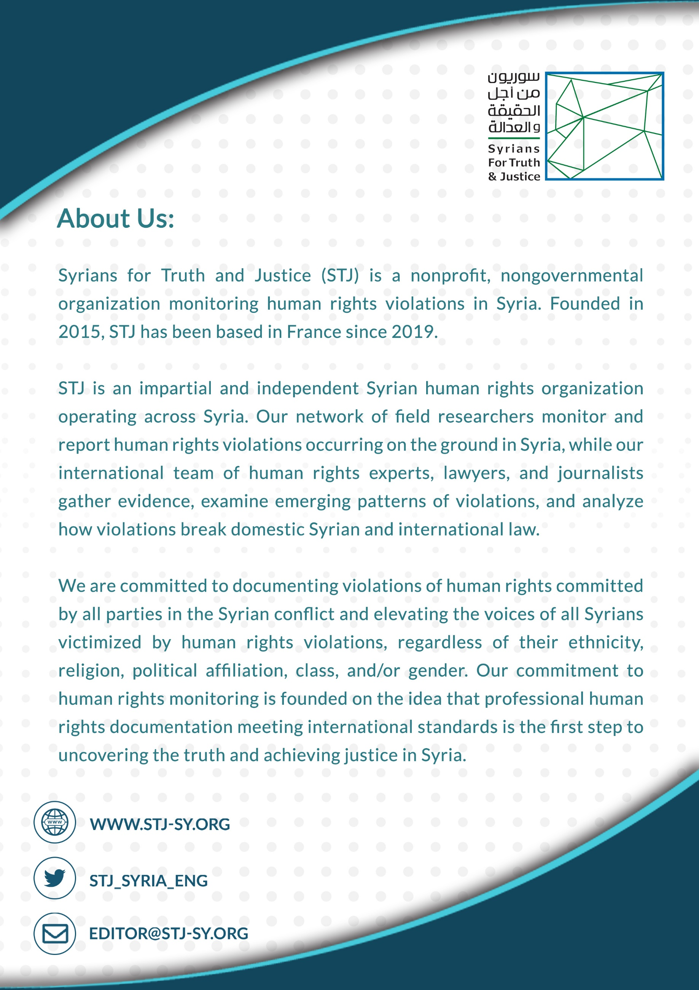

Article 5 of the convention : « The widespread or systematic practice of enforced disappearance constitutes a crime against humanity as defined in applicable international law and shall attract the consequences provided for under such applicable international law. »
See: https://stj-sy.org/en/syria-arbitrary-deprivation-of-truth-and-life/
For reference, following operation Peace Spring, over 122 people disappeared, see : https://stj-sy.org/en/northeast-syria-more-than-120-people-disappeared-following-operation-peace-spring/
See: https://stj-sy.org/en/syria-584-persons-arrested-in-afrin-over-2021/
See: https://stj-sy.org/en/afrin-311-arbitrary-arrests-in-the-first-half-of-2022/
See: https://stj-sy.org/en/russias-and-turkeys-recruitment-of-syrian-mercenaries-to-libya-two-faces-of-the-same-colonialist-coin/
For an analysis of the involvement of Russia and Turkey through private military companies in Syria, see: https://stj-sy.org/en/mercenarism-in-syria-predatory-recruitment-and-the-enrichment-of-criminal-militias/
For instance, Syrian mercenaries recruited by the Wagner Group were relocated from Lybia to Russia. See: https://stj-sy.org/en/ukraine-wagner-group-begins-relocating-syrian-fighters-from-libya-to-russia/
Independent International Commission of Inquiry on the Syrian Arab Republic, Without a trace: enforced disappearances in Syria (Conference room paper)
Articles 555 and 556 of the General Penal Code, and Legislative Decree No. 20 of 2013.
Article 9 of the Convention : ‘’Each State Party shall take the necessary measures to establishes competence to exercise jurisdiction over the offence of enforced disappearance’’
See for instance: https://www.un.org/en/un75/new-era-conflict-and-violence
S/RES/2396 (2017), see: https://www.un.org/securitycouncil/content/sres23962017
Article 3 of the Convention : « Each State Party shall take appropriate measures to investigate acts defined in Article 2 committed by persons or groups of persons acting without the authorization, support or acquiescence of the State and to bring those responsible to justice. »
Article 24 of the Convention : « 2. Each victim has the right to know the truth regarding the circumstances of the enforced disappearance, the progress and results of the investigation and the fate of the disappeared person. Each State Party shall take appropriate measures in this regard. 3. Each State Party shall take all appropriate measures to search for, locate and release disappeared persons and, in the event of death, to locate, respect and return their remains. 4. Each State Party shall ensure in its legal system that the victims of enforced disappearance have the right to obtain reparation and prompt, fair and adequate compensation. 5. The right to obtain reparation referred to in paragraph 4 of this Article covers material and moral damages and, where appropriate, other forms of reparation such as: (a) Restitution; b) Rehabilitation; (c) Satisfaction, including restoration of dignity and reputation; (d) Guarantees of non-repetition. 6. Without prejudice to the obligation to continue the investigation until the fate of the disappeared person has been clarified, each State Party shall take the appropriate steps with regard to the legal situation of disappeared persons whose fate has not been clarified and that of their relatives, in fields such as social welfare, financial matters, family law and property rights. 7. Each State Party shall guarantee the right to form and participate freely in organizations and associations concerned with attempting to establish the circumstances of enforced disappearances and the fate of disappeared persons, and to assist victims of enforced disappearance. »

