Check against delivery

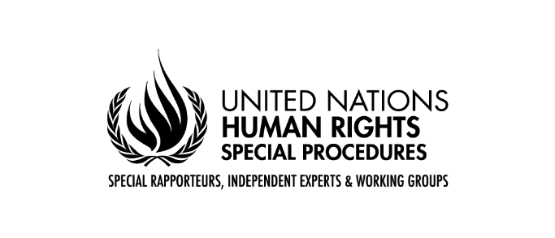

Statement by MR. GERARD QUINN,

UNITED NATIONS Special Rapporteur on THE RIGHTS OF PERSONS WITH DISABILITIES

Fifteenth Conference of States Parties to the Convention on the Rights of Persons with Disabilities

Opening remarks

NEW YORK
14 June 2022

Secretary-General,
President,
Excellencies,
Distinguished delegates and participants,

I wish to thank the Bureau for the invitation to participate in the opening of the 15th session of the Conference of States Parties to the Convention on the Rights of Persons with Disabilities.

Looking back, when drafting first commenced on the proposed treaty on the rights of persons with disabilities, many States were at a loss as to what the human rights framing of disability looked like.
At the end of the drafting process, they competed among each other to provide ever better framings of human rights and disability! It was exceptionally gratifying to witness this.

Looking forward, the COVID-19 pandemic, climate change and conflicts, have all conspired since then, to seriously challenge where we thought we had arrived.

These grand challenges are periodic and, in a sense, inevitable. We will have more. What they really reveal is that the invisibility [of persons with disabilities] we thought we had rolled back with the Convention [on the Rights of Persons with Disabilities] is still there. While the general narrative in disability has inched forward, it can lurch backwards especially when States are faced with unprecedented challenges.

We all imagined a new era of co-production of policy as a result of the Convention. But initial policy reactions to COVID studiously avoided active consultation. As a result, many mistakes were made. Continued institutionalisation heightened the risks faced by persons with disabilities many times over. And our support systems simply evaporated - leaving a major challenge in building back better and more reliable support systems.

We had all imagined that wars would be a thing of the past since the UN Charter is so crystal clear on this. Yet here we are, with more than 20 active wars happening, in every corner of the world. They are happening in places and urban centres with large populations of persons with disabilities. Funny enough, we thought the disability treaty would have an automatic ripple effect informing and broadening understandings under previous treaties like the Fourth Geneva Convention on the protection of civilians during conflicts. No - we have learned this takes conscious effort in our part. This is a visibility project - making persons with disabilities visible during conflicts and making international humanitarian law norms sensitive to their particular protection and more general rights and needs. This process began recently but needs to be accelerated.

And the invisibility should not end with these norms - it needs to carry over into mechanisms to ensure clear accountability under both international criminal law and other mechanisms. Further, the constructive role of persons with disabilities as natural champions of building more inclusive and sustainable communities has been considerably untapped. We need greater room and visibility in UN and other peacebuilding frameworks for persons with disabilities.

Climate change will be felt by all - no one will escape. But persons with disabilities come to it with accumulated disadvantages and ongoing invisibility. If we want a human rights -based response to climate change, this has to change. I am glad to report the new UN Special Rapporteur on climate change and human rights is alive to this need.

Ending invisibility of persons with disabilities is a core part of my mission. The deep logic of the Convention requires that ableism be uprooted.

I am glad to see a fantastic array of side-events on a broad range of topics this year - as usual. I pay tribute to the energy, commitment and enthusiasm of all involved. The reports by States on their innovation and creativity is especially welcome. I am especially looking forward to the event on the role of Regional Organisations in advancing disability rights around the world as more can be done to harness their unique capacities. And the side event on atonement, moral repair and acknowledgement of historic wrongs - and building the case for reparations - will be ground breaking - as indeed every element of the programme will be.

I look forward to the deliberations and especially the creative chemistry that our interactions will have in the next few days.

I thank you.

[ENDS]

