Check against delivery

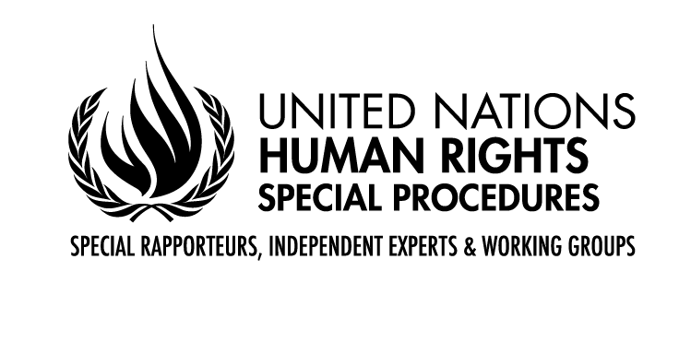

CLOSING REMARKS BY MR. GERARD QUINN,

UNITED NATIONS Special Rapporteur on THE RIGHTS OF PERSONS WITH DISABILITIES

Fifteenth Conference of States Parties to the Convention on the Rights of Person

Interactive dialogue on the Implementation of the Convention of States Parties with the United Nations system and other stakeholders with Disabilities

NEW YORK
14 June 2022

President,
Excellencies,
Distinguished delegates and participants,

In these challenging times, it is easy to lose sight of the fact that the Convention on the Rights of Persons with Disabilities (CRPD) is a child of the 21st century - always looking forward and not back.

It provides norms and standards to help us measure where we are.

But it also gives us tools to constrict a much better future even in the face of the most pressing challenges.

Arguably, the CRPD is what all human rights should have looked like if the Cold War had not intervened. Its focus is not on who when or under what conditions to take rights away and to police that process. Its focus is on how to give meaning and reality to rights through appropriate positive intervention. Its creative blending of civil and political al rights with economic, social and cultural rights gives Governments the tools to achieve this.

We know the changes needed run deep and wide. We know that old narratives have a half-life - they linger on to complicate the process of change.

To me, the process innovations of the Convention are as clever as are its norms and standards. It was as if the drafters knew that the treaty - any - treaty - is not self-executing and needs a mechanism to keep ratcheting change forward.

It is the creative partnership of power (governments) with voice (civil society) and new ideas that drives change.

Together we can change our policy imagination, which creates the space to find new and better solutions that work locally.

The last three days have been all about changing our policy imagination. The mutual learning afforded by COSP is invaluable.

Seeing how artificial intelligence (AI) is regulated in some countries gives us hope that there is a way to balance the promise of new technology with known risks of discrimination.

Learning how climate change strategies can become more sensitized to the rights of persons with disabilities gives us all a chance to adjust.
Appreciating the role of persons with disabilities as active economic agents and entrepreneurs shows how economic empowerment can both liberate the person and generate more economic activity to the benefit of all.

Learning how regional groupings can add their own distinct value to the implementation of the convention closer to home gives us hope of sustaining change.

Connecting the debate about moral repair and concrete atonement for grievous historic wrongs opens up whole new policy imaginations. Coming to terms with the past is vital to constructing a better future.

You will go home with the seeds of change planted in your hearts and minds. This is what stretching the policy imagination is all about. And this is why COSP is invaluable.

I applaud all your energy, enthusiasm and willingness to share and learn.

And I congratulate the bureau on a thoughtful, practical programme that has laid the seeds for change.

Thank you.

[ENDS]

