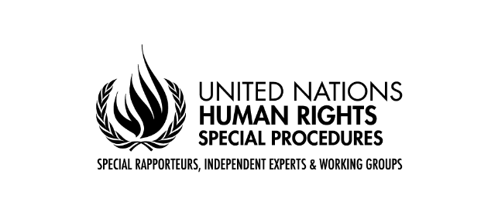
Statement by the Special Rapporteur on the rights of persons with disabilities, Heba Hagrass
79th session of the General Assembly
Third Committee
Item 71 (a-d)
1st November 2024

Chairperson,
Excellencies,
Distinguished delegates,
As I conclude my first year in my capacity as Special Rapporteur on the rights of persons with disabilities, I am honoured to present my first report to the General Assembly, in accordance with Human Rights Council Resolution 53/14.
My report addresses a critical topic—the participation and inclusion of persons with disabilities in the review and follow-up processes of the 2030 Agenda for Sustainable Development.
Today, I stand before you with a clear and urgent message: progress toward achieving the Sustainable Development Goals remains slow, and persons with disabilities continue to be severely left behind. Despite the global commitment to "leave no one behind," the voices of 1.3 billion persons with disabilities around the world are still too often unheard in policy discussions that shape their futures.
As the world grapples with growing inequalities, conflicts, climate change, and the lasting impacts of the COVID-19 pandemic, persons with disabilities bear a disproportionate share of these crises. The 2030 Agenda offers an unprecedented opportunity to turn these challenges into catalysts for change. It is a practical blueprint to realize the transformative potential of the Convention on the Rights of Persons with Disabilities.
Yet, six years from the 2030 deadline, only five of the indicators to achieve targets for persons with disabilities are on track, while for 30 per cent progress is insufficient and for 14 per cent has been missed or gone into reverse. This is simply not enough.
My report focuses on the commitment from States to a robust, voluntary, effective, participatory, transparent, and integrated follow-up and review framework at the national, regional, and global levels, and how persons with disabilities ought to be included in these processes. It outlines several key concerns and offers recommendations to rectify gaps for the full participation and inclusion of persons with disabilities.
Excellencies,
While the SDGs aim to be inclusive, many national and international review processes fail to ensure that persons with disabilities are meaningfully included. The lack of accessible consultation mechanisms, limited disability-disaggregated data, and insufficient capacity-building efforts for organizations of persons with disabilities are some of the major barriers identified in my report.
The Convention on the Rights of Persons with Disabilities emphasizes the importance of meaningful participation in Article 4.3. Yet, as my report shows, the level of consultation is inconsistent. In many countries, persons with disabilities remain invisible in SDGs review mechanisms. For example, of the 37 voluntary national reviews conducted in 2024, only nine mention consulting persons with disabilities. This is far from sufficient.
Inclusion also means data. Without reliable, disaggregated data, it is impossible to design policies that truly address the needs of persons with disabilities. We must urgently scale up efforts to collect disability-disaggregated data to ensure that the implementation of the SDGs reflects the realities faced by persons with disabilities.
Distinguished delegates,
The implementation of the 2030 Agenda can succeed only through country-led policies, strategies, and programmes. Voluntary National Reviews provide an excellent opportunity to shed light on the lived realities of persons with disabilities. Simply mentioning persons with disabilities as a group at risk is not sufficient. Reviews should address the disability-specific progress across all the Goals. They also need to be produced through consultative preparatory processes.
At the international level, the system of “major groups and other stakeholders” is a good platform for persons with disabilities to express their views and contribute to the implementation of the 2030 Agenda from a disability rights perspective. But challenges for meaningful participation also exist at this level, including a lack of accessibility and funding for grassroots organizations to participate.
My report offers concrete recommendations for the meaningful participation of persons with disabilities, including establishing accessible consultation platforms, providing independent funding to organizations of persons with disabilities, and integrating persons with disabilities into national and subnational monitoring bodies for the SDGs.
Furthermore, I call upon the United Nations system to strengthen its own commitments. The implementation of the UN Disability Inclusion Strategy must be accelerated, particularly at the country level. UN country teams play a vital role in supporting States to make their SDG reviews inclusive.
As we prepare for the post-2030 discussions, I urge all Member States to ensure that the rights of persons with disabilities are at the heart of future development agendas. I was pleased to see that the outcome document of this year’s Summit for the Future, the Pact for the Future, commits to work on key areas for persons with disabilities.
Excellencies,
Our actions today will determine whether the next generation of persons with disabilities faces the same barriers or enjoys the full realization of their human rights. In conclusion, the time to act is now. Leaving no one behind must be more than a slogan—it must be a global imperative. Thank you.

