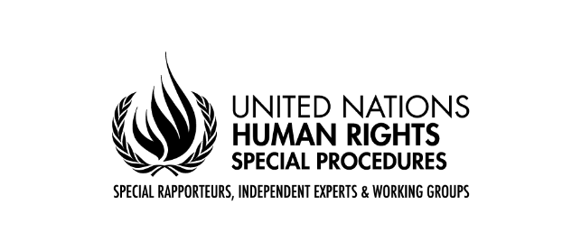

Statement by the Special Rapporteur on the rights of persons with disabilities, Gerard Quinn
78th session of the General Assembly
Third Committee
Item 71 (a-d)
26 October 2023

Chairperson,
Excellencies,
Distinguished delegates,

It is my great honor to be with you today at the 78th session of the General Assembly to present my thematic report on peacebuilding and disability.

When I assumed the position of Special Rapporteur, I promised to connect debates about disability rights to broader challenges facing the international community. One of those is the scourge of armed conflict.

I did so not just because of the intrinsic importance of the subject but also as a way of reminding the international community that the United Nations Convention on the Rights of Persons with Disabilities itself draws the connections between disability as a traditional subject and these broader domains.

In the abstract, we make much of the linkage between human rights, peace and security, and development. But the uniqueness of the Convention on the Rights of Persons with Disabilities is that it draws these three domains together and especially in its famous Article 11 on situations of risk and humanitarian emergencies. Article 11 is a standing invitation to connect the disability rights debate to debates about civilian protection during armed conflicts under international humanitarian law.

My last report on this topic which I presented to the General Assembly last year, focused on the interaction between the core principles of international humanitarian law (protection of civilians, protection of critical civilian infrastructure) and international disability rights under the United Nations Convention on the Rights of Persons with Disabilities. Thanks to a highly constructive partnership with the International Committee of the Red Cross, I put forward recommendations to better align the core principles of international humanitarian law with the Convention on the Rights of Persons with Disabilities. Today I take that process a step further.

All conflicts must end. They typically lead to a peacebuilding process - one that promises a break from the past and to address the conditions that fueled the conflict in the first place. Such unique moments in the life of a polity don't happen often. They enable a re-set to occur that can address systemic exclusion and plot a different pathway into the future. It is therefore a matter of vital importance that such moments would be open to, and genuinely inclusive of, groups that have been traditionally excluded such as those with disabilities.

My report asserts that such inclusion is valuable as a good in itself since it allows voices that have been neglected in the past to be heard. But it also injects another dynamic into the peace process - one that helps sustain it even in trying circumstances. Persons with disabilities know how to transcend traditional sectarian and other boundaries to reach common ground. Their ethic of inclusion is one of the glues that can make peace work. It follows that any process that includes them and that seeks to reverse their historic exclusion will pay dividends across the peace dynamic. Put the other way around, any process that does not include them runs the risk of non-sustainability.

It therefore comes as somewhat of a shock that only an estimated 6% of peace treaties in the last 30 years or so have even referenced disability - and usually only from a medical point of view. This is a huge wasted opportunity not just for persons with disabilities but for the peace process itself. My thematic report is all about reversing that dynamic so that disability becomes an automatic inflection in the peace process. That primarily concerns making due deliberate space for the participation of persons with disabilities in the process. That way, historic injustices that might not otherwise see the light of day can be properly addressed. That way, persons with disabilities can play their part in re-building their own societies.

Most of my report’s recommendations are directed at the United Nations Institutional architecture for peace building. But they have relevance for all actors involved in the process. The time is right for the international community to consider how to build on the historic Security Council Resolution 2475 which specifically references the role of persons with disabilities in reconciliation, re-building and peace making.

Facing the future also means facing the past. It also comes as somewhat of a shock that ongoing debates about ‘moral repair’ for past historic wrongs and transitional justice have tended to exclude persons with disabilities. My report opens the whole domain of 'moral repair’ for past historic wrongs and asks the altogether logical question - why have persons with disabilities been left out of the relevant debates? These debates concern truth-telling processes, public apologies, memorialization, reparations, and the like. My intention - as always - is not to be prescriptive. My intention is to highlight the curious fact that persons with disabilities are conspicuously absent from these debates. I expect this debate has only just begun.

As always, I am most thankful to all States, Agencies and civil society groups that responded to my call for inputs. I am eager to hear your ideas about how to move forward with a much more inclusive peacebuilding architecture. And I am especially interested to learn about how to build on Security Council Resolution 2475 in a way that delivers an inclusive, sustainable and just peace. Thank you.

