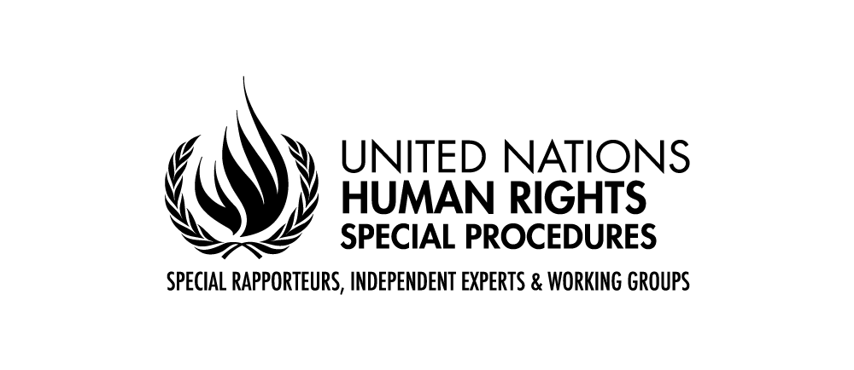

Statement by Mr. Surya Deva
United Nations Special Rapporteur on the right to development

78th Session of the United Nations General Assembly

New York

13 October 2023

Mr. President, Excellencies, distinguished delegates, ladies and gentlemen,

I am honoured to present to the General Assembly my first thematic report on the role of businesses in realising the right to development.

Mr. President

The right to development is a human right relevant for everyone, everywhere. It provides a pathway to realise all other human rights and fundamental freedoms. The right to development also embodies the practical application of the principle that human rights are indivisible, interdependent and interrelated. Moreover, this right is central to achieving the Sustainable Development Goals, addressing root causes of conflicts, and underpinning a just transition to a green economy.

Despite such significance of the right to development, the right remains unrealised for millions of people in all world regions. In my vision report presented to Human Rights Council last month (A/HRC/54/27), I identified six challenges undermining the ability of States and other actors to fully realize the right to development and proposed targeted strategies to overcome these challenges.

Distinguished delegates

Businesses have an indispensable role in realising the right to development. They construct houses, build infrastructure, offer loans and banking services, create employment opportunities, foster vocational capabilities, develop new medicines and vaccines, provide Internet services, offer various means of transport and provide access to essential public services. At the same time, business activities can also undermine the right to development, for example, by evading tax payment, promoting the sale of unhealthy products, exploiting migrant workers, causing environmental pollution or displacing Indigenous Peoples for development projects.

The report provides a road map to harness the positive contribution of business and minimise the adverse impacts of business activities on the right to development. By operating in line with the UN Guiding Principles on Business and Human Rights and other international standards, businesses should contribute to realising all four facets of the right to development, that is, economic, social, cultural and political development. They can do so, for example, by paying living wages to workers, bridging the digital divide, paying tax, advancing substantive gender equality, respecting the cultural rights of Indigenous Peoples, and facilitating the participation of people in decision making processes.

At the same time, we should acknowledge that many business models are inconsistent with a holistic understanding of the right to development, because they are creating inequalities and destroying the planet. The existing development narrative reflecting a sequencing mindset between economic development and human rights is also problematic.

The world therefore needs a new model of “planet-centred participatory development”. We also need a fundamental shift in the current role and place of business in society. I propose three elements of this fundamental shift.

First, the purpose of business in society should be reimagined. The shareholder primacy model, which pushes many companies to take decisions that harm people or the planet, must change. Similarly, the current compensation model of corporate executives should be reformed because it discourages focus on long-term value creation or protection of the environment.

Second, businesses should change irresponsible business models. To contribute to a human rights economy, people and the planet should be at the heart of business models. Companies should not treat workers as a commodity to maximize profits, encourage the use of unhealthy products such as tobacco, promote unsustainable consumption with total disregard for the environment, or indulge in lobbying against States’ policies on phasing out fossil fuel.

Third, businesses should go beyond the “do no harm” approach. Realising the right to development will require businesses to go beyond respecting human rights. To end poverty, hunger and child labour or to achieve substantive gender equality, businesses would need to take positive steps to aid – not as charity but as part of their human rights responsibility – individuals or groups left behind systemically by the current economic order.

States and civil society organisations have a critical enabling role in supporting this fundamental shift in the role of business in society. States should create binding human rights obligations for businesses. They should also change the current legal architecture – comprising corporate laws and international investment agreements – that facilitates business abuse of human rights or pollution of the environment. On the other hand, civil society organisations should continue to address imbalances of power between people and businesses and support inclusive participation of people in development-related decisions made by businesses.

Mr President

The time has come for the world community to give the right to development its legitimate space in the universe of human rights. In this context, it will be critical to adopt the draft Covenant on the Right to Development as soon as possible and take proactive measures to implement the right at the national level. As we mark the 75th anniversary of the Universal Declaration of Human Rights and the 30th anniversary of the Vienna Declaration and Programme of Action, I call on all States and other actors to work together to ensure that the right to development remains central to the 2030 Agenda for Sustainable Development, the Summit of the Future, and the Secretary General’s calls to address structural issues in the current economic and financial architecture.

Thank you very much for your kind attention and I look forward to the interactive dialogue.

