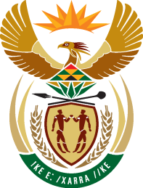

24th SESSION OF THE WORKING GROUP ON THE RIGHT TO DEVELOPMENT

SOUTH AFRICA STATEMENT

TITLE

16 MAY 2023

ROOM XX

PALAIS DES NATIONS, GENEVA
(Check against Delivery)

Chairperson,

South Africa’s comment is on the title of the instrument. We appreciate the commentary by the Expert Drafting Group on the overall text and with regard to the title.

Noting the commentary provided relating to the editorial procedures, South Africa proposes, as also expressed by other delegations, as an option to changing the title from an International ‘Convention’ to an International ‘Covenant’ on the Right to Development.”

An update from a Convention to a Covenant would reflect consistency with provisions already negotiated and adopted by the UN Member States, namely International Covenant on Civil and Political Rights and International Covenant on Economic, Social and Cultural Rights.

This title change would support the relationship of the “right to development” with other civil, political, economic, social, and cultural rights and fundamental freedoms as enshrined in both Covenants.

The aim of this proposal does not , however, seek to stand in the way of consensus that would prevent progress of this process.

I thank you.

