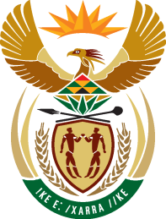

24th SESSION OF THE WORKING GROUP ON THE RIGHT TO DEVELOPMENT

SOUTH AFRICA STATEMENT

CONSIDERATION AND INTERGOVERNMENTAL NEGOTIATION OF THE SECOND REVISED DRAFT CONVENTION ON THE CONVENTION ON THE RIGHT TO DEVELOPMENT
(Agenda Item 4.3)

15-19 MAY 2023

ROOM XX

PALAIS DES NATIONS, GENEVA
(Check against Delivery)

Chairperson,

South Africa aligns itself with the statement delivered by Azerbaijan on behalf of the Non-Aligned Movement.

My delegation would like to thank you, Excellency, and the drafting experts for presenting the comprehensive second revised draft convention which we have before us. This text before us is a critical contribution towards the practical realisation of the right to development for all.

South Africa reaffirms is recognition for the right to development both under international law and in its domestic policy. South Africa is State Party to the African Charter on Human and People’s Rights, which was adopted in 1981, and in its Preamble and Article 22 explicitly mentions the Right to Development, and is thus a testimony to the Continent’s commitment towards the practical realisation of this right.

We are hopeful that such recognition can further transcend beyond national and regional levels and to the international level, through the elaboration of a legally binding international instrument to, among others, ensure policy coherence and international cooperation.

South Africa assures you its active and constructive participation during the process of intergovernmental negotiations on this text.

In conclusion, we are hopeful of wider support in this process towards enabling us make real progress in the elaboration of a legally binding instrument on the right to development and elevating this inalienable right to its rightful place on par with all human rights and fundamental freedoms

I thank you.

